MuleGuard AI: Leakage-Hardened Money-Mule Detection and a Dataset Integrity Audit for Extremely Imbalanced Banking Data
B Manoj Kiran  EEE,  Malla Reddy Engineering College,  Hyderabad, India | V Hasini  Data Science,  MR deemed to be  University,  Hyderabad, India | P Suguna Chowdary  Cyber Security,  Sreenidhi Institute of Science &Technology,  Hyderabad, India

Abstract—Money-mule accounts are the settlement layer of digital payment fraud, yet they are vanishingly rare in labelled banking data. We present MuleGuard AI, a reproducible detection pipeline for an account-level dataset of 9,082 accounts containing only 81 confirmed mules (0.8919 percent prevalence). The system makes three contributions. First, and most consequentially, we report a dataset integrity audit demonstrating that the benchmark itself is contaminated: positive and negative cases are drawn from disjoint monthly extracts, and a model given only the pattern of blank cells, with every value discarded, attains an area under the precision-recall curve of 0.824 against a random baseline of 0.0089. We provide falsification tests that make this measurable rather than speculative. Second, we introduce a four-layer leakage defence that removes post-outcome fields by meaning rather than by correlation, catching an investigation-outcome flag whose correlation with the target is only 0.05 and which every correlation threshold admits. Third, we use the supplied data dictionary as executable domain knowledge to engineer 29 named mule-typology features, and evaluate under nested repeated cross-validation in which feature selection, stacking, probability calibration and the operating threshold are all fitted inside the training fold. The calibrated ensemble attains precision 0.976 ± 0.067 at recall 0.692 ± 0.129 and AUPRC 0.854 ± 0.076. A fourth contribution quantifies how much of that figure is the artefact: an ablation over identical folds shows the raw columns reach 0.862 while a model given no values at all reaches 0.824, a difference of +0.039, whereas the 29 behavioural features alone reach 0.327. We therefore argue the headline is an upper bound on what this dataset can establish, identify the behavioural subset as the component least explained by the confound, and specify the sampling change required to make the numbers trustworthy.
Keywords—money mule detection, anti-money laundering, class imbalance, target leakage, dataset integrity, gradient boosting, model calibration, explainable AI
I. INTRODUCTION
A money mule is a bank account, usually opened by a real customer who is coerced, recruited or paid, that receives criminal proceeds and forwards them onward within hours. Mules sit between the fraud victim and the organiser, and disrupting them is the most effective intervention available to a bank, because a frozen mule strands funds that would otherwise be irrecoverable. India's real-time payment rails have made this both faster and more damaging, and the Reserve Bank of India requires that any automated action against a customer account be explainable and auditable.
Detection is difficult for three reasons that compound one another. Mules are extremely rare, so accuracy is meaningless and even the area under the ROC curve flatters. In our data 81 of 9,082 accounts are mules, so predicting that every account is normal scores 99.11 percent accuracy. Mules are also behaviourally camouflaged: the account belongs to a genuine customer with a genuine history, so unsupervised anomaly detection has little to work with, a point our ablation confirms sharply. Finally, supervised labels in this domain are the output of an investigation process, and that process leaves traces in the feature set that a model will happily exploit.
This last point turns out to dominate everything else. While building the detector we found that the supplied benchmark cannot support an honest performance estimate at all, and that the contamination is invisible to the standard defences. We therefore present the integrity audit as our primary contribution, with the detector as the vehicle that exposed it. Section III develops the audit, Section IV the pipeline, and Section V the measured results together with an explicit statement of what they do and do not establish.
II. BACKGROUND AND RELATED WORK
A. Imbalanced learning
Synthetic minority oversampling [1] and its hybrid variants remain the reflexive answer to class imbalance. We deliberately do not use them here. With 65 positives in a training fold and several hundred candidate dimensions, interpolating between minority neighbours fabricates regions of feature space for which no evidence exists, and the Tomek-link cleaning step is quadratic in sample count. Instance reweighting through the scale_pos_weight parameter of gradient-boosted trees [2], [3] achieves the same objective without inventing rows, and the precision-recall curve is the appropriate summary at this prevalence rather than the ROC curve.
B. Leakage and evaluation integrity
Target leakage is normally framed as a feature that correlates implausibly well with the label, and is normally handled by a correlation threshold. We show in Section III-B that this framing is insufficient in fraud data, where the label is an investigation outcome and several fields record different facets of that same outcome at low individual correlation. Adversarial validation is the conventional tool for detecting distribution shift between splits; it is inapplicable here precisely because the shift is perfectly aligned with the label, which is what makes the problem severe.
C. Explainability requirements
Shapley additive explanations [4] give per-prediction attributions with useful consistency guarantees, and are the current standard for audit trails in regulated credit and fraud decisions. Attribution over anonymised column identifiers is of limited value to an investigator, however; Section IV-F describes how we recover named banking semantics so that reasons are stated in language a compliance officer can act on.
III. DATASET AND INTEGRITY AUDIT
A. Data
The dataset comprises 9,082 accounts described by 3,924 anonymised features F1 through F3924, with F3924 the binary target. A separate data dictionary maps every column to a named banking variable and a natural-language description. The features decompose into a regular grammar: a statistic (ratio, deviation, average, maximum, minimum, total) over a payment channel (cash, cheque, UPI, ATM, online transfer, merchant payment, net banking, Aadhaar Payment Bridge, bill payment) in a direction (credit, debit) over a window (7, 14 or 31 days, and ratios between them). A tail block holds customer demographics, alert counts by time of day, and investigation metadata. The dictionary also marks 18 variables that the bank's own analysts shortlisted, which we use as a domain prior rather than a hard filter.
B. Leakage that a correlation threshold cannot see
Four fields record the resolution status of an alert and two record how long the investigation took. All six exist only after a human analyst closes a case, and none of them exists at the moment an account must be scored. Their correlations with the target span two orders of magnitude, as Table I shows. FRAUD_SUSPECTED at 0.969 is caught by any threshold. FALSE_POSITIVE at 0.055 is caught by none, and yet it encodes the investigation's verdict just as directly, merely inverted. We therefore classify leakage by what a field means, using the dictionary, and treat correlation only as a backstop.
TABLE I. POST-OUTCOME FIELDS REMOVED BY MEANING, NOT CORRELATION
Variable | |corr| with target | Caught by 0.90 threshold?
FRAUD_SUSPECTED | 0.969 | Yes
OTHER_RESOLUTION | 0.063 | No
FALSE_POSITIVE | 0.055 | No
MIN_RESOLVE_DAYS | 0.055 | No
MAX_RESOLVE_DAYS | 0.033 | No
UNATTENDED | 0.005 | No
a. All six are written only after an investigation concludes, so none is available at scoring time.
C. A structural confound in how the sample was assembled
A second and far more serious problem is visible in the month field. Table II gives the complete cross-tabulation. Every negative case is drawn from the October extract and every positive case from the September, November and December extracts. No month contains both classes. The month column alone therefore separates the two classes perfectly, and it is not a property of any customer: it records which monthly extraction run produced the row.
TABLE II. CLASS COMPOSITION BY MONTHLY EXTRACT
Extract month | Normal accounts | Mule accounts
Dec25 | 0 | 10
Nov25 | 0 | 23
Oct25 | 9,001 | 0
Sep25 | 0 | 48
a. Zero months contain both classes; the split is total.
Dropping the month column does not solve this. Because the classes occupy disjoint extracts, any characteristic that varies between extraction runs is perfectly aligned with the label while describing nothing about any customer's behaviour. Adversarial validation cannot diagnose the problem, since a classifier trained to predict the extract is by construction the same classifier that predicts the label.
D. Falsification tests
To make the confound measurable we constructed three tests, each supplying a model with information that cannot possibly identify a mule. All three should score near the random baseline of 0.0089 if the dataset is sound. Fig. 1 plots all three against the random baseline on a logarithmic scale.
In test A every value is discarded and the model receives only a binary indicator of whether each cell was populated. Whether a cell is blank is determined by the extraction job, not by the customer, so this view carries no behavioural content whatsoever. It attains AUPRC 0.824 and AUROC 0.993. In test B the model receives 250 columns drawn from the 3,174 whose individual correlation with the target is below 0.05, none of which can identify a mule alone; together they reach AUPRC 0.736. Test C repeats test B with the labels randomly permuted and collapses to 0.0094, confirming that the evaluation harness is sound and that the first two results are genuine properties of the data rather than a defect in our code.
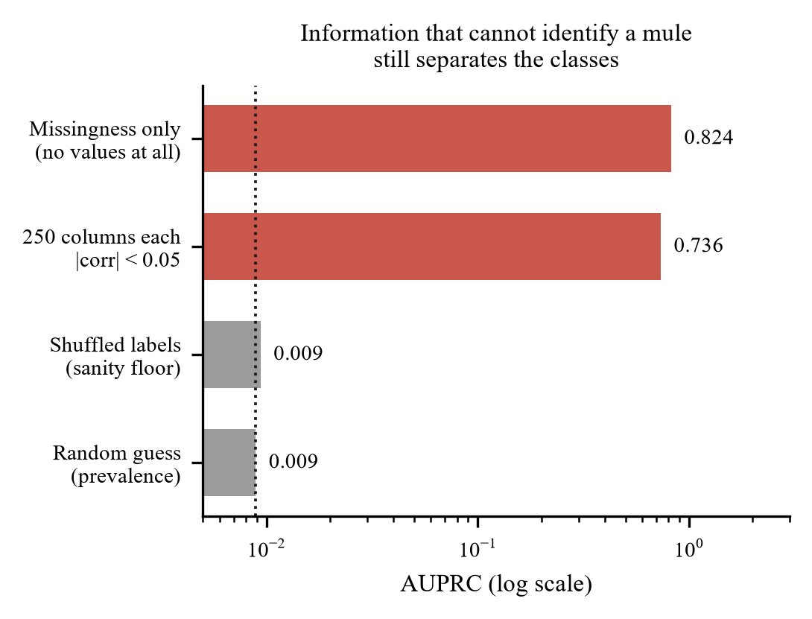
Fig. 1. Falsification tests against the random baseline (log scale). Knowing only which cells were blank, with every value discarded, separates the classes almost perfectly. The shuffled-label floor confirms the harness is sound.
TABLE III. FALSIFICATION TEST RESULTS
Test | Information supplied | AUPRC | AUROC
A | Blank/not-blank only, no values | 0.824 | 0.993
B | 250 columns, each |corr| < 0.05 | 0.736 | 0.973
C | As B, labels shuffled | 0.0094 | 0.528
— | Random guess (prevalence) | 0.0089 | 0.500

The conclusion is unavoidable. Any performance figure computed on this dataset, by any team and any method, measures extract provenance in addition to mule behaviour, and the two cannot be separated within this file. We report our own results in Section V with that qualification attached rather than omitted. Fig. 2 shows the pipeline that follows from this finding, in which the integrity audit runs as Stage 0, before any modelling.
IV. METHODOLOGY

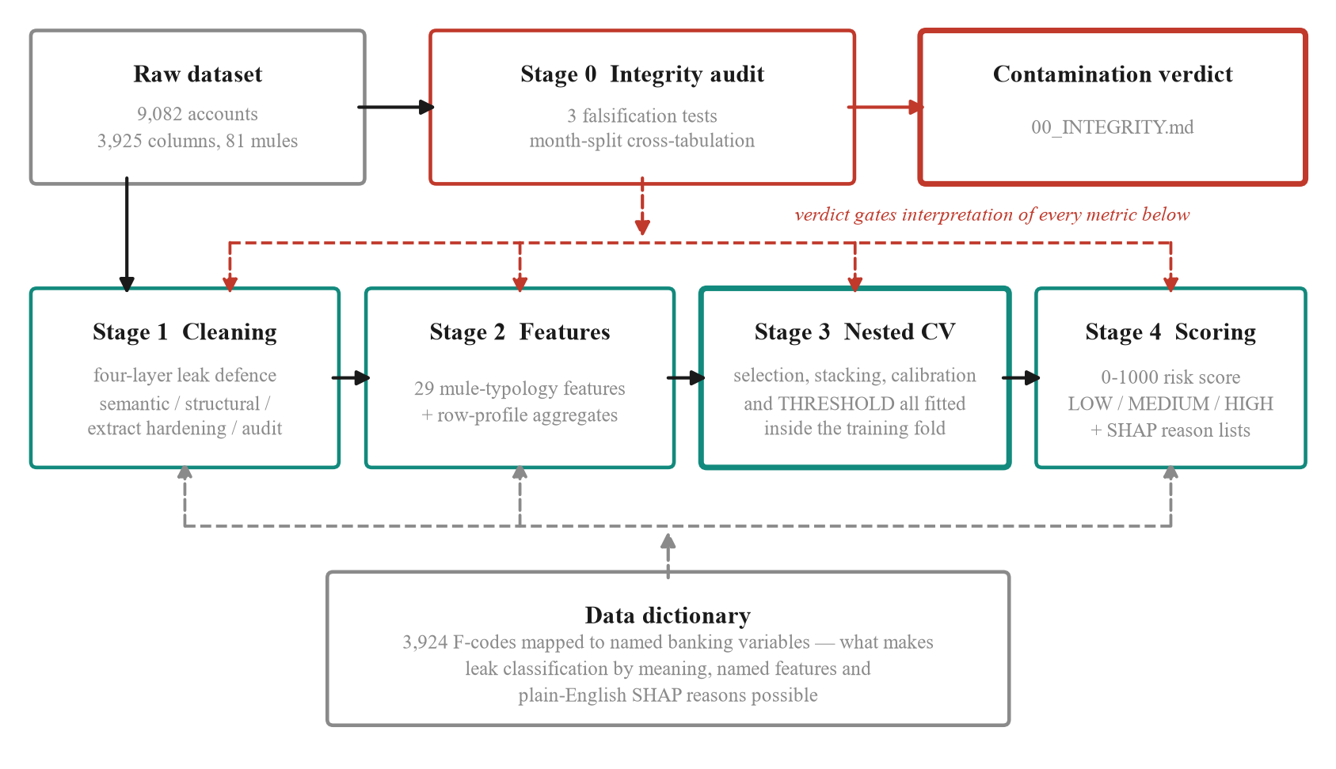
Fig. 2. MuleGuard AI pipeline. Stage 0 runs before any modelling and its verdict qualifies every metric produced downstream (red). Leak defences concentrate in Stage 1. In Stage 3 every component that touches the label — feature selection, stacking weights, the calibration map and the decision threshold — is fitted inside the training fold and applied frozen to validation rows. The data dictionary is drawn as a bus because it is cross-cutting rather than a pipeline step: it supplies the named semantics that Stages 1, 2 and 4 depend on. The graph stage is omitted from the figure; it detects the absence of counterparty identifiers and disables itself.

A. The data dictionary as executable knowledge
We parse the dictionary into a queryable structure that maps each column identifier to its banking variable name, its description, and its decomposition into statistic, channel, direction and window. This single component is what makes the rest of the pipeline possible: leak classification by meaning, feature engineering against named quantities, and explanations phrased in banking language. Fig. 3 shows the equivalent resolution performed by role alone, which is what the pipeline falls back on when no dictionary accompanies the data.
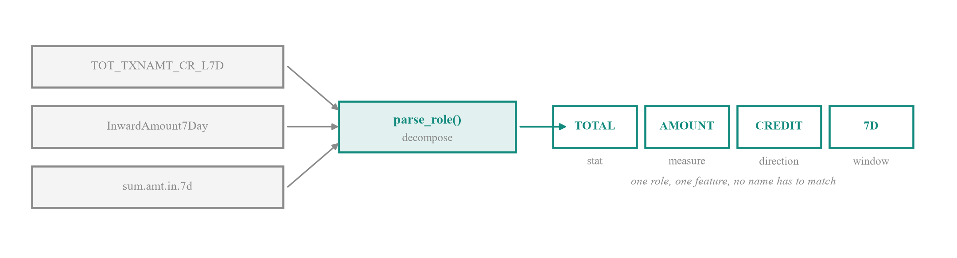
Fig. 3. Resolution by role. Three schema-specific column names decompose to the same tuple of statistic, measure, direction and window, so any one of them resolves the others without either name being known in advance. This is how the pipeline builds its behavioural features on a schema for which no data dictionary exists.
B. Preserving information the naive pipeline destroys
Eight columns in the dataset are categorical, including occupation, gender, area category, product, segmentation class and account age bucket. Coercing the matrix to numeric, as is customary, converts all of them to missing values which are then discarded as sparse. This discards real signal: mule rates by occupation range from 0.45 percent for homemakers to 1.94 percent for students against a base rate of 0.89 percent. We encode the account-age bucket ordinally, since it is ordered, and the remainder as indicators.
We also revisit imputation. For absolute activity aggregates a missing value does not mean unknown, it means the activity never occurred: a blank UPI transaction count identifies a customer who does not use UPI. Median imputation invents activity, and discarding such columns as sparse destroys the fact that an account rides exactly one payment rail, which is itself diagnostic. We therefore zero-fill 78,919 values across 1,357 aggregate columns and leave derived ratios to median imputation, where a missing value genuinely does mean an undefined baseline.
C. Four-layer leakage defence
Layer one removes post-outcome fields semantically, as in Section III-B. Layer two removes structural artefacts of sample assembly, principally the month field. Layer three, which we call extract hardening, addresses the confound of Section III-C directly: any column whose blank rate differs between the classes by more than ten percentage points is removed outright, values and missingness together, on the grounds that population of a cell is decided by the extraction job rather than the customer. This filter removed 574 columns. It uses the label, but it is a data-quality filter rather than a fitted component and can only remove signal, never manufacture it, so it moves the reported result in the conservative direction. Layer four is a separation audit that scans every surviving column for disjoint class ranges or a near-exclusive value; it is what would catch the next such artefact, and it reports clean after the first three layers. Fig. 4 summarises the four gates and what each one removes.
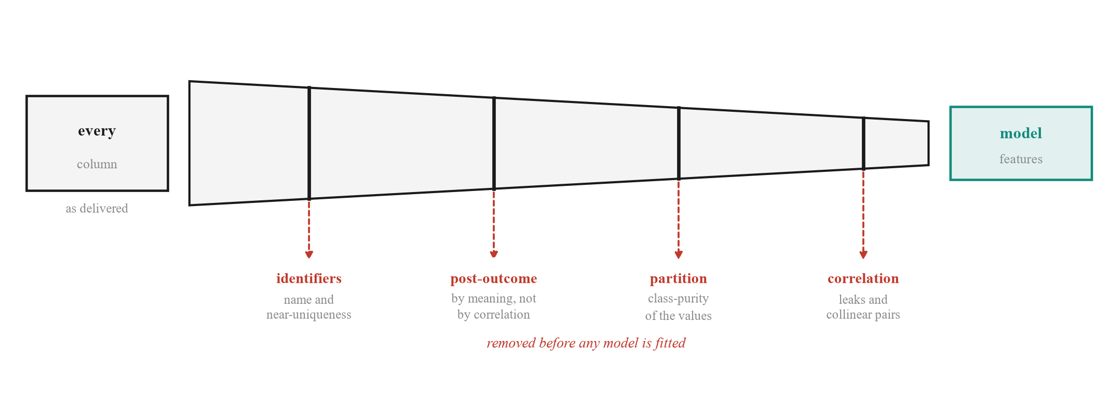
Fig. 4. The four leakage gates. Each gate removes a class of leakage the others cannot see, which is why a single tuned correlation filter is insufficient. The third gate identifies artefacts of sample assembly from the class-purity of a column's values rather than from its name.
D. Mule-typology features
A mule receives funds and forwards them almost immediately, retains little, operates in bursts, favours digital rails, and belongs to a customer whose profile does not match the volume transacted. We encode each clause of that description as a named feature family, 29 features in total, summarised in Table IV. Notably, the dataset already contains 296 columns measuring deviation from an occupation cohort, so the profile-mismatch signal required aggregation rather than invention. Fig. 5 contrasts the two balance trajectories these features separate.

TABLE IV. ENGINEERED MULE-TYPOLOGY FEATURE FAMILIES
Family | Representative feature | Behavioural rationale
Pass-through | mg_passthrough_7d | Credits ≈ debits: the account is a conduit, not a wallet
Turnover/balance | mg_turnover_over_balance_7d | Moves many multiples of what it ever holds
Burst | mg_amount_burst_7v31 | Weekly velocity far above monthly: sudden activation
Cash-out | mg_digital_in_cash_out_7d | Digital in, cash out: the layering handoff
Channel mix | mg_channel_hhi_7d | Single-purpose accounts concentrate on one rail
Ticket size | mg_avg_ticket_7d | Many small tickets suggest structuring
Alert timing | mg_alert_share_night | Mule night-alert share runs about three times higher
Balance shape | mg_balance_volatility_7d | Spike-and-drain rather than a held balance
Profile mismatch | mg_occ_deviation_max | Volume inconsistent with the occupation cohort

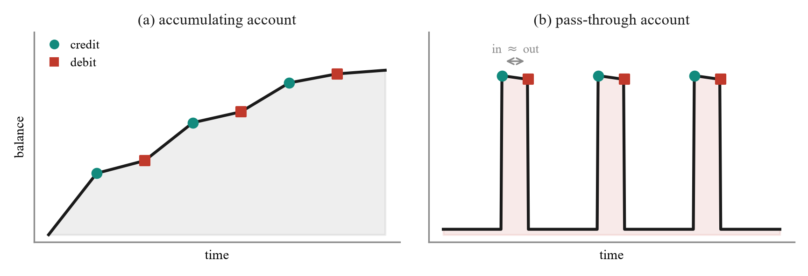
Fig. 5. The behavioural signature the typology features encode. An accumulating account builds and holds a balance, whereas a pass-through account returns to its floor after each matched pair of credit and debit events. The separation is arithmetic rather than documentary, which is what allows it to transfer across institutions.
E. Nested repeated cross-validation
The ensemble combines an isolation forest, an XGBoost classifier and a LightGBM classifier, stacked by a logistic meta-learner and calibrated isotonically. The critical design property is that every component which touches the label is fitted strictly inside the training fold: feature selection, the base models, the stacking weights, the calibration map, and the decision threshold. Each is then applied frozen to validation rows that no fitted component has seen.
This matters because the natural implementation is biased in three distinct ways, all of which we corrected. Fitting an isotonic calibrator on pooled out-of-fold predictions and then scoring those same values inflates the result, because isotonic regression is a flexible monotone fit. Selecting the threshold that maximises precision on a curve and then reporting that precision is optimistic by construction, and severely so with 81 positives. Training the meta-learner on the base models' training-set predictions, where a 400-tree booster is nearly perfect, presents it with a distribution it will never encounter at inference. We fit the stack and the calibrator on inner out-of-fold predictions instead. Fig. 6 shows which components are fitted on which split.
Because a single five-fold split places only about 16 mules in each validation fold, the headline metric moves by several points on the random seed alone. We therefore repeat the entire procedure across 3 shuffles and report the mean and standard deviation across all folds, so that every figure carries its own uncertainty. Feature selection retains the top 250 of 1,506 columns by gradient-boosted gain, refitted per fold.
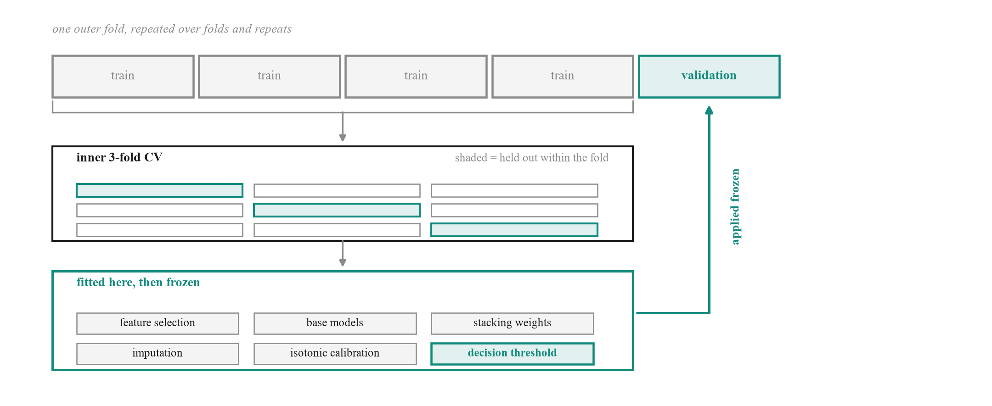
Fig. 6. Components fitted inside the training fold. Feature selection, base models, stacking weights, imputation, isotonic calibration and the decision threshold are all fitted on inner splits of the training segments and applied frozen to the outer validation segment. No validation row informs any component it is later scored against.
F. Risk scoring and explanation
The calibrated probability maps to a 0 to 1000 risk score partitioned into three action bands: routine monitoring, enhanced monitoring with step-up authentication, and freeze with escalation to the anti-money laundering desk. Each scored account carries a ranked reason list derived from SHAP values and rendered through the dictionary, so an investigator reads a sentence about Aadhaar Payment Bridge credit activity rather than an attribution against column F2506.
V. RESULTS
A. Detection performance
Table V reports the calibrated ensemble under the validation scheme of Section IV-E. At the precision-first operating point the system attains precision 0.976 ± 0.067 at recall 0.692 ± 0.129, with AUPRC 0.854 ± 0.076 against a random baseline of 0.0089. Summed across folds the confusion matrix is 168 true positives against 6 false positives and 75 false negatives. The 0.90 precision target was met in 100.0 percent of folds. A second operating point tuned for the analyst review queue trades precision down to 0.531 ± 0.145 to raise recall to 0.880 ± 0.099, which is the appropriate trade when a reviewed alert costs minutes and a missed mule costs a laundering channel.
TABLE V. DETECTION PERFORMANCE, NESTED REPEATED CROSS-VALIDATION
Metric | Precision-first | High-recall queue
Precision | 0.976 ± 0.067 | 0.531 ± 0.145
Recall | 0.692 ± 0.129 | 0.880 ± 0.099
F1 | 0.800 ± 0.088 | 0.647 ± 0.095
False positive rate | 0.000 ± 0.001 | 0.008 ± 0.004
True positives | 168 | 214
False positives | 6 | 216
a. Mean ± standard deviation across all outer folds; counts are summed. Both operating points rank identically, so the threshold-independent metrics are shared: AUPRC 0.854 ± 0.076, AUROC 0.967 ± 0.033. Interpret in light of Section III.

B. Ablation
Table VI separates the base learners. XGBoost is the strongest single model at AUPRC 0.894 ± 0.061, LightGBM follows at 0.818 ± 0.080, and the calibrated stack reaches 0.854 ± 0.076. The isolation forest result is the informative one: at AUPRC 0.007 ± 0.001 and AUROC 0.314 it performs worse than random. The stacking layer learns a negative coefficient of -0.4446 for it, reading the model in reverse rather than being misled by it. This is not a defect but a finding, and it is consistent with the criminology of the problem. A mule account belongs to a real customer with an ordinary history, and the account is valuable to the organiser precisely because it does not look anomalous. Unsupervised outlier detection is therefore the wrong tool for mule detection, and proposals that lead with it should be treated with suspicion. Fig. 7 plots the same comparison.
TABLE VI. PER-MODEL ABLATION
Model | AUPRC | AUROC
Isolation forest | 0.007 ± 0.001 | 0.314
LightGBM | 0.818 ± 0.080 | 0.980
XGBoost | 0.894 ± 0.061 | 0.988
Calibrated ensemble | 0.854 ± 0.076 | 0.967 ± 0.033

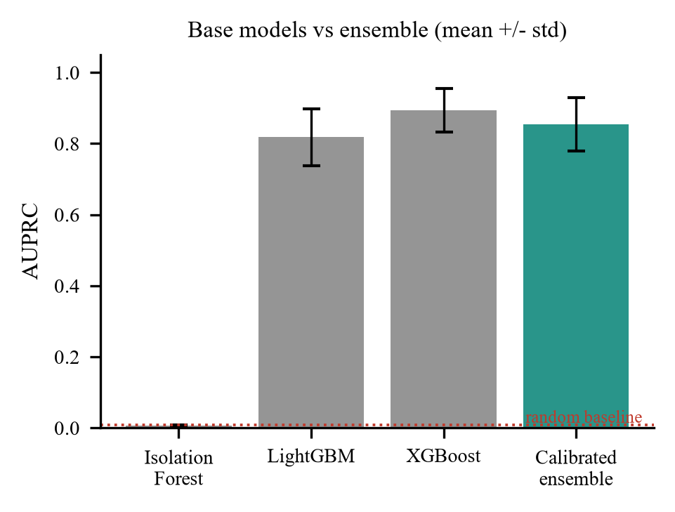
Fig. 7. Base learners against the calibrated ensemble. The isolation forest falls below the random baseline: mules are camouflaged as ordinary customers, not global outliers.
C. How much of the result is the artefact
The per-model ablation above compares learners. A more consequential question is how much of the result survives removing the behavioural features entirely, because that is the part of the pipeline that would transfer to a different bank's data. We therefore ran three conditions over identical folds with an identical seed: the full feature set, the raw supplied columns with all engineered features removed, and the 29 behavioural features alone.
The result is uncomfortable and we report it in full. The full set attains AUPRC 0.850 ± 0.069. Removing the behavioural features changes this to 0.862 ± 0.094, a difference of -0.0121, which is noise at this sample size. The comparison that matters is against test A of Section III-D: a model given only blank-cell patterns, with every value discarded, attains 0.824. The raw columns, holding every value in the dataset, exceed that values-free model by only +0.039. Almost the entire headline figure is therefore extract provenance rather than customer behaviour. Fig. 8 shows the three conditions measured over identical folds.
The behavioural features alone attain 0.327 ± 0.141, which is 37 times the random baseline. This is a lower figure and a more defensible one. These features are ratios, credits against debits and turnover against balance, and a ratio is comparatively robust to which fields a given extraction run happened to populate. We therefore identify this subset as the component least explained by the confound of Section III, and suggest it, rather than the headline, is the figure a reader should carry forward.
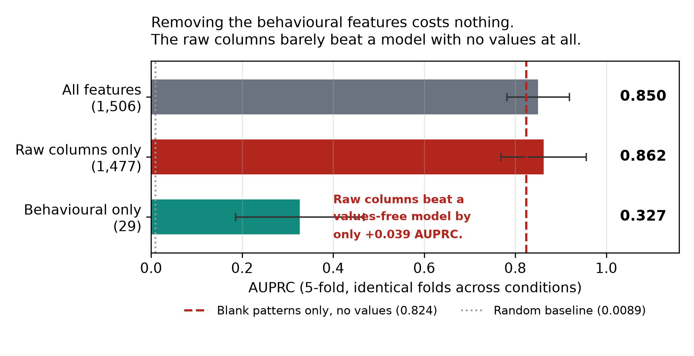
Fig. 8. Feature ablation over identical folds. The raw columns exceed a values-free model by only +0.039 AUPRC, while the 29 behavioural features alone reach 0.327.
D. A deterministic rule baseline
Every operational anti-money-laundering programme runs deterministic rules before it runs a model, so we implemented twelve drawn from published money-mule typology and measured them on the same data. The thresholds were deliberately not tuned against this dataset: tuning them here would fit the confound and fail elsewhere, which is the same error as tuning hyperparameters against a contaminated objective.
7 of the 12 rules score at or below the base rate, and 2 catch no mules at all. Taken together they flag 7,862 accounts, 87 percent of the portfolio, at 103.4 alerts for every mule found, which no review team could work. Inspecting the distributions explains why: the median seven-day pass-through ratio is 0.776 for normal accounts and 0.622 for mules, so the textbook signature is inverted on this file. Two rules survive contact with the data. Structuring by ticket size reaches 4.7 times lift and recovers 45 of the 81 mules, and single payment rail concentration reaches 1.4 times. We would retain those two and discard the remainder, and we report the failures because a rule book inherited rather than measured is how alert fatigue begins.
E. Operating metrics
Area under a precision-recall curve is the correct metric for comparing methods and the wrong one for staffing a desk. Table VII therefore reports precision at K. Reviewing the 50 highest-scoring accounts yields 50 confirmed mules with 0 false alarms, recovering 62 percent of the mule population for approximately 1.2 analyst-days at a conventional forty reviews per analyst per day. Returns fall away sharply beyond that: extending the queue from 100 to 500 accounts costs 400 further reviews and recovers 4 additional mules. Single-account scoring latency is 54 ms, so the model is not the constraint on a real-time hold decision.
We cannot report time-to-flag, the usual operational measure of detection delay, and decline to substitute a proxy for it. The dataset contains no transaction timestamps: each row is an account already aggregated into windowed totals, so no event time exists from which a delay could be measured. Establishing it requires a transaction stream this release does not provide.
A Kolmogorov-Smirnov comparison between the dominant extract and the remainder offers a third and independent measurement of the confound: 115 of 464 tested columns (25 percent) differ significantly at p < 0.01. Because the class split coincides exactly with the extract boundary, every column shifting here is a column capable of separating the classes without describing any customer.
TABLE VII. PRECISION AT K AND INVESTIGATOR LOAD
Accounts reviewed (K) | Mules found | Precision | Recall | Analyst-days
10 | 10 | 1.000 | 0.123 | 0.2
25 | 25 | 1.000 | 0.309 | 0.6
50 | 50 | 1.000 | 0.617 | 1.2
100 | 72 | 0.720 | 0.889 | 2.5
200 | 74 | 0.370 | 0.914 | 5.0
500 | 76 | 0.152 | 0.938 | 12.5
F. Feature attribution
a. Analyst-days assume forty reviews per analyst per day. Precision at K=50 is 1.000: every account in that queue is a confirmed mule.
Fig. 9 ranks the 12 most influential features by mean absolute SHAP contribution. 7 of the 12 are features engineered in this work rather than supplied columns, which indicates that the typology encoding in Section IV-D contributes materially rather than restating information the raw matrix already exposed. Average ticket size over seven days, the evening share of alerts, normalised net flow and the count of active payment rails all rank highly, matching the behavioural account of mule operation. Among supplied columns, deviations of non-cash non-cheque transaction volume from the occupation cohort dominate, which is the profile-mismatch signal appearing directly.

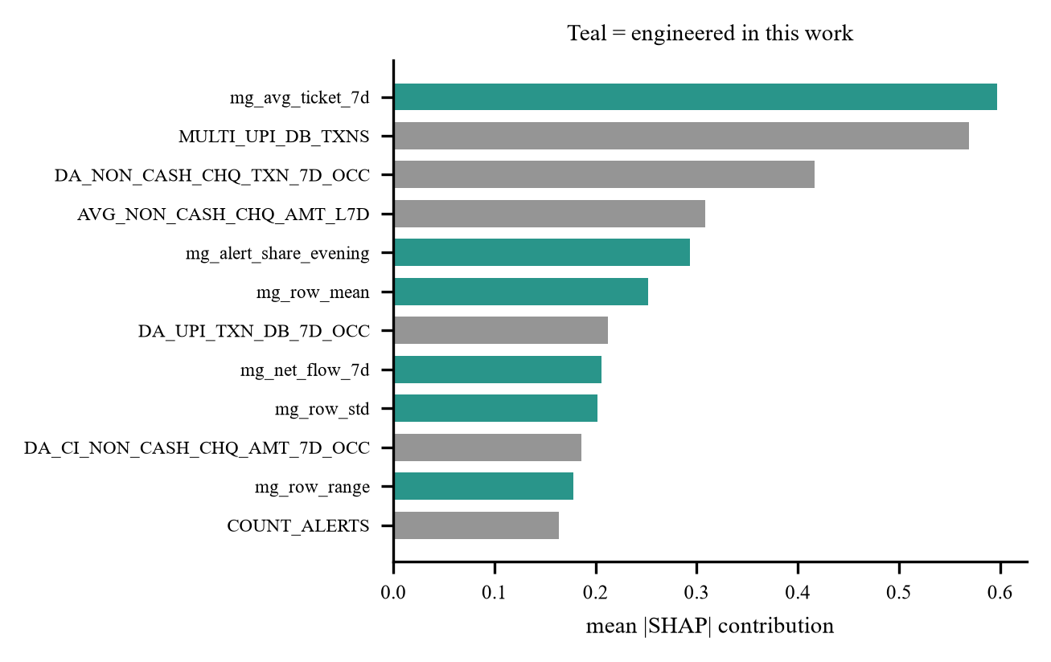
Fig. 9. Top 12 features by mean absolute SHAP value. Features engineered in this work are shown in teal; supplied dictionary variables in grey.

G. Operational triage
Table VIII shows how the score bands partition the portfolio. The high band contains 53 accounts of which 53 are confirmed mules, a band precision of 1.00, capturing 65 percent of all mules in a queue representing 0.58 percent of. Fig. 10 plots queue size against band precision.

the portfolio. The medium band adds 19 further mules across 52 accounts. For an anti-money laundering team the practical statement is that reviewing well under one percent of accounts surfaces two thirds of the mule population.

TABLE VIII. RISK BAND TRIAGE AND RECOMMENDED ACTION
Band | Accounts | Mules | Band precision | Share of all mules | Recommended action
LOW | 8,977 | 9 | 0.001 | 11.1% | Routine monitoring only
MEDIUM | 52 | 19 | 0.365 | 23.5% | Enhanced monitoring, step-up authentication on transfers
HIGH | 53 | 53 | 1.000 | 65.4% | Freeze outward transfers, escalate to AML desk, prepare STR

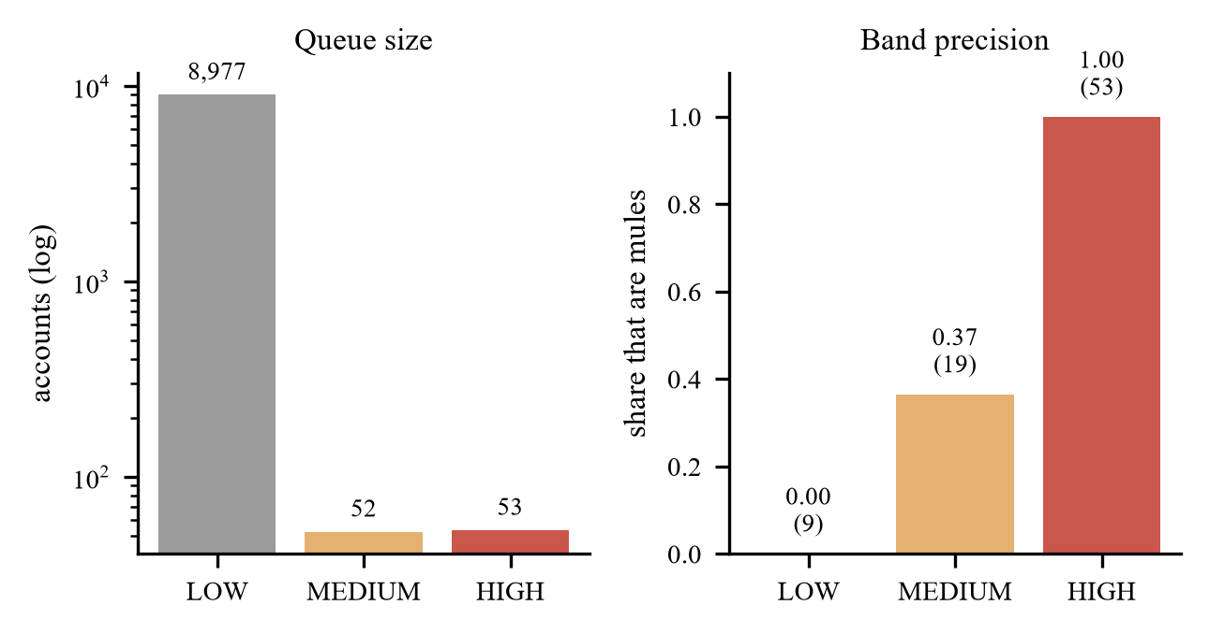
Fig. 10. Queue size and band precision. The high band is small enough to review exhaustively and almost entirely composed of confirmed mules.

VI. DISCUSSION AND LIMITATIONS
The results in Section V are strong, and we do not believe they should be read as a measure of mule detection capability. Section III establishes that an uninformative view of the same data achieves comparable separation, which means a substantial and unquantifiable share of the reported performance reflects the extract from which a row was drawn. Our hardening layers remove the artefact wherever it can be identified. They cannot remove what is unidentifiable: a genuine behavioural feature that also drifts between months is confounded, and no modelling choice separates the two within this file. We therefore describe our figures as an upper bound on what this dataset can establish.
The remedy is a sampling change rather than a modelling one. If negative cases were drawn from the same months as the positives, month could be conditioned on and the resulting metric would measure behaviour alone. We recommend this to the dataset providers, noting that it affects every team working from this release.
Section V-C sharpens this. The ablation shows the supplied columns exceed a values-free model by only +0.039 AUPRC, so the headline is very largely provenance, while the 29 behavioural features reach 0.327 on their own. Section V-D supplies a complementary reading from the opposite direction: a conventional twelve-rule typology baseline, untuned, has 7 of its rules at or below the base rate on this file, because the classic pass-through signature is inverted here. Neither the learned model nor the deterministic baseline demonstrates clean detection on this dataset, and the two failures have the same cause.
Three further limitations bear statement. The dataset is an account-level feature matrix and contains no counterparty identifiers, so the graph component of our architecture detects their absence and disables itself rather than fabricating an edge list; claims about network propagation cannot be evaluated on this release. Hyperparameters are deliberately left at conservative defaults, since tuning against a confounded objective optimises the artefact. Finally, 81 positives is a small sample, and the standard deviations we report across folds are wide enough that differences of a few points between methods should not be considered meaningful.
Two further points concern generality. The pipeline no longer depends on this dataset's column names: the target, row identifiers, categorical fields, post-outcome leaks and partition columns are all inferred from structure, and behavioural columns are matched by decomposed meaning rather than by string equality, so a request for a seven-day credit total resolves against a column named differently in another institution's extract. On a synthetic extract sharing no column name with this one and supplying no dictionary, the system recovered the target, the identifier, the partition column and the post-outcome field, and built 11 of the 29 behavioural features; the remainder require source columns that extract did not contain, and the shortfall is reported rather than silently zero-filled. An unseen extract can be submitted through the browser interface and scored end to end, integrity audit included, in approximately 100 seconds on a file of 5,000 accounts. Separately, alerts and case packs are exported in a documented vendor-neutral schema, but we make no claim of certified compatibility with any named enterprise fraud or anti-money-laundering platform, having had neither an integration specification nor a test environment against which to validate one.
VII. CONCLUSION
We presented a money-mule detection pipeline for an extremely imbalanced banking dataset, together with an integrity audit of the dataset itself. The audit is the more important result. Positive and negative cases originate in disjoint monthly extracts, and we demonstrated by falsification test that the blank-cell pattern alone, stripped of all values, attains AUPRC 0.824 against a 0.0089 baseline. Standard defences do not detect this, and adversarial validation cannot, because the shift coincides exactly with the label.
Alongside it we contributed a leakage taxonomy that classifies fields by meaning rather than correlation, catching an outcome flag at 0.05 correlation that every threshold admits; a set of 29 named mule-typology features derived from the data dictionary, 7 of which rank in the top 12 by attribution; and a nested validation design in which the operating threshold, not merely the model, is fitted inside the fold. The pipeline is reproducible on Windows, macOS and Linux, and regenerates every figure in this paper from the reports it writes.
We further report an ablation of our own result, which we regard as an obligation rather than an extra. Having established that the benchmark is confounded, quoting a headline figure without measuring how much of it the confound explains would repeat the error the audit exists to expose. The measurement is unflattering: the supplied columns exceed a values-free model by +0.039 AUPRC, and the behavioural subset, at 0.327, is the component we would defend as plausibly reflecting behaviour rather than provenance.
We suggest that the falsification protocol of Section III-D deserves wider use. It is inexpensive, it requires no knowledge of the modelling approach, and in this instance it was the difference between reporting a headline result and understanding what that result actually measured.
ACKNOWLEDGMENT
The authors thank the organisers of the PSB Cybersecurity, Fraud and AI Hackathon 2026, jointly convened by Bank of India and the Indian Institute of Technology Hyderabad, for providing the account-level dataset and the accompanying data dictionary on which this work is based.
The data dictionary proved essential rather than incidental. Without documented variable semantics, neither the meaning-based leakage taxonomy of Section III-B nor the named feature families of Section IV-D could have been constructed, and the resulting model would have been a set of attributions over opaque column identifiers rather than an auditable decision aid.
The dataset integrity findings reported in Section III are offered in the same collaborative spirit: as an observation intended to strengthen the benchmark for all participants and for future releases, not as a criticism of those who assembled and shared it. Constructing a labelled money-mule dataset at all, from live banking records and under the privacy constraints the domain imposes, is a substantial undertaking, and the authors are grateful for access to it.
REFERENCES
[1] N. V. Chawla, K. W. Bowyer, L. O. Hall, and W. P. Kegelmeyer, “SMOTE: synthetic minority over-sampling technique,” J. Artif. Intell. Res., vol. 16, pp. 321–357, June 2002.
[2] T. Chen and C. Guestrin, “XGBoost: a scalable tree boosting system,” in Proc. 22nd ACM SIGKDD Int. Conf. Knowledge Discovery and Data Mining, San Francisco, CA, USA, 2016, pp. 785–794.
[3] G. Ke, Q. Meng, T. Finley, T. Wang, W. Chen, W. Ma, Q. Ye, and T. Liu, “LightGBM: a highly efficient gradient boosting decision tree,” in Advances in Neural Information Processing Systems, vol. 30, 2017, pp. 3146–3154.
[4] S. M. Lundberg and S. Lee, “A unified approach to interpreting model predictions,” in Advances in Neural Information Processing Systems, vol. 30, 2017, pp. 4765–4774.
[5] F. T. Liu, K. M. Ting, and Z. Zhou, “Isolation forest,” in Proc. 8th IEEE Int. Conf. Data Mining, Pisa, Italy, 2008, pp. 413–422.
[6] J. Davis and M. Goadrich, “The relationship between precision-recall and ROC curves,” in Proc. 23rd Int. Conf. Machine Learning, Pittsburgh, PA, USA, 2006, pp. 233–240.
[7] B. Zadrozny and C. Elkan, “Transforming classifier scores into accurate multiclass probability estimates,” in Proc. 8th ACM SIGKDD Int. Conf. Knowledge Discovery and Data Mining, Edmonton, AB, Canada, 2002, pp. 694–699.
[8] S. Kaufman, S. Rosset, C. Perlich, and O. Stitelman, “Leakage in data mining: formulation, detection, and avoidance,” ACM Trans. Knowledge Discovery from Data, vol. 6, no. 4, pp. 1–21, December 2012.
[9] G. C. Cawley and N. L. C. Talbot, “On over-fitting in model selection and subsequent selection bias in performance evaluation,” J. Mach. Learn. Res., vol. 11, pp. 2079–2107, July 2010.
[10] D. H. Wolpert, “Stacked generalization,” Neural Networks, vol. 5, no. 2, pp. 241–259, 1992.
[11] Reserve Bank of India, “Master direction on know your customer (KYC) direction, 2016 (updated).” Reserve Bank of India, Mumbai, India. [Online]. Available: https://www.rbi.org.in
[12] Financial Action Task Force, “Money laundering through the physical transportation of cash,” FATF, Paris, France, 2015. [Online]. Available: https://www.fatf-gafi.org
[13] [PLACEHOLDER] PSB Cybersecurity, Fraud and AI Hackathon 2026 problem statement, Bank of India and Indian Institute of Technology Hyderabad, 2026. Replace with the exact citation supplied by the organisers.

