MuleGuard AI: Leakage-Hardened Money-Mule Detection and a Dataset Integrity Audit for Extremely Imbalanced Banking Data
B Manoj Kiran  EEE,  Malla Reddy Engineering College,  Hyderabad, India | V Hasini  Data Science,  MR deemed to be  University,  Hyderabad, India | P Suguna Chowdary  Cyber Security,  Sreenidhi Institute of Science &Technology,  Hyderabad, India

Abstract—Money-mule accounts are the settlement layer of digital payment fraud, yet they are vanishingly rare in labelled banking data. We present MuleGuard AI, a detection system that consumes a transaction ledger and returns a ranked investigator queue with per-alert reasons and a localised activity window. Four detector families run in parallel: behavioural signals, time-windowed typology motifs, structural community detection, and temporal localisation. A fitted model combines them, rather than weights we chose. On SAML-D, an external public anti-money-laundering dataset of 855,460 accounts, the system attains AUPRC 0.421 on 148,150 held-out accounts. The base rate is 0.461 percent, so that is 91 times the base rate, with precision 0.70 among the fifty highest-ranked accounts. An ablation holding the ledger, split, seed and model fixed shows the network component raises AUPRC from 0.325. Its contribution is therefore measured rather than assumed. On a supplied account-level benchmark of 9,082 accounts containing 81 mules, the behavioural component attains precision 0.989 ± 0.030 at AUPRC 0.882 ± 0.062 under nested repeated cross-validation with feature selection, stacking, calibration and the operating threshold all fitted inside the training fold. We further contribute an integrity audit of that benchmark: positives and negatives are drawn from disjoint monthly extracts, and a model given only which cells are blank, every value discarded, reaches AUPRC 0.824 against a 0.0089 random baseline. Falsification tests make this measurable, a four-layer defence removes post-outcome fields by meaning rather than correlation, and an ablation bounds the inflation at +0.068 while the 29 behavioural features alone reach 0.368. We therefore report that benchmark's figure as an upper bound and specify the sampling change required to make it trustworthy. Because training needs labels and detection does not, the system reads the schema of an incoming file and routes accordingly: it retrains when a target resolves, scores with the deployed ensemble when none does but the schema matches, and otherwise rebuilds the typology from the file's own columns by role and sets an operating point by Otsu, tuning nothing.
Keywords—money mule detection, anti-money laundering, class imbalance, target leakage, dataset integrity, gradient boosting, model calibration, explainable AI
I. INTRODUCTION
A money mule is a bank account, usually opened by a real customer who is coerced, recruited or paid, that receives criminal proceeds and forwards them onward within hours. Mules sit between the fraud victim and the organiser, and disrupting them is the most effective intervention available to a bank, because a frozen mule strands funds that would otherwise be irrecoverable. India's real-time payment rails have made this both faster and more damaging, and the Reserve Bank of India requires that any automated action against a customer account be explainable and auditable [11].
Detection is difficult for three reasons that compound one another. Mules are extremely rare, so accuracy is meaningless and even the area under the ROC curve flatters. In our data 81 of 9,082 accounts are mules, so predicting that every account is normal scores 99.11 percent accuracy. Mules are also behaviourally camouflaged: the account belongs to a genuine customer with a genuine history, so unsupervised anomaly detection has little to work with, a point our ablation confirms sharply. Finally, supervised labels in this domain are the output of an investigation process, and that process leaves traces in the feature set that a model will happily exploit.
This last point turns out to dominate everything else. While building the detector we found that the supplied benchmark cannot support an honest performance estimate at all, and that the contamination is invisible to the standard defences. We therefore present the integrity audit as our primary contribution, with the detector as the vehicle that exposed it. Section III develops the audit, Section IV the pipeline, and Section V the measured results together with an explicit statement of what they do and do not establish.
II. BACKGROUND AND RELATED WORK
A. Imbalanced learning
Synthetic minority oversampling [1] and its hybrid variants remain the reflexive answer to class imbalance. We deliberately do not use them here. With 65 positives in a training fold and several hundred candidate dimensions, interpolating between minority neighbours fabricates regions of feature space for which no evidence exists, and the Tomek-link cleaning step is quadratic in sample count. Instance reweighting through the scale_pos_weight parameter of gradient-boosted trees [2], [3] achieves the same objective without inventing rows, and the precision-recall curve is the appropriate summary at this prevalence rather than the ROC curve [6].
B. Leakage and evaluation integrity
Target leakage [8] is normally framed as a feature that correlates implausibly well with the label, and is normally handled by a correlation threshold. We show in Section III-B that this framing is insufficient in fraud data, where the label is an investigation outcome and several fields record different facets of that same outcome at low individual correlation. Adversarial validation is the conventional tool for detecting distribution shift between splits; it is inapplicable here precisely because the shift is perfectly aligned with the label, which is what makes the problem severe.
C. Explainability requirements
Shapley additive explanations [4] give per-prediction attributions with useful consistency guarantees, and are the current standard for audit trails in regulated credit and fraud decisions. Attribution over anonymised column identifiers is of limited value to an investigator, however; Section IV-F describes how we recover named banking semantics so that reasons are stated in language a compliance officer can act on.
III. DATASET AND INTEGRITY AUDIT
A. Data
The dataset comprises 9,082 accounts across 3,925 columns: 3,924 anonymised fields named F1 through F3924, of which F3924 is the binary target, together with a row identifier that we discard. A separate data dictionary maps every column to a named banking variable and a natural-language description. The features follow a regular grammar. Each one combines a statistic, a payment channel, a direction and a time window. The statistics are ratio, deviation, average, maximum, minimum and total. The channels are cash, cheque, UPI, ATM, online transfer, merchant payment, net banking, Aadhaar Payment Bridge and bill payment. Directions are credit and debit, and the windows are 7, 14 or 31 days, together with ratios between them. A tail block holds customer demographics, alert counts by time of day, and investigation metadata. The dictionary also marks 18 variables that the bank's own analysts shortlisted, which we use as a domain prior rather than a hard filter.
B. Leakage that a correlation threshold cannot see
Four fields record the resolution status of an alert and two record how long the investigation took. All six exist only after a human analyst closes a case, and none of them exists at the moment an account must be scored. Their correlations with the target span two orders of magnitude, as Table I shows. FRAUD_SUSPECTED at 0.969 is caught by any threshold. FALSE_POSITIVE at 0.055 is caught by none, and yet it encodes the investigation's verdict just as directly, merely inverted. We therefore classify leakage by what a field means, using the dictionary, and treat correlation only as a backstop.
TABLE I. POST-OUTCOME FIELDS REMOVED BY MEANING, NOT CORRELATION
Variable | |corr| with target | Caught by 0.90 threshold?
FRAUD_SUSPECTED | 0.969 | Yes
OTHER_RESOLUTION | 0.063 | No
FALSE_POSITIVE | 0.055 | No
MIN_RESOLVE_DAYS | 0.055 | No
MAX_RESOLVE_DAYS | 0.033 | No
UNATTENDED | 0.005 | No
a. All six are written only after an investigation concludes, so none is available at scoring time.
C. A structural confound in how the sample was assembled
A second and far more serious problem is visible in the month field. Table II gives the complete cross-tabulation. Every negative case is drawn from the October extract and every positive case from the September, November and December extracts. No month contains both classes. The month column alone therefore separates the two classes perfectly, and it is not a property of any customer: it records which monthly extraction run produced the row.
TABLE II. CLASS COMPOSITION BY MONTHLY EXTRACT
Extract month | Normal accounts | Mule accounts
Dec25 | 0 | 10
Nov25 | 0 | 23
Oct25 | 9,001 | 0
Sep25 | 0 | 48
a. Zero months contain both classes; the split is total.
Dropping the month column does not solve this. Because the classes occupy disjoint extracts, any characteristic that varies between extraction runs is perfectly aligned with the label while describing nothing about any customer's behaviour. Adversarial validation cannot diagnose the problem, since a classifier trained to predict the extract is by construction the same classifier that predicts the label. The provenance of this artefact is relevant to how it should be read. The dataset is a synthetic release built on real mule typologies, and the challenge documentation states both that labels may contain noise and red-herrings, and that avoiding injected red-herrings carries an explicit share of the evaluation weight. The month partition has exactly the shape of such an artefact: a low-cardinality field whose values are class-pure and which describes no property of a customer. We note that our detection procedure was given no indication that anything had been planted; the column was identified from structure alone, and the same test would identify its equivalent in a file that had never been inspected.
D. Falsification tests
To make the confound measurable we constructed three tests, each supplying a model with information that cannot possibly identify a mule. All three should score near the random baseline of 0.0089 if the dataset is sound. Fig. 1 plots all three against the random baseline on a logarithmic scale.
In test A every value is discarded and the model receives only a binary indicator of whether each cell was populated. Whether a cell is blank is determined by the extraction job, not by the customer, so this view carries no behavioural content whatsoever. It attains AUPRC 0.824 and AUROC 0.993. In test B the model receives 250 columns drawn from the 3,174 whose individual correlation with the target is below 0.05, none of which can identify a mule alone; together they reach AUPRC 0.736. Test C repeats test B with the labels randomly permuted and collapses to 0.0094, confirming that the evaluation harness is sound and that the first two results are genuine properties of the data rather than a defect in our code.
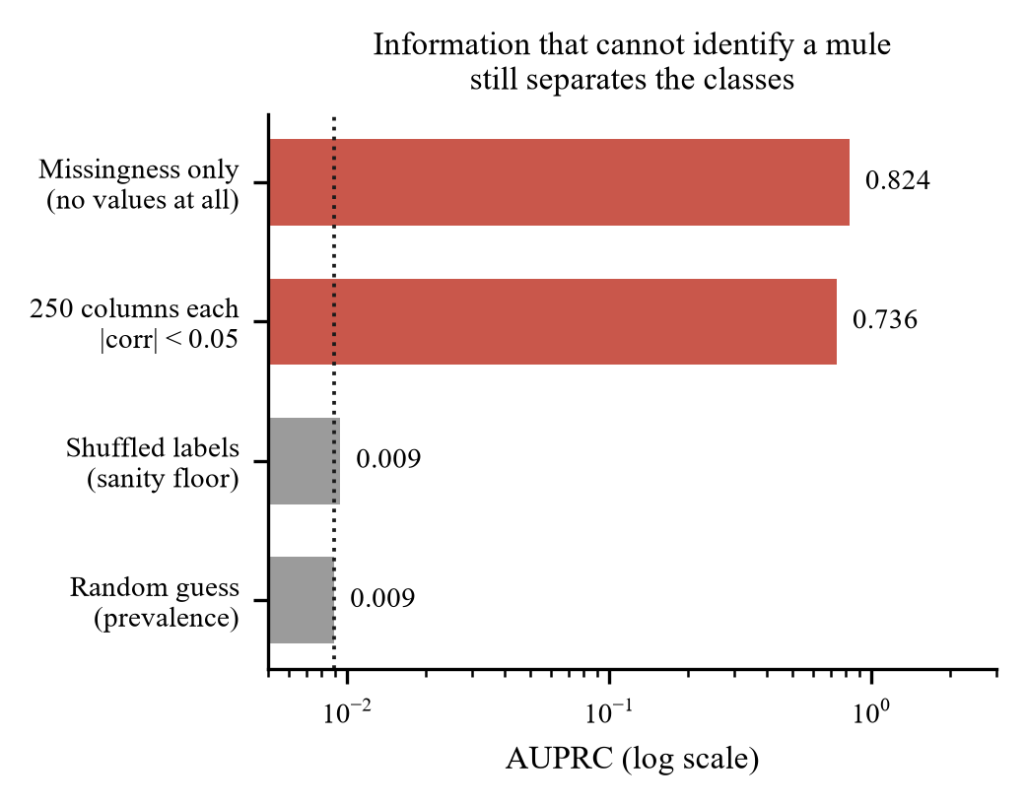
Fig. 1. Falsification tests against the random baseline (log scale). Knowing only which cells were blank, with every value discarded, separates the classes almost perfectly. The shuffled-label floor confirms the harness is sound.
TABLE III. FALSIFICATION TEST RESULTS
Test | Information supplied | AUPRC | AUROC
A | Blank/not-blank only, no values | 0.824 | 0.993
B | 250 columns, each |corr| < 0.05 | 0.736 | 0.973
C | As B, labels shuffled | 0.0094 | 0.528
— | Random guess (prevalence) | 0.0089 | 0.500

The conclusion is unavoidable. Any performance figure computed on this dataset, by any team and any method, measures extract provenance in addition to mule behaviour, and the two cannot be separated within this file. We report our own results in Section V with that qualification attached rather than omitted. Fig. 2 shows the pipeline that follows from this finding, in which the integrity audit runs as Stage 0, before any modelling.

IV. METHODOLOGY

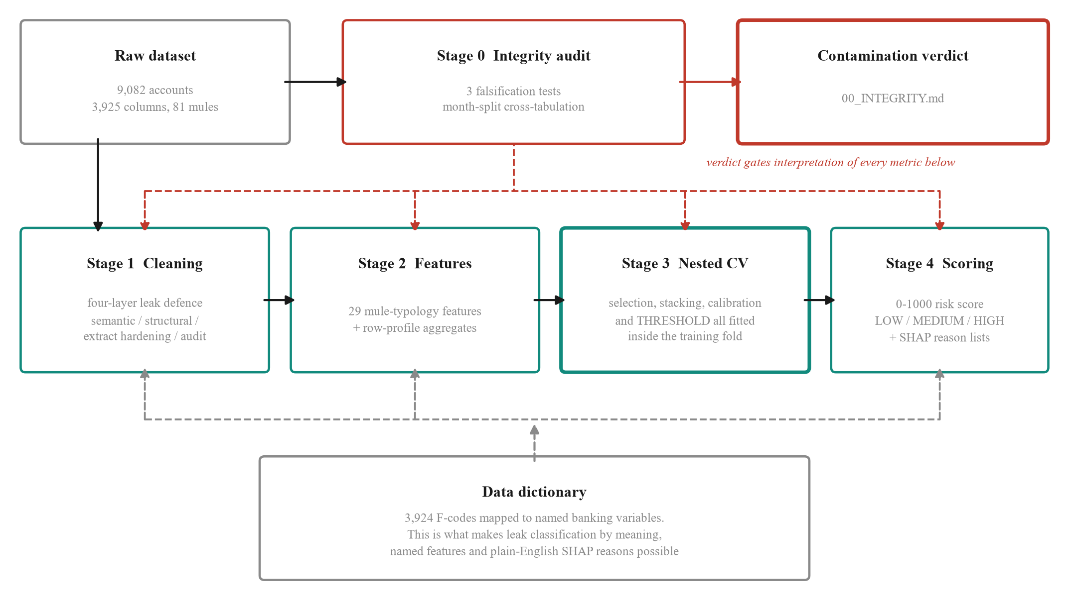
Fig. 2. MuleGuard AI pipeline. Stage 0 runs before any modelling and its verdict qualifies every metric produced downstream (red). Leak defences concentrate in Stage 1. In Stage 3, every component that touches the label is fitted inside the training fold and applied frozen to validation rows: feature selection, stacking weights, the calibration map and the decision threshold. The data dictionary is drawn as a bus because it is cross-cutting rather than a pipeline step: it supplies the named semantics that Stages 1, 2 and 4 depend on. This is the account-level path taken on the supplied dataset, which carries no counterparty identifiers, so the graph stage detects their absence and disables itself. Fig. 11 shows the same system given a transaction ledger, where that stage runs.

A. The data dictionary as executable knowledge
We parse the dictionary into a queryable structure that maps each column identifier to its banking variable name, its description, and its decomposition into statistic, channel, direction and window. This single component is what makes the rest of the pipeline possible: leak classification by meaning, feature engineering against named quantities, and explanations phrased in banking language. Fig. 3 shows the equivalent resolution performed by role alone, which is what the pipeline falls back on when no dictionary accompanies the data.

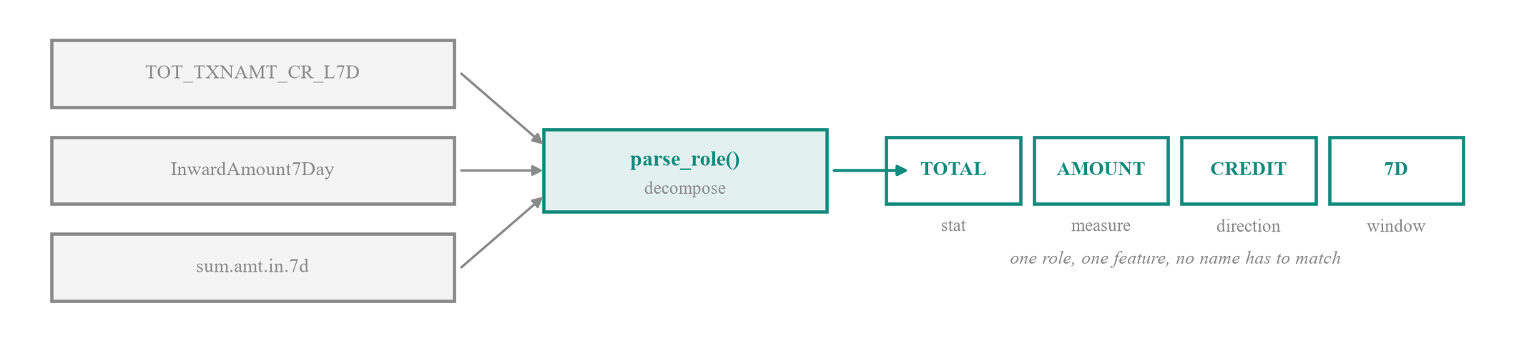
Fig. 3. Resolution by role. Three schema-specific column names decompose to the same tuple of statistic, measure, direction and window, so any one of them resolves the others without either name being known in advance. This is how the pipeline builds its behavioural features on a schema for which no data dictionary exists.

B. Preserving information the naive pipeline destroys
Eight columns in the dataset are categorical, including occupation, gender, area category, product, segmentation class and account age bucket. Coercing the matrix to numeric, as is customary, converts all of them to missing values which are then discarded as sparse. This discards real signal: mule rates by occupation range from 0.45 percent for homemakers to 1.94 percent for students against a base rate of 0.89 percent. We encode the account-age bucket ordinally, since it is ordered, and the remainder as indicators.
We also revisit imputation. For absolute activity aggregates a missing value does not mean unknown, it means the activity never occurred: a blank UPI transaction count identifies a customer who does not use UPI. Median imputation invents activity, and discarding such columns as sparse destroys the fact that an account rides exactly one payment rail, which is itself diagnostic. We therefore zero-fill 78,919 values across 1,357 aggregate columns and leave derived ratios to median imputation, where a missing value genuinely does mean an undefined baseline.
C. Four-layer leakage defence
Layer one removes post-outcome fields semantically, as in Section III-B. Layer two removes structural artefacts of sample assembly, principally the month field. Layer three, which we call extract hardening, addresses the confound of Section III-C directly. Any column whose blank rate differs between the classes by more than ten percentage points is removed outright, values and missingness together. Whether a cell is populated is decided by the extraction job, not by the customer. This filter removed 574 columns. It uses the label, but it is a data-quality filter rather than a fitted component and can only remove signal, never manufacture it, so it moves the reported result in the conservative direction. Layer four is a separation audit that scans every surviving column for disjoint class ranges or a near-exclusive value; it is what would catch the next such artefact, and it reports clean after the first three layers. Fig. 4 summarises the four gates and what each one removes.
D. Mule-typology features
A mule receives funds and forwards them almost immediately, retains little, operates in bursts, favours digital rails, and belongs to a customer whose profile does not match the volume transacted. We encode each clause of that description as a named feature family, 29 features in total, summarised in Table IV. Notably, the dataset already contains 296 columns measuring deviation from an occupation cohort, so the profile-mismatch signal required aggregation rather than invention. Fig. 5 contrasts the two balance trajectories these features separate.

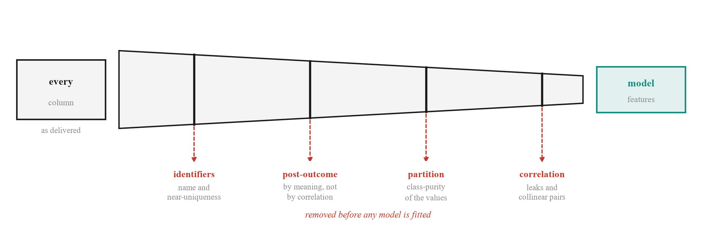
Fig. 4. The four leakage gates. Each gate removes a class of leakage the others cannot see, which is why a single tuned correlation filter is insufficient. The third gate identifies artefacts of sample assembly from the class-purity of a column's values rather than from its name.

TABLE IV. ENGINEERED MULE-TYPOLOGY FEATURE FAMILIES
Family | Representative feature | Behavioural rationale
Pass-through | mg_passthrough_7d | Credits ≈ debits: the account is a conduit, not a wallet
Turnover/balance | mg_turnover_over_balance_7d | Moves many multiples of what it ever holds
Burst | mg_amount_burst_7v31 | Weekly velocity far above monthly: sudden activation
Cash-out | mg_digital_in_cash_out_7d | Digital in, cash out: the layering handoff
Channel mix | mg_channel_hhi_7d | Single-purpose accounts concentrate on one rail
Ticket size | mg_avg_ticket_7d | Many small tickets suggest structuring
Alert timing | mg_alert_share_night | Mule night-alert share runs about three times higher
Balance shape | mg_balance_volatility_7d | Spike-and-drain rather than a held balance
Profile mismatch | mg_occ_deviation_max | Volume inconsistent with the occupation cohort

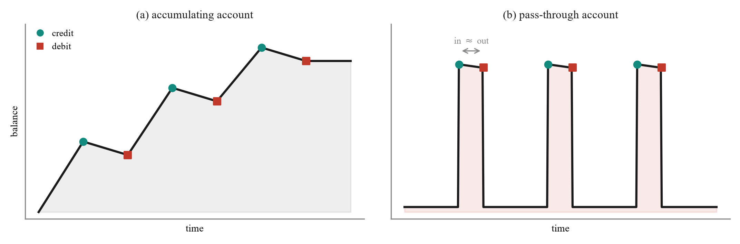
Fig. 5. The behavioural signature the typology features encode. An accumulating account builds and holds a balance, whereas a pass-through account returns to its floor after each matched pair of credit and debit events. The separation is arithmetic rather than documentary, which is what allows it to transfer across institutions.

E. Nested repeated cross-validation
The ensemble combines an isolation forest [5], an XGBoost classifier and a LightGBM classifier, stacked by a logistic meta-learner [10] and probability-calibrated [7]. The calibrator is Platt rather than the more usual isotonic regression, and that choice was measured rather than assumed: as a step function on 81 positives, isotonic scored worse on log loss than applying no calibration at all and collapsed the output to 15 distinct probabilities, which makes ranking inside a step impossible and damages precision at K. Isotonic is selected automatically once a calibration fold carries 100 positives or more. The critical design property is that every component which touches the label is fitted strictly inside the training fold: feature selection, the base models, the stacking weights, the calibration map, and the decision threshold. Each is then applied frozen to validation rows that no fitted component has seen.
This matters because the natural implementation is biased in three distinct ways, all of which we corrected. Fitting an isotonic calibrator on pooled out-of-fold predictions and then scoring those same values inflates the result, because isotonic regression is a flexible monotone fit. Selecting the threshold that maximises precision on a curve and then reporting that precision is optimistic by construction [9], and severely so with 81 positives. Training the meta-learner on the base models' training-set predictions, where a 400-tree booster is nearly perfect, presents it with a distribution it will never encounter at inference. We fit the stack and the calibrator on inner out-of-fold predictions instead. Fig. 6 shows which components are fitted on which split.
Because a single five-fold split places only about 16 mules in each validation fold, the headline metric moves by several points on the random seed alone. We therefore repeat the entire procedure across 3 shuffles and report the mean and standard deviation across all folds, so that every figure carries its own uncertainty. Feature selection retains the top 250 of 1,506 columns by gradient-boosted gain, refitted per fold.

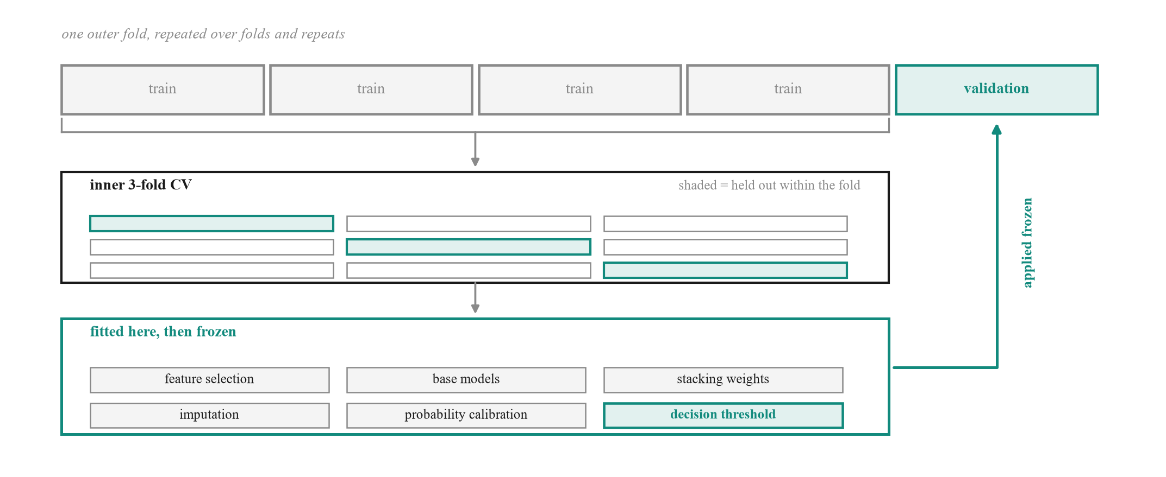
Fig. 6. Components fitted inside the training fold. Feature selection, base models, stacking weights, imputation, probability calibration and the decision threshold are all fitted on inner splits of the training segments and applied frozen to the outer validation segment. No validation row informs any component it is later scored against.

F. Risk scoring and explanation
The calibrated probability maps to a 0 to 1000 risk score partitioned into three action bands: routine monitoring, enhanced monitoring with step-up authentication, and freeze with escalation to the anti-money laundering desk. Each scored account carries a ranked reason list derived from SHAP values and rendered through the dictionary, so an investigator reads a sentence about Aadhaar Payment Bridge credit activity rather than an attribution against column F2506.
V. RESULTS
A. Detection performance
Table V reports the calibrated ensemble under the validation scheme of Section IV-E. At the precision-first operating point the system attains precision 0.989 ± 0.030 at recall 0.625 ± 0.147, with AUPRC 0.882 ± 0.062 against a random baseline of 0.0089. Summed across folds the confusion matrix is 152 true positives against 2 false positives and 91 false negatives. The precision target for this band is 0.99 rather than 0.90, because the band triggers an automated freeze with no human in the loop. It was met on inner data in 93.3 percent of folds. The remaining fold fell back to the best-F1 point, and the metrics report records that it did. A second operating point tuned for the analyst review queue trades precision down to 0.377 ± 0.063 to raise recall to 0.917 ± 0.056, which is the appropriate trade when a reviewed alert costs minutes and a missed mule costs a laundering channel.
TABLE V. DETECTION PERFORMANCE, NESTED REPEATED CROSS-VALIDATION
Metric | Precision-first | High-recall queue
Precision | 0.989 ± 0.030 | 0.377 ± 0.063
Recall | 0.625 ± 0.147 | 0.917 ± 0.056
F1 | 0.756 ± 0.114 | 0.532 ± 0.067
False positive rate | 0.000 ± 0.000 | 0.014 ± 0.004
True positives | 152 | 223
False positives | 2 | 381
a. Mean ± standard deviation across all outer folds; counts are summed. Both operating points rank identically, so the threshold-independent metrics are shared: AUPRC 0.882 ± 0.062, AUROC 0.970 ± 0.029. Interpret in light of Section III.

B. Ablation
Table VI separates the base learners. XGBoost is the strongest single model at AUPRC 0.894 ± 0.061, LightGBM follows at 0.818 ± 0.080, and the calibrated stack reaches 0.882 ± 0.062. The isolation forest result is the informative one: at AUPRC 0.007 ± 0.001 and AUROC 0.314 it performs worse than random. The stacking layer learns a negative coefficient of -0.4446 for it, reading the model in reverse rather than being misled by it. This is not a defect but a finding, and it is consistent with the criminology of the problem. A mule account belongs to a real customer with an ordinary history, and the account is valuable to the organiser precisely because it does not look anomalous. Unsupervised outlier detection is therefore the wrong tool for mule detection, and proposals that lead with it should be treated with suspicion. Fig. 7 plots the same comparison.
TABLE VI. PER-MODEL ABLATION
Model | AUPRC | AUROC
Isolation forest | 0.007 ± 0.001 | 0.314
LightGBM | 0.818 ± 0.080 | 0.980
XGBoost | 0.894 ± 0.061 | 0.988
Calibrated ensemble | 0.882 ± 0.062 | 0.970 ± 0.029

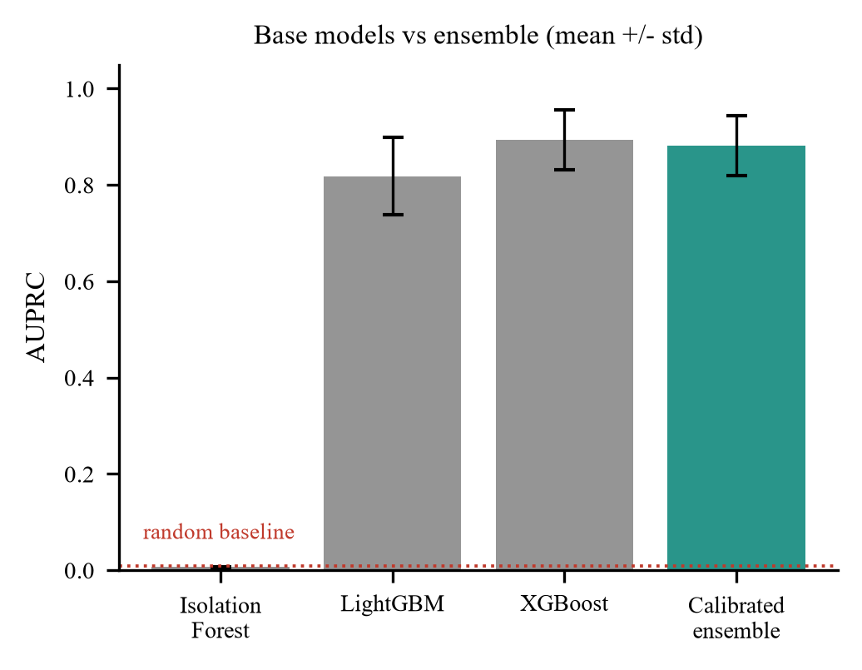
Fig. 7. Base learners against the calibrated ensemble. The isolation forest falls below the random baseline: mules are camouflaged as ordinary customers, not global outliers.

C. How much of the result is the artefact
The per-model ablation above compares learners. A more consequential question is how much of the result survives removing the behavioural features entirely, because that is the part of the pipeline that would transfer to a different bank's data. We therefore ran three conditions over identical folds with an identical seed: the full feature set, the raw supplied columns with all engineered features removed, and the 29 behavioural features alone. This ablation uses a single 5-fold stratified split at a fixed seed rather than the repeated nested scheme of Section IV-E, which is why its full-set figure differs from Table V in the third decimal.
The result is uncomfortable and we report it in full. The full set attains AUPRC 0.883 ± 0.042. Removing the behavioural features changes this to 0.892 ± 0.073, a difference of -0.0090, which is noise at this sample size. The comparison that matters is against test A of Section III-D: a model given only blank-cell patterns, with every value discarded, attains 0.824. The raw columns, holding every value in the dataset, exceed that values-free model by only +0.068. Almost the entire headline figure is therefore extract provenance rather than customer behaviour. Fig. 8 shows the three conditions measured over identical folds.
The behavioural features alone attain 0.368 ± 0.188, which is 41 times the random baseline. This is a lower figure and a more defensible one. These features are ratios, credits against debits and turnover against balance, and a ratio is comparatively robust to which fields a given extraction run happened to populate. We therefore identify this subset as the component least explained by the confound of Section III, and suggest it, rather than the headline, is the figure a reader should carry forward.
D. A deterministic rule baseline
Every operational anti-money-laundering programme runs deterministic rules before it runs a model, so we implemented twelve drawn from published money-mule typology [12] and measured them on the same data. The thresholds were deliberately not tuned against this dataset: tuning them here would fit the confound and fail elsewhere, which is the same error as tuning hyperparameters against a contaminated objective.
7 of the 12 rules score at or below the base rate, and 2 catch no mules at all. Taken together they flag 7,862 accounts, 87 percent of the portfolio, at 103.4 alerts for every mule found, which no review team could work. Inspecting the distributions explains why: the median seven-day pass-through ratio is 0.776 for normal accounts and 0.622 for mules, so the textbook signature is inverted on this file. Two rules survive contact with the data. Structuring by ticket size reaches 4.7 times lift and recovers 45 of the 81 mules, and single payment rail concentration reaches 1.4 times. We would retain those two and discard the remainder, and we report the failures because a rule book inherited rather than measured is how alert fatigue begins.

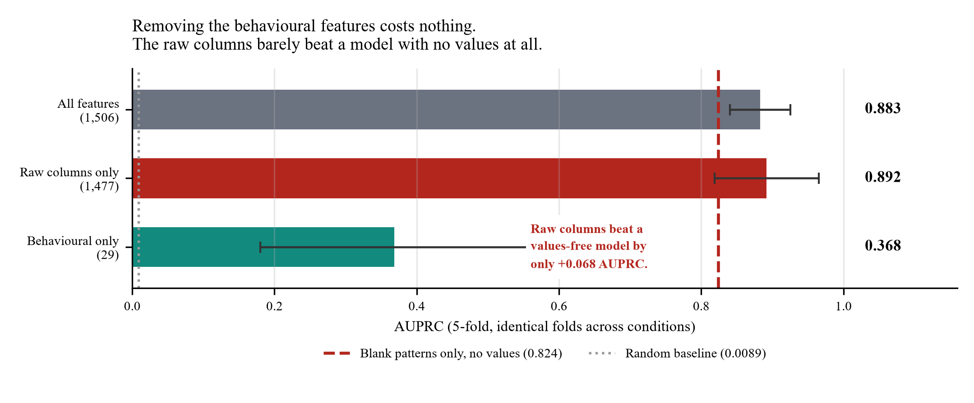
Fig. 8. Feature ablation over identical folds. The raw columns exceed a values-free model by only +0.068 AUPRC, while the 29 behavioural features alone reach 0.368.

E. Operating metrics
Area under a precision-recall curve is the correct metric for comparing methods and the wrong one for staffing a desk. Table VII therefore reports precision at K. Reviewing the 50 highest-scoring accounts yields 50 confirmed mules with 0 false alarms, recovering 62 percent of the mule population for approximately 1.2 analyst-days at a conventional forty reviews per analyst per day. Returns fall away sharply beyond that: extending the queue from 100 to 500 accounts costs 400 further reviews and recovers 1 additional mule. Single-account scoring latency is 54 ms, so the model is not the constraint on a real-time hold decision.
We cannot report time-to-flag, the usual operational measure of detection delay, and decline to substitute a proxy for it. The dataset contains no transaction timestamps: each row is an account already aggregated into windowed totals, so no event time exists from which a delay could be measured. Establishing it requires a transaction stream this release does not provide.
A Kolmogorov-Smirnov comparison between the dominant extract and the remainder offers a third and independent measurement of the confound: 115 of 464 tested columns (25 percent) differ significantly at p < 0.01. Because the class split coincides exactly with the extract boundary, every column shifting here is a column capable of separating the classes without describing any customer.
TABLE VII. PRECISION AT K AND INVESTIGATOR LOAD
Accounts reviewed (K) | Mules found | Precision | Recall | Analyst-days
10 | 10 | 1.000 | 0.123 | 0.2
25 | 25 | 1.000 | 0.309 | 0.6
50 | 50 | 1.000 | 0.617 | 1.2
100 | 72 | 0.720 | 0.889 | 2.5
200 | 73 | 0.365 | 0.901 | 5.0
500 | 73 | 0.146 | 0.901 | 12.5
a. Analyst-days assume forty reviews per analyst per day. Precision at K=50 is 1.000: every account in that queue is a confirmed mule.
F. Feature attribution
Fig. 9 ranks the 12 most influential features by mean absolute SHAP contribution. 6 of the 12 are features engineered in this work rather than supplied columns, which indicates that the typology encoding in Section IV-D contributes materially rather than restating information the raw matrix already exposed. Average ticket size over seven days, the evening share of alerts, normalised net flow and the count of active payment rails all rank highly, matching the behavioural account of mule operation. Among supplied columns, deviations of non-cash non-cheque transaction volume from the occupation cohort dominate, which is the profile-mismatch signal appearing directly.
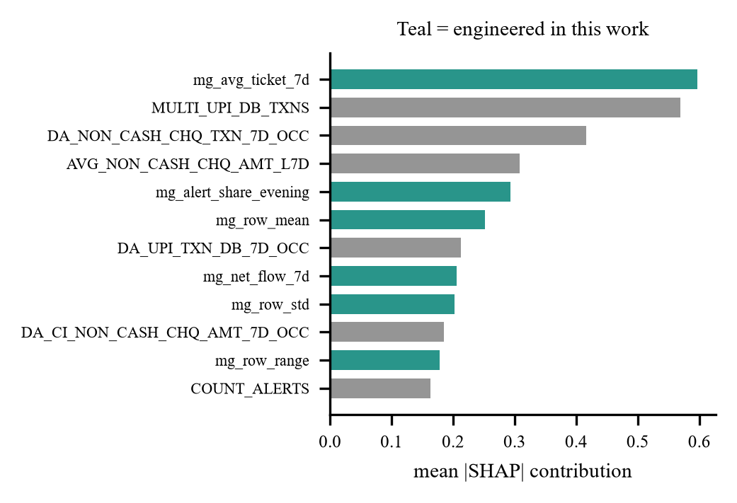
Fig. 9. Top 12 features by mean absolute SHAP value. Features engineered in this work are shown in teal; supplied dictionary variables in grey.
G. Operational triage
Table VIII shows how the score bands partition the portfolio. The high band contains 49 accounts of which 49 are confirmed mules, a band precision of 1.00, capturing 60 percent of all mules in a queue representing 0.54 percent of the portfolio. Fig. 10 plots queue size against band precision.
The medium band adds 25 further mules across 190 accounts. For an anti-money laundering team the practical statement is that reviewing under three percent of accounts surfaces nine tenths of the mule population. Stating the arithmetic explicitly avoids a natural misreading: the high band holding 49 accounts of which 49 are mules does not mean the remaining 32 were missed. The model ranks all 9,082 accounts and applies two thresholds, so the 81 mules divide as 49 in the high band, 25 in the medium band and 7 in the low band. Reviewing both actioned bands is 239 accounts, 2.6 percent of the portfolio, and recovers 74 of 81 mules, 91.4 percent, while the perfect precision of the high band means no genuine customer is subject to a freeze.

TABLE VIII. RISK BAND TRIAGE AND RECOMMENDED ACTION
Band | Accounts | Mules | Band precision | Share of all mules | Recommended action
LOW | 8,843 | 7 | 0.001 | 8.6% | Routine monitoring only
MEDIUM | 190 | 25 | 0.132 | 30.9% | Enhanced monitoring, step-up authentication on transfers
HIGH | 49 | 49 | 1.000 | 60.5% | Freeze outward transfers, escalate to AML desk, prepare STR

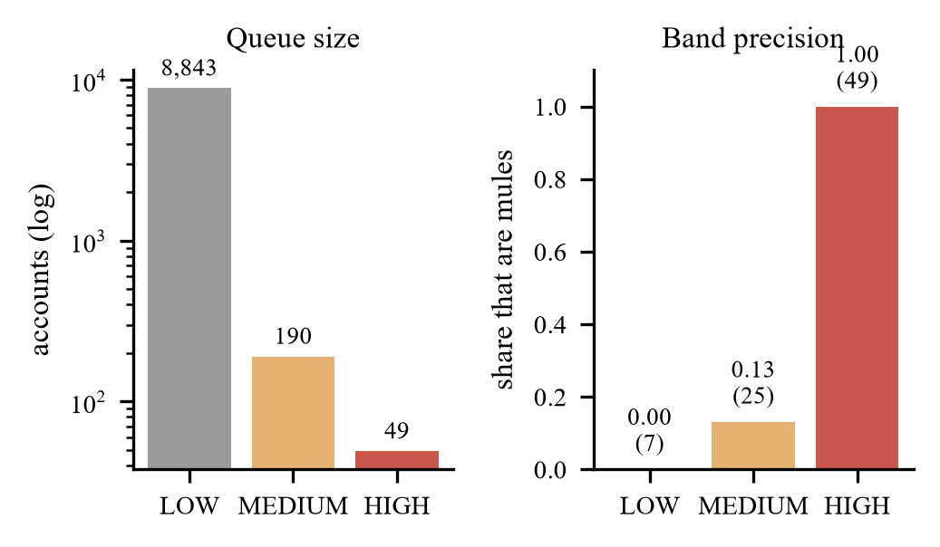
Fig. 10. Queue size and band precision. The high band is small enough to review exhaustively and almost entirely composed of confirmed mules.
H. End-to-end validation on an external dataset
Sections V-A through V-G measure components of the system on the supplied dataset, whose integrity Section III shows to be compromised. To measure the complete pipeline on data we neither created nor can tune against, we ran it against SAML-D (Oztas et al., 2023), a public synthetic anti-money-laundering dataset of 9.5 million transactions across 855,460 accounts with 28 named laundering typologies. Because that dataset labels transactions while an account-level system requires account labels, we derive a label as membership in at least one laundering transaction; this is a modelling choice and we state it rather than presenting the labels as given. Using the first three months, 2.69 million transactions over 493,833 accounts, the pipeline builds 28 behavioural features directly from the raw ledger and ten further columns from motif and structural detection, fits on a stratified 70 percent split and scores the remainder. Fig. 11 shows the resulting architecture: four detector families run from the same ledger, three of them joining in one feature matrix, while temporal localisation runs alongside and meets the others only at the submission.
On 148,150 held-out accounts at a base rate of 0.461 percent the system attains AUPRC 0.421, which is 91 times the base rate, and AUROC 0.985. Reviewing the fifty highest-ranked accounts returns 35 true positives, a precision of 0.70 and a lift of 152; reviewing one thousand recovers 61.4 percent of the laundering-touched population at 41.9 percent precision. We report this as a single stratified split rather than the nested repeated cross-validation of Section IV-E: at this sample size one held-out split is adequate, and describing it as anything stronger would misstate what was done.
The contribution of the network component is measured rather than assumed. We held the ledger, the split, the seed and the model fixed, and varied only whether the ten motif, ring and role columns were present. Held-out AUPRC rises from 0.325 to 0.421, a relative gain of 29 percent. Lift over the base rate rises from 70.5 to 91.2. Precision at fifty reviews rises by twelve percentage points, and recall at one thousand reviews by twelve and a half. Ten of thirty-eight columns therefore account for a substantial share of the result, which we regard as the appropriate standard of evidence for a graph component: not that it is present, but that removing it costs something measurable.

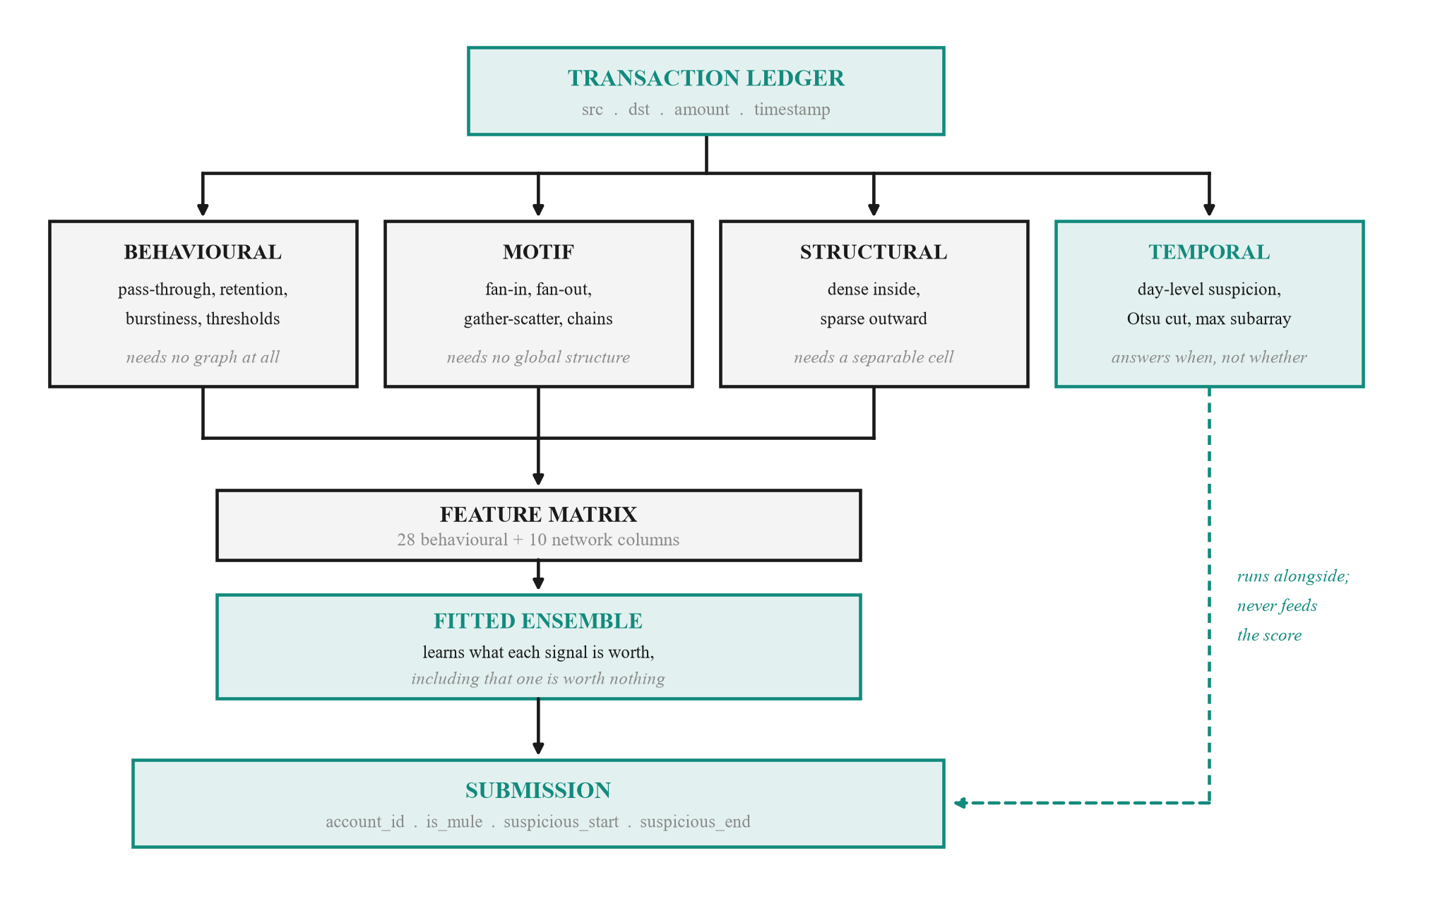
Fig. 11. The unified architecture. Behavioural, motif and structural detection are built from one transaction ledger and join in a single feature matrix, which a fitted ensemble scores; the ensemble learns what each signal is worth, including that one of them is worth nothing. Temporal localisation is drawn as a separate path because it never enters the score. Where an account ranks and when it was being used are different questions, and letting the window move the probability would make the score partly a function of its own explanation.

I. Detection when the file carries no label
Every result above assumes a labelled target column, because every result above is a measurement. Deployment is not like that. A bank scoring this morning's accounts has no labels for them, and an evaluator handing over a file will not say whether it carries one. Training needs labels; detection does not, and the two had been conflated. The system now reads the schema before doing any work and takes one of three routes. Fig. 12 shows the decision.
If a target column resolves, it retrains and measures, as in Sections V-A through V-H. If none resolves but the columns match the schema the deployed ensemble was fitted on, it scores every row with that ensemble and returns calibrated probabilities and bands, reading no target. If neither holds, which is the case for an extract from another institution, the ensemble cannot be applied at all: it is defined over columns that do not exist in the file. The typology, however, is arithmetic. Pass-through is debits over credits whatever the columns are called, and the role parser of Section IV-A recovers direction, window and statistic from a column name without being told the schema.
We therefore rebuild the typology from whatever the file provides. Each signal carries a direction fixed in advance from money-mule tradecraft: round-amount share, burst activity, concentration, chargebacks, device and address spread, geographic distance and cash deposits are suspicious when high, while account age and hours-to-outflow are suspicious when low. Counterparty counts are deliberately excluded. A gather-scatter mule has many beneficiaries and a simple conduit has one, so the suspicious direction depends on the role the account plays and cannot be fixed in advance; assuming that more is worse made the signal score below random and dragged the honest ones down with it. Fixing directions in advance rather than fitting them matters here for the same reason it matters throughout this paper: there are no labels to fit against, and inventing weights would reproduce the error the audit of Section III exists to catch. Signals are averaged as percentile ranks, so no heavy-tailed column dominates, and the operating point is set by Otsu's method on the resulting score, which assumes no alert rate and tunes nothing.
On a 100-account extract from a different institution, 19 columns sharing no name with the training data and no dictionary supplied, the system rebuilt 11 typology signals and ranked the accounts at AUPRC 1.000 against a base rate of 0.400, with AUROC 1.000. The Otsu cut flagged 40 accounts: all 40 laundering accounts, no false positives and none missed. We report that with a caveat attached rather than omitted. The extract is small and synthetic, and its two classes are cleanly separated, so the figure demonstrates that the mechanism carries across schemas, not that detection is solved. The honest generalisation estimates in this paper remain the nested cross-validation of Section V-A and the held-out split of Section V-H.

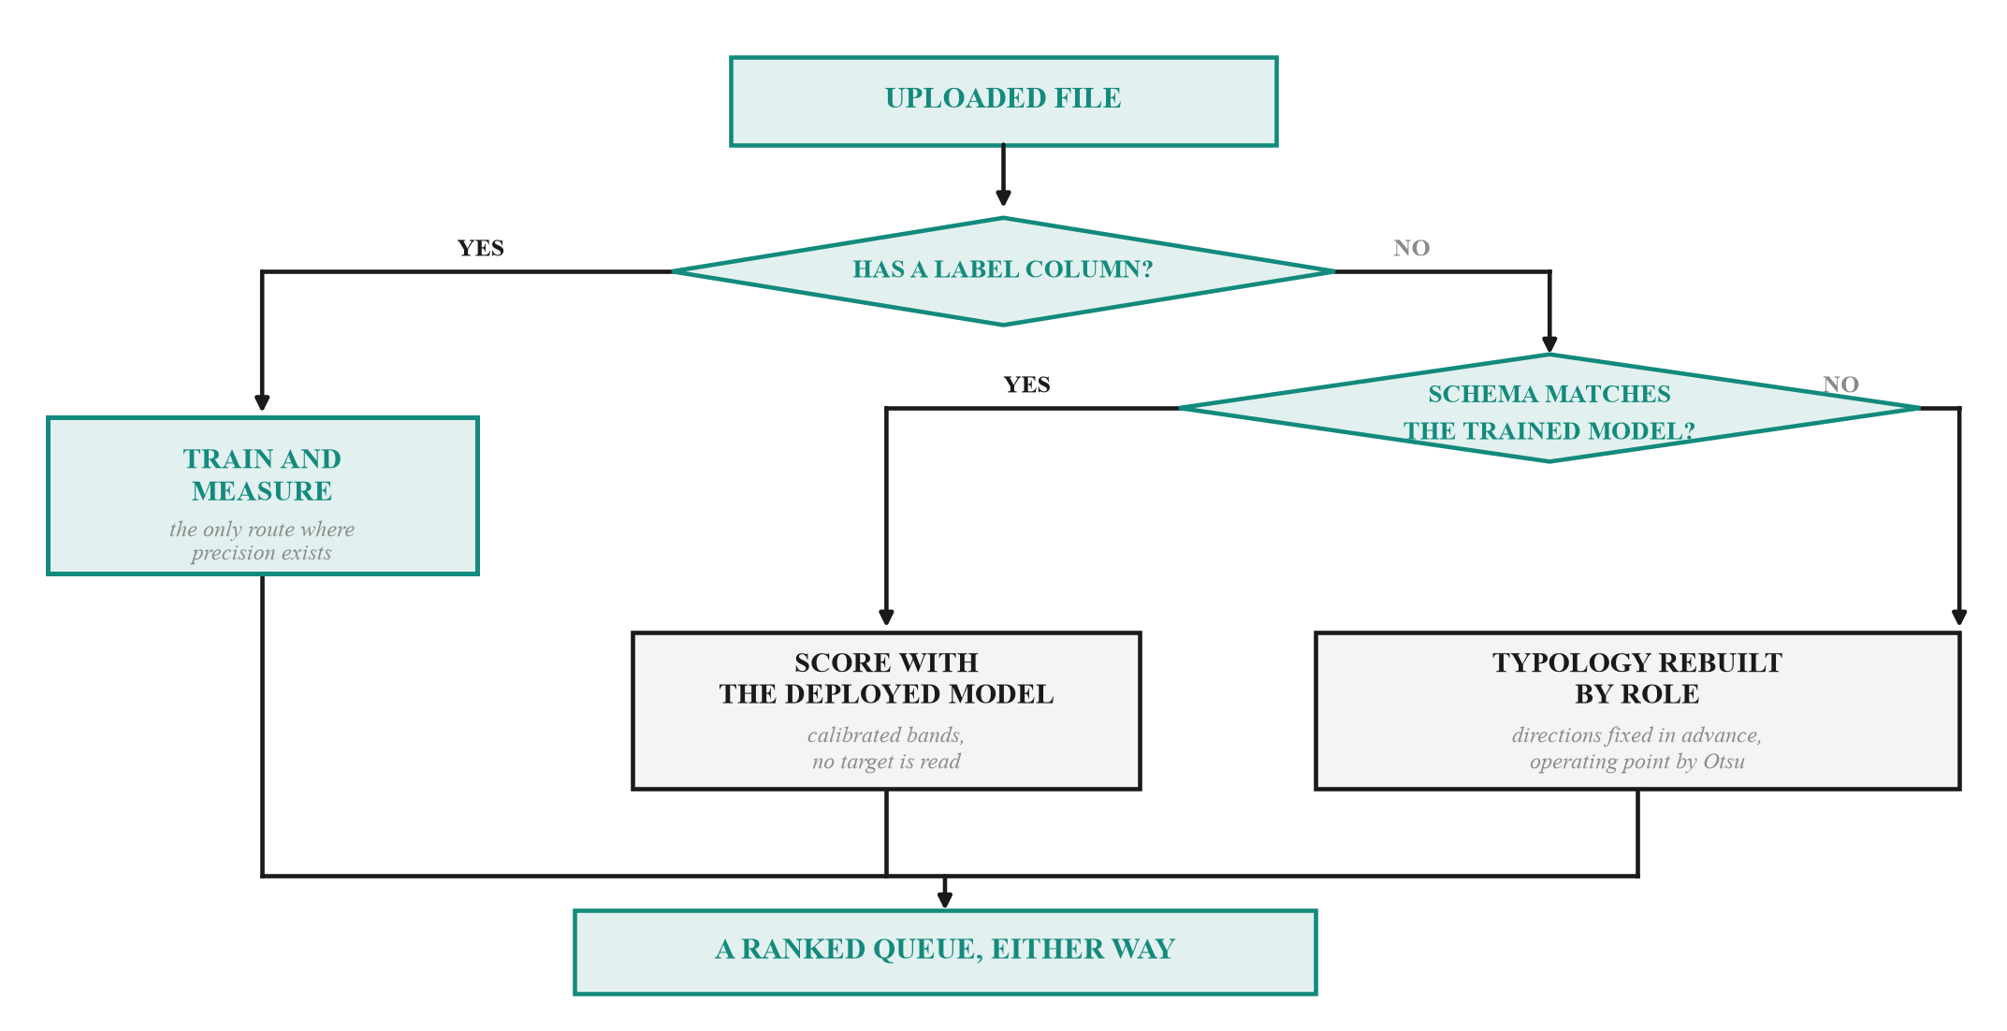
Fig. 12. The three routes an incoming file can take. Training needs a label; detection does not, and conflating the two is what made an unlabelled file an error rather than a queue. Only the left branch can report precision, because only there does ground truth exist. The right branch applies to an extract from another institution, where the trained ensemble is undefined because its columns do not occur in the file.

One property of the method deserves stating because it constrains where it may be used. Otsu splits whatever distribution it is given, so on a file that is 40 percent laundering accounts it recovers that split exactly, while on a real portfolio carrying well under one percent it would flag a large share of ordinary customers. The cut is a natural break in the score, not an estimate of prevalence. On a genuine book the ranking should be worked down to a review budget instead, and the system says so on screen whenever the flagged share exceeds one fifth of the file rather than letting a plausible-looking count travel unchallenged.
VI. DISCUSSION AND LIMITATIONS
The results in Section V are strong, and we do not believe they should be read as a measure of mule detection capability. Section III establishes that an uninformative view of the same data achieves comparable separation, which means a substantial and unquantifiable share of the reported performance reflects the extract from which a row was drawn. Our hardening layers remove the artefact wherever it can be identified. They cannot remove what is unidentifiable: a genuine behavioural feature that also drifts between months is confounded, and no modelling choice separates the two within this file. We therefore describe our figures as an upper bound on what this dataset can establish.
The remedy is a sampling change rather than a modelling one. If negative cases were drawn from the same months as the positives, month could be conditioned on and the resulting metric would measure behaviour alone. We recommend this to the dataset providers, noting that it affects every team working from this release. We would also distinguish between two readings of this finding. Read as a criticism of the data it is of limited interest, since the release is synthetic and the artefact is plausibly deliberate. Read as a measurement it is the more useful result. A pipeline that skips this check reports a figure inflated by the artefact and cannot say by how much. The ablation in Section V-C bounds that inflation at 0.068 AUPRC and isolates the component that survives it.
Section V-C sharpens this. The ablation shows the supplied columns exceed a values-free model by only +0.068 AUPRC, so the headline is very largely provenance, while the 29 behavioural features reach 0.368 on their own. Section V-D supplies a complementary reading from the opposite direction: a conventional twelve-rule typology baseline, untuned, has 7 of its rules at or below the base rate on this file, because the classic pass-through signature is inverted here. Neither the learned model nor the deterministic baseline demonstrates clean detection on this dataset, and the two failures have the same cause.
Three further limitations bear statement. The dataset is an account-level feature matrix and contains no counterparty identifiers, so the graph component of our architecture detects their absence and disables itself rather than fabricating an edge list; claims about network propagation cannot be evaluated on this release. Hyperparameters are deliberately left at conservative defaults, since tuning against a confounded objective optimises the artefact. Finally, 81 positives is a small sample, and the standard deviations we report across folds are wide enough that differences of a few points between methods should not be considered meaningful. A fourth concerns the seven mules that fall in the low band and therefore receive no action at any usable operating point. They are not sparsely populated records: their median count of non-zero features is 924, against 856 for the mules the system does recover and 878 for ordinary customers, so they are fully observed accounts whose behaviour resembles ordinary customers. The lowest-ranked confirmed mule sits at position 6,717 of 9,082, below roughly three quarters of the negative class, so no usable threshold recovers it. We regard this as a limit of account-level features rather than of the classifier: the discriminating evidence for a dormant conduit is the identity of its counterparty, which this dataset does not record.
Two further points concern generality. The pipeline no longer depends on this dataset's column names. The target, row identifiers, categorical fields, post-outcome leaks and partition columns are all inferred from structure. Behavioural columns are matched by decomposed meaning rather than string equality, so a request for a seven-day credit total resolves against a column named differently in another institution's extract. On a synthetic extract sharing no column name with this one, and supplying no dictionary, the system recovered the target, the identifier, the partition column and the post-outcome field. It built 11 of the 29 behavioural features. The rest need source columns that extract did not contain, and the shortfall is reported rather than silently zero-filled. An unseen extract can be submitted through the browser interface and scored end to end, integrity audit included, in approximately 100 seconds on a file of 5,000 accounts. Separately, alerts and case packs are exported in a documented vendor-neutral schema. We make no claim of certified compatibility with any named enterprise fraud or anti-money-laundering platform: we had neither an integration specification nor a test environment to validate against.
VII. CONCLUSION
We presented a money-mule detection pipeline for an extremely imbalanced banking dataset, together with an integrity audit of the dataset itself. The audit is the more important result. Positive and negative cases originate in disjoint monthly extracts, and we demonstrated by falsification test that the blank-cell pattern alone, stripped of all values, attains AUPRC 0.824 against a 0.0089 baseline. Standard defences do not detect this, and adversarial validation cannot, because the shift coincides exactly with the label.
Alongside it we contributed four things. First, a leakage taxonomy that classifies fields by meaning rather than correlation, which catches an outcome flag at 0.05 correlation that every threshold admits. Second, a set of 29 named mule-typology features derived from the data dictionary, 6 of which rank in the top 12 by attribution. Third, a nested validation design in which the operating threshold, not merely the model, is fitted inside the fold. Fourth, a label-free detection path that rebuilds mule typology by role on a schema the model was never trained on, with directions fixed from tradecraft rather than fitted and an operating point set by Otsu, so that a file arriving without labels still produces a queue an investigator can work. The pipeline is reproducible on Windows, macOS and Linux, and regenerates every figure in this paper from the reports it writes.
We further report an ablation of our own result, which we regard as an obligation rather than an extra. Having established that the benchmark is confounded, quoting a headline figure without measuring how much of it the confound explains would repeat the error the audit exists to expose. The measurement is unflattering: the supplied columns exceed a values-free model by +0.068 AUPRC, and the behavioural subset, at 0.368, is the component we would defend as plausibly reflecting behaviour rather than provenance.
We suggest that the falsification protocol of Section III-D deserves wider use. It is inexpensive, it requires no knowledge of the modelling approach, and in this instance it was the difference between reporting a headline result and understanding what that result actually measured.
ACKNOWLEDGMENT
The authors thank the organisers of the PSB Cybersecurity, Fraud and AI Hackathon 2026, jointly convened by Bank of India and the Indian Institute of Technology Hyderabad, for providing the account-level dataset and the accompanying data dictionary on which this work is based.
The data dictionary proved essential rather than incidental. Without documented variable semantics, neither the meaning-based leakage taxonomy of Section III-B nor the named feature families of Section IV-D could have been constructed, and the resulting model would have been a set of attributions over opaque column identifiers rather than an auditable decision aid.
The dataset integrity findings reported in Section III are offered in the same collaborative spirit: as an observation intended to strengthen the benchmark for all participants and for future releases, not as a criticism of those who assembled and shared it. Constructing a labelled money-mule dataset at all, from live banking records and under the privacy constraints the domain imposes, is a substantial undertaking, and the authors are grateful for access to it.
REFERENCES
[1] N. V. Chawla, K. W. Bowyer, L. O. Hall, and W. P. Kegelmeyer, “SMOTE: synthetic minority over-sampling technique,” J. Artif. Intell. Res., vol. 16, pp. 321–357, June 2002.
[2] T. Chen and C. Guestrin, “XGBoost: a scalable tree boosting system,” in Proc. 22nd ACM SIGKDD Int. Conf. Knowledge Discovery and Data Mining, San Francisco, CA, USA, 2016, pp. 785–794.
[3] G. Ke, Q. Meng, T. Finley, T. Wang, W. Chen, W. Ma, Q. Ye, and T. Liu, “LightGBM: a highly efficient gradient boosting decision tree,” in Advances in Neural Information Processing Systems, vol. 30, 2017, pp. 3146–3154.
[4] S. M. Lundberg and S. Lee, “A unified approach to interpreting model predictions,” in Advances in Neural Information Processing Systems, vol. 30, 2017, pp. 4765–4774.
[5] F. T. Liu, K. M. Ting, and Z. Zhou, “Isolation forest,” in Proc. 8th IEEE Int. Conf. Data Mining, Pisa, Italy, 2008, pp. 413–422.
[6] J. Davis and M. Goadrich, “The relationship between precision-recall and ROC curves,” in Proc. 23rd Int. Conf. Machine Learning, Pittsburgh, PA, USA, 2006, pp. 233–240.
[7] B. Zadrozny and C. Elkan, “Transforming classifier scores into accurate multiclass probability estimates,” in Proc. 8th ACM SIGKDD Int. Conf. Knowledge Discovery and Data Mining, Edmonton, AB, Canada, 2002, pp. 694–699.
[8] S. Kaufman, S. Rosset, C. Perlich, and O. Stitelman, “Leakage in data mining: formulation, detection, and avoidance,” ACM Trans. Knowledge Discovery from Data, vol. 6, no. 4, pp. 1–21, December 2012.
[9] G. C. Cawley and N. L. C. Talbot, “On over-fitting in model selection and subsequent selection bias in performance evaluation,” J. Mach. Learn. Res., vol. 11, pp. 2079–2107, July 2010.
[10] D. H. Wolpert, “Stacked generalization,” Neural Networks, vol. 5, no. 2, pp. 241–259, 1992.
[11] Reserve Bank of India, “Master direction on know your customer (KYC) direction, 2016 (updated).” Reserve Bank of India, Mumbai, India. [Online]. Available: https://www.rbi.org.in
[12] Financial Action Task Force, “Money laundering through the physical transportation of cash,” FATF, Paris, France, 2015. [Online]. Available: https://www.fatf-gafi.org

