Children in Child Care Institutions
  - A Fact File
Kiran Sankar Das
In West Bengal, presently there are 56 Govt. run Units of Home including 8 units for Child in Conflict with Law and 75 NGO run Units of Home including 6 units for CCL functioning under the umbrella of Mission Vatsalya.
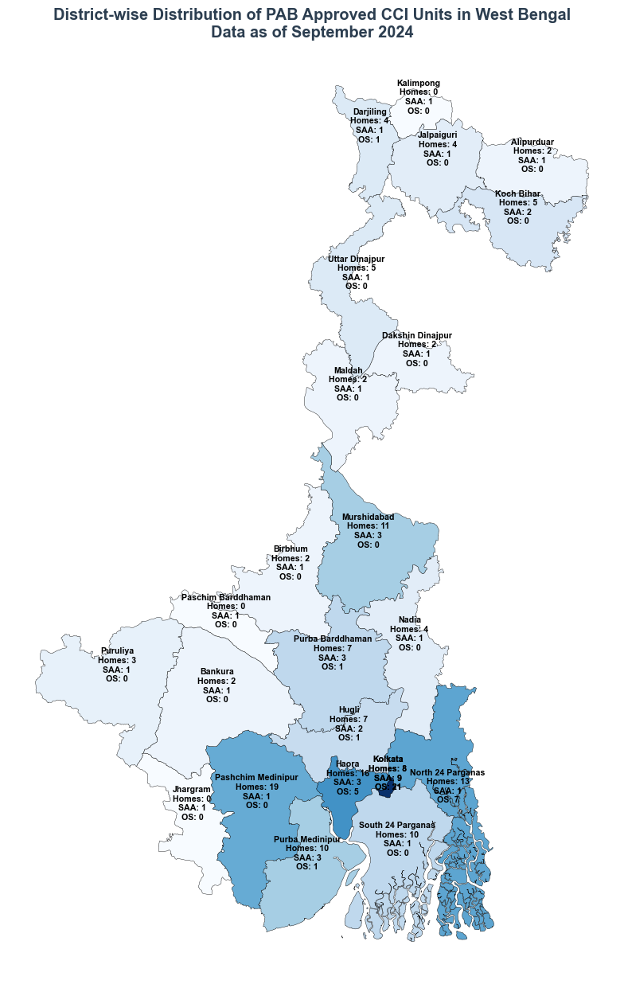
As on 31st March 2023 a total of 4148 inmates among different categories are being facilitated in the above-mentioned homes.
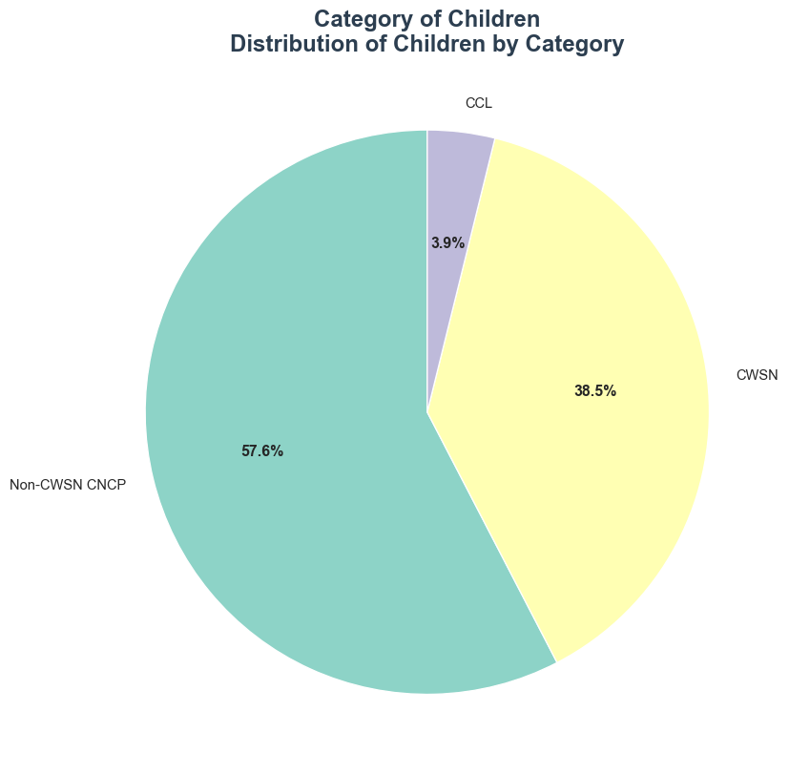
During FY 2020-21, due to COVID-19 pandemic, number of children facilitated through Mission Vatsalya, erstwhile CPS was declined but this improved in the following years.
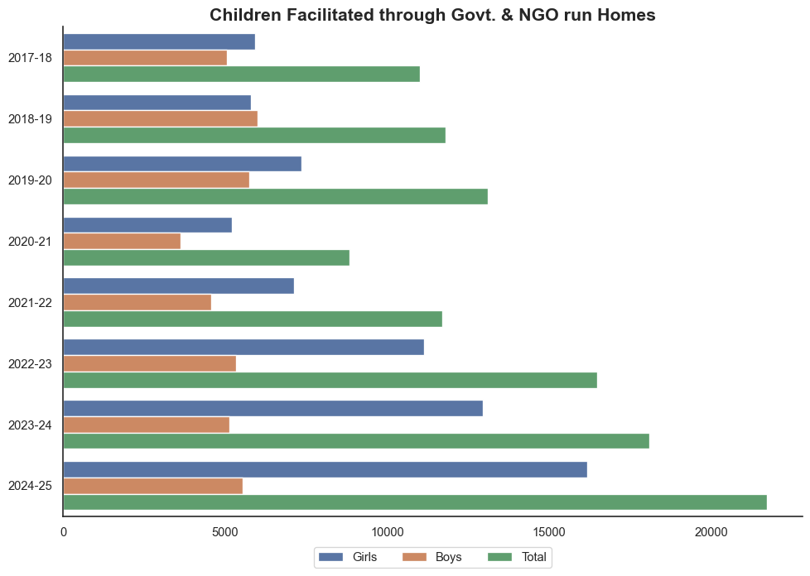
Enrollment in Formal Education has also improved during this financial year as more non-CWSN CNCP children are enrolled with the formal education system through NIOS. Children with Special Needs who are unable to be enrolled in formal system are getting special education through Special Educators engaged at the CCI.
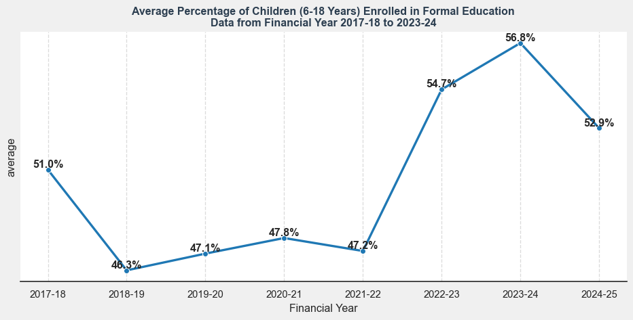
During pandemic hit years, Vocational Training Programs were vastly halted as access to CCIs was restricted, but these programs are resuming, and enrollment has also improved during this financial year.
