1. Create a test directory on your home directory under Ex: /home/username and create more files with content in it (it should be created via ROOT user only)
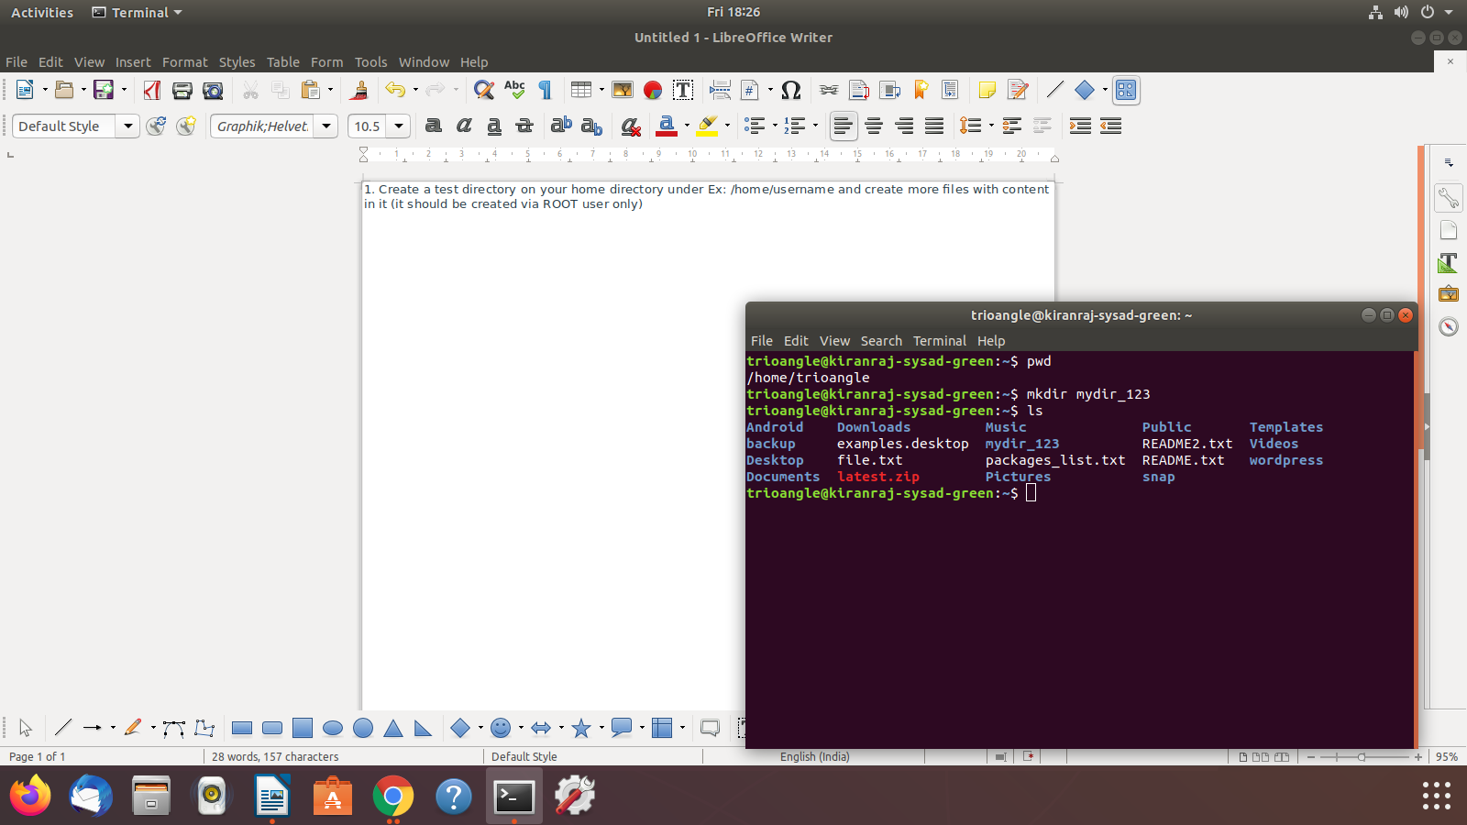
a) b)

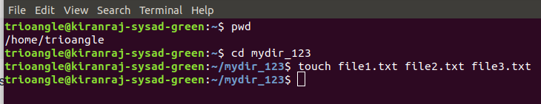
c)

2. Login as your username using su command and change to your home directory

a) user has been created b) user has been changed to another user usin su cmd
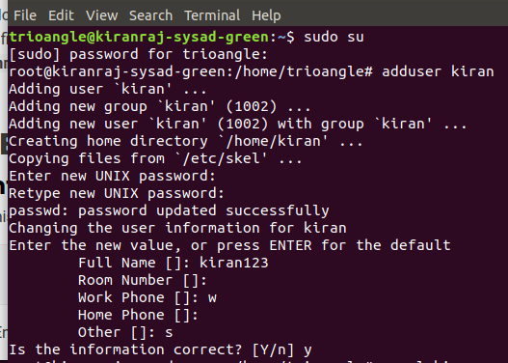
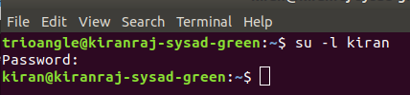

3. List content of a test directory
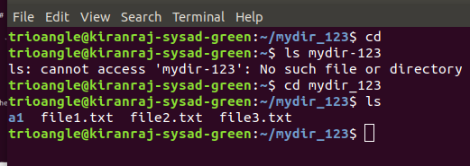

4. How do you view your current directory using command?
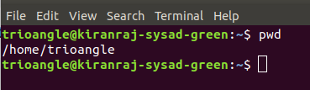

5. Change permissions to your all files (Files were created in #1) to 644 using single command

a) providing 644 command b) providing 755 command
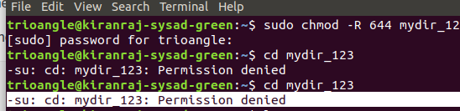
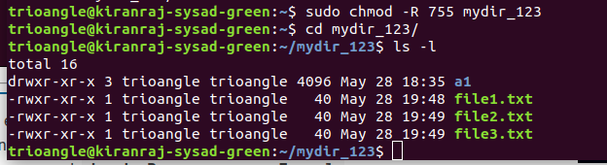

6. change owner (owner should be your username) of test directory and files in a single command

7. searching any content within files using "grep" command

grep command is used to find the particular content in the file
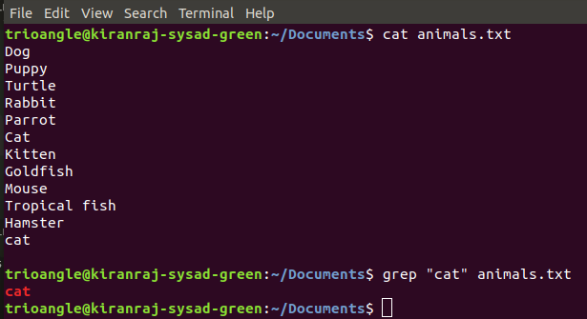

8. change your shell to root user?

