**WEB TECHNOLOGY**

**VEHICLE REGISTRATION SYSTEM**

**BACHELOR OF TECHNOLOGY**

**(III YEAR-II SEM)**

**(2017-2018)**

**DEPARTMENT OF**

**COMPUTER SCIENCE AND ENGINEERING**



**DEPARTMENT OF COMPUTER SCIENCE AND ENGINEERING**

**SAGI RAMA KRISHNAM RAJU ENGINEERING COLLEGE**

**(AFFILIATED TOANDHRA UNIVERSITY, VISAKHAPATANAM)**

**(RECOGNIZED BY A.I.C.T.E, NEW DELHI)**

**BHIMAVARAM**

**(2015-2019)**

**S.R.K.R. ENGINEERING COLLEGE**

**BHIMAVARAM**



*CERTIFICATE*

This is to certify that this is a bonafide work on “**VEHICLE REGISTRATION SYSTEM** ” and has been submitted by Miss. P. Geeta Sri (315175710175), Miss. P. Kalyani(315175710176), Mr.RajKiran(315175710165) in partial fulfillment of the requirements for the award of the degree of Bachelor of Technology in Computer Science and Engineering, during the academic year 2017-2018. The candidate worked right under my Supervision and guidance.

**Lecturers In-Charge**

Miss.D.HemaLatha,

Assistant Professor,

Department of CSE,

S.R.K.R. Engineering College,

Bhimavaram.

**ABSTRACT**

**Project Overview**

Vehicle registration system deals with the registration of vehicles. It stores the details of the owner of the vehicle along with the details of vehicle in the system. This system facilitates the buying the second hand vehicles and before buying it will checks the status of vehicle like type of vehicle, vehicle number, owner address for communication etc. It also changes or update the owner of the vehicle in case of second hand vehicles.

Home page

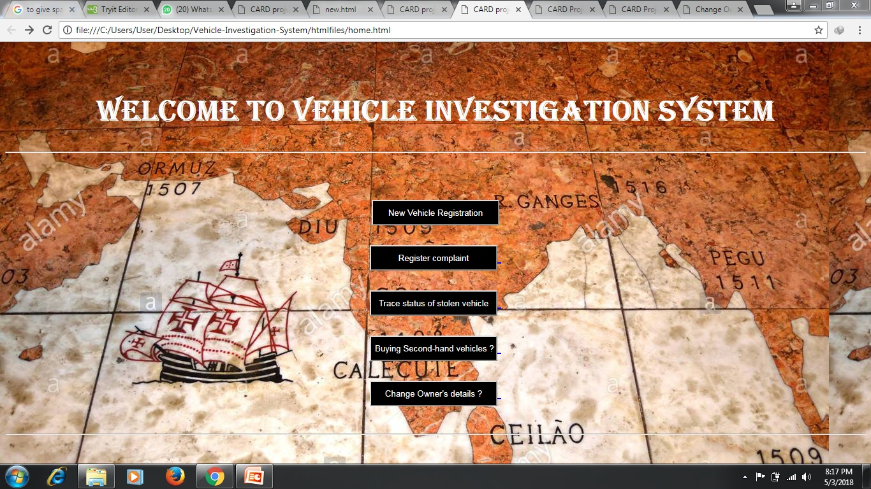

<html>

<Title> CARD project - Vehicles Department </title>

</title>

<body background="C:\Users\User\Desktop\a1.jpg" vlink=blue alink=blue link=blue>

<br><br><center> <font size="5"face="Cooper Black" color=white> <h1> Welcome to Vehicle Investigation System </h1> <hr> </center><br><br>

<center>

<a href="newreg.html">

<input type="button"style="height:40px;width:200px;color:white;background-color:black" value="New Vehicle Registration"></a><br><br>

<a href="stolen.html">

<input type="button"style="height:40px;width:200px;color:white;background-color:black" value="Register complaint"> </a> <br><br>

<a href="trace.html">

<input type="button"style="height:40px;width:200px;color:white;background-color:black" value="Trace status of stolen vehicle"> </a> <br><br>

<a href="seconds.html">

<input type="button"style="height:40px;width:200px;color:white;background-color:black" value="Buying Second-hand vehicles ? Check status "> </a><br><br>

<a href="change.html">

<input type="button"style="height:40px;width:200px;color:white;background-color:black" value="Change Owner's details ?"> </a> <br><br>

<hr></center>

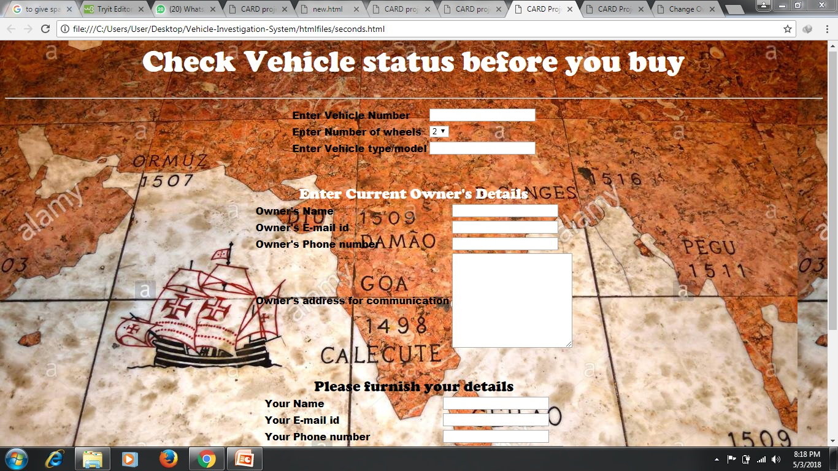

<html> <head>

<title> CARD Project - Check Vehicle status before you buy </title>

</head> <script language="javascript">

function check()

{

if(document.form1.vno.value=="")

{

alert("Vehicle Number not entered ");

document.form1.vno.focus();

return;

}

if(document.form1.model.value=="")

{

alert("model not entered ");

document.form1.model.focus();

return;

}

if(document.form1.oname.value=="")

{

alert("Owners name not entered ");

document.form1.oname.focus();

return;

}

if(document.form1.email.value=="")

{

alert("E-mail not entered ");

document.form1.email.focus();

return;

}

if(document.form1.phone.value=="")

{

alert("Phone number not entered ");

document.form1.phone.focus();

return;

}

if(isNaN(document.form1.phone.value))

{

alert("Invalid Phone number ");

document.form1.phone.focus();

return;

}

if(document.form1.addr.value=="")

{

alert("Address not entered ");

document.form1.addr.focus();

return;

}

if(document.form1.uname.value=="")

{

alert("Your name not entered ");

document.form1.uname.focus();

return;

}

if(document.form1.uemail.value=="")

{

alert("Your email id not entered ");

document.form1.uemail.focus();

return;

}

if(document.form1.uphone.value=="")

{

alert("Your phone number not entered ");

document.form1.uphone.focus();

return;

}

if(isNaN(document.form1.uphone.value))

{

alert("Invalid Phone number ");

document.form1.uphone.focus();

return;

}

if(document.form1.uaddr.value=="")

{

alert("Your address not entered ");

document.form1.uaddr.focus();

return;

}

document.form1.submit();

}

</script><body background="C:\Users\User\Desktop\a1.jpg">

<form name=form1 method=post action="http://localhost:8080/seconds.jsp">

<center> <font size="5"face="Cooper Black" color = white >

<h1>Check Vehicle status before you buy </h1><hr></font>

</center>

<center>

<font face="Arial Black" >

<table>

<tr> <td> Enter Vehicle Number </td>

<td> <input type=text name=vno> </td>

<tr> <td> Enter Number of wheels </td>

<td> <select name=wheels > <option>2 <option>3

<option>4 <option>6 </select > </td>

<tr> <td> Enter Vehicle type/model </td>

<td> <input type = text name=model> </td>

</table><br><br>

<center><font size="5"face="Cooper Black" color=white> Enter Current

Owner's Details</font> </center>

<table>

<tr> <td> Owner's Name </td>

<td> <input type=text name=oname> </td>

<tr> <td> Owner's E-mail id </td>

<td> <input type=text name=email> </td>

<tr> <td> Owner's Phone number </td>

<td> <input type=text name=phone> </td>

<tr> <td> Owner's address for communication </td>

<td> <textarea rows=10 cols=25 name=addr> </textarea> </td>

</tr></table><br><br>

<center><font size="5"face="Cooper Black" color=black>Please furnish your details </font></center>

<table>

<tr> <td> Your Name </td>

<td> <input type=text name=uname> </td>

<tr> <td> Your E-mail id </td>

<td> <input type=text name=uemail> </td>

<tr> <td> Your Phone number </td>

<td> <input type=text name=uphone> </td>

<tr> <td> Your address for communication </td>

<td> <textarea rows=10 cols=25 name=uaddr></textarea> </td>

</tr>

</font>

</table><p>

<center>

<input type=button style="height:40px;width:100px;color:white;background-color:black" Value="Check" onClick="check()">

<input type=Reset style="height:40px;width:100px;color:white;background-color:black">

</center>

<br>

<html></html>

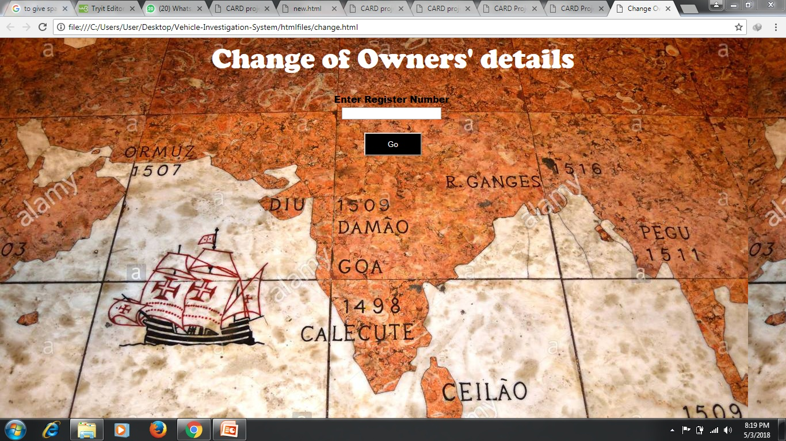

<html> <head> <title> Change Owners' Details </title>

</head> <script language="javascript">

function check()

{

if(document.form1.rno.value=="")

{

alert("Register number not entered !");

document.form1.rno.focus();

return;

}

document.form1.submit();

}

// -->

</script>

<body background="C:\Users\User\Desktop\a1.jpg"> <form name=form1 method=post

action = "http://localhost:8080/change.jsp">

<center><font size="5"face="Cooper Black" color=white>

<h1> Change of Owners' details </h1></font>

<font face="Arial Black" > Enter Register Number <br>

<input type=text name=rno> <br><br>

<input type=button style="height:40px;width:100px;color:white;background-color:black" value="Go" onClick="check()">

</html>

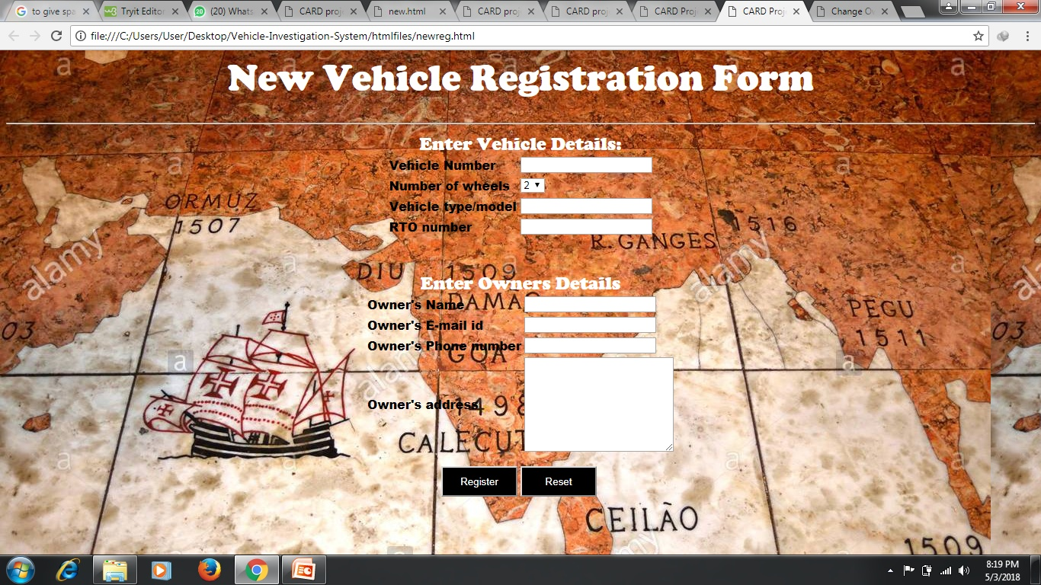

<html>

<title> CARD Project - New Vehicle Registration</title>

<script language="javascript">

//document.form1.vno.focus();

function check()

{

if(document.form1.vno.value=="")

{ alert("Vehicle number should be furnished");

document.form1.vno.focus();

return;

}

if(document.form1.model.value=="")

{ alert("Vehicle model should be furnished");

document.form1.model.focus();

return; }

if(document.form1.oname.value=="")

{ alert("Owner name should be furnished");

document.form1.oname.focus();

return;}

if(document.form1.email.value=="")

{ alert("Owners email not furnished ! ");

document.form1.email.focus();

return;}

if(document.form1.phone.value=="")

{ alert("Phone number missing! ");

document.form1.phone.focus();

return; }

if(document.form1.rtono.value=="")

{ alert("Vehicle RTO number not mentioned ");

document.form1.rtono.focus();

return; }

if(isNaN(document.form1.phone.value))

{

alert("Invalid phone number. Remove extra characters");

document.form1.phone.focus();

return;

}

mail=document.form1.email.value;

for(i=0;i<mail.length;i++)

{

if(mail.charAt(i)=='@')

{

m1=mail.substring(0,i);

m2=mail.substring(i+1,mail.length);

}

}

for(i=0;i<m1.length;i++)

{

if((m1.charAt(i)=='.')||(m1.charAt(i)==' '))

{

alert("Wrong e-mail id. Retype");

return;

}

}

for(i=0;i<m2.length;i++)

{

if((m2.charAt(i)==' ')||(m2.charAt(i)=='@'))

{

alert("Wrong e-mail id. Retype");

return;

}

}

document.form1.submit();

}

</script>

<body background="C:\Users\User\Desktop\a1.jpg">

<center> <font size="5"face="Cooper Black" color=white >

<h1>New Vehicle Registration Form </h1><hr>

</center></font>

<form name=form1 action="http://localhost:8080/jsp1.jsp" method=post>

<center>

<font face="Arial Black" >

<center> <font size="5"face="Cooper Black" color=white>

Enter Vehicle Details: </font></center>

<table>

<tr> <td> Vehicle Number </td>

<td> <input type=text name=vno> </td>

<tr> <td> Number of wheels </td>

<td> <select name=wheels > <option>2 <option>3

<option>4 <option>6 </select > </td>

<tr> <td> Vehicle type/model </td>

<td> <input type = text name=model> </td>

<tr> <td> RTO number </td>

<td> <input type=text name=rtono></td> </tr>

</table>

<br><br>

<center><font size="5"face="Cooper Black" color=white>

Enter Owners Details</font></center>

<table>

<tr> <td> Owner's Name </td>

<td> <input type=text name=oname> </td>

<tr> <td> Owner's E-mail id </td>

<td> <input type=text name=email> </td>

<tr> <td> Owner's Phone number </td>

<td> <input type=text name=phone> </td>

<tr> <td> Owner's address </td>

<td> <textarea cols=25 rows=8 name=addr> </textarea></td>

</tr>

</table> </font>

</center>

<p>

<center>

<input type=button style="height:40px;width:100px;color:white;background-color:black" Value="Register" onClick="check()">

<input type=Reset style="height:40px;width:100px;color:white;background-color:black">

</form>

<br>

Change.jsp

<html><title>Change is Owners' details </title >

<%@ page import = "java.sql.*" %>

<%! Connection con; Statement st; ResultSet rs; %>

<%

try{

Class.forName("sun.jdbc.odbc.JdbcOdbcDriver");

con=DriverManager.getConnection("jdbc:odbc:vis","vis","disco");

String cmd = "Select oname,email,phone,ownadd from rvehicles where rno=" +request.getParameter("rno");

st=con.createStatement();

rs=st.executeQuery(cmd);

if(rs.next())

{ %>

<script language="javascript">

function check()

{

if(document.form1.oname.value=="")

{

alert("Owner name should be entered!");

document.form1.oname.focus();

return;

}

if(document.form1.email.value=="")

{

alert("E-mail should be entered!");

document.form1.email.focus();

return;

}

if(document.form1.phone.value=="")

{

alert("Owners phone number should be entered!");

document.form1.phone.focus();

return;

}

if(document.form1.addr.value=="")

{

alert("Owners address should be entered!");

document.form1.addr.focus();

return;

}

document.form1.submit();

}

</script>

<body>

<form name=form1 method=post action="http://localhost:8080/update.jsp">

<center><h1> Vehicle Investigation System </h1>

<font color=red>

<h3>Change necessary Details </h3>

<font size=4 color=Blue> <table>

<tr><td>Owner Name :

<td> <input type=text name=oname value="<%= rs.getString(1) %>">

<tr> <td> E-mail :

<td> <input type=text name=email value="<%= rs.getString(2) %>">

<tr> <td>Phone :

<td> <input type=text name=phone value="<%= rs.getInt(3) %>">

<tr> <td>Address :

<td><input type=text name=addr value="<%= rs.getString(4) %>">

</tr></table>

<input type=hidden name=myrno

value="<%= request.getParameter("rno") %>">

<input type=button value=" Go " onClick="check()">

</form></body>

<%

} else {

%> <center><font color=red>

<h3> Invalid Register Number! Retype </h3> </center> </font>

<%@ include file="change.html" %>

<%

}

}catch(Exception e)

{ e.printStackTrace(); }

%>

</body>

</html>

Seconds.jsp

<html> <Title> Checking Second-hand vehicle status </title>

<%@ page import ="java.sql.*" %>

<%! Connection con; ResultSet rs; Statement st; %>

<%

try{

Class.forName("sun.jdbc.odbc.JdbcOdbcDriver");

con=DriverManager.getConnection("jdbc:odbc:vis","vis","disco");

String cmd="select rno from stolenlist where vno='"+ request.getParameter("vno")+"'";

st=con.createStatement();

rs=st.executeQuery(cmd);

if(rs.next())

{

int i=rs.getInt(1);

cmd = "insert into foundlist values("+i+",'"+

request.getParameter("vno")+"',"+

request.getParameter("wheels")+",'"+

request.getParameter("model")+"','"+

request.getParameter("oname")+"','"+

request.getParameter("addr")+"','"+

request.getParameter("email")+"',"+

request.getParameter("phone")+",'"+

request.getParameter("uname")+"','"+

request.getParameter("uaddr")+"','"+

request.getParameter("uemail")+"',"+

request.getParameter("uphone")+",SYSDATE)";

st.execute(cmd);

out.println("<font size=4 color=red><center>");

out.println("Vehicle found in 'stolen vehicles' list! ");

out.println("Do not purchase this vehicle</font>");

out.println("<hr>");

%>

<%@ include file="home.html" %>

<%

}

else

{

out.println("<center><font size=4 color=Magenta>");

out.println("No complaint against the vehicle is registered!");

out.println("<br>Vehicle may be purchased");

out.println("<br>To avail benefits of this site ");

out.println("register the vehicle after purchase ");

out.println("</font></center>");

%>

<%@ include file="home.html" %>

<%

}

}catch(Exception e)

{

e.printStackTrace();

out.println(e);

}

%>

</body>

</html>

Update.jsp

<html><title> Updation in progress...</title>

<%@ page import = "java.sql.*" %>

<%! Connection con; Statement st; ResultSet rs; %>

<%

try{

Class.forName("sun.jdbc.odbc.JdbcOdbcDriver");

con= DriverManager.getConnection("jdbc:odbc:vis","vis","disco");

String s1=request.getParameter("oname");

String s2=request.getParameter("email");

String s3=request.getParameter("phone");

String s4=request.getParameter("addr");

String s5=request.getParameter("myrno");

String cmd = "update rvehicles set oname='"+s1+"',email='"+

s2+"',phone="+ s3 +",ownadd='"+ s4 +"' where rno="+s5;

%>

<%

st=con.createStatement();

st.execute(cmd);

out.println("<center> <font color=red size=6>Record updated</font></center>");

out.println("<hr>");

%>

<%@include file="home.html" %>

<%

}

catch(Exception e)

{

out.println(e);

e.printStackTrace();

}

%>

</body>

</html>

Trace.jsp

<html><title>Tracing stolen vehicle</title>

<%@ page import = "java.sql.*" %>

<%! Connection con; ResultSet rs; Statement st; %>

<%

try

{

Class.forName("sun.jdbc.odbc.JdbcOdbcDriver");

con=DriverManager.getConnection("jdbc:odbc:vis","vis","disco");

String cmd = "select * from foundlist where rno="+ request.getParameter("rno");

st=con.createStatement();

rs=st.executeQuery(cmd);

if(rs.next())

{

out.println("<font color=red size=4><center>");

out.println("Whereabouts of the vehicle can be");

out.println("obtained from the following addresses :<br>");

out.println("<u>First Address</u> : <br>");

out.println("<br>Name : "+rs.getString(5));

out.println("<br>Address:"+rs.getString(6));

out.println("<br>E-mail:"+ rs.getString(7));

out.println("<br>Phone:"+rs.getString(8));

out.println("<br><u>Second address</u>: <br>");

out.println("<br>Name:"+rs.getString(9));

out.println("<br>Address:"+rs.getString(10));

out.println("<br>E-mail:"+rs.getString(11));

out.println("<br>Phone:"+rs.getString(12));

out.println("</font></center><hr>");

%> <%@ include file="home.html" %> <%

}

else

{

out.println("<font size=4 color=Magenta><center>");

out.println("Vehicle still not traced.<br></center> <hr>");

%>

<%@ include file="home.html" %>

<%

}

}

catch(Exception e)

{

e.printStackTrace();

out.println(e);

}

%>

</body></html>

Jsp1.jsp

<html>

<body>

<%@ page import = "java.sql.*" %>

<%! Connection con; Statement st; ResultSet rs,rs1; %>

<%

int i=0; String d="";

try{

Class.forName("sun.jdbc.odbc.JdbcOdbcDriver");

con=DriverManager.getConnection("jdbc:odbc:vis","vis","disco");

String cmd= "select RNO from rvehicles where VNO='"+

request.getParameter("vno")+"'";

st=con.createStatement();

rs=st.executeQuery(cmd);

if(!rs.next())

{

cmd="select rnoseq.nextval from dual";

rs1=st.executeQuery(cmd);

if(rs1.next())

i = rs1.getInt(1) ;

String thisvno = request.getParameter("vno");

int thiswh = Integer.parseInt( request.getParameter("wheels") );

String thismodel = request.getParameter("model");

String thisrtono =request.getParameter("rtono");

String thisoname=request.getParameter("oname");

String thisemail=request.getParameter("email");

int thisphone=Integer.parseInt( request.getParameter("phone"));

String thisaddr=request.getParameter("addr");

cmd = "insert into rvehicles(rno,vno,wheels,vtype,rtono,oname,"

+ "email,phone,ownadd,regdate) values(" +i+",'"+ thisvno+"',"+thiswh+

",'"+thismodel+"','"+thisrtono+"','"+thisoname+

"','"+thisemail+"',"+thisphone+",'"+thisaddr+

" ',SYSDATE)" ;

st.execute(cmd);

%>

<h3> Registration Successful </h3>

<h4> Remember the following registration number for future

reference </h4> <font size=5 color=red>

<%= i %>

<p><hr>

<%@ include file="home.html" %>

<%

}else

{

String s=rs.getString(1); %>

<h2> The vehicle is already registered with the number

<%= s %> .</h2>

<font size=5 color=red> Enter correct vehicle number.

<%@ include file="newreg.html" %>

<%

}

}catch(Exception e)

{

e.printStackTrace();

out.println(" "+e);

} %>

</body>

</html>