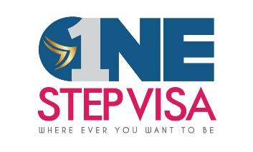

**STUDENT AT A GLANCE FORM**

Student Name: TERIKOTI RAVI KIRAN

Date of Birth: 03-03-2002

Country of Birth: INDIA

Passport No: Y5199096

Educational Qualification:

|  |  |  |  |  |  |
| --- | --- | --- | --- | --- | --- |
| **Degree** | **Institution** | **Subjects** | **% of marks** | **Duration**  **(From-To)** | **Backlogs** |
| **10th**  **Inter**  **B-Tech** | **sri chaitanya**  **sri gayatri**  **Welfare institute of science technology and management** | **SSC**  **MPC**  **CSE** | **7.0**  **5.75**  **(6.90)** | **2017**  **2020**  **2020-2024** | **0**  **0**  **2** |
|  |  |  |  |  |  |
|  |  |  |  |  |  |

TOEFL/IELTS scores (Available/Expected):

GRE/GMAT scores (Available/Expected): NA

Work Experience, if any:

Any specific Location: US

Intended Major: MS in CS

Intended Intake: fall 2024