K.Shiva Kiran
2503B05121

Set 1
1. Q1. Write a Python function to calculate the factorial of a number. Use a coding assistant
and document how you refine your prompt to ensure the function handles negative
input and zeros.
(Each question carries 5 marks)

Prompt: Write a Python function named factorial(n) that returns the factorial of n.
The `factorial` function:
- Accepts non-negative integers and returns n! as an int.
- Raises `ValueError` for negative inputs and `TypeError` for non-integers.

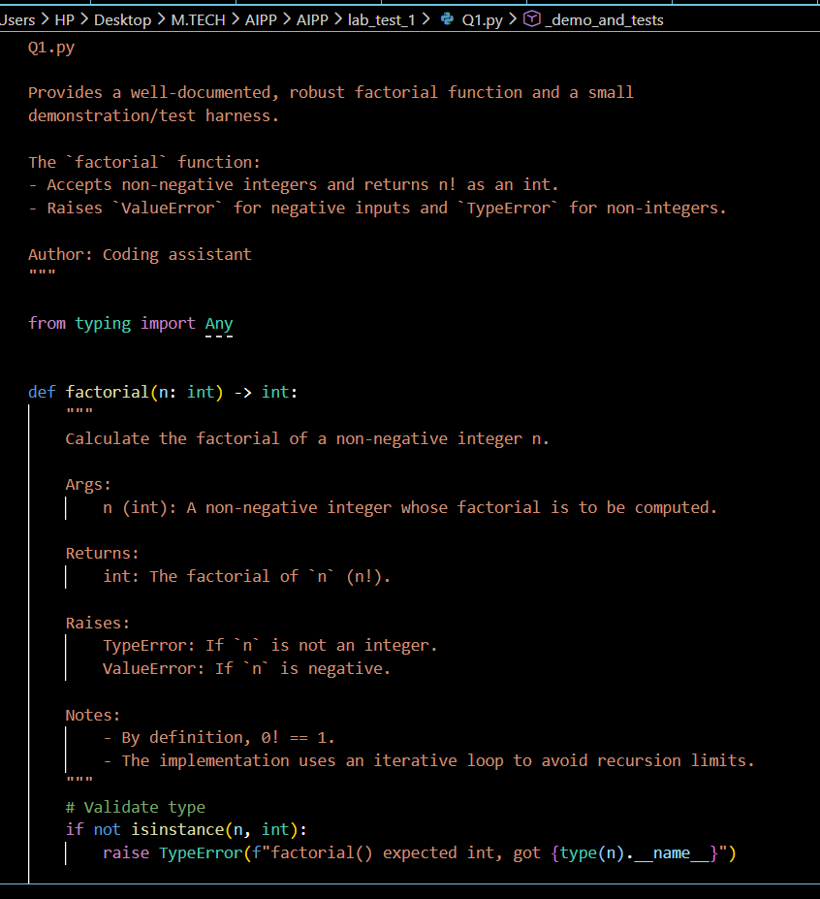

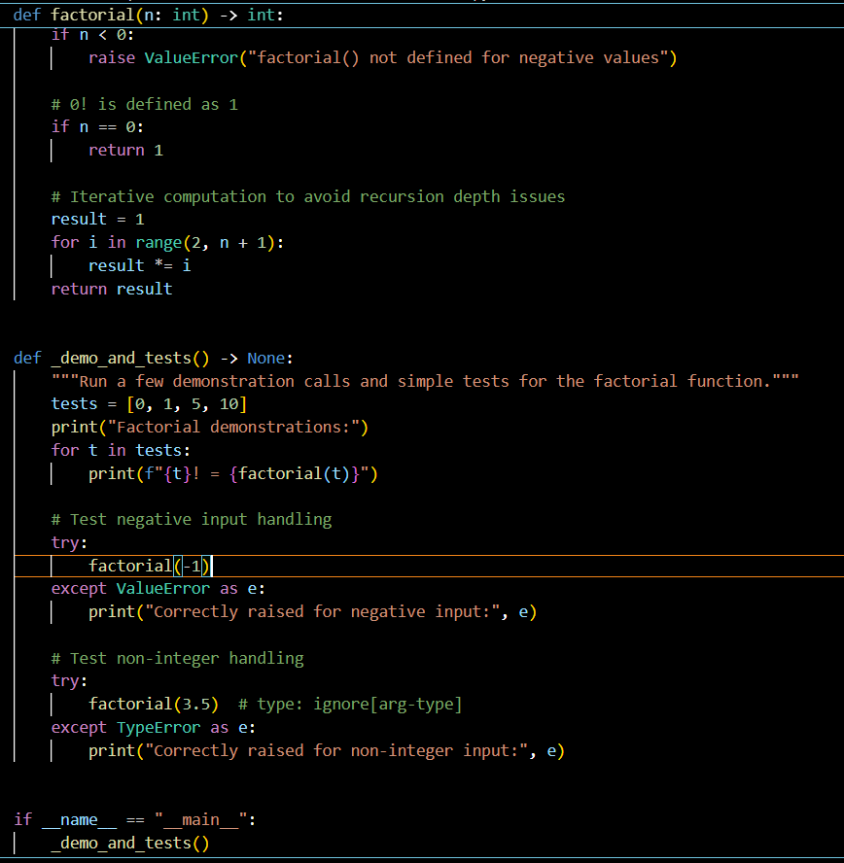

OUT PUT:
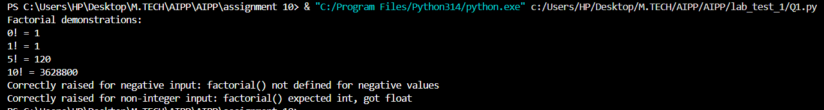

2. Q2. Given a list of student marks, compute the mean and list all students above the
mean. Demonstrate zero-shot, one-shot, and few-shot prompts to guide an AI tool to
solve this. Summarize the differences in approach.
(Each question carries 5 marks)

Prompt:"Given a list of student names and their marks, compute the mean mark and "
"return the list of students who scored strictly above the mean. Output the mean "
"and each student's name with their mark. Do not include any extra commentary."

"Example:\nInput: [('Alice', 70), ('Bob', 80), ('Carol', 60)]\nOutput: mean = 70.0; students above mean = [('Bob', 80)]\n\nNow solve:\nGiven a list of student names and marks, compute the mean and list students above mean."
Give python code according to it.

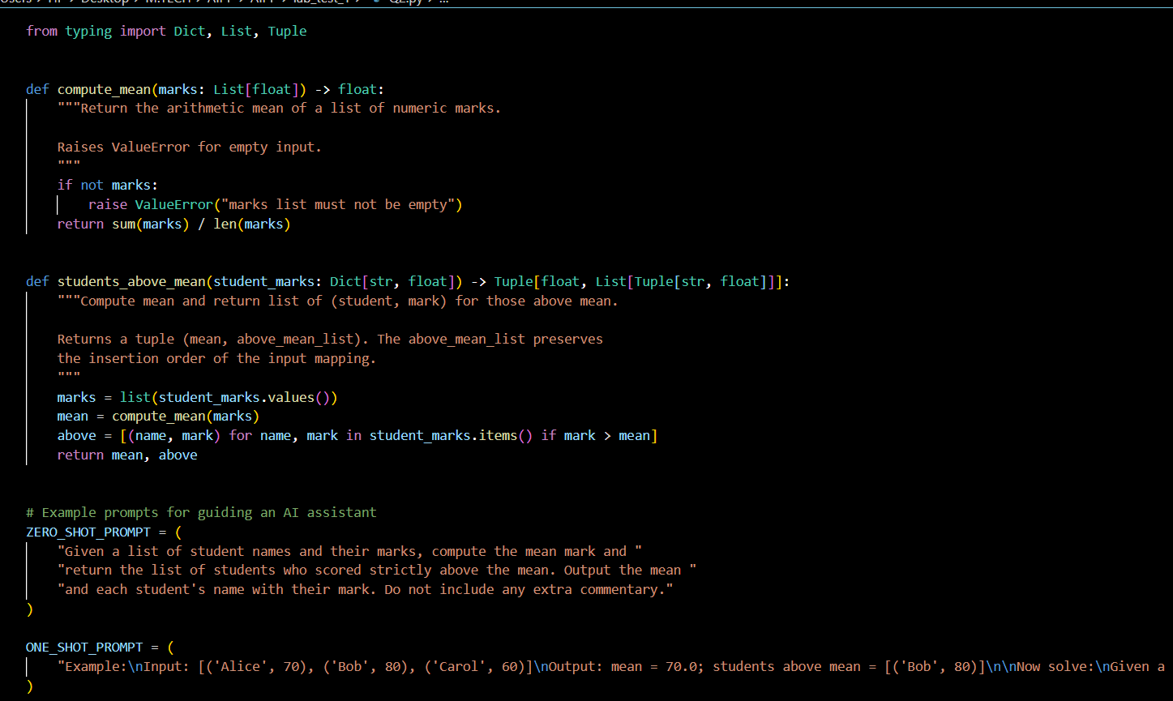

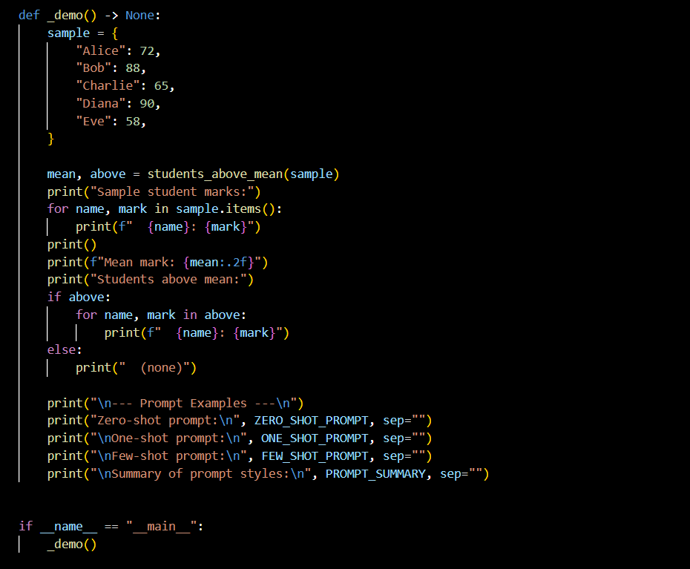

OUTPUT:
