Performance Metrics — Data Prep and ETL Run

1. Purpose
This document outlines the required file checks, data prep steps, ETL job execution sequence, and post-run data validation for the Performance Metrics process.

2. File Naming Standards (All Sources)
• Use underscores (_) to separate words in file names (no spaces).
• Examples (expected formats):
- Octane_defects_selected_filtered_Nov_2025.xlsx
- Monthly_Service_Now_Extract_Nov_2025.csv
- Nov_Performance_Measures_Report_Results.xlsx
- Performance_Measures_PM_Reports_December_2025.xlsx
- CMS_Certification_Outcome_Case_Management_Detail_Nov25.xlsx

3. Source File Prep and Formatting Requirements

3.1 CMS Certification Outcome Case Management Detail (Excel)
CMS_Certification_Outcome_Case_Management_Detail_May26.xlsx
- Remove rows 1–11 (header/preamble rows).
- Remove any footer content at the bottom of the file.

3.3 Performance Measures — PM Report (Excel)
Performance_Measures_PM_Reports_June_2026.xlsx
- Ensure all worksheet tabs (bottom tabs in Excel) are named using underscores (_).
Operations_Meeting_Tracker
Change_Requests
Status_Report_Metrics
Task_Slipping_Report
For Performance_Measures_PM_Reports_<Month>.xlsx:
- The file must contain (current month – 1) data.
- The file name should reflect the current month.
  - Example: Use Performance_Measures_PM_Reports_July.xlsx when running the July process (contains June data).
- All tabs at bottom of excel sheet are separated by Underscore
  - Example: Operations_Meeting_Tracker, Change_Requests, Status_Report_Metrics and Task_Slipping_Report.

3.4 Performance Measures Report Results (Excel)
Performance_Measures_Report_Results.xlsx:
- Add underscores file name
- Confirm the report names are exactly in first column - Report_Name:
Claim lines Summary Report
Enrollment Detail Report
- Confirm the fields/columns are in the required order (per the approved field order list).
- After loading into DB2 table Report_Row_Count value need to be updated from exponential format to numeric format.
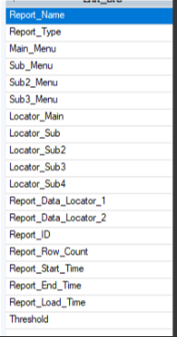

3.6 Octane Defects -ServiceNow Monthly Extract (CSV)
Octane_defects_selected_filitered_May_2026.xlsx
- Confirm the worksheet name is Sheet1.
- Confirm the “ID” column is the first column in the file.
- Check Colum Names and Order.
Add column C - Open_Vulnerabilities
Remove Rank – column T
Rename Done date to Closed_on
Add Phase column after Closed_on from column E
Remove Phase column from column C
- Confirm all columns match the template column order exactly. Please refer to the document ‘Octane_defects_(ALM Defects)_TEMPLATE.xlsx’.
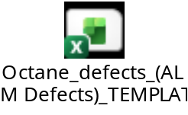

"ID" -- move from third place to first
"Name"
"Open_Vulnerabilities"
"User Story Id"
"Phase" -- additional , should move after done date or Closed_on
"UAT Hotfix"
"Task Count"
“Suite_runs” -- missing , add after Task Count
"Sub Team"
"Story points"
"Sprint"
"SIT"
"Severity Level Accepted by State"
"Root Cause Sub Category"
"Root Cause"
"Requirements"
"Reoccurrence"
"Remaining hours"
"Related UAT Test Case"
"Related UAT Defect"
"Related Req Num"
"Rank" -- additional , this is not needed , can be deleted
"Progress"
"Original id"
"Milestone"
"Last modified"
"Item origin"
"Is draft"
"Invested hours"
"Incident Number"
"Impact Analysis"
"Hot Fix"
"Historical Date Reported"
"Functional Area"
"Fixed in build"
"Feature"
"Failed Test Step Number"
"Expected Resolution Business Hours"
"Estimated hours"
"Environment tags"
"Email Distiribution"
"Dev"
"Detected in release"
"Detected in build"
"Defect type"
"Defect root cause"
"Complexity"
"Blocked reason"
"Blocked"
"Author"
"Area Affected"
"Actual Resolution Business Hours"
"Issue Type"
"Issue Status"
"Severity"
"Detected by"
"Deloitte Response"
"QA owner"
"Historical Issue Tracking Number"
"Application modules"
"Tags"
"Creation time"
"Done date" -- rename to "Closed_on"
"Phase" -- add Phase from third or fourth Column
"Priority"
"Owner"
"PMC ID"
"Has attachments"
"Team"
"Release"
"Description"
"Remediation Plan Submitted"

3.7 For Monthly_Service_Now_Extract_<Mon_YYYY>.csv:
Monthly_Service_Now_Extract_May_2026.csv
- All timestamp fields must be in the format: YYYY-MM-DD HH:MM:SS
Timestamp fields are six:
opened_at
resolved_at
closed_at
reopened_time
u_date_time_1
u_date_time_2
- Fields must be in the following order:
- number
- opened_at
- state
- priority
- u_asset1
- incident_state
- assignment_group
- assigned_to
- contact_type { add this column}
- resolved_at
- closed_at
- close_code
- closed_by
- short_description
- category
- caller_id { Rename opened_by to caller_id }
- impact
- reopened_by
- parent_incident
- reopened_time
- resolved_by
- urgency
- u_date_time_1
- u_date_time_2
- u_text_field_1
- u_text_field_2
- u_dropdown_1
- u_module_functionality

3.8 Monthly KPI File:
MayKPI2026.xlsx
/data/NE_DMA/PERF_METRIC/
Remove AccountCreatedDate column from excel sheet
Use job: CopyOfJ_KPI_USERS_LIST_V2 instead of J_KPI_USERS_LIST_V2

4. File Transfer to Production
After all files are verified and cleaned:
- Copy old files from /data/NE_DMA/PERF_METRIC/input to /data/NE_DMA/PERF_METRIC/input/Archive
- Transfer files to the DataStage Production server using WinSCP.
- Target directory: /data/NE_DMA/PERF_METRIC/input
- Server: Prod IIS server (PANVLHIAAP03)
Important: Confirm the Admin team has also placed the Monthly KPI file in the same location.
- Example: DecKPI2025.xlsx

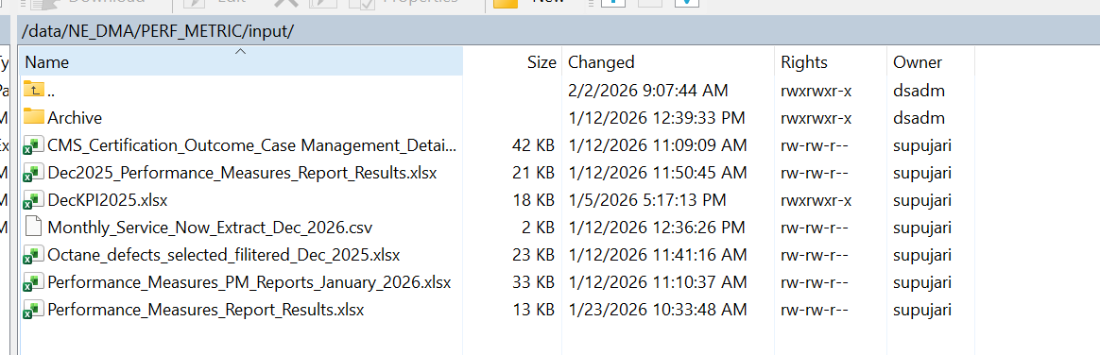

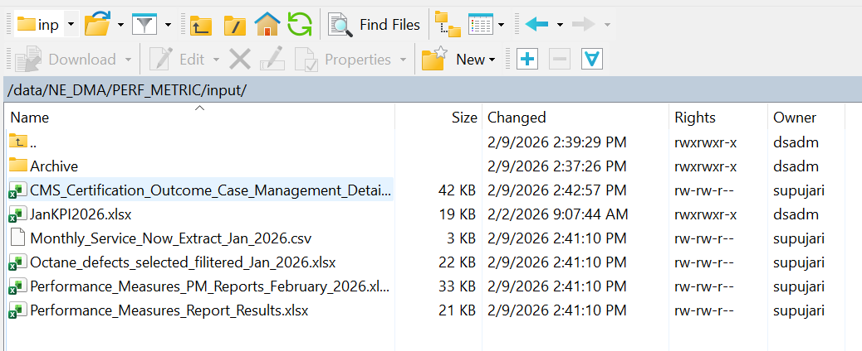

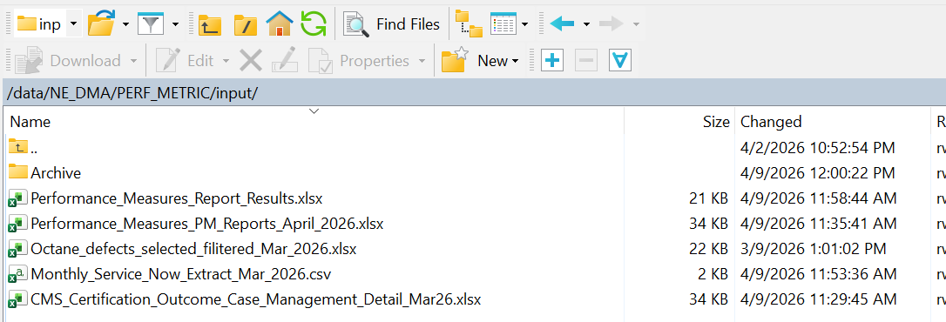

5. ETL Job Run Process (DataStage)

5.1 Navigation
- Open DataStage Director.
- Navigate to: NE_DMA_RPT → KPI_RPT

5.2 Job Execution Steps (Run in Order)

1) J_KPI_INVESTIGTN_ACTIVITY
- Source file: CMS_Certification_Outcome_Case_Management_Detail_Month23.xlsx
- Parameters:
  - SrcFile = source file name
  - File date = first day of the last month, format YYYY-MM-DD
  - Example: 2023-07-01

2) J_KPI_USERS_LIST_V2
- Source file: <MONTH>KPI.xlsx
- Parameters:
  - SrcFile = latest KPI file name
  - File date = first day of the last month, format YYYY-MM-DD

5.3 Navigate to PERF_TRACKER
- Navigate to folder: PERF_TRACKER

3) J_PM_ALM
- Source file: Octane_defects_filtered_<…>.xlsx
- Parameters:
  - SrcFile = source file name
  - File date = first day of the last month, format YYYY-MM-DD

4) J_OPS_MTNG_TRACKER
- Source file: Performance_Measures_PM_Reports_<Month>.xlsx
- Parameters:
  - SrcFile = source file name
  - File date = first day of the last month, format YYYY-MM-DD

5) J_SERVICENOW_EXTRACT
- Source file: ServiceNow_Performance_Management_Monthly_Extract_<MonYY>.csv
- Parameters:
  - SrcFile = source file name
  - File date = first day of the last month, format YYYY-MM-DD

6) J_REPORT_METRICS
- Source file: Performance_Measures_Report_Results_<MonYY>.xlsx
- Parameters:
  - SrcFile = source file name
  - File date = first day of the current month, format YYYY-MM-DD
  - Example: 2023-08-01

7) J_STATUS_RPT_METRIC
- Source file: Performance_Measures_PM_Reports_<Month>.xlsx
- Note: Uses a different tab than J_OPS_MTNG_TRACKER.
- Parameters:
  - File date = first day of the last month, format YYYY-MM-DD

8) J_REPORT_RUNTIME_METRIC
- Parameters: None

9) J_SEQ_PERF_TRKR_SUMMARY (Last Job)
- Parameters:
  - File date = first day of the last month, format YYYY-MM-DD

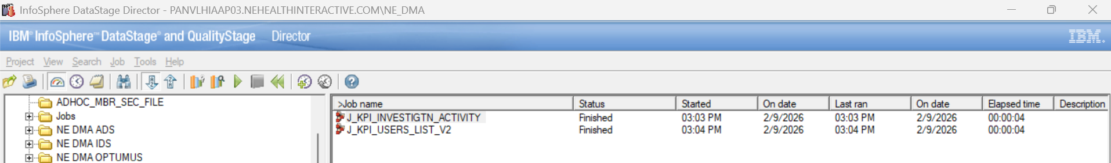

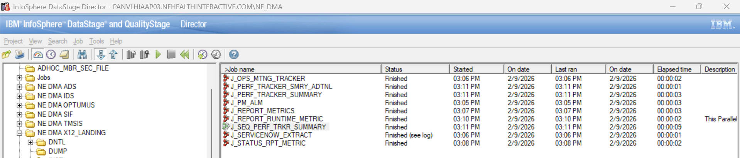

6. Data Validation (Post-Run)
After all jobs complete successfully, validate the following tables.

6.1 Monthly Performance Tracker Tables (example FILE_DATE = 2025-12-01)
- IDS_NE.T_AM_PM (expected: 4 rows)
- IDS_NE.T_OPS_MTNG_TRACKER (expected: 0 rows)
- IDS_NE.T_ALM_PM (expected: 1 row)
- IDS_NE.T_KPI_USER_MGR (expected: 92 rows)
- IDS_NE.T_INVESTIGTN_ACTIVITY_METRIC (expected: 376 rows)
- IDS_NE.T_PERF_TRKR_SUMMARY (validate by PERF_MONTH = 2025-12-01; expected: 66 rows)

6.2 Reporting Tables (example FILE_DATE = 2026-01-01)
- IDS_NE.T_REPORT_ALM (expected: 22 rows)
- IDS_NE.T_REPORT_RUNTIME_METRIC (expected: 22 rows)

7. Output
Once validation is complete, the Performance Metric Report can be generated.

