**Date :**

**Expt.No: 5**

# AMPLITUDE MODULATION AND DEMODULATION

**AIM:**

To design and set up AM modulator and demodulator and to observe the waveforms.

## COMPONENTS REQUIRED

|  |  |  |  |
| --- | --- | --- | --- |
| Sl. No: | Component | Specification | Quantity |
| 1 | Resistors | 56kΩ  10kΩ  1.2kΩ  33kΩ  1kΩ | 1  1  1  1  1 |
| 2 | Capacitors | 0.1μF  1μF  0.3μF | 1  1  1 |
| 3 | Transistor | BF 495 | 1 |
| 4 | Diode | OA79 | 1 |
| 5 | Inductance Box |  | 1 |

## CIRCUIT DIAGRAM

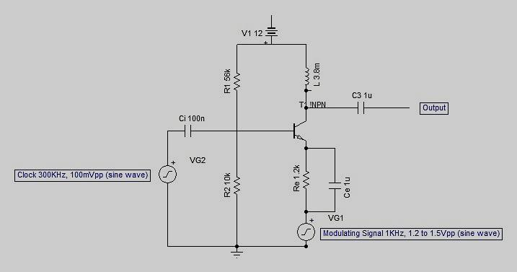

Fig 1: Amplitude Modulation Circuit

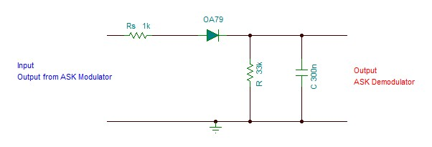

Fig 2: Amplitude Demodulation Circuit

**PINOUT DIAGRAM OF OA79(Germanium Diode)**



**PINOUT OF BF495**



**THEORY:**

Modulation is defined as the process by which some characteristics of a carrier signal is varied in accordance with a modulating signal. The base band signal is referred to as the modulating signal and the output of the modulation process is called as the modulation signal.

Amplitude modulation is defined as the process in which is the amplitude of the carrier wave is varied about a means values linearly with the base band signal. The envelope of the modulating wave has the same shape as the base band signal provided the following two requirements are satisfied

1. The carrier frequency fc must be much greater then the highest frequency components fm of the message signal m (t)
2. i.e. fc >>fm
3. The modulation index must be less than unity. if the modulation index is greater than unity, the carrier wave becomes over modulated.

AM Modulation

•When no modulating signal present, the circuit operates as a linear amplifier. Theoutput is simply the carrier amplified by the quiescent voltage gain• When a modulating signal is applied, the amplifier operates nonlinearly, andsignal multiplication occurs

• The modulating signal varies the gain of the amplifier at a sinusoidal rate equal tothe frequency of the modulating signal and can be expressed as:

*AV = Aq [1+ m sin(2πfmt)]*

where AV = amplifier voltage gain with modulation

Aq = amplifier quiescent (without modulation) voltage gain

Operation of the modulator is briefly described below

• Modulating signal is applied through isolation transformer to the emitter oftransistor and the carrier is applied directly to the base.

• The modulating signal drives the circuit into both saturation and cut-off states,producing the nonlinear amplification necessary for modulation to occur

• The collector waveform includes the carrier, upper and lower side frequencies aswell as a component at the modulating frequency

• Coupling capacitor C removes the modulating signal frequency from thewaveform, producing a symmetrical AM envelope at Vout

AM Demodulation

The process of detection provides a means of recovering the modulating Signal from modulating signal. Demodulation is the reverse process of modulation. The detector circuit is employed to separate the carrier wave and eliminate the side bands. Since the envelope of an AM wave has the same shape as the message, independent of the carrier frequency and phase, demodulation can be accomplished by extracting envelope.

An increased time constant RC results in a marginal output follows the modulation envelope. A further increase in time constant the discharge curve become horizontal if the rate of modulation envelope during negative half cycle of the modulation voltage is faster than the rate of voltage RC combination ,the output fails to follow the modulation resulting distorted output is called as “ diagonal clipping : this will occur even high modulation index.

The depth of modulation at the detector output greater than unity and circuit impedance is less than circuit load (R >Zm) results in clipping of negative peaks of modulating signal. It is called “negative clipping “

Ideally, anenvelope detector produces an output signal that follows the envelop of the input signal wave form exactly;hence, the name. Some version of this circuit is used in almost all commercial AM radio receivers.

The Modulation Index is defined as, m = $\frac{(V_{max }- V_{min})}{(V_{max}+V_{min})}$

whereVMAX and VMIN are the maximum and minimum amplitudes of the modulated wave.

**PROCEDURE**

1. Connections are made for the AM Modulator and Demodulator as shown in the circuit diagrams.
2. Verify whether the circuit is working as an amplifier. Apply carrier signal 1st without modulating signal and check the output is amplified
3. Now apply both modulating and carrier signals
4. Adjust amplitudes of the two signal sources to obtain AM signal at the output.
5. Note down VMAXand VMIN of the AM signal and calculate the modulation index using the formula
6. Observe the output waveforms and plot it.

## DESIGN

Vcc = 12V, β= 50 Ic = 1mA

Choose BF 495 Transistor

VRE = 10% of Vcc = 1.2V

RE =VRE / IE = 1.2 / (1mA) = 1.2kΩ

IB = IC /β = 1mA/50 = 0.02mA

VR2 = VBE(sat) + VRE  = 0.7V + 1.2V = 1.9V

VR1 = VCC - VR2  = 12V – 1.9V = 10.1V

Assume 10IBis flowing through R1 and 9IBflowing through R2

R2 =VR2 / 9IB = 1.9 / (9x0.02mA) = 10.5kΩ🡺 choose R2 = 10kΩ

R1 =VR1 / 10IB = 10.1 / (10x0.02mA) = 50.5kΩ🡺 choose R1= 56kΩ

Frequency, f = 200 kHz

XCE = 10% of RE = 100Ω🡺 CE = 1 / (2∏ x 100 x 200 k) = 0.00795μF

Choose CE =1μF

V RFC = 40% of V CC = 4.8V

X RFC = V RFC / IC  = 4.8 / (1mA) = 4.8kΩ🡺 L = 4.8k/(2∏ x 200 k) = 3.8mH

Ri = R1 // R2 // βre = 56k // 10k // ( 50 x (2.5mV/1mA) ) = 123.18Ω

XCi= 10% of Ri= 12.318Ω🡺Ci= 1 / (2∏ x 12.13 x 200 k) = 0.065μF

Choose Ci = 0.1μF

**AM DETECTOR**

Let RS = 1kΩ

RC >> time period of radio frequency

Take RC=10T

T = 1/f = 1/1k = 1ms

Choose C = 0.3μF

R = 10 x 1m / (0.3μ) = 33.33kΩ

Choose R = 33kΩ

**CALCULATIONS**

Vmax=

Vmin =

Modulation Index, m = (Vmax - Vmin) / (Vmax + Vmin)

**EXPECTED WAVEFORMS**

**AM Modulation**



**AM Demodulation**



**RESULT**