**INFERENCE:**

Date:

Expt No: 3

# MONOSTABLE MULTIVIBRATOR USING OP-AMP

## AIM:

To design and set up an astable multivibrator using op-amp and 555 timer IC.

## COMPONENTS AND EQUIPMENTS REQUIRED:

|  |  |  |  |
| --- | --- | --- | --- |
| **Sl.No.** | **Components/Apparatus** | **Specification** | **Quantity** |
| 1 | Op-amp | LM741 | 1 |
| 2 | IC | NE/SE 555 | 1 |
| 2 | Resistors | 10k  15k  8.2k | 2  1  1 |
| 3 | Capacitors | 0.01μF  0.1μF | 1  1 |
| 4 | Diode | IN4001 | 2 |
| 5 | Breadboard |  |  |
| 6 | DC Power Supply |  |  |
| 7 | CRO |  |  |

## THEORY:

Monostable multivibrator is also called one shot. It has a stable state and a quasistable state. The circuit remains in stable state until triggering signal causes a transition to quasistable state. After a time interval, it returns to the stable state. So a single pulse of predetermined duration can be generated using this circuit.

Monostable multivibrator is also known as triangular wave generator. It has one stable and one quasi stable state. The circuit is useful for generating single output pulse of time duration in response to a triggering signal. The width of the output pulse depends only on external components connected to the op-amp. The diode gives a negative triggering pulse. When the output is +Vsat, a diode clamps the capacitor voltage to 0.7V. Then, a negative going triggering impulse magnitude Vi passing through RC and the negative triggering pulse is applied to the positive terminal. Let us assume that the circuit is instable state. The output V0i is at +Vsat. The diode D1 conducts and Vc the voltage across the capacitor ‘C’ gets clamped to 0.7V. The voltage at the positive input terminal through R1R2 potentiometer divider is +ßVsat. Now, if a negative trigger of magnitude Vi is applied to the positive terminal so that the effective signal is less than 0.7V.the output of the Op-Amp will switch from +Vsat to –Vsat. The diode will now get reverse biased and the capacitor starts charging exponentially to –Vsat. When the capacitor charge Vc becomes slightly more negative than –ßVsat, the output of the op-amp switches back to +Vsat. The capacitor ‘C’ now starts charging to +Vsat through R until Vc is 0.7V.

Consider the instant at which output VO = +Vsat. Now the diode D1 clamps the capacitor voltage VC at 0.7V. Feedback voltage availing at non-inverting terminal is +βVsat. When the negative going trigger is applied such that the potential at non-inverting terminal becomes less than 0.7V, the output switches to -Vsat. Now the capacitor charges through R towards -Vsat, because the diode becomes reverse biased. When the capacitor voltage becomes more negative than -Vsat., the comparator switches back to +Vsat, and capacitor C starts charging to +Vsat through R until VC reaches 0.7V.

The pulse width is given by T = 2RC ln (1/ (1-β)) approximately. If β =0.5, T=0.69RC. The time period of the trigger must be larger than the output pulse width T.

The circuit does not respond to a trigger that appears before the specified output pulse width and hence it is called non retriggerable multivibrator

## CIRCUIT DIAGRAM:

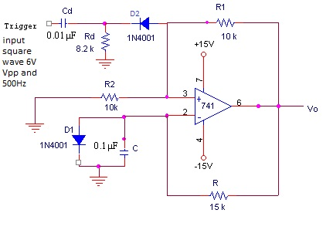

## DESIGN:

We have, T =RC ln (1+VD/Vsat)/(1-β). Let β = 0.5. Then T=0.69RC

Time period T= 1ms and C= 0.1 μF. R2 = R1 =10k.

Design of differentiating circuit: RdCd<0.016Tt.

Take trigger time period Tt = 5ms and Cd= 0.01μF.

Then Rd =8.2k.

## PROCEDURE:

1. Verify whether the op-amp is in good condition by wiring it as ZCD or voltage follower.
2. Set up the monostable multivibrator and feed 6Vpp, 200 Hz square wave at the trigger input. If pulse generator is available, use narrow pulses instead of square wave.
3. Observe the waveforms at pin nos. 6 and 2 of op-amp on CRO and note down its amplitude and frequency.

## EXPECTED WAVEFORMS

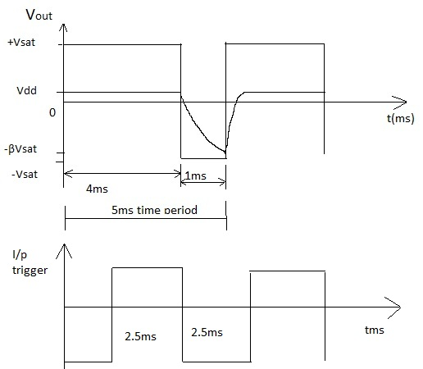

Output of pin 6

Output of pin 2 capacitor output

Input signal

## RESULT:

Pulse width =………………..

## INFERENCE: