**Date :**

**Expt.No: 8**

# AMPLITUDE SHIFT KEYING

**AIM:**

To design and set up ASK modulator and demodulator and observe the waveform.

**COMPONENTS AND EQUIPMENTS REQUIRED:**

|  |  |  |  |
| --- | --- | --- | --- |
| Sl. No: | Component | Specification | Quantity |
| 1. | Op-amp | LM741 | 2 |
| 1 | Resistors | 1kΩ  10k pot | 5  1 |
| 2 | Capacitors | . 01μF  .1μF  1μF  0.3μF | 2  2  1  1 |
| 3 | Transistor | BF 495 | 1 |
| 4 | Diode | OA79 | 1 |
| 5 | Inductance Box |  | 1 |

**THEORY:**

In the ASK modulator we have a transistor working as an inverter and also a Wein bridge oscillator is designed to work at a frequency of 15kHz when Vin  frequency is a 1kHz square wave. When Vin is high the transistor is on and the inverting terminal is at ground and works like ordinary WeinBridge oscillator. When Vin is low the transistor is off and hence the net resistance at the inverting arm is R1+RC. The gain of the oscillator reduces and hence we get an ASK modulated waveform.

For demodulating ASK signal, we dip the ASK signal using a diode IN4007 and a capacitor to bypass the ac components, then given into an op-amp based comparator with reference voltage level at non inverting terminal, which is a dc voltage between the voltage levels of ASK modulated signal. Thus we get the ASK modulated signal at the output.

**PINOUT DIAGRAM**



BC 547

**SYMBOL OF 741 IC:**

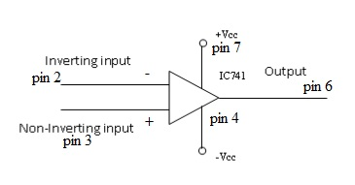

**PIN CONFIGURATION OF 741:**



**CIRCUIT DIAGRAM**

**ASK modulation and demodulation**

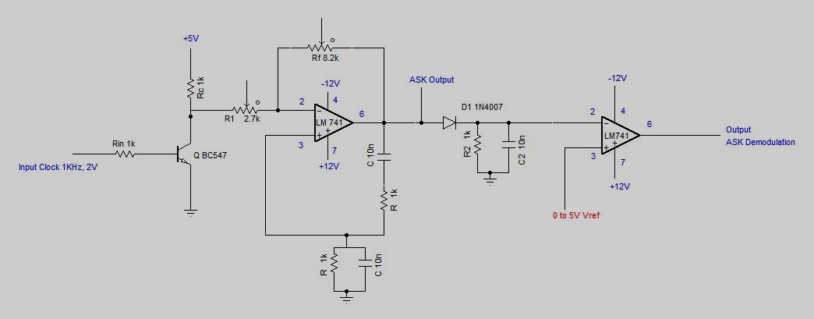

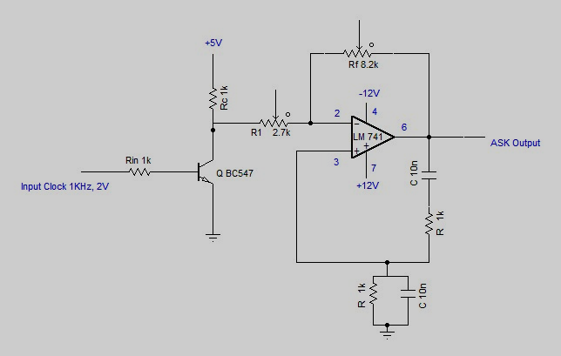

**ASK Demodulation**

**DESIGN:**

**Modulator**

For the Wein-bridge oscillator, frequency f0= 15 kHz; C=0.01μF

f0 = so that R =  = 1061 Ω.

Select R = 1 kΩ

When Vin = HIGH, so that R = 2R1 = 2kΩ

When Vin = LOW, R=R1 +RC

The gain of Wein-bridge oscillator is 3.

Af = 1+

3 = 1+

Select R1 = 2.7K pot

Rf = 2R1 = 5.4KΩ.

Choose Rf = 10KΩ pot and also choose Rin = 1kΩ.

VCC =5V, IC =5mA, β = 125

RC ==  1kΩ

Choose RC =1kΩ.

Demodulator

For demodulation in the ASK, we have a dipper formed by a diode 1N 4007 and a resistor of 1KΩ

T=  = 0.066ms

10T = R2C2

Let C1 = 1μF

R2 =  = 666 Ω

Choose R2 = 1kΩ

**PROCEDURE:**

* Set up the circuit as shown in the circuit diagram
* Input the square wave at the base of the transistor, 1KHz and 2V( from function generator or from trainer kit)
* Observe the ASK modulated output
* ASK modulated output is given as input to ASK demodulation circuit to get demodulated output on the CRO and plot the waveforms
* In ASK demodulation Vrefof 0 to 5V DC is applied to get the original signal back

**EXPECTED OUTPUT:**

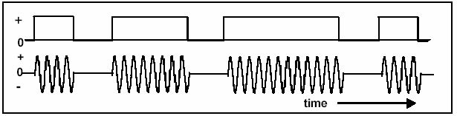

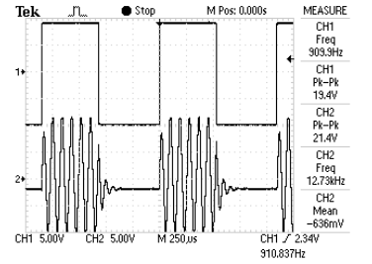

Fig: ASK waveform

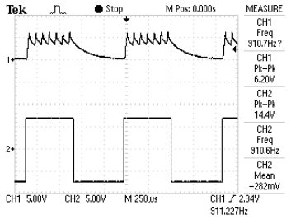

Fig: ASK Demodulated waveform

**RESULT:**