**Date :**

**Expt.No:9**

# PHASE SHIFT KEYING

**Aim:**

To design and set up PSK modulator .

**Components and equipments required:**

|  |  |  |  |
| --- | --- | --- | --- |
| **Sl no.** | **COMPONENT** | **SPECIFICATION** | **QUANTITY** |
| 1 | IC | LM 741 | 1 |
|  |  | 4053 | 1 |
|  |  | 555 | 1 |
| 2 | Resistors | 18k | 2 |
|  |  | 1k | 2 |
| 3 | Capacitors | 0.1µF | 1 |
| 4 | Diode | 1N4007 | 1 |

**Theory:**

A *binary phase-shift keying* (BPSK) signal can be defined by

 

where *A* is a constant, *m*(*t*) = +1 or -1, *fc* is the carrier frequency, and *T* is the bit duration. The signal has a power *P* = *A*/2, so that *A* = 2*P* . Thus equation can be written as

*E* = *P T*

Where *E* is the energy contained in a bit duration.

**Design:**

Assume carrier frequency F=2kHz and amplitude= 4V.

Input binary signal rate as 500 bits/sec.

Ton=Toff=1ms

Ton=0.693R1C

Let C=0.1µF

R1=10-3/(0.693*0.1µ)=14.43k

Choose R1=18k

R2=Toff/0.693C=14.43k

Choose R2=18k

Opamp Inverting amplifier gain = -Rf/R1 = 1

Rf=R1

Choose both Rf=R1=1k

**Circuit diagram:**

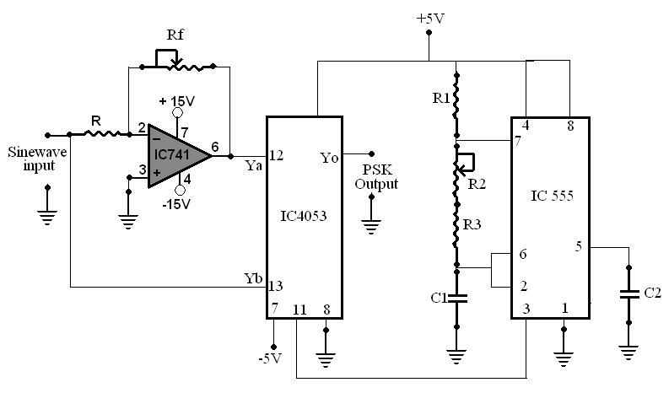

**Procedure:**

1. Set up the circuit as shown in the circuit diagram.
2. Input the digital binary data scheme to the input of inverter.
3. Observe the PSK modulator output on CRO and plot the waveform.

**Expected waveform:**

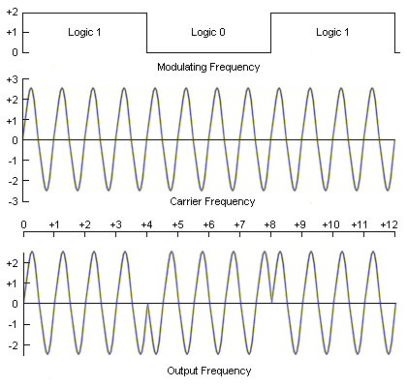

**Result:**