**Date :**

**Expt.No: 6**

# PULSE AMPLITUDE MODULATION

**AIM:**

To design and set up a pulse amplitude modulation system using:

1. CD4016 working as a switch
2. BC 547 transistorized circuit

**COMPONENTS AND EQUIPMENTS REQUIRED:**

|  |  |  |  |  |
| --- | --- | --- | --- | --- |
| **SL No:** | **Components** |  | **Specification** | **Quantity** |
| 1 | Semiconductor | IC | CD4016 | 1 |
| 2 | Transistor | Q1 | BC547 | 1 |
| 3 | Resistor | R1 | 47KΩ | 1 |
|  |  | RC | 2.2KΩ | 1 |
|  |  | RE | 270Ω | 1 |

**THEORY:**

Pulse amplitude modulation is a scheme, which alters the amplitude of regularly spaced rectangular pulses in accordance with the instantaneous values of a continuous message signal.

Then amplitude of the modulated pulses represents the amplitude of the intelligence.

A train of very short pulses of constant amplitude and fast repetition rate is chosen the amplitude of these pulse is made to vary in accordance with that of a slower modulating signal the result is that of multiplying the train by the modulating signal the envelope of the pulse height corresponds to the modulating wave .the Pam wave contain upper and lower side band frequencies .besides the modulating and pulse signals.

In PAM the amplitude of the pulses are varied in accordance with the modulating signal. (The modulating signal is denoted as m (t)). PAM is achieved simply by multiplying the carrierwith the m (t) signal. The balanced modulators are frequency used as multipliers for thispurpose. The Output is a series of pulses, the amplitude of which vary in proportion to the modulating signal.

1. CD 4016 based PAM system: CD4016 consists of 4 blocks working as a switch with enable control signal. The modulating signal is given as input and the clock pulse is given as the control signal. When the clock is high the input signal is passed on the output, i.e. when the pulse is high the instantaneous amplitude of the modulating signal appears at the output.
2. BC547 transistor based PAM system: We have a transistor BC547 working as an emitter follower. The clock signal is of amplitude greater than that of modulating signal. The clock and modulating signals are given tothe collector and baseof the transistor respectively. When the clock is high the output voltage amplitude is in accordance with the varying amplitude of the modulating signal. When clock input is low the output is zero, the voltage at transistor base is negative and thus the transistor is off. Thus we get a pulse amplitude modulated signal at the emitter.

**DESIGN:**

VCC =5V, IC = 2mA

VRE = 10% of VCC = 0.5V

RE = = = 250Ω

Take RE =270Ω

VCC =ICRC  + VCE + IERE

RC =

= = 2.13KΩ

Take RC =2.2KΩ

$β$ =125

IB = = = 16μA

R1 = = = 50KΩ

Take R1 =47KΩ

**PIN CONFIGURATION**

 

**BC547 CD4016**

# CIRCUIT DIAGRAM:

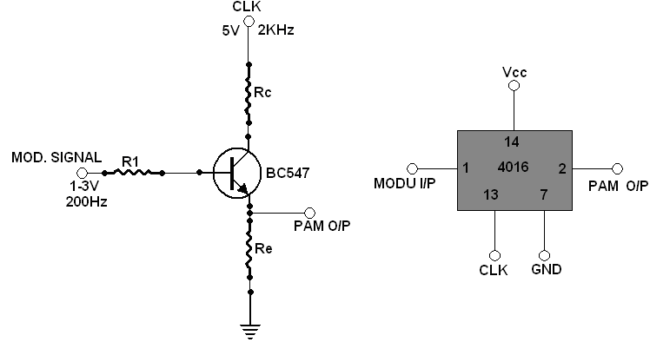

Fig: Circuit diagram for obtaining PAM signal

**PROCEDURE:**

* Set up the circuit as shown in the circuit diagram.
* Apply modulating signal and clock pulse to the circuit.
* For BC547, apply modulating signal, sine wave, of 200Hz with 1 to 3 VPP and clock, pulse, of 2 KHz and 5VPP
* Can take output from collector side of the transistor and also reverse the signal applying, i.e., apply input to collector terminal and clock to base terminal of transistor.
* Output from collector terminal of transistor gives voltage range output.
* Observe the pulse amplitude modulated waveform on the CRO and plot them.
* Apply same modulating and clock signals for CD4016 and observe the waveform.
* Note twoinputs and output signals amplitude, time-period and frequency are to be noted and drawn. Also vary the modulating and clock signals offset in function generator to get the waveform of PAM correctly.

# MODEL GRAPH:

Amplitude (V)

# CARRIER SIGNAL

T(msec)

Amplitude (V)

**MESSAGE SIGNAL**

T(ms)

Amplitude (V) PAM OUTPUT



T(msec)

Amasdffgf

**RESULT:**