**Date :**

**Expt.No: 7**

## PULSE WIDTH MODULATION

**AIM:**

To design and set up a pulse width modulation system based on:

1. 555 timers working in monostable mode.
2. Op-amp circuit.

*Design a PWM system working at a sampling frequency of 2 KHz for a modulating signal of 400 Hz.*

**COMPONENTS AND EQUIPMENTS REQUIRED:**

|  |  |  |  |  |
| --- | --- | --- | --- | --- |
| **SL No:** | **Components** |  | **Specification** | **Quantity** |
| 1 | Op-amp | IC | 741 | 3 |
| 2 | Timer | IC | 555 | 1 |
| 3 | Diode | D1 | IN40001 | 1 |
|  | Op-amp |  |  |  |
| 4 | Resistor | R1 | 820Ω | 1 |
|  |  | R2 | 18KΩ | 1 |
| 5 | Capacitor | C1 | 0.001μF | 1 |
|  |  | C2 | 0.01μF | 1 |
|  | 741 |  |  |  |
| 6 | Resistor | R1,R2 | 10KΩ | 2 |
|  | POT | R4 | 47KΩ | 1 |
|  | POT | R3 | 22KΩ | 1 |
| 7 | Capacitor | C | 0.022μF | 1 |

**THEORY:**

Pulse width Modulation (PWM) is also known as Pulse durationModulation (PDM). Three variations of PWM are possible. In One variation, the leading edgeof the pulse is held constant and change in the pulse width with signal is measured withrespect to the leading edge. In other Variable, the tail edge is held in constant and w.r.t to it,the pulse width is measured in the third variation, the center of the pulse is held constant andpulse width changes on either side of the center of the pulse. The PWM has the disadvantagewhen compared to ‘PDM’ that its pulses are of varying width and therefore of varying powercontent, this means the transmitter must be powerful enough to handle the max width pulses.

a) 555 timer based PWM system: We have a 555 timer working in a monostable mode. The R1C1 network acts as a differentiator to provide the triggering pulse for the monostable multivibrator. The clock pulse is differentiated by R1C1 network, positive half is bypassed by diode D1 and negative spikes is introduced at pin 2. When no modulating input is given output is a square wave of frequency f= (1.1R2C2)-1. When modulating signal is input, the charging time of the capacitor varies as it charges to (2/3VCC+ Vmod), where Vmod is the modulating voltage magnitude, which can be either positive or negative; which results in variation of pulse width of output signal.

b) Op-amp based PWM system: Here we have two parts the first being a sawtooth wave generator and the second part being a comparator. The sawtooth wave generator consists of a square wave generator i.e. a Schmitt Trigger and integrator. The sawtooth output has a frequency f=R3/4R1R2C. The sawtooth output is given at the inverting terminal of the comparator to whose non-inverting terminal is given the modulating signal. The output of the summer is pulse width modulated signal.

**PIN DIAGRAM OF 555:**

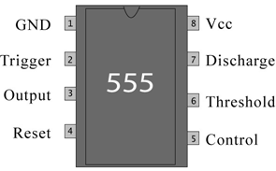

**PIN DESCRIPTION**

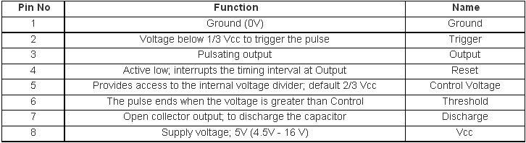

**SYMBOL OF 741 IC:**

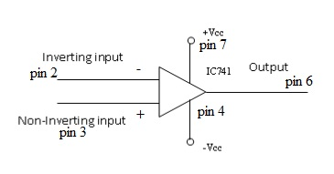

**PIN CONFIGURATION OF 741:**



**INTERNAL BLOCK DIAGRAM OF 555 TIMER**

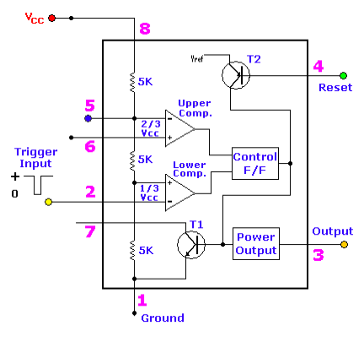

**Function of Various Pins of 555 IC:**

**Pin (1)** of 555 is the ground terminal; all the voltages are measured with respect to this pin.

**Pin (2)** of 555 is the trigger terminal, If the voltage at this terminal is held greater than one-third of VCC, the output remains low. A negative going pulse from Vcc to less than Vec/3 triggers the output to go High. The amplitude of the pulse should be able to make the comparator (inside the IC) change its state. However the width of the negative going pulse must not be greater than the width of the expected output pulse.

**Pin (3)** is the output terminal of IC 555. There are 2 possible output states. In the low output state, the output resistance appearing at pin (3) is very low (approximately 10 Ω). As a result the output current will goes to zero , if the load is connected from Pin (3) to ground , sink a current I Sink (depending upon load) if the load is connected from Pin (3) to ground, and sinks zero current if the load is connected between +VCC and Pin (3).

**Pin (4)** is the Reset terminal. When unused it is connected to +Vcc. Whenever the potential of Pin (4) is drives below 0.4V, the output is immediately forced to low state. The reset terminal enables the timer over-ride command signals at Pin (2) of the IC.

**Pin (5)** is the Control Voltage terminal.This can be used to alter the reference levels at which the time comparators change state. A resistor connected from Pin (5) to ground can do the job. Normally 0.01μF capacitor is connected from Pin (5) to ground. This capacitor bypasses supply noise and does not allow it affect the threshold voltages.

**Pin (6)** is the threshold terminal. In both astable as well as monostable modes, a capacitor is connected from Pin (6) to ground. Pin (6) monitors the voltage across the capacitor when it charges from the supply and forces the already high O/p to Low when the capacitor reaches +2/3 VCC.

**Pin (7)** is the discharge terminal. It presents an almost open circuit when the output is high and allows the capacitor charge from the supply through an external resistor and presents an almost short circuit when the output is low.

**Pin (8)** is the +Vcc terminal. 555 can operate at any supply voltage from 5V to 10V.

# CIRCUIT DIAGRAM:



Fig: 555 timer based PWM system:

C

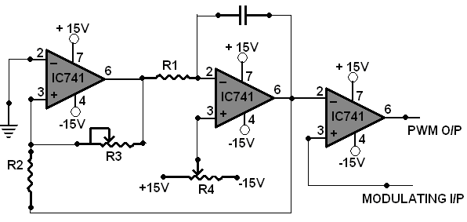

Fig:Op-amp based PWM system

**DESIGN:**

1. PWM using 555 timer

R1C1≤ 0.0016Tt ---- (1) [condition for differentiation]

Ts =  = 0.5ms

Tt> Ts. So take Tt= 0.5ms

Let C1 = 0.001μF. Then R1 = 820Ω [from eq (1)]

Now, T = 1.1R2C2 (The time for which the capacitor voltage increases to 2/3 VCC.)

0.2ms = 1.1R2C2

Let C2 = 0.01μF. Then R2 = 18.18 kΩ.

Choose R2 = 18 kΩ

1. PWM using 741

Let the output voltage of sawtooth wave 5V peak to peak i.e.

VO=(2R1×Vsat)/R4= 7V

Assume Vsat = 12V and choose R1 =10KΩ

R4 = (2R2×Vsat)/ Vout =48KΩ

Choose R4 = 47 KΩ.

Let the output frequency of the sawtooth wave be 2 kHz

f =

Let R1 = 10KΩ

C =

C = ${10K}/{4×10K×47K×2KHz}$

Choose C = 0.022µF.

Sawtooth wave can be obtained by varying R4.

**PROCEDURE:**

1. Set up the circuit as shown in the circuit diagram
2. Apply the modulating signal, 200Hz, 5VPP and the clock pulse,2KHz, 10VPPto the circuit
3. Note for 555 timer PWM output is obtained correctly by varying offset of input.
4. Observe the pulse width modulated wave on the CRO and plot the waveform
5. For 741 circuits, first check the output of 1st op-amp, which should be square wave of Schmitt trigger output by adjusting R3 pot. This input is given to 2nd op-amp. Check the output of 2nd op-amp which is saw tooth wave by adjusting R4 pot, output will be triangle which should be made saw tooth. Saw tooth and modulating signal are applied of 3rd op-amp, which act as comparator to get PWM output.
6. Observe the pulse width modulated wave on the CRO and plot the waveform

**MODEL GRAPH**

USING 555

**Message signal**

Amplitude (V)

**Carrier signal** T(msec)

**PWM** T(msec)

T(msec)

USING 741:



**RESULT:**