Date:

Expt No: 4

**RC Phase Shift Oscillator**

**AIM:**

To Design and set up RC phase shift oscillator using Op-Amp to obtain a sinusoidal waveform of frequency of oscillation 1kHz.

**CIRCUIT DIAGRAM:**

220K Pot

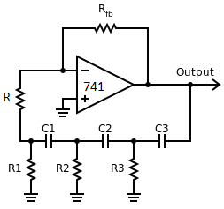

680Ώ

680Ώ

0.1uF

0.1uF

4

-

+

7

6

3

2

0.1uF

680Ώ

6.8K

**COMPONENTS REQUIRED:**

|  |  |  |  |
| --- | --- | --- | --- |
| Sl. No: | Component | Specification | Quantity |
|  | IC | LM 741 | 1 |
|  | Resistors | 680Ω | 3 |
| 6.8Ω | 1 |
| 220k pot | 1 |
|  | Capacitors | 0.1µF | 3 |

**THEORY:**

**DESIGN**

The frequency of Oscillation fo  = ___1___

2π RC√6

Rfb  = 29R

Let f = 1 Khz

Assume C = 0.1 μF

R = 1/(2π fo√6 C) = 649.75 Ω 🡺 Use 680 Ω

To prevent loading of the amplifier due to RC network, R1 = 10 R

i.e. R1= 6.8KΩ

Since RF  = 29R1 🡺 Rfb = 197.2KΩ ( Use 220k potentiometer )

**OBSERVATION**

**PROCEDURE**

1. Set up the circuit after checking the components.
2. Ensure that the op amp is operating as a inverting amplifier of the required gain.
3. Observe and plot the output waveform.

Note:

* Adjust the potentiometer to get the sine wave without any distortion
* Amplitude is almost equal to Vsat.

**WAVE FORM**

**RESULT**

Frequency of oscillation =