Module 1

Principles of Programming

Programming is a skill best acquired by practice rather than from books.This mainly consists of a set of instructions. Programming is the process of writing a sequence of instructions to be executed by a computer to solve a problem.Computer programming has many facets.It should be carefully designed to be reliable and inexpensive to maintain.

Principle steps in programming :

- Make a plan
- Break the problem down
- Do the programming of new subroutines
- Program the main routine

Attributes of a good programming language :
- Clarity ,Simplicity & Unity
- Orthogonality
- Naturalness for the application
- Support for abstraction
- Ease of program verification
- Programming environment
- Cost of use

The programmers basically begin the program by analyzing the problem and breaking it into manageable pieces and developing a general solution for each piece called ‘Algorithm’. An algorithm is a verbal or written description of a logical sequence of actions applied to objects.

System Life Cycle

Large scale computer program is considered as a system. This system contains many complex interacting parts.These programs undergo a development process called system life cycle.

Importance of phased approach :

- This breaks the problem of developing software into successfully performing a set of phases each handling a different concern of software development.
- This ensures that the cost of development is lower than it would have been if the whole problem is tackled together.
- A phased process allows proper checking for quality & progress at some define points during the development. (End of phases)
- Without these one would have to wait till the end to see what the software has produced.
- Hence for managing the complexity,project tracking & quality all the development process consist of a set of phases.

The life cycle consists of different phases:
- Requirement Analysis
- Design
- Coding
- Testing
- Maintenance

Requirement Analysis
Design
Coding
Testing

Requirements Gathering And Analysis
The goal of systems analysis is to determine where the problem is in attempt to fix the system. This step involves breaking down the system in different pieces and drawing diagrams to analyze the situation. Analysts project goals, breaking down functions that need to be created, and attempt to engage users so that definite requirements can be defined.

Design
In systems design functions and operations are described in detail, including screen layouts, business rules, process diagrams and other documentation. The output of this stage will describe the new system as a collection of modules or subsystems.

Build or Coding
Modular and subsystem programming code will be accomplished during this stage. Unit testing and module testing are done in this stage by the developers. This stage is intermingled with the next in that individual modules will need testing before integration to the main project. Planning in software life cycle involves setting goals, defining targets, establishing schedules, and estimating budgets for an entire software project.

Testing
The code is tested at various levels in software testing. Unit, system and user acceptance testing are often performed. This is a grey area as many different opinions exist as to what the stages of testing are and how much if any iteration occurs. Iteration is not generally part of the waterfall model, but usually some occurs at this stage.
Types of testing:
- Data set testing
- Unit testing
- System testing
- Integration testing
- Black box testing
- White box testing
- Module testing
- Regression testing
- Automation testing
- User acceptance testing
Recursive Algorithm

The recursive functions are characterized based on:
- whether the function calls itself or not (direct or indirect recursion).
- whether there are pending operations at each recursive call (tail-recursive or not).
- the shape of the calling pattern -- whether pending operations are also recursive (linear or tree-recursive).

Direct Recursion:
A function is directly recursive if it contains an explicit call to itself. For example, the function
int foo(int x) {

if (x <= 0) return x;

return foo(x - 1);
}
includes a call to itself, so it's directly recursive. The recursive call will occur for positive values of x.

Indirect Recursion:
A function foo is indirectly recursive if it contains a call to another function which ultimately calls foo.
The following pair of functions is indirectly recursive. Since they call each other, they are also known as . mutually recursive functions
int foo(int x) {

if (x <= 0) return x;

return bar(x);
}

int bar(int y) {
return foo(y - 1);
}

Performance Analysis
Two important ways to characterize the effectiveness of an algorithm are its space complexity and time complexity.
Space Complexity

Space complexity of an algorithm is the amount to memory needed by the program for its completion. Space needed by a program has the following components:

- Instruction Space
Space needed to store the compiled version of program. It depends on
  - Compiler used
  - Options specified at the time of compilation
e.g., whether optimization specified, Is there any overlay option etc.
  - Target computer
e.g., For performing floating point arithmetic, if hardware present or not.

- Data Space
Space needed to store constant and variable values. It has two components:
  - Space for constants:
e.g., value ‘3’ in program 1.1
Space for simple variables:
e.g., variables a,b,c in program 1.1

Program 1.1
int add (int a, int b, int c)
{
return (a+b+c)/3;
}

  - Space for component variables like arrays, structures, dynamically allocated memory.
e.g., variables a in program 1.2

Program 1.2
int Radd (int a[], int n)
1 {
2 If (n>0)
3 return Radd (a, n-1) + a[n-1];
4 else
5 return 0;
6 }

- Environment stack space
Environment stack is used to store information to resume execution of partially completed functions. When a function is invoked, following data are stored in Environment stack.
  - Return address.
  - Value of local and formal variables.
  - Binding of all reference and constant reference parameters.

Space needed by the program can be divided into two parts.
i. Fixed part independent of instance characteristics. E.g., code space, simple variables, fixed size component variables etc.
- Variable part. Space for component variables with space depends on particular instance. Value of local and formal variables.
Hence we can write the space complexity as
S(P) = c + S_{p} (instance characteristics)

Example 1.1
Refer Program 1.1
One word for variables a,b,c. No instance characteristics. Hence S_{p}(TC) = 0

Program 1.3
int Aadd (int *a, int n)
1 {
2 int s=0;
3 for (i=0; i<n; i++)
4 s+ = a[i];
5 return s;
6 }
One word for variables n and i. Space for a[] is address of a[0]. Hence it requires one word.
No instance characteristics. Hence S_{p}(TC) = 0

Example 1.2
Refer Program 1.2
Instance characteristics depend on values of n. Recursive stack space includes space for formal parameters, local variables and return address. So one word each for a[],n, return address and return variables. Hence for each pass it needs 4 words. Total recursive stack space needed is 4(n).
Hence S_{p}(TC) = 4(n).

Time Complexity
Time complexity of an algorithm is the amount of time needed by the program for its completion. Time taken is the sum of the compile time and the execution time. Compile time does not depend on instantaneous characteristics. Hence we can ignore it.

Program step: A program step is syntactically or semantically meaningful segment of a program whose execution time is independent of instantaneous characteristics. We can calculate complexity in terms of

- Comments:
No executables, hence step count = 0

- Declarative Statements:
Define or characterize variables and constants like (int , long, enum, …)
Statement enabling data types (class, struct, union, template)
Determine access statements ( public, private, protected, friend )
Character functions ( void, virtual )
All the above are non executables, hence step count = 0

- Expressions and Assignment Statements:
Simple expressions : Step count = 1. But if expressions contain function call, step count is the cost of the invoking functions. This will be large if parameters are passed as call by value, because value of the actual parameters must assigned to formal parameters.

Assignment statements : General form is <variable> = <expr>. Step count = expr, unless size of <variable> is a function of instance characteristics. eg., a = b, where a and b are structures. In that case, Step count = size of <variable> + size of < expr >

- Iterative Statements:
While <expr> do
Do .. While <expr>
Step count = Number of step count assignable to <expr>
For (<init-stmt>; <expr1>; <expr2>)
Step count = 1, unless the <init-stmt>, <expr1>,<expr2> are function of instance characteristics. If so, first execution of control part has step count as sum of count of <init-stmt> and <expr1>. For remaining executions, control part has step count as sum of count of <expr1> and <expr2>.

- Switch Statements:
Switch (<expr>) {
Case cond1 : <statement1>
Case cond2 : <statement2>
.
.
Default : <statement>
}

Switch (<expr>) has step count = cost of <expr>
Cost of Cond statements is its cost plus cost of all preceding statements.

- If-else Statements:
If (<expr>) <statement1>;
Else <statement2>;
Step count of If and Else is the cost of <expr>.

- Function invocation:
All function invocation has Step count = 1, unless it has parameters passed as called by value which depend s on instance characteristics. If so, Step count is the sum of the size of these values.
If function being invoked is recursive, consider the local variables also.

- Memory management Statements:
new object, delete object, sizeof(object), Step count =1.

- Function Statements:
Step count = 0, cost is already assigned to invoking statements.

- Jump Statements:
continue, break, goto has Step count =1
return <expr>: Step count =1, if no expr which is a function of instance characteristics. If there is, consider its cost also.

Example 1.4
Refer Program 1.2
Introducing a counter for each executable line we can rewrite the program as

int Radd (int a[], int n)
{
count++ // if
If (n>0)
{
count++ // return
return Radd (a, n-1) + a[n-1];
}
else
{
count++ // return
return 0;
}
}
Case 1: n=0
t_{Radd} = 2
Case 2: n>0
2 + t_{Radd} (n-1)
= 2 + 2 + t_{Radd} (n-2)
= 2 * 2 + t_{Radd} (n-2)
.
.
= 2n + t_{Radd} (0)
= 2n + 2

Example 1.5
Program 1.4
int Madd (int a[][], int b[][], int c[][], int n)
1 {
2 For (int i=0; i<m; i++)
3 For (int j=0; j<n; j++)
4 c[i][j] = a[i][j] + b[i][j];
5 }

Introducing a counter for each executable line we can rewrite the program as
int Madd (int a[][], int b[][], int c[][], int n)
{
For (int i=0; i<m; i++)
{
count++ //for i
For (int j=0; j<n; j++)
{
count++ //for j
c[i][j] = a[i][j] + b[i][j];
count++ //for assignment
}
count++ //for last j
}
count++ //for last i
}

Step count is 2mn + 2m +1.

Step count does not reflect the complexity of statement. It is reflected in step per execution (s/e).

Refer Program 1.2
Line | s/e | Frequency |  | Total Steps
Line | s/e | n=0 | n>0 | n=0 | n>0
1 | 0 | 1 | 1 | 0 | 0
2 | 1 | 1 | 1 | 1 | 1
3 | 1 + t_{Radd} (n-1) | 0 | 1 | 0 | 1 + t_{Radd} (n-1)
4 | 0 | 1 | 0 | 0 | 0
5 | 1 | 1 | 0 | 1 | 0
Total no. of steps |  |  |  | 2 | 2 + t_{Radd} (n-1)

Refer Program 1.3
Line | s/e | Frequency | Total Steps
1 | 0 | 1 | 0
2 | 1 | 1 | 1
3 | 1 | n+1 | n+1
4 | 1 | n | n
5 | 1 | 1 | 1
6 | 0 | 1 | 0
Total no. of steps |  |  | 2n + 3

Refer Program 1.4
Line | s/e | Frequency | Total Steps
1 | 0 | 1 | 0
2 | 1 | m+1 | m+1
3 | 1 | m(n+1) | m(n+1)
4 | 1 | mn | mn
5 | 0 | 1 | 0
Total no. of steps |  |  | 2mn + 2m + 1

Asymptotic Notations
Step count is to compare time complexity of two programs that compute same function and also to predict the growth in run time as instance characteristics changes. Determining exact step count is difficult and not necessary also. Because the values are not exact quantities. We need only comparative statements like c₁n² ≤ t_{p}(n) ≤ c₂n².

For example, consider two programs with complexities c₁n² + c₂n and c₃n respectively. For small values of n, complexity depend upon values of c₁, c₂ and c₃. But there will also be an n beyond which complexity of c₃n is better than that of c₁n² + c₂n.This value of n is called break-even point. If this point is zero, c₃n is always faster (or at least as fast). Common asymptotic functions are given below.

Function | Name
1 | Constant
log n | Logarithmic
n | Linear
n log n | n log n
n² | Quadratic
n³ | Cubic
2^{n} | Exponential
n! | Factorial

      - Big ‘Oh’ Notation (O)

O(g(n)) = { f(n) : there exist positive constants c and n₀ such that 0 ≤ f(n) ≤ cg(n) for all n ≥ n₀ }
It is the upper bound of any function. Hence it denotes the worse case complexity of any algorithm. We can represent it graphically as

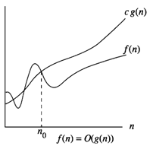
Fig 1.1

Find the Big ‘Oh’ for the following functions:

Linear Functions

Example 1.6
f(n) = 3n + 2

General form is f(n) ≤ cg(n)

When n ≥ 2, 3n + 2 ≤ 3n + n = 4n
Hence f(n) = O(n), here c = 4 and n₀ = 2

When n ≥ 1, 3n + 2 ≤ 3n + 2n = 5n
Hence f(n) = O(n), here c = 5 and n₀ = 1

Hence we can have different c,n₀ pairs satisfying for a given function.

Example 1.7
f(n) = 3n + 3
When n ≥ 3, 3n + 3 ≤ 3n + n = 4n
Hence f(n) = O(n), here c = 4 and n₀ = 3

Example 1.8
f(n) = 100n + 6
When n ≥ 6, 100n + 6 ≤ 100n + n = 101n
Hence f(n) = O(n), here c = 101 and n₀ = 6

Quadratic Functions

Example 1.9
f(n) = 10n² + 4n + 2
When n ≥ 2, 10n² + 4n + 2 ≤ 10n² + 5n
When n ≥ 5, 5n ≤ n², 10n² + 4n + 2 ≤ 10n² + n² = 11n²
Hence f(n) = O(n²), here c = 11 and n₀ = 5

Example 1.10
f(n) = 1000n² + 100n - 6
f(n) ≤ 1000n² + 100n for all values of n.
When n ≥ 100, 5n ≤ n², f(n) ≤ 1000n² + n² = 1001n²
Hence f(n) = O(n²), here c = 1001 and n₀ = 100

Exponential Functions

Example 1.11
f(n) = 6*2^{n} + n²
When n ≥ 4, n² ≤ 2^{n}
So f(n) ≤ 6*2^{n} + 2^{n} = 7*2^{n}
Hence f(n) = O(2^{n}), here c = 7 and n₀ = 4

Constant Functions

Example 1.12
f(n) = 10
f(n) = O(1), because f(n) ≤ 10*1

      - Omega Notation (Ω)
Ω (g(n)) = { f(n) : there exist positive constants c and n₀ such that 0 ≤ cg(n) ≤ f(n) for all n ≥ n₀ }
It is the lower bound of any function. Hence it denotes the best case complexity of any algorithm. We can represent it graphically as
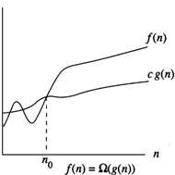
Fig 1.2
Example 1.13
f(n) = 3n + 2
3n + 2 > 3n for all n.
Hence f(n) = Ω(n)

Similarly we can solve all the examples specified under Big ‘Oh’.

      - Theta Notation (Θ)
Θ(g(n)) = {f(n) : there exist positive constants c₁,c₂ and n₀ such that c₁g(n) ≤f(n) ≤c₂g(n) for all n ≥ n₀ }
If f(n) = Θ(g(n)), all values of n right to n₀ f(n) lies on or above c₁g(n) and on or below c₂g(n). Hence it is asymptotic tight bound for f(n).
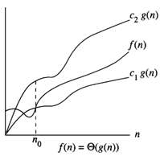
Fig 1.3
Example 1.14
f(n) = 3n + 2
f(n) = Θ(n) because f(n) = O(n) , n ≥ 2.

Similarly we can solve all examples specified under Big’Oh’.

The time complexity of a program can be represented as some instance characteristics. This can be used to compare two programs performing same task. But this is actually meant for greater values of n.
Fig 1.4 shows how the various functions grow with n.

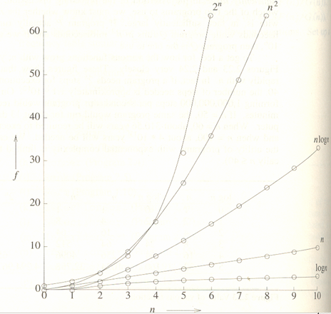
Fig 1.4

Module 2

Sparse Matrix

Matrix with many zero entities is called a sparse matrix. For effective memory utilization we store
only the non zero elements. Each element is uniquely identified by its row and column position.
(row, column, element)
It is stored in the row major form. ie., in the ascending order of rows. Inside each row, store elements in the ascending order of columns.

e.g.
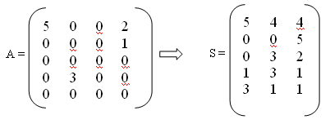
S[0][0] = number of rows in original matrix
S[0][1] = number of columns in original matrix
S[0][2] = number of non zero elements

Program
function sparse (int a[][], int m, int n)
{
int i, j, k;
S[0][0] = m; s[0][1] = n; k=1;
for (i=0; i<m; i++)
for (i=0; i<n; i++)
if (a[i][j] != 0)
{
S[k][0] = i;
S[k][1] = j;
S[k][2] = S[i][j];
k++;
}
S[0][2] = k-1;
}

Transpose of a sparse matrix

Steps:
- Fix the first row as transpose matrix as
T[0][0] = S[0][1]; T[0][1] = S[0][1]; T[0][2] = S[0][2];
- Iterate through the 2nd column n times, where n is the number of columns in original matrix, ie, S[0][1].
    - Iterate through the 2nd column t times, where t is the number of non zero elements
      - Select all elements in that column and store into the transpose matrix.

Program
function Transpose (int a[][])
{
int m, n, p, q, t, col, b[][];
m = a[0][0]; n = a[0][1]; t = a[0][2];
b[0][0] = n; b[0][1] = m; b[0][2] = a[0][2];
if ( t > 0 )
{
q = 1;
for (col=0; col<n; col++)
for (p=0; p<t; p++)
if (a[p][1] == col)
{
b[q][0] = a[p][1];
b[q][1] = a[p][0];
b[q][2] = a[p][2];
q++;
}
}
}

Time Complexity:
Line no. 10 :nt times
Line no. 12 – 15 : t times

Hence time complexity is O(nt). Worse case, ie., when t is of order mn, complexity is O(mn²).

Fast Transpose

Steps:
- Fix the first row as transpose matrix as
T[0][0] = S[0][1]; T[0][1] = S[0][1]; T[0][2] = S[0][2];
- Determine number of non zero elements in each column. From this find the starting position of elements corresponding to each column as
start[i] = start[i-1] + number[i-1]
- Fill the elements corresponding to each column.

Program
function FastTranspose (int a[][])
{
int i, pos, n, terms, s[], n[], b[][];
m = a[0][0]; n = a[0][1]; terms = a[0][2];
b[0][0] = n; b[0][1] = m; b[0][2] = a[0][2];
if (terms > 0 )
{
for (i=0; i<n; i++)
n[i] = 0;
for (i=1; i<=terms; i++)
n[a[i][1]] += 1;
s[0] = 1;
for (i=1; i<n; i++)
s[i] = s[i-1] + n[i-1];
for (i=1; i<=terms; i++)
{
pos = s[a[i][1]];
b[pos][0] = a[i][1];
b[pos][1] = a[i][0];
b[pos][2] = a[i][2];
s[a[i][1]]++;
}
}
}

Time Complexity:
There are four loops executing n, terms, n-1 and terms times. Hence complexity is O(n+t) or O(n). It becomes O(mn) when t is of the order mn. Hence this algorithm gives better performance that previous one but space complexity increases.

Sparse Matrix Addition

Program

function SparseAdd (int a[][])
{
int a_index, b_index, c_index, a_terms, b_terms, c_terms, c[][];

if (a[0][0] != b[0][0] || a[0][1] != b[0][1])
printf(“Incompatible matrix”);
else
{
c[0][0] = a[0][0]; c[0][1] = a[0][1];
a_terms = 1; b_terms = 1; c_terms = 1;
while (a_terms <= a[0][2] && b_terms <= b[0][2])
{
a_index = a[a_terms][0] * a[0][1] + a[a_terms][1];
b_index = b[b_terms][0] * b[0][1] + b[b_terms][1];
if (a_index < b-index)
{
c[c_terms][0] = a[a_terms][0];
c[c_terms][1] = a[a_terms][1];
c[c_terms][2] = a[a_terms][2];
a_terms++;
}
else if (a_index > b-index)
{
c[c_terms][0] = b[b_terms][0];
c[c_terms][1] = b[b_terms][1];
c[c_terms][2] = b[b_terms][2];
b_terms++;
}
else
{
c[c_terms][0] = a[a_terms][0];
c[c_terms][1] = a[a_terms][1];
c[c_terms][2] = a[a_terms][2] + b[b_tems][2];
a_terms++;
b_terms++;
}
c_terms++;
}
for (; a_terms < a[0][2]; a_terms++; c_terms++)
{
c[c_terms][0] = a[a_terms][0];
c[c_terms][1] = a[a_terms][1];
c[c_terms][2] = a[a_terms][2];
}
for (; b_terms < b[0][2]; b_terms++; c_terms++)
{
c[c_terms][0] = b[b_terms][0];
c[c_terms][1] = b[b_terms][1];
c[c_terms][2] = b[b_terms][2];
}

}
}

Stacks

Stack is an ordered collection of items into which new items are added and deleted at one end, called top. Last element inserted will be taken out first. Hence called Last In First Out (LIFO). A stack can pictorially represented as below.
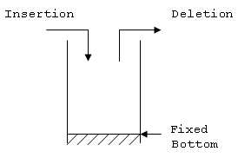
Advantages:
- Recursion implementation
- Parenthesis matching
- Expression evaluation

Stack Operations

Push
An item is put on top of the stack, increasing the stack size by one. As stack size is usually limited, this may provoke a stack overflow if the maximum size is exceeded.

Program
void push(int s[], int stacksize, int item)
{
if (top == stacksize -1)
printf(“Stack full”);
else
{
s[top] = item;
top++;
}
}

Pop or pull
The top item is taken from the stack, decreasing stack size by one. In the case where there was no top item (i.e. the stack was empty), a stack underflow occurs

Program
int pop(int s[])
{
if (top == -1)
printf(“Stack empty”);
else
return(s[top--]);
}

The combination of pushing and pulling the stack is sometimes referred to as "shaking" the stack (because of the pushing and pulling).

Queue
It is a list where, insertion is done at one end, while deletion is performed at the other end.
Accessing the elements of queues follows a First In, First Out (FIFO) order.
Like customers standing in a check-out line in a store, the first customer in is the first customer served.
Insertion is done at one end, whereas deletion is performed at the other end

Three states of the queue with this representation are as below:
Queue is empty
FRONT=0
REAR=0
Queue is full
REAR=N
FRONT=1
Queue contains elements >=1
FRONT<=REAR
Number of element =REAR-FRONT+1

Algorithm for inserting an item
Input:An element ITEM that has to be inserted.
Output:The ITEM is at the REAR of the queue.
Data Structure:Q is the array representation of queue structure ; two pointers FRONT and REAR of the
queue Q are known.
Steps
- If (REAR=N) then
  - print “Queue is full”
  - Exit
- Else
  - If (REAR=0) and (FRONT=0)
- FRONT=1
2. EndIf
3. REAR=REAR+1
4. Q[REAR]=ITEM
3. EndIf
4. Stop

Algorithm for deleting an item
Input: A queue with elements .Front and REAR are the two pointers of the queue Q.
Output: The deleted element is stored in ITEM.
Data structures: Q is the array representation of queue structure.
Steps
- If (Front=0)then
  - Print “Queue is empty”
  - Exit
- Else
  - ITEM=Q [FRONT]
  - If (FRONT=REAR)
- REAR=0
- FRONT=0
3. Else
1. FRONT=FRONT+1
4. EndIf
3. EndIf
4. Stop

Applications of Queue
- Round robin techniques :Process scheduling
- Print server routines
- All types of customer service software(Railway/airticket reservation)

Deque
Another Variation of queue is known as deque .Unlike queue, in deque , both insertion and deletion operation can be made at either end of the structure. The term deque is originated from double ended queue.
Remove
Insert
Remove
rear
front
Insert
It is clear from the deque structure that it is a general representation of both stack and queue.
Operations on Dequeue
(1) Add an element at the rear end
(2)Add an element at the front end
(3)Delete an element from the front end
(4)Delete an element from the rear end

Algorithm for Add an element at the rear end

/* This algorithm is same as the algorithm of inserting an element in simple queue. */

Algorithm for Add an element at the front end

- If (FRONT =1)then
  - ahed =LENGTH //If FRONT is at extreme left
- Else
  - If (FRONT =LENGTH )or (FRONT =0)then
    - ahead =1
2. Else
1. ahead= FRONT -1
3. EndIf
3. If (ahead = REAR) then
1. Print “Deque is full”
2. Exit
4. Else
1. FRONT =ahead
2. DQ [FRONT] =ITEM
5. Stop
Algorithm for Delete an element from the front end
/* this algorithm is same as the algorithm of deleting an element in simple queue. */
Algorithm for Delete an element from the rear end

- If (FRONT=) then
  - Print “ Deque is empty”
  - Exit
- Else
  - If (FRONT=REAR) then
    - ITEM =DQ [REAR]
    - FRONT=REAR=0
2. Else
1. If (REAR =1) then

1. ITEM =DQ [REAR]
2. REAR=LENGTH
2. Else
1. If (REAR =LENGTH) then
1. ITEM =DQ [REAR]
2. REAR=1
2. Else
1. ITEM =DQ [REAR]
2. REAR=REAR -1
3. EndIf
3. EndIf
4. Stop
Circular Queue
For a queue represented using array when the REAR pointer reaches at the end, insertion will be denied even if room is available at the front. One way to remove this is using a circular array. Physically a circular array is the same as ordinary array, say A [1…N], but logically it implies that A[1] comes after A[N] or after A[N], A[1] appears.
A very big drawback of linear queue is that, once the queue is FULL, even though we delete few elements from the "front" and relieve some occupied space, we are not able to add anymore elements, as the "rear" has already reached the Queue's rear most position. The solution lies in a queue in which the moment "rear" reaches the Queue's watermark, the "first" element will become the queue's new "rear".
Initially, when such a queue is empty, the "front" and the "rear" values are n-, where n is the size of the queue. Every time we add an element to the queue, the "rear" value increments by 1 till the time it reaches the upper limit of queue; after which it starts all over again from 0. Similarly, every time we delete an element from queue, the "front" value increments by 1 till the time it reaches the upper limit of queue; after which it starts all over again from 0. A circular queue can be diagrammatically represented as below.
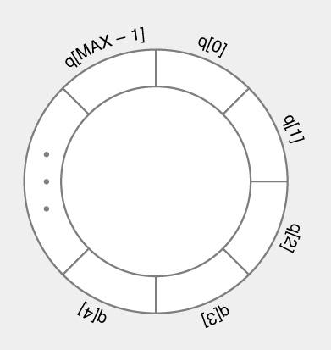

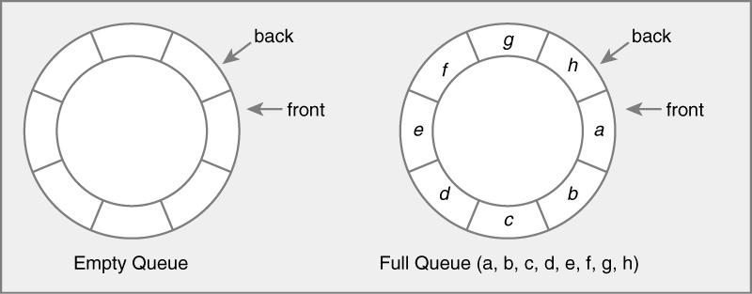

Circular queue is empty

FRONT=0
REAR=0.
Circular queue is full
FRONT=[REAR MOD LENGTH ] +1
ALGORITHM FOR INSERTING AN ITEM INTO A CIRCULAR QUEUE.
STEPS
- If ( FRONT=0) then
  - FRONT=1
  - REAR=1
  - CQ[FRONT]=ITEM
- Else
  - Next=[REAR MOD LENGTH] +1
  - If (next ≠ FRONT ) then
    - REAR=next
    - CQ[REAR]=ITEM
  - Else
    - PRINT “ QUEUE IS FULL”
  - End If
- End If
- STOP
ALGORITH FOR DELETING AN ITEM FROM A CIRCULAR QUEUE
- If (FRONT=0) then
  - PRINT “QUEUE IS EMPTY”
  - EXIT
- Else
  - ITEM=CQ[FRONT]
  - If (FRONT=REAR) Then
    - FRONT=0
    - REAR=0
  - Else
    - FRONT=[FRONT MOD LENGTH ] +1
  - End If
- End If
- STOP
Refer figure number 5.8 in page number 155 in D. Samanta for insertion and deletion operation.
    - Priority Queue
An abstract data type to efficiently support finding the item with the highest priority across a series of operations. There are two types of priority queues, ascending priority queues and descending priority queues.
Ascending priority queues: Elements can be inserted arbitrarily, but only the smallest element can be deleted.
Descending priority queues: Elements can be inserted arbitrarily, but only the biggest element can be deleted.
If we want to delete middle elements, there are different methods
- Give special indicator if element is deleted. This can be a never existing value like -1 or separate filed for each element to indicate whether empty. Insertion can be performed in the normal way, but if rear reaches max_size, elements are to be compacted. Disadvantage is that, deletion involves searching deleted elements also. Once in a while we have to search every single position.
- Deletion labels position as in the previous case, but insert elements into first possible empty position. This reduces efficiency of insertion.
- After each deletion, shift element to one position and change rear accordingly. Another method is to shift either preceding or succeeding elements depending on which is economical. Disadvantage is that, we have to maintain front and rear pointers.
- Instead of an unordered array, maintain ordered circular array. Here deletion involves increasing front by 1 (for ascending queues) or incrementing rear by 1 (for descending queues). Insertion will be complicated, because we have to insert in the exact position since queue is a sorted array.

Expressions

Infix, Postfix and Prefix notations are three different but equivalent ways of writing expressions

Infix notation is the common arithmetic and logical formula notation, in which operators are written between the operands they act on. In infix notation, parentheses surrounding groups of operands and operators are necessary to indicate the intended order in which operations are to be performed. In the absence of parentheses, certain precedence rules determine the order of operations.
eg., 3 + 4

Postfix notation is one in which operands precede the operator, thus dispensing with the need for parentheses.
eg., 34+

Prefix notation is one in which operands precede the operator, thus dispensing with the need for parentheses.
eg., +34

Sl.No. | Infix | Postfix | Prefix
1 | A+B | AB+ | +AB
2 | A+B-C | AB+C- | -+ABC
3 | (A+B)*(C-D) | AB+CD-* | *+AB-CD
4 | A$B*C-D+E/F/(G+H) | AB$C*D-EF/GH+/+ | +-*$ABCD//EF+GH
5 | ((A+B)*C-(D-E))$(F+G) | AB+C*DE--FG+$ | $-*+ABC-DE+FG
6 | A-B/(C*D$E) | ABCDE$*/- | -A/B*C$DE

Infix to Postfix conversion

Method 1:
- Fully parenthesize the expression.
A$B*C-D+E/F/(G+H) -> ((((A$B)*C)-D)+((E/F)/(G+H)))
- Move all operators so that they replace their corresponding right parenthesis.
((((A$B)*C)-D)+((E/F)/(G+H))) -> ((((AB$C*D-((EF/(GH+/+
- Delete all parenthesis.
((((AB$C*D-((EF/(GH+/+ -> AB$C*D-EF/GH+/+

Method 2:
- Read a character.
  - if an operand, print it.
  - else if an operator, check whether it is ‘)’, pop and print till ‘(‘.
  - else compare incoming symbol priority and in stack priority, if incoming priority is high push element to stack. Else pop and print elements until incoming element’s priority is high.
- when expression is over, pop and print the remaining elements from stack.

Program
void postfix(char e[])
{
stack[top] = ‘#’;
top = 1;
x= nexttoken(e);
while( x!= ‘#’)
{
if ( x is an operand)
prinft(“%c”,x);
else if (x == ‘)’)
{
while (stack[top] != ‘(‘)
{
y = pop(s);
printf(“%c”, y);
}
}
else
{
while (isp(stack[top]) >= icp(x))
{
y = pop(s);
printf(“%c”, y);
}
push(s,size,x);
}
x = nexttoken(e);
}
while (top > 0 )
{
y = pop(s);
printf(“%c”, y);
}
}

Postfix Evaluation

Steps:
Read a character.
  - if an operand, push to stack.
  - else pop as many operands as we need to evaluate the expressions. Push the result to stack.

Program
void evaluate(char e[])
{
top = 0;
x= nexttoken(e);
while( x!= ‘#’)
{
if x is an operand
push(s, size, x);
else
{
z = pop(s);
y = pop(s);
y = eval (y, x, z);
push(s, size,y);
}
x= nexttoken(e);
}
}

Polynomial representation using Arrays

Polynomials like 5x^4 + 2x^3+7x^2+10x-8 can be maintained using an array. To achieve this each element of array should consist of 2 values: coefficient, exponent. While maintaining the polynomial it is assumed that the exponent of each successive term is less than the previous term.

Coefficient
Exponent

struct term
{ int coeff;
int exp;
} t [MAX];

Algorithm to add two polynomials

Case 1: If the exponents of two terms are equal , the coefficients of two polynomials are added .

Case 2: If exponent of first polynomial is greater than that of the second , then the term in the first polynomial is added to the resultant.

Case 3: If exponent of second polynomial is greater than that of the first , then the term in the second polynomial is added to the resultant.

Explanation: Here the arrays representing the 2 polynomials are traversed. While traversing the polynomials are compared on the term by term basis. If the exponents of the two terms being compared are equal then their coefficients are added and the result is stored in the third polynomial. If the exponents of two terms are not equal then the term with the bigger exponent is added to the third polynomial. If the term with an exponent is present in one of the polynomial being added ,that is added to the third polynomial.

Code Snippet

void polyadd(poly &p1 ,poly &p2)
{
int c= p1.noofterms > p2.noofterms? p1.noofterms: p2.noofterms;
for (int i=0,j=0;i<=c;noofterms++)
{
if (p1.t[i].coeff == 0 && p2.t[j].coeff == 0)
break;

if (p1.t[i].exp >= p2.t[j].exp)
{

if (p1.t[i].exp == p2.t[j].exp)
{
t [noofterms].coeff = p1.t[i].coeff + p2.t[j].coeff;
t [noofterms].exp = p1.t[i].exp;
i++;
j++;
}
Else

{
t [noofterms].coeff = p1.t[i].coeff;
t [noofterms].exp = p1.t[i].exp;
i++;
}

}

else
{
t [noofterms].coeff = p2.t[i].coeff;
t [noofterms].exp = p2.t[i].exp;
j++;
}

}}

MODULE 3

LINKED LIST

Linked list is called dynamic data structure where amount of memory required can be varied during its use. In linked list, adjacency between elements is maintained by means of links or pointers. A link or a pointer actually is the address of a subsequent element. Thus, in a linked list, data and link both are required to be maintained. An element in a linked list is specially termed as a node. A node consists of two fields:
DATA (to store the actual information) and LINK (to point to the next node).
DATALINK
LINK TO THE NEXT NODE
Definition: a linked list is an ordered collection of finite, homogenous elements called nodes where the linear order is maintained by means of links or pointers.

Disadvantages of sequential search
- Insertion and deletion is more expensive
- Inefficient to store elements of varying size, we have to assign size of maximum element, hence wastage of space.
- Cannot store elements if consecutive

3.1 Singly Linked List

Data can be placed anywhere in the memory. Hence order of elements is not same as in ordered list.
The singly-linked list is the most basic of all the linked data structures. A singly-linked list is simply a sequence of dynamically allocated objects, each of which refers to its successor in the list. Despite this obvious simplicity, there are myriad implementation variations. Figure shows several of the most common singly-linked list variants.

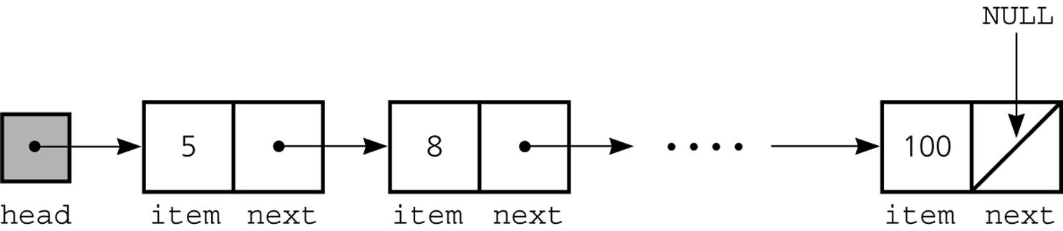

Operation

Following are the operation performed on a linked list:

- checking whether the list is empty;
- accessing a node to modify it or to obtain the information in it;
- traversing the list to access all elements (e.g., to print them, or to find some specific element);
- determining the size (i.e., the number of elements) of the list;
- inserting or removing a specific element (e.g., the first one, the last one, or one with a certain value);
- creating a list by reading the elements from an input stream;
- Converting a list to and from an array, string, etc.

Inserting a new element as the first one of a list
To insert a new element as the first one of a list: -
- we allocate a new node for the element (note that we are given the element (e.g., a string), but we still must create the node for it),
- we assign the element to the info instance field,
- we concatenate the new node with the original list,
- we make the newly created node the first one of the list.
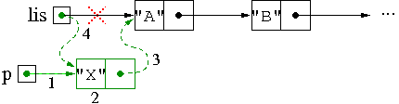
Note that we do not need to actually access the elements of the list to perform this operation.
Algorithm for creating a node
- p=getnode()
- p->info=x;
- p->next=NULL;
Algorithm- inserting at front
- p=getnode()
- p->info=x;
- p->next=list;
- list=p;

Algorithm- inserting at middle
- Let r be the new node to be inserted.
- r->next=p->next
- p->next=r
Algorithm- inserting at end
  - Let r be the new node to be inserted.
  - r->next=NULL
  - p->next=r

Deleting the first element of a list
In general, deleting an element of a list means to modify the list in such a way that the element is no longer connected to its predecessor and successor, while bridging the deleted element to maintain the connection of the other elements.
To delete the first element of a list we proceed as follows: -
- If the list is empty, we don't do anything.
- Otherwise, we return the list starting at the element that follows the first one.
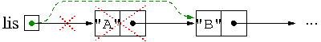
`
Algorithm –deleting from front
- p=list;
- list=p->next
- x=p->info
- freenode(p)
Algorithm –deleting from middle
- r=p->next
- p->next=r->next
Algorithm-deleting from end
- p->next=null
- freenode(r)
Linked-List Implementation of Stack
One disadvantage of using an array to implement a stack is the wasted space---most of the time most of the array is unused. A more elegant and economical implementation of a stack uses a linked list, which is a data structure that links together individual data objects as if they were ``links'' in a ``chain'' of data.
Here is a sketch of a linked-list-based ``stack'' that holds 1, then 5, and then 20 at the bottom: ---
top ---> | 1 |
|---| ---
| A|---> | 5 |
--- |---| ----
| B-|---> | 20 |
--- |----|
|null|
----
The list consists of three ``cells,'' each of which holds a data object and a ``link'' to another cell. A variable, top, holds the address of the first cell in the list. An empty stack looks like this: top ---> null
(That is, variable top holds value, null.) Each time an object is pushed, a cell is constructed, the object is inserted into the cell, and the cell is linked to the front of the chain of cells. For example, pushing 20 onto the empty stack gives us
----
top ---> | 20 |
|--- |
|null|
----
After 5 and then 1 are pushed, we obtain the picture first seen.
Say that we pop an object from the stack; the picture changes to this:
---
top ---> | 5 |
|---| ----
| B-|---> | 20 |
--- |----|
|null|
----
Algorithm for insertion
- Create a temp node and insert the data item into its info field .
- This node is now linked to the existing linked list using the statement temp->next = top
- Now make this temp as the top node , top = temp
Algorithm for deletion
- Get the data part of the top node into a variable
- Now advance the link to the next node in the list and make it as the new top top = top - > link.

Stack Program

#include<stdio.h>
#include<stdlib.h>
#include<conio.h>

struct node
{
int data;
struct node *link;
};
struct node *top=NULL,*temp;
void main()
{
int choice,data;
clrscr();

while(1)//infinite loop is used to insert/delete infinite number of nodes
{
printf("\n1.Push\n2.Pop\n3.Display\n4.Exit\n");
printf("\nEnter ur choice:");
scanf("%d",&choice);
switch(choice)
{
case 1:
temp=(struct node *)malloc(sizeof(struct node));
printf("Enter a node data :");
scanf("%d",&data);
temp->data=data;
temp->link=top;
top=temp;
break;
case 2:
if(top!=NULL)
{
printf("The poped element is %d",top->data);
top=top->link;
}
else
{
printf("\nStack Underflow");
}
break;

case 3:
temp=top;
if(temp==NULL)
{
printf("\nStack is empty\n");
}

while(temp!=NULL)
{
printf("->%d->",temp->data);
temp=temp->link;
}
break;
case 4:
exit(0);
}

}
}

Linked-List Implementation of queue
B
A
Leave
queue
enter
queue
first
last
∅

The head of the list is the front of the queue, and
the tail of the list is the rear of the queue.
LinkedListQueue is an alternative implementation of Queue to ArrayQueue.
Unlimited capacity -- no wasted memory, no more QueueFullException

- When we insert into a Linked List, we:
  - Create a new node object, and
  - Regoranise the links to add the node into the list.

- For a queue, this involves:
  - making the last element in the queue link to the the new node.
  - Re-updating the “last” property to refer to the new node.

Algorithm for inserting an item:
// first create the node // now add the node to the list
node ← getnode() last.next ← node
node.element ← item last ← node
node.next ← null size ← size + 1

Inserting into a Linked List Queue
- Step 1: Create the new node
first
last
∅
A
B
C
∅

- Step 2: Make the current “last” node point to the new node
first
last
A
B
C
∅

- Step 3: Update the “last” entry point to point to the new last node in the list
first
last
A
B
C
∅

- To remove items from a linked list:
  - We must make the “first” entry point refer to the second item in the list, and
  - Return the contents of the node (the “element” part).

Algorithm dequeue():
temp ← first
first ← first.next
size ← size - 1
return temp.element

Removal from a Linked List Queue
- Task: Remove the next item from the queue
last
A
B
C
∅

- Step 1: Create a temporary variable (temp)
first
last
A
B
C
∅
temp

- Step 2: Update “first”
first
last
A
B
C
∅
temp

Step 3: Return the contents of temp
first
last
B
C
∅

Special Cases
- There are two special cases we have not covered so far:
  - Inserting into an empty queue, and
  - Removing the last item from a queue

- By definition, an empty queue is one where the “first” and “last” entry points both point to null.
Inserting into an Empty Linked List Queue
Task: Add “Shanghai” to the queue below
first
last
∅

- Step 1: Create the new node
first
last
∅
∅
B

- Step 2: Make the current “last” node point to the new node???
first
last
∅
∅
B

- Really, we need to make first point to the new node, as step 3 (next slide) will make last point to the new node
- Step 2(b): Make first point to the new node
first
last
∅
B
∅

- Step 3: Update the “last” entry point to point to the new last node in the list
first
last
∅
B

New Insertion Algorithm
Algorithm for inserting an item:
// first create the node
node ← new Node
node.element ← item
node.next ← null

if first = null then
first ← node
else
last.next ← node

last ← node
size ← size + 1
Removal from a Single Item Linked List Queue
- Task: Remove the last item from the queue
first
last
∅
B

- Step 1: Create a temporary variable (temp)
first
last
∅
B
temp

- Step 2: Update “first”
first
last
∅
B
temp
∅

Step 3: Return contents of temp
first
last
∅
B
temp
∅

- But, last still points to the old node:
  - The old node is not deleted, and
  - Any new nodes will be inserted onto the end of a removed node!
Step 3(b): Make last point to null.
first
last
∅
B
temp
∅

- Step 4: Return the contents of temp
first
last
∅

New Removal Algorithm
Algorithm for deleting an item:
temp ← first
first ← first.next

if first = null then
last ← null

size ← size – 1
return temp.element

DOUBLY LINKED LIST
Definition: A variant of a linked list in which each item has a link to the previous item
as well as the next. This allows easily accessing list items backward as well as forward
and deleting any item in constant time. Also known as two-way linked list,
symmetrically linked list.
- info: the user's data
- next, back: the address of the next and previous node in the list
back
. next
. info
Operations on a doubly linked list
Inserting into a Doubly Linked List
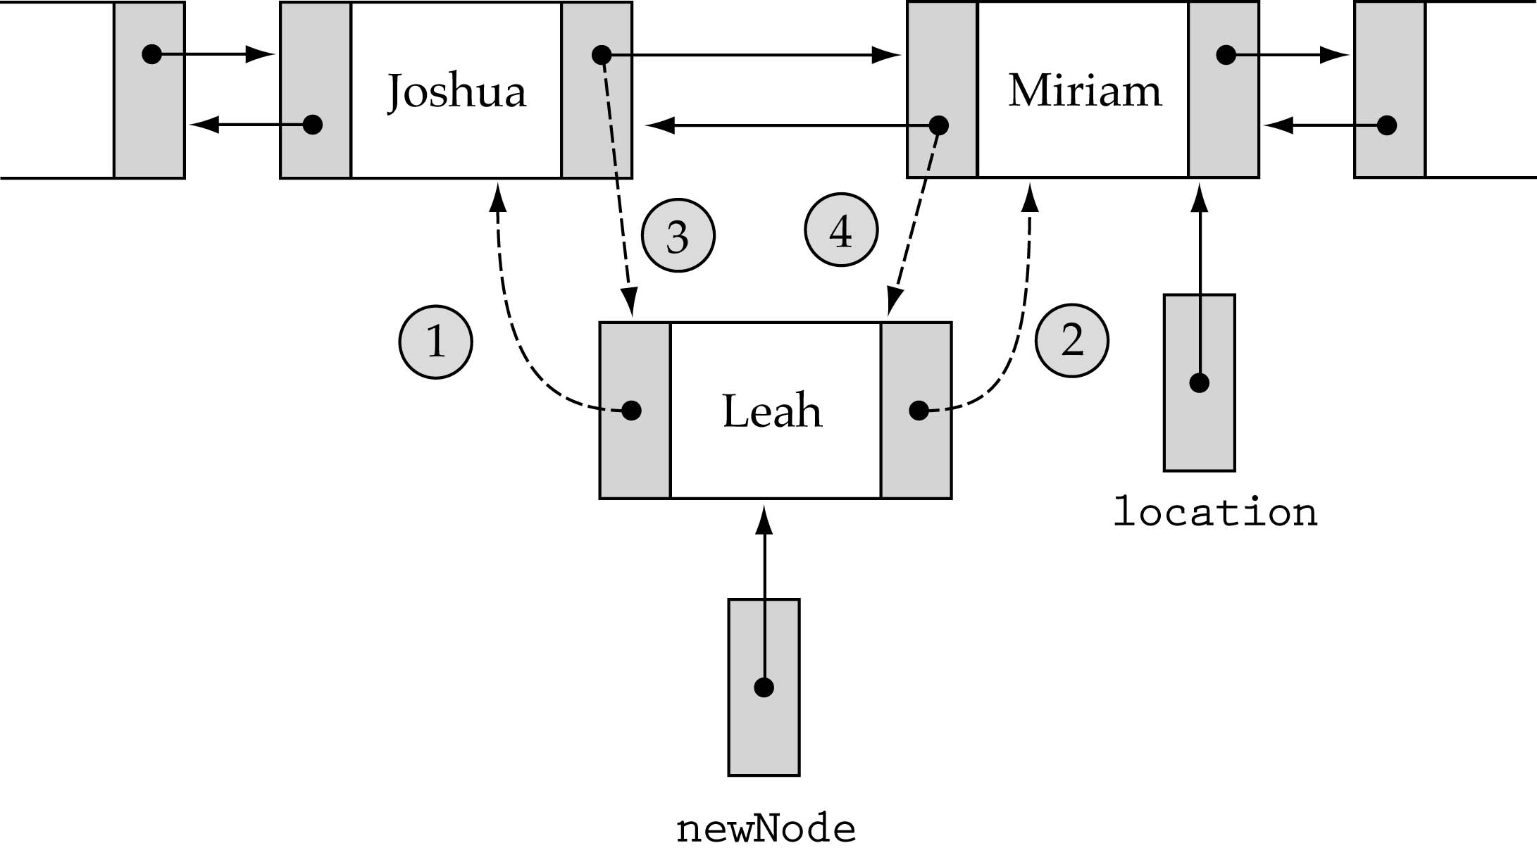
1. newNode->back = location->back;
2. newNode->next = location
3. location->back->next=newNode;
4. location->back = newNode;

Algorithm
Insert at Front
Input: X the data content of the node to be inserted.
Output: A double linked list enriched with a node containing data as X at the front
Data Structure: Doubly linked list structure whose pointer to the header node is
HEADER.
Steps
1.ptr = HEADER.RLINK
2.new = GETNODE(NODE)
3. if(new ≠ NULL) then
1. new.LLINK = HEADER
2.HEADER.RLINK = new
3.new.RLINK=ptr
4.ptr.LLINK=new
5.new.DATA = X
4.Else
1.Print “ Unable to allocate memory:insertion is not possible”
5.Endif
6.Stop

Insert at End
Input: X the data content of the node to be inserted.
Output: A double linked list enriched with a node containing data as X at the end.
Data Structure: Doubly linked list structure whose pointer to the header node is
HEADER.
Steps
1.ptr = HEADER
2.while(ptr.RLINK≠NULL) do
1.ptr=ptr.RLINK
3.Endwhile
4.new = GETNODE(NODE)
5. if(new ≠ NULL) then
1. new.LLINK = ptr
2.HEADER.RLINK = new
3.new.RLINK=NULL
4.new.DATA = X
6.Else
1.Print “ Unable to allocate memory:insertion is not possible”
7.Endif
8.Stop

Insertion of a node at any position in the list
Input: X the data content of the node to be inserted and KEY the data content of the
node after which the new node to be inserted..
Output: A double linked list enriched with a node containing data as X after the node
with data KEY , if any.
Data Structure: Doubly linked list structure whose pointer to the header node is
HEADER.
Steps
1.ptr = HEADER
2.while(ptr.DATA≠KEY) and (ptr.RLINK≠NULL) do
1.ptr=ptr.RLINK
3.Endwhile
4.new = GETNODE(NODE)
5.if(new=NULL)then
1.print “memory is not available”
2.Exit
6.Endif
7. if(ptr.RLINK= NULL) then
1. new.LLINK = ptr
2. ptr.RLINK = new
3.new.RLINK=NULL
4.new.DATA = X
8.Else
1. ptr1=new.RLINK
2. new.LLINK = ptr
3.new.RLINK=ptr1
4.ptr.RLINK = new
5.ptr1.LLINK=new
6.ptr=new
7.new.DATA=X
9.Endif
10.Stop

FindItem(listData, item, location, found)
- RetrieveItem, InsertItem, and DeleteItem all require a search !
- Write a general non-member function FindItem that takes item as a parameter and returns location and found.
- InsertItem and DeleteItem need location (ignore found)
- RetrieveItem needs found (ignores location)

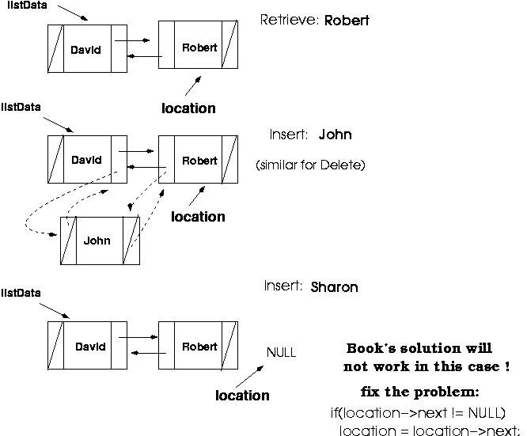
Special case: inserting in the beginning

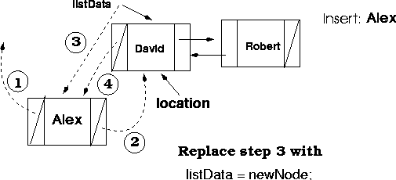

Deleting from a Doubly Linked List

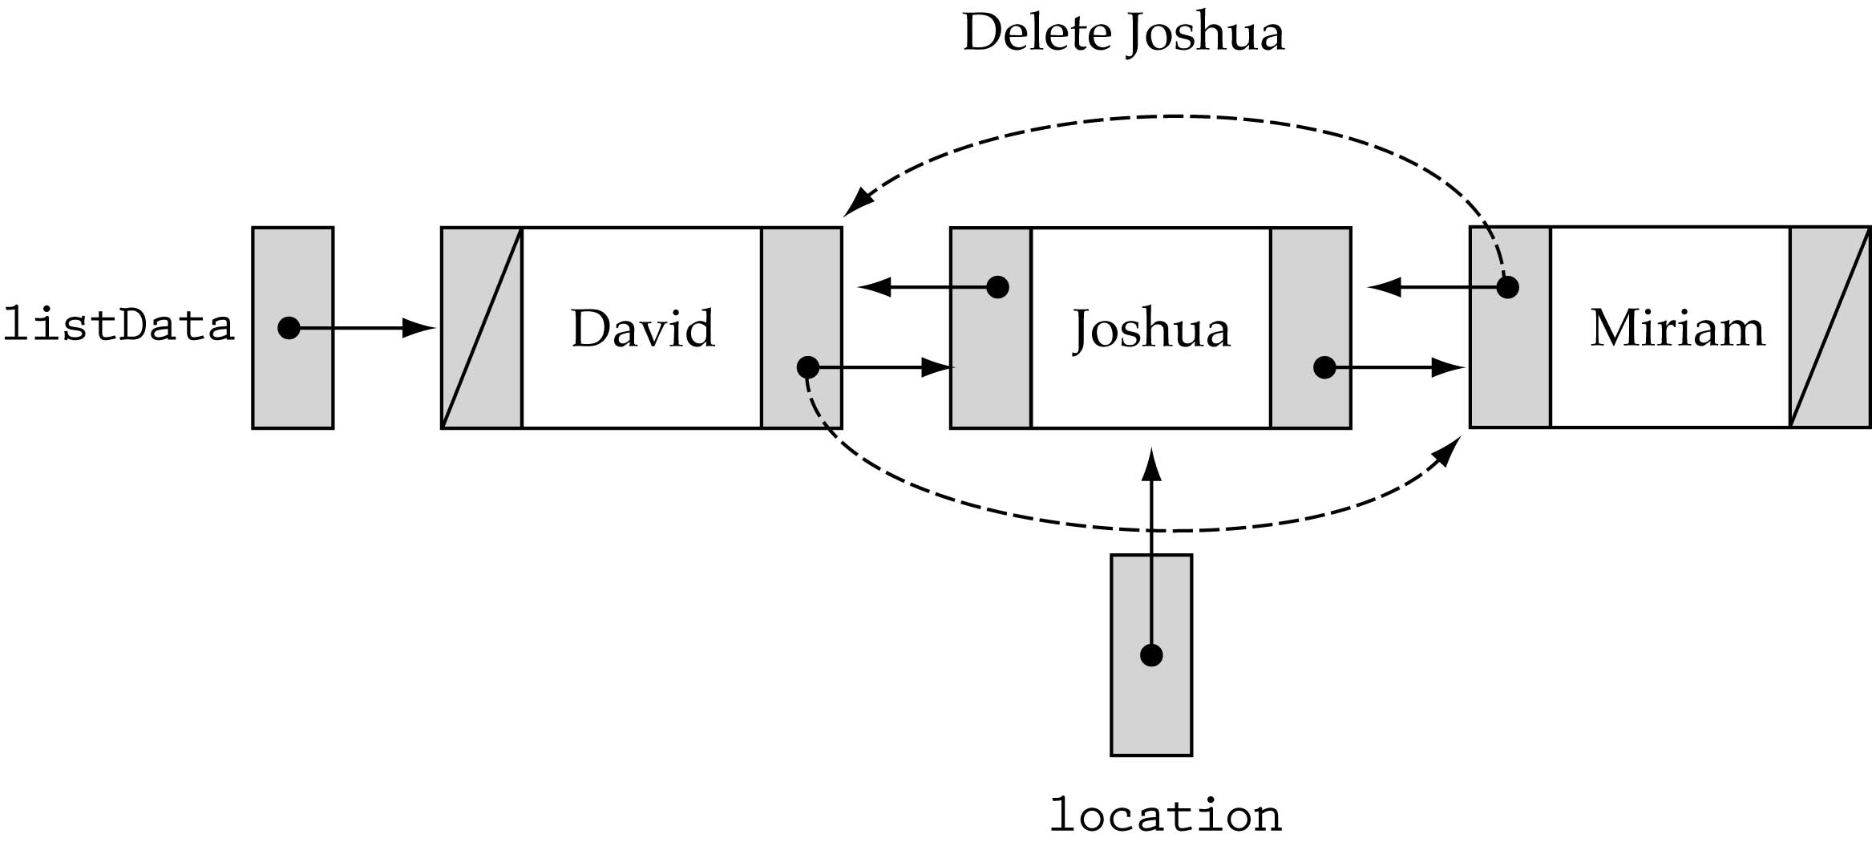

Algorithm
Delete at Front

Input: A double linked list with data
Output: A reduced double linked list.
Data Structure: Double linked list structure whose pointer to the header node is
HEADER
Steps
- ptr=HEADER.RLINK
- if(ptr=NULL) then
  - Print “List is empty: No deletion is made”
  - Exit
- Else
1. Ptr1=ptr.RLINK
2. HEADER.RLINK=ptr1
3. if (ptr1≠NULL)
1. Ptr1.LLINK=HEADER
4. Endif
Stop
Delete at End
Input: A double linked list with data
Output: A reduced double linked list.
Data Structure: Double linked list structure whose pointer to the header node is
HEADER
Steps
- ptr=HEADER
- while (ptr.RLINK≠NULL) do
  - ptr=ptr.RLINK
- Endwhile
- if(ptr=HEADER) then
  - Print “List is empty: No deletion is made”
  - Exit
- Else
1. Ptr1=ptr.LLINK
2. Ptr1.RLINK=NULL
3. Returnnode (ptr)
- Endif
- Stop
Deletion of a node at any position in the list

Input: A double linked list with data, and KEY ,the data content of the key node to be
deleted.
Output: A reduced double linked list,without a node having data content KEY ,if any.
Data Structure: Double linked list structure whose pointer to the header node is
HEADER
Steps
- ptr=HEADER.RLINK
- if(ptr=NULL) then
  - Print “List is empty: No deletion is made”
  - Exit
- Endif
- while(ptr.DATA≠KEY) and (ptr.RLINK≠NULL) do
  - ptr=ptr.RLINK
- Endwhile
- if(ptr.DATA=KEY)then
1. Ptr1=ptr.LLINK
2. Ptr2=ptr.RLINK
3.ptr1.RLINK=ptr2
4.if(ptr2≠NULL) then
1.ptr2.LLINK=ptr1
5.Endif
6. Returnnode (ptr)
7.Else
1. print “the node does not exist in the given list”
8. Endif
9.Stop

//program
#include<stdio.h>
#include<stdlib.h>
void infront();
void inend();
void delfront();
void delend();
void delmiddle();
void inmiddle();
void display();
struct node
{
int data;
struct node *next;
struct node *prev;
}*list=NULL,*end=NULL;
void main()
{
int ch,c;
char z='y';
while(z == 'y')
{
printf("Enter your choice\n");
printf("\n1:insert\n2:delete\n3:display\n");
scanf("%d",&ch);
switch(ch)
{
case 1:{
printf("Enter where to insert");
printf("\n1:infront\n2:after\n3:at end\n");
scanf("%d",&c);
if(c == 1)
infront();
else if(c == 2)
inmiddle();
else if(c==3)
inend();
else
printf("invalid choice");
}
break;
case 2:
{
printf("Enter where to delete");
printf("\n1:infront\n2:after\n3:at end\n");
scanf("%d",&c);
if(c == 1)
delfront();
if(c == 2)
delmiddle();
if(c == 3)
delend();
}
break;
case 3:
display();
break;
default :printf("\nInvalid choice\n");
break;
}
printf("\nEnter y to continue and n to exit\n");
scanf("%s",&z);
}
getch();
}

void infront()
{
struct node *p;
int n,x;
p=(struct node*)malloc(sizeof(struct node));
printf("Enter number to be inserted:");
scanf("%d",&x);
p->data=x;
p->next=list;
p->prev=NULL;
if(list == NULL)
end=p;
list=p;
}
void inmiddle()
{
struct node *p,*r,*temp;
int n,x,c;
n=1;
printf("Enter after how many elements in the following list:");
display();
scanf("%d",&c);
printf("\nEnter the number to be inserted:");
scanf("%d",&x);
r=list;
while(r->next != NULL)
{
if(n == c)
break;
r=r->next;
n++;
}
p=(struct node*)malloc(sizeof(struct node));
p->next=r->next;
p->prev=r;
r->next=p;
p->data=x;
}
void delfront()
{
struct node *p;
int x;
if(list == NULL)
printf("\nList empty\n");
else
{
p=list;
x=list->data;
if(list == end)
{
list=NULL;
end=NULL;
}
else
list=p->next;
list->prev=NULL;
printf("\n%d is deleted\n",x);
free(p);
}
}
void inend()
{
struct node *p;
int n,x;
printf("Enter number to be inserted\n");
scanf("%d",&x);
p=(struct node*)malloc(sizeof(struct node));
if(end != NULL)
end->next=p;
p->next=NULL;
p->data=x;
p->prev=end;
end=p;
if(list == NULL)
list=p;
}
void delmiddle()
{
struct node *p,*r,*temp;
int n,c=0,item;
if(list == NULL)
printf("\nList empty\n");
else
{
printf("Enter the position of number to be deleted:");
scanf("%d",&n);
r=list;
while(c != (n-1))
{
p=r;
r=r->next;
c++;
}
item=r->data;
printf("%d is deleted\n",item);
p->next=r->next;
temp=r->next;
temp->prev=p;
free(r);
}
}
void delend()
{
int n,x;
struct node *p,*r;
if(list == NULL)
printf("\nlist empty\n");
else
{
r=end;
if(list == end)
{
x=list->data;
printf("\n%d deleted",x);
free(list);
list=NULL;
end=NULL;
}
else
{
r->prev->next=NULL;
printf("%d deleted",r->data);
end=r->prev;
}
free(r);
}
}
void display()
{
struct node *p;
p=list;
if(p != NULL)
{
printf("\nlist\n");
while(p != NULL)
{
printf("%d\n",p->data);
p=p->next;
}
}
else
printf("\nList is empty\n");
}

Polynomial representation using Linked List

Polynomials can be maintained using a linked list. To have a polynomial like 5x⁴ +2x³+ 7x² + 8 , each node should consist of three elements, namely coefficient, exponent and a link to the next item. While maintaining the polynomial it is assumed that the exponent of each successive term is less than that of the previous term. Once we build a linked list to represent the polynomial we can perform operations like addition and multiplication. It can be represented as

struct polynode
{
int coeff;
int exp;
struct polynode * next;
};

5 4
2 3
7 2
8 0 NULLN

void create(struct link *node)
{
char ch;
do
{
printf("\n enter coeff:");
scanf("%d",&node->coeff);
printf("\n enter power:");
scanf("%d",&node->pow);
node->next=(struct link*)malloc(sizeof(struct link));
node=node->next;
node->next=NULL;
printf("\n continue(y/n):");
ch=getch();
}
while(ch=='y' || ch=='Y');
}

void polyadd(struct link *poly1,struct link *poly2,struct link *poly)
{
while(poly1->next && poly2->next)
{
if(poly1->pow>poly2->pow)
{
poly->pow=poly1->pow;
poly->coeff=poly1->coeff;
poly1=poly1->next;
}
else if(poly1->pow<poly2->pow)
{
poly->pow=poly2->pow;
poly->coeff=poly2->coeff;
poly2=poly2->next;
}
else
{
poly->pow=poly1->pow;
poly->coeff=poly1->coeff+poly2->coeff;
poly1=poly1->next;
poly2=poly2->next;
}
poly->next=(struct link *)malloc(sizeof(struct link));
poly=poly->next;
poly->next=NULL;
}
while(poly1->next || poly2->next)
{
if(poly1->next)
{
poly->pow=poly1->pow;
poly->coeff=poly1->coeff;
poly1=poly1->next;
}
if(poly2->next)
{
poly->pow=poly2->pow;
poly->coeff=poly2->coeff;
poly2=poly2->next;
}
poly->next=(struct link *)malloc(sizeof(struct link));
poly=poly->next;
poly->next=NULL;
}

main()
{
struct polynode *poly1, *poly2, *poly;
// allocate memory for the polynodes
create(poly1);
create (poly2);
polyadd(poly1, poly2, poly);
}

Strings
Collection of characters enclosed in “” is called string.The following are the string
functions

Strlen()
Syntax: len = strlen(ptr);
where len is an integer and
ptr is a pointer to char
strlen() returns the length of a string, excluding the null.
Eg: int len;
char str[15];

strcpy(str, "Hello, world!");
len = strlen(str);

strcpy()
Syntax: strcpy(ptr1, ptr2);
where ptr1 and ptr2 are pointers to char
strcpy() is used to copy a null-terminated string into a variable. Given the following
declarations, several things are possible.
char S[25];
char D[25];
- Putting text into a string:
- strcpy(S, "This is String 1.");
- Copying a whole string from S to D:
- strcpy(D, S);
- Copying the tail end of string S to D:
- strcpy(D, &S[8]);

strcat()
Syntax: strcat(ptr1, ptr2);
where ptr1 and ptr2 are pointers to char
strcat() is used to concatenate a null-terminated string to end of another string variable.
This is equivalent to pasting one string onto the end of another, overwriting the null
terminator. There is only one common use for strcat().
char S[25] = "world!";
char D[25] = "Hello, ";
- Concatenating the whole string S onto D:
- strcat(D, S);

strcmp()
Syntax: diff = strcmp(ptr1, ptr2);
where diff is an integer and
ptr1 and ptr2 are pointers to char
strcmp() is used to compare two strings. The strings are compared character by character
starting at the characters pointed at by the two pointers. If the strings are identical, the
integer value zero (0) is returned. As soon as a difference is found, the comparison is
halted and if the ASCII value at the point of difference in the first string is less than that
in the second (e.g. 'a' 0x61 vs. 'e' 0x65) a negative value is returned; otherwise, a positive
value is returned. Examine the following examples.
char s1[25] = "pat";
char s2[25] = "pet";
diff will have a negative value after the following statement is executed.
diff = strcmp(s1, s2);
diff will have a positive value after the following statement is executed.
diff = strcmp(s2, s1);
diff will have a value of zero (0) after the execution of the following statement, which
compares s1 with itself.
diff = strcmp(s1, s1);

strrev
#include <string.h>
char *strrev(char *str)
{
char *p1, *p2;
if (! str || ! *str)
return str;
for (p1 = str, p2 = str + strlen(str) - 1; p2 > p1; ++p1, --p2)
{
*p1 ^= *p2;
*p2 ^= *p1;
*p1 ^= *p2;
}
return str;
}
Pattern matching
Finding the position where a string , first appers in the given string is called pattern matching.Pattern matching is a process , in which we check whether or not a given pattern string p appears in a text string s. the easiest way to approach this problem is to construct an algorithm , which would take 2 arguments, a pattern string s and return the position at which a match is found.

brute force string search
Definition: An algorithm to find a string within another string or body of text by trying each position one at a time. Also known as naive string search. According to this algorithm the string S in which the pattern string is to be searched is scanned char-by-char.Begining from the 0th character of the string S, each character is compared with each and every character of the pattern string p.This process continues till either there is no mismatch or the string P is not exhausted. If a match is found then the index of the character of S from which the comparison began is returned as the position where the pattern string P is found. However, if there is a mismatch then next character of the string S is considered and there onwards again it is compared with the characters of the pattern string P.The process ends either when a match is found or when the number of characters in the string S, remained to be scanned, is less than the total number of characters in the pattern string P.
Brute-force algorithm
Step 1 Align pattern at beginning of text
Step 2 Moving from left to right, compare each character of
pattern to the corresponding character in text until
    - all characters are found to match (successful search); or
    - a mismatch is detected
Step 3 While pattern is not found and the text is not yet
exhausted, realign pattern one position to the right and
repeat Step 2
Time efficiency: Θ(mn) comparisons (in the worst case)
// program
Algorithm BruteForceMatch(T, P)
Input text T of size n and pattern
P of size m
Output starting index of a
substring of T equal to P or -1
if no such substring exists
for i ← 0 to n - m
{ test shift i of the pattern }
j ← 0
while j < m ∧ T[i + j] = P[j]
j ← j + 1
if j = m
return i {match at i}
else
break while loop {mismatch}
return -1 {no match anywhere}
Refer yashavat kanitkar page no 86-88 for program.change that program into C

Module 4
Tree
- A tree, is a finite set of nodes together with a finite set of directed edges that define parent-child relationships. Each directed edge connects a parent to its child. Example:

Nodes={A,B,C,D,E,f,G,H}
Edges={(A,B),(A,E),(B,F),(B,G),(B,H),
(E,C),(E,D)}

A
B
E
C
D
F
H
G

TREE TERMINOLGIES
- Root :Specially designed first node
- Degree of a node: Number of subtrees of a node
- Degree of a Tree :Maximum degree of node in a given Tree.
- Terminal node/Leaf node: Node with degree zero.
- Non terminal node : Any node (except root) with degree is not zero
- Siblings: Children nodes of same parent node
- Level :Root – level 0,next immediate – level1 etc.. such as if a node is at level n, then it’s children will be at level n+1
- Path: If n1,n2,…nk be node sequence of a tree ,is also called path from node n1 to node
- Length of path :One less than number of nodes in a path.
- Ancestor/descendant of a node: If there is a path from node a to node b, then a is an ancestor of b, and b is descendant of a.
- Proper Ancestor/Proper Descendant : An ancestor or descendant of node ,other than the node itself is called proper ancestor or proper descendant.
- Height of a node :Length of the longest path from node to a leaf.
- Height of tree: Height of the root.
- Depth of a node : Length of the unique path from root to that node.
- Depth of a tree : Maximum level of any node in a given tree.

IMPLEMENTATION OF TREE
- Array Representation
- Linked List representation

Array Representation
A complete binary tree has a simple array representation. Suppose we number the nodes from left to right, beginning at the top and ending at the bottom. Then we can store the various data items in the corresponding elements of an array. For example
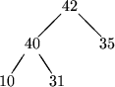
can be represented by the array

42 | 40 | 35 | 10 | 31
A [1] A [2] A [3] A [4] A [5]
This in fact corresponds to the level order enumeration of the tree. Note that we only use an initial segment of the array. Provided the array is long enough, and we know the number of tree nodes, it doesn't matter how many unused components there are at the end.

An important benefit of the array representation is that we can move around the tree, from parent to children or from child to parent, by simple arithmetic. In general
- the children of node i are at 2i and 2i+1
- the parent of node i is at i/2
where division, to obtain the parent, returns the integer part. Of course node i may not have any children, or it may only have one child. Suppose there are n nodes in the tree. Then node i has a left child if 2i<n and a right child if 2i+1<n. Conversely, node i has a parent if i>0, otherwise it is the root.
You should note that some authors leave the first element of the array empty, so that the data items are stored in elements 1….n. The children are then at 2i and 2i+1 and the parent is at i/2. This might make for slightly more efficient code, but overall our coding will be simpler if we load the array from 0.

Linked list Representation

Trees can be represented by links, where each node contains the address of the left child and the right child. The leaf node contains a NULL value in its link fields, as there is no child to a leaf node . Some nodes contain a NULL value in its left or right link field because the respective child of that particular node could be empty.

A

B
C

N | D | N
 | E | N
N | F | N
N | G | N

N | H | N

In the figure, the link fields of node C contain the address of the nodes F and G. The left link field of node E contains the address of the node H. Similarly the right link contains a NULL value as there is only one child of node E.The node D, F, G and H contain a NULL value in both their link fields, as these are the leaf nodes.
Binary trees
- No node can have more than 2 children
- Definition
A binary tree T is defined as finite set of elements called nodes
(1) T is empty
(2) T contains special node R (root) and remaining form an ordered pair of disjoined binary trees.
- Left Skewed: If a binary tree has only left subtree it is called left skewed.
- Right Skewed:If a binary tree has only right subtree it is called right skewed.
- Binary tree with n nodes has (n-1) edges.

Operations of binary tree

The General Steps of Insertion
A binary tree is constructed by the repeated insertion of new nodes into a binary tree structure. Insertion must maintain the order of the tree. That is, values to the left of a given node must be less than that node, and values to the right must be greater.

The Technical Details of Insertion
Inserting a node into a tree is actually two separate operations. First, the tree must be searched to determine where the node is to be inserted. Second, on the completion of the search, the node is inserted into the tree.
Assuming that duplicate entries are not allowed in the tree, two cases must be considered when constructing a binary tree.
- Insertion into an empty tree.
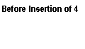 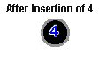
In this case, the node inserted into the tree is considered the root node.
- Inserting into a non-empty tree.
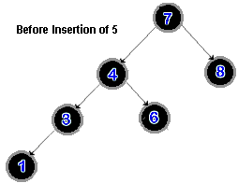 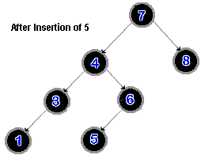
The tree must be searched, as was noted above, to determine where the node is to be inserted. The new node is compared first to the root node of the tree.
If the value of the new node is less than the value of the root node, the new node is:
  - appended as the left leaf of the root node if the left subtree is empty
  - else, the search continues down the left subtree.
If the value of the new node is greater than the value of the root node, the new node is:
  - appended as the right leaf of the root node if the right subtree is empty
  - else, the search process continues down the right subtree.
If this search procedure finds that the insertion node already exists in the tree, the procedure terminates as it can not insert it again.
Note that careful consideration of the above algorithm reveals that the searching procedure described is actually a modified inorder traversal of the tree.

Complexity
Average case is O(log2n).
Worst case is O(n).

Insertion General Steps
- If this is the first insertion then create a node, and set its fields
- If the name is not already in the tree, then attach the new node to the existing tree else write (‘Item already there’)

Detailed Algorithm
Insert (T, Info)

If T.head = Null then
T.info = info
T.lp = null
T.rp = null
current = T;

while (!inserted)
if info < current.info then

if current.lp = null
then current = current.lp

else
inserted = true
T.info = info
T.lp = null
T.rp = null
else if info > current.info then
if current.rp < > null
then current = current.rp

else
inserted = true
T.info = info
T.lp = null
T.rp = null
else if current.info = T.info
then print(‘Item already in tree’)
end
end

The General Steps of Deletion
The algorithm to delete an arbitrary node from a binary tree is deceptively complex, as there are many special cases. The algorithm used for the delete function splits it into two separate operations, searching and deletion. Once the node which is to be deleted has been determined by the searching algorithm, it can be deleted from the tree. The algorithm must ensure that when the node is deleted from the tree, the ordering of the binary tree is kept intact.
Special Cases that have to be considered:
1.The node to be deleted has no children.
In this case the node may simply be deleted from the tree.
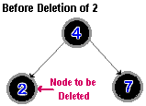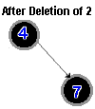
2.The node has one child.
- The child node is appended to its grandparent. (The parent of the node to be deleted.)

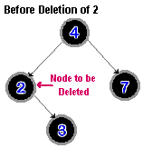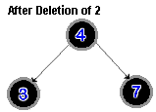
4.The node to be deleted has two children.
This case is much more complex than the previous two, because the order of the binary tree must be kept intact. The algorithm must determine which node to use in place of the node to be deleted:

Use the inorder successor of the node to be deleted.
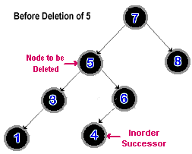
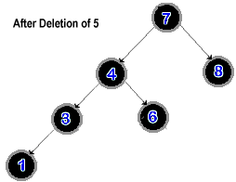
Else if no right subtree exists replace the node to be deleted with the it's left child.
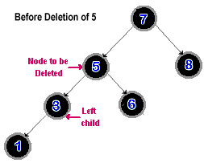
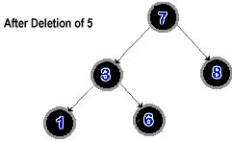
Deletion of the root node is also a special case. It can be accomplished using the methods described above, checking for the separate cases with no children, two children, or one.

Complexity
Average case is O(log2n).
Worst case is O(n).

Deletion Detailed Algorithm
Delete (T, info)
Parent : pointer variable
Current : node to be deleted
Found: boolean to indicate node for deletion found
T: first node in the tree
direction: direction from parent node to node marked for deletion

parent = T
current = T
found = false
while found = false
if current.info == info then
found = true;
else if current.info < info then
direction = 'L'
parent = current
current = current.lp
else if current.info > info then
direction = 'R'
parent = current
current = current.rp
end
delete_case(current, parent, direction)

end.
delete_case (deleted_node, deleted_parent, direction)
deleted_parent : pointer variable
deleted_node : pointer variable
current : node currently being examined
successor : node next to be examined
direction: direction from parent node to node marked for deletion
current = deleted_node
if current.rp == null and current.lp == null then
if direction == 'L' then
deleted_parent.lp = null
else deleted_parent.rp = null
else if current.rp < > null and current.lp == null then
successor = current.rp
if direction == 'L' then
deleted_parent.lp = successor
else deleted_parent.rp = successor
end
else if current.rp == null and current.lp < > null then
successor = current.lp
if direction == 'L' then
deleted_parent.lp = successor
else deleted_parent.rp = successor
end
else if current.rp < > null and current.lp < > null then
current = current.lp if current.rp < > null then
successor := current.rp
while current.rp < > null then
current = successor
successor = current.rp
end
current.rp = null
successor.lp = deleted_node.lp
successor.rp = deleted_node.rp
if direction == 'L' then deleted_parent.lp = successor
else deleted_parent.rp = successor
end
else
successor = current
successor.rp = deleted_node.rp if direction == 'L'
deleted_parent.lp = successor
else deleted_parent.rp = successor
end
end end.

Traversal
Tree-traversal refers to the process of visiting each node in a tree data structure, exactly once, in a systematic way. Such traversals are classified by the order in which the nodes are visited. The following algorithms are described for a tree. There are 3 traversal
1. Preorder
2. Inorder
3. Postorder
To traverse a non-empty binary tree in preorder, perform the following operations recursively at each node, starting with the root node:
- Visit the root.
- Traverse the left subtree.
- Traverse the right subtree.
To traverse a non-empty binary tree in inorder, perform the following operations recursively at each node:
- Traverse the left subtree.
- Visit the root.
- Traverse the right subtree.
To traverse a non-empty binary tree in postorder, perform the following operations recursively at each node:
- Traverse the left subtree.
- Traverse the right subtree.
- Visit the root.

Example
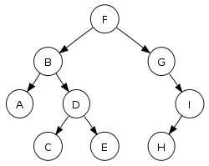

In this binary search tree,
- Preorder traversal sequence: F, B, A, D, C, E, G, I, H (root, left, right)
- Inorder traversal sequence: A, B, C, D, E, F, G, H, I (left, root, right)
- Postorder traversal sequence: A, C, E, D, B, H, I, G, F (left, right, root)
Algorithm for inorder traversal
Input: ROOT is the pointer to the root node of the binary tree.
Output:Visiting of all the nodes in inorder fashion
Data Structure:Linked structure of binary tree.
Steps
1.ptr=ROOT
2.If(ptr≠NULL) then
1.INORDER(ptr.LC)
2.VISIT(ptr)
3.INORDER(ptr.RC)
3.Endif
4.Stop
Algorithm for preorder traversal
Input: ROOT is the pointer to the root node of the binary tree.
Output:Visiting of all the nodes in preorder fashion
Data Structure:Linked structure of binary tree.
Steps
1.ptr=ROOT
2.If(ptr≠NULL) then
1. VISIT(ptr)
2.PREORDER(ptr.LC)
3.INORDER(ptr.RC)
3.Endif
4.Stop
Algorithm for preorder traversal
Input: ROOT is the pointer to the root node of the binary tree.
Output:Visiting of all the nodes in postorder fashion
Data Structure:Linked structure of binary tree.
Steps
1.ptr=ROOT
2.If(ptr≠NULL) then
1.PREORDER(ptr.LC)
2.INORDER(ptr.RC)
3. VISIT(ptr)
3.Endif
4.Stop

//source code
//inorder traversal
inorder(TreeNode* currentNode)
{
if (currentNode) {
inorder(currentNode->LeftChild);
cout << currentNode->data;
inorder(currentNode->RightChild);
}
}
//preorder traversal
preorder(TreeNode* currentNode)
{
if (currentNode) {
cout << currentNode->data;
preorder(currentNode->LeftChild);
preorder(currentNode->RightChild);
}
}

//postorder traversal
postorder(TreeNode* currentNode)
{
if (currentNode) {
postorder(currentNode->LeftChild);
postorder(currentNode->RightChild);
cout << currentNode->data;
}
}
Application of Binary Trees
- Binary trees have many important uses. Two examples are:
  - Binary decision trees.
    - Internal nodes are conditions. Leaf nodes denote decisions.

Condition1
Condition2
Condition3
decision1
decision2
decision3
decision4
false
false
false
True
True
True

- Expression Trees

+
a
*
d
-
b
c

Binary search tree

In computer science, a binary search tree (BST) is a binary tree data structure which has the following properties:
- Each node (item in the tree) has a distinc
- t value.
- Both the left and right subtrees must also be binary search trees.
- The left subtree of a node contains only values less than the node's value.
- The right subtree of a node contains only values greater than the node's value.
The major advantage of binary search trees over other data structures is that the related sorting algorithms and search algorithms such as in-order traversal can be very efficient.
Binary search trees can choose to allow or disallow duplicate values, depending on the implementation.
Binary search trees are a fundamental data structure used to construct more abstract data structures such as sets, multisets, and associative arrays.
A binary search tree of size 9 and depth 3, with root 8 and leaves 1, 4, 7 and 13
Operations

- Searching
- Insertion
- Deletion
- Traversal

Searching
Searching a binary tree for a specific value can be a recursive or iterative process. This explanation covers a recursive method.
We begin by examining the root node. If the tree is null, the value we are searching for does not exist in the tree. Otherwise, if the value equals the root, the search is successful. If the value is less than the root, search the left subtree. Similarly, if it is greater than the root, search the right subtree. This process is repeated until the value is found or the indicated subtree is null. If the searched value is not found before a null subtree is reached, then the item must not be present in the tree.
Algorithm
Steps
BST-SEARCH(item)
1. ptr=ROOT,flag=FALSE
2. while (ptr≠NULL) and (flag = FALSE) do
1.case:ITEM<ptr.DATA
1.ptr=ptr.LCHILD
2. case: ptr.DATA = ITEM
1.flag=TRUE
3.case:ITEM>ptr.DATA
1.ptr=ptr.RCHILD
4.EndCase
3.Endwhile
4.if(flag=TRUE) then
1.print “ITEM has found at the node”,ptr
5.Else
1.print “ITEM does not exist:search is unsuccessful”
6.Endif
7.Stop
Insertion
Algorithm
Steps
BST-INSERT(item)

1. Ptr=ROOT,flag=FALSE
2. While (ptr≠NULL) and (flag=FALSE) do
1. Case: ITEM<ptr.DATA
1. Ptr1=ptr
2. Ptr=ptr.LCHILD
2. case:ITEM>ptr.DATA
1. Ptr1=ptr
2. Ptr=ptr.RCHILD
3. Case: ptr.DATA = ITEM
1. Flag=TRUE
2. Print “ITEM already exists”
3. Exit
4. Endcase
3. Endwhile
4.if(ptr=NULL) then
1. New=GETNODE (NODE)
2. New.DATA=ITEM
3. New.LCHILD=NULL
4. New.RCHILD=NULL
5. If (ptr1.DATA < ITEM) then
1. Ptr1.RCHILD =new
6. Else
1. Ptr1.LCHILD=new
5. Endif
Stop

Deletion

Some examples of Binary Search Tree insertions and deletions.
There are several cases to be considered:
- Deleting a leaf: Deleting a node with no children is easy, as we can simply remove it from the tree.
- Deleting a node with one child: Delete it and replace it with its child.
- Deleting a node with two children: Suppose the node to be deleted is called N. We replace the value of N with either its in-order successor (the left-most child of the right subtree) or the in-order predecessor (the right-most child of the left subtree).
Algorithm
Steps
BST-DELETE(item)
1. Ptr=ROOT,flag=FALSE
2. While (ptr≠NULL) and (flag=FALSE) do
1. Case: ITEM<ptr.DATA
1. Parent=ptr
2. Ptr=ptr.LCHILD
2. case:ITEM>ptr.DATA
1. Parent =ptr
2. Ptr=ptr.RCHILD
3. Case: ptr.DATA = ITEM
1. Flag=TRUE
4. Endcase
3. Endwhile
4.if(flag=FALSE) then
1.print “ITEM does not exist:no deletion”
2.Exit
5.Endif
6.if(ptr.LCHILD = NULL) and (ptr.RCHILD =NULL) then
1.Case =1
7.Else
1. if(ptr.LCHILD ≠ NULL) and (ptr.RCHILD ≠NULL) then
1.Case =3
2.Else
1.Case =2
3.Endif
8. Endif
9.if(case=1) then
1.if(parent.LCHILD=ptr)then
1.parent.LCHILD=NULL
2.Else
1.parent.RCHILD=NULL
3.Endif
4.RETURN_NODE(ptr)
10.Endif
11.if(case=2) then
1.if(parent.LCHILD=ptr)then
1.if(ptr.LCHILD=NULL) then
1.parent.LCHILD=ptr.RCHILD
2.Else
1.parent.LCHILD=ptr.LCHILD
3.Endif
2.Else
1.if(parent.RCHILD=ptr)then
1.if(ptr.LCHILD=NULL) then
1.parent.RCHILD=ptr.RCHILD
2.Else
1.parent.RCHILD=ptr.LCHILD
3.Endif
3.Endif
4.RETURN_NODE(ptr)
12.Endif
13.if(case=3)
1.ptr1=SUCC(ptr)
2.item1=ptr1.DATA
3.BST_DELETE(item1)
4.ptr.DATA=ITEM
14.Endif
15.Stop
Algorithm
Steps
SUCC(PTR)
1.ptr1=PTR.RCHILD
2.if(ptr1≠NULL) then
1.while(ptr1.LCHILD≠NULL) do
1.ptr1=ptr1.LCHILD
2. Endwhile
3. Endif
4. Return (ptr)
5. Stop
Traversal
Algorithm for inorder traversal
Input: ROOT is the pointer to the root node of the binary tree.
Output:Visiting of all the nodes in inorder fashion
Data Structure:Linked structure of binary tree.
Steps
1.ptr=ROOT
2.If(ptr≠NULL) then
1.INORDER(ptr.LC)
2.VISIT(ptr)
3.INORDER(ptr.RC)
3.Endif
4.Stop
Algorithm for preorder traversal
Input: ROOT is the pointer to the root node of the binary tree.
Output:Visiting of all the nodes in preorder fashion
Data Structure:Linked structure of binary tree.
Steps
1.ptr=ROOT
2.If(ptr≠NULL) then
1. VISIT(ptr)
2.PREORDER(ptr.LC)
3.INORDER(ptr.RC)
3.Endif
4.Stop
Algorithm for preorder traversal
Input: ROOT is the pointer to the root node of the binary tree.
Output:Visiting of all the nodes in postorder fashion
Data Structure:Linked structure of binary tree.
Steps
1.ptr=ROOT
2.If(ptr≠NULL) then
1.PREORDER(ptr.LC)
2.INORDER(ptr.RC)
3. VISIT(ptr)
3.Endif
4.Stop
//program
#include<stdio.h>
#include<stdlib.h>
#include<conio.h>
struct node
{
int data;
struct node *left;
struct node *rite;
}*root,*temp,*ptr,*lcptr,*rcptr,*ptr4,*ptr3,*ptr1,*ptr2,*parent;
int flag;
int c;
void insert(int item);
void deletion(int item);

int item1;
struct node* succ(struct node*);

void inorder(struct node *temp);
void preorder(struct node *temp);
void postorder(struct node *temp);
void display(struct node*);

void postorder(struct node *temp)
{
if(temp!=NULL)
{
postorder(temp->left);
postorder(temp->rite);
printf(" %d",temp->data);
}
}
void preorder(struct node *temp)
{
if(temp!=NULL)
{
printf(" %d",temp->data);
preorder(temp->left);
preorder(temp->rite);
}
}

void display(struct node *root1)
{
int i;
printf("\nEnter the order\n1:inorder\n2:preorder\n3:postorder\n");
scanf("%d",&i);
if(i==1)
{
inorder(root1);

}
else if(i==2)
preorder(root1);
else

postorder(root1);
}
void inorder(struct node *temp)
{
if(temp!=NULL)
{
inorder(temp->left);
printf(" %d",temp->data);
inorder(temp->rite);
}
}
void main()
{
int i,j,k,l,item;
int w=9;
clrscr();
temp=(struct node*)malloc(sizeof(struct node));
root=temp;
printf("enter the data for the root:\n");
scanf("%d",&item);
root->data=item;
root->left=NULL;
root->rite=NULL;
while(w==9)
{
printf("Enter yout choice\n1:insert\n2:deletion\n3:display\n4:exit\n");
scanf("%d",&i);
switch(i)
{
case 1:
{
printf("Enter item to be inserted");
scanf("%d",&item);
insert(item);
}
break;
case 2:

{
printf("Enter item to be deleted");
scanf("%d",&item);
deletion(item);
if(c==3)
ptr->data=item1;
}
break;
case 3:
display(root);
//display();
break;
case 4:exit(0);
break;
}
}
getch();
}

void insert(int item)
{
ptr=root;
flag=0;
while((ptr!=NULL)&&(flag==0))
{
if(item<ptr->data)
{
ptr1=ptr;
ptr=ptr->left;
}
else if(ptr->data<item)
{
ptr1=ptr;
ptr=ptr->rite;
}
else
{
flag=1;
printf("Item exists");
return;

}

}
if(ptr==NULL)
{
temp=(struct node*)malloc(sizeof(struct node));
temp->data=item;
temp->left=NULL;
temp->rite=NULL;
if(ptr1->data<item)
ptr1->rite=temp;
else
ptr1->left=temp;
}
}

void deletion(int item)
{
int item2;
//int c;
ptr=root;
flag=0;
while((ptr!=NULL)&&(flag==0))
{
if(item<ptr->data)
{
parent=ptr;
ptr=ptr->left;
}
else if(ptr->data<item)
{
parent=ptr;
ptr=ptr->rite;
}
else
{
flag=1;
// printf("Item exists");
//return;

}

}
if(flag==0)
{
printf("Item absent");
return;
}

if((ptr->left==NULL)&&(ptr->rite==NULL))
c=1;
else if((ptr->left!=NULL)&&(ptr->rite!=NULL))
c=3;
else
c=2;

if(c==1)
{
if(parent->left==ptr)
parent->left=NULL;
else
parent->rite=NULL;
free(ptr);
}

if (c==2)
{
if(parent->left==ptr)
{
if(ptr->left==NULL)
parent->left=ptr->rite;
else
parent->left=ptr->left;
}

else if(parent->rite==ptr)
{
if(ptr->left==NULL)
parent->rite=ptr->rite;
else
parent->rite=ptr->left;
}
free(ptr);
}

if(c==3)
{
ptr1=succ(ptr);
item1=ptr1->data;
item2=item1;
deletion(item1);
ptr->data=item2;
}
// if(c==3)
// ptr->data=item1;
}
struct node* succ(struct node *temp)
{
ptr2=temp->rite;
if(ptr2!=NULL)
{

while(ptr2->left!=NULL)
ptr2=ptr2->left;
}
return(ptr2);
}

- Graph
Graph G consists of 2 sets: Set V of vertices & set E of edges. i.e. G= (V, E).Here V is a finite & non-empty set of vertices, E is a set of pair of vertices.

- Directed Graph
Here each edge is represented by a directed pair <v1, v2>.v1 is the tail and v2 is the head of the edge. <v1, v2> and <v2,v1> represent two different edges. A directed graph is also called a diagraph.

- Undirected Graph
Here a pair of vertices representing any edge is unordered. Thus the pairs (v1, v2) and (v2, v1) represent the same edge. Here the edge has no specific direction.

- Weighted Graph
A graph or diagraph is said to be a weighted graph if all the edges in it are represented with some weights.

- Mixed Graph
Here some of the edges are directed and some are undirected in a graph.

- Path
Path from vertex ‘u’ to vertex ‘v’ is a sequence of vertices u,i1,i2,i3,…….ik,v such that (u,i1),(i1,i2)…..(ik,v) are edges in the graph. The length of the path is the number of edges in it.

- Simple Path
It is a path in which the first and last vertices are distinct.

- Cycle
It is a path in which the first and last vertices are the same.

- Acyclic Graph
If a graph does not contain any cycle in it, it is called an acyclic graph.

- Connected Graph
A graph in which there is a path from every node to every other node in the graph.

- Degree
The number of edges for a node is known as Degree.

- Indegree
In as diagraph, indegree is the incoming direction to a node

- Outdegree
In as diagraph, outdegree is the outgoing direction from a node

- Multiple Edges
Distinct edges e & e’ are called multiple edges if they connect the same end points.
i.e. If e = [u, v] & e’ = [u, v]

- Loop
An edge ‘e’ is called a loop if it has identical endpoints i.e. e= [u, u]

- Multigraph
A
B

C

D

- Tree
- Complete Graph

Application of linked list
The main Applications of Linked Lists are
- For representing Polynomials It means in addition/subtraction /multipication.. of two polynomials. Eg:p1=2x^2+3x+7 and p2=3x^3+5x+2 p1+p2=3x^3+2x^2+8x+9
- In Dynamic Memory Management In allocation and releasing memory at runtime. *In Symbol Tables in Balancing paranthesis
- Representing Sparse Matrix

Graph representations

- Adjacency Matrices
- Adjacency Lists

There are two standard ways to represent graph G, in computer memory. One way called the sequential representation of G by the means of adjacency matrix. The other way is the linked representation of G, is by means of linked lists of neighbours.

Adjacency Matrix

Graphs can also be represented in the form of matrices. The major advantage of matrix representation is that the calculation of paths and cycles can easily be performed using well known operations of matrices. However, the disadvantage is that this form of representation takes away from the visual aspect of graphs. It would be difficult to illustrate in a matrix, properties that are easily illustrated graphically.

Example: Matrix representation of a graph
Consider the following directed graph G (in which the vertices are ordered as v₁, v₂, v₃, v₄, and v₅), and its equivalent adjacency matrix representation :
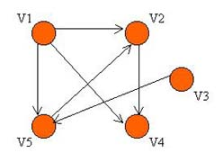
   | v1 | v2 | v3 | v4 | v5
  v1 | 0 | 1 | 0 | 1 | 1
  v2 | 0 | 0 | 0 | 1 | 0
  v3 | 0 | 0 | 0 | 0 | 1
  v4 | 0 | 0 | 0 | 0 | 0
  v5 | 0 | 1 | 0 | 0 | 0
As you can see from the above graph, if a path of length 1 exists from one vertex to another (ie. the two vertices are adjacent), there must be an entry of 1 in the corresponding position in the matrix. For example, from the vertex v1, we can reach vertices v2, v4, and v5. Therefore, we have a corresponding entry of 1 in the matrix in the first row and the second, fourth and fifth columns.
In general, the number of 1's in the ith row, corresponds to the number of edges leaving the vertex v_{i}, and the number of 1's in the jth column, corresponds to the number of edges entering the vertex v_{j}. If the graph is undirected, then the entries adj[x][y] and adj[y][x] are 1 if and only if there is an edge connecting vertices x and y. Otherwise the entry is 0.
Definition of an Adjacency Matrix
An adjacency matrix is defined as follows: Let G be a graph with "n" vertices that are assumed to be ordered from v₁ to v_{n}.
The n x n matrix A, in which
a_{ij}= 1 if there exists a path from v_{i} to v_{j}
a_{ij} = 0 otherwise
is called an adjacency matrix.

Adjacency List

An adjacency list is a list of vertices to which a vertex has connections (i.e., it is a list of vertices that are attached to this vertex by edges). In an adjacency list representation, each vertex typically points to its adjacency list of edges. In an undirected graph, if there is an edge from x to y, then the adjacency list for x will have an entry for y and the adjacency list for y will have an entry for x.

The adjacency list is another form of graph representation in a computer. This structure consists of a list of all vertices in a given graph. Furthermore, each vertex in the list is linked to its own (linked) list containing the names of all vertices that are adjacent to itself.
For example, let's consider a graph consisting of vertices A, B,C and F, Vertex B is adjacent to vertices C and F, vertex C is adjacent to vertices A and C, and finally, vertex F is adjacent to vertex A
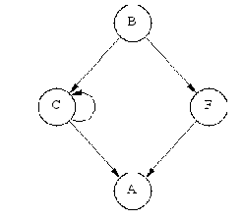
The resulting list would appear as follows:
B -> C -> F
C -> A -> C
F -> A

The above adjacency list is easy to follow, and clearly illustrates the adjacent nature of the three vertices. It is most often used when the graph contains a small to moderate number of edges.

Matrices versus Lists
As a rough rule of thumb, matrices are typically used for dense arrays and adjacency lists for sparse arrays. The reason is that matrices consume less space for dense arrays and adjacency lists consume less space for sparse arrays. However, space is only one consideration. Other factors must also be taken into account:
- Inserting an edge, determining if an edge exists, and deleting an edge all take O(1) time in a matrix but potentially O(V) time in an adjacency list. If time is of the essence and these operations predominate, then a matrix may be the best choice, period.
- Initializing a matrix takes O(V^2) time. Consequently, while subsequent operations may be fast, the initial start-up time for any algorithm involving a matrix requires O(V^2) time. Hence, any algorithm involving a matrix is minimally an O(V^2) algorithm. Important: This is a case where Big-O notation can trip you up. In a long-running system like an airline reservation system, the most important consideration is generally how long the steady-state operations take, not how long the initialization step takes. Consequently, while an algorithm may appear to be O(n^2) because of the initialization time, for all intents and purposes the algorithm may act like an O(n) algorithm or an O(1) algorithm if it runs for a long period of time. Nonetheless, in computing the Big-O running time of an algorithm, the time devoted to the initialization steps must be included.

Graph traversals

- Depth First Search
- Breadth First Search

B
H
F

A
C

G
D
I

E

Depth First Search (DFS)

DFS likes to get as far as away from the starting point as quickly as possible & returns only when it reaches the dead end. The term depth is used to indicate the distance from the starting point. This kind of search is implemented using a stack.

Algorithm:

Rule 1: If possible visit an adjacent unvisited vertex, mark it & push it on to the stack.
Rule 2: If you can’t follow Rule 1, then if possible pop a vertex of the stack.
Rule 3:If you can’t follow Rule 1 or Rule 2 you are done with DFS.

The above graph is taken to perform DFS traversal.

Stack Contents during DFS:

Event | Stack
Visit A | A
Visit B | AB
Visit F | ABF
Visit H | ABFH
Pop H | ABF
Pop F | AB
Pop B | A
Visit C | AC
Pop C | A
Visit D | AD
Visit G | ADG
Visit I | ADGI
Pop I | ADG
Pop G | AD
Pop D | A
Visit E | AE
Pop E | A
Pop A | -
Done

Code Snippet for DFS:

void dfs () // depth first search
{
// begin at vertex 0
vertex [0].wasVisited = true; // mark it
displayVertex(0); // display it
pushIntoStack (0); // push it
while(!theStackisEmpty()) // until Stack empty
{
//get an unvisited vertex adjacent to stack top
int v = getAdjUnvisitedVertex(peekTheStack());
if(v==-1) // if no such vertex
popOffStack();
else //if it exists
{
vertexList[v].wasVisited = true; // mark it
displayVertex(v); //display it
pushIntoStack(v); //push it
}
}// end while

// Stack is empty , so we are done
for(int j=0;j<nVerts;j++) // reset flags
vertexList[j].wasVisited = false;
} // end DFS

int getAdjUnvisitedVertex(int v)
{
for(int j=0;j<nVerts;j++)
if(adjMat[v][j] ==1 && vertexList[j].wasVisited == false)
return j;
return -1;
} // end getAdjUnvisitedVertex()

Breadth First Search(BFS)

In BFS the algorithm likes to stay as close as possible to the starting point unlike DFS.It visits all the vertices adjacent to the starting vertex & then only goes further. This kind of search is implemented using a queue.

Here vertex ‘A’ is considered as the starting vertex, so you visit it and make it the current vertex. Then you follow these rules.

Rule 1:Visit the next unvisited vertex (if there is one) that is adjacent to the current vertex, mark it & insert into the queue.

Rule 2:If you can’t carry out Rule 1 because there are no more unvisited vertices remove a vertex from the queue & make it as the current vertex.

Rule 3:If you can’t carry out the above Rule2 because the queue is empty, then you are done with BFS.

Event | Queue (Front to Rear)
Visit A
Visit B | B
Visit C | BC
Visit D | BCD
Visit E | BCDE
Remove B | CDE
Visit F | CDEF
Remove C | DEF
Remove D | EF
Visit G | EFG
Remove E | FG
Remove F | G
Visit H | GH
Remove G | H
Visit I | HI
Remove H | I
Remove I | -
Done | -

Code Snippet for BFS:
void bfs()
{ // begin at vertex 0
vertexList[0].wasVisited = true; // mark it
displayVertex(0); // display it
insertIntoQueue(0); // insert at tail
int v2;
while(! QueueisEmpty()) // until Queue is empty
{
int v1 = removeFromQueue(); // remove vertex at head
//until it has no unvisited neighbours
while(v2 = getAdjUnvisitedVertex(v1))!= -1)
{ // get one
vertexList[v2].wasVisited = true; // mark it
displayVertex(v2); // display it
insertIntoQueue(v2); // insert at tail
} // end while(unvisited neighbours)
} // end while(queue not empty)

// Queue is empty , so we are done
for(int j=0;j<nVerts;j++) // reset flags
vertexList[j].wasVisited = false;
} // end BFS

int getAdjUnvisitedVertex(int v)
{
for(int j=0;j<nVerts;j++)
if(adjMat[v][j] ==1 && vertexList[j].wasVisited == false)
return j;
return -1;
} // end getAdjUnvisitedVertex()

Module 5
SELECTION_SORT
This type of sorting is called "Selection Sort" because it works by repeatedly element. It works as follows: first find the smallest in the array and exchange it with the element in the first position, then find the second smallest element and exchange it with the element in the second position, and continue in this way until the entire array is sorted.
Algoritm
SELECTION_SORT (A)
for i ← 1 to n-1 do
min j ← i;
min x ← A[i]
for j ← i + 1 to n do
If A[j] < min x then
min j ← j
min x ← A[j]
A[min j] ← A [i]
A[i] ← min x
example
For example, consider the following array, shown with array elements in sequence separated by commas:
The leftmost element is at index zero, and the rightmost element is at the highest array index, in our case, 4 (the effective size of our array is 5). The largest element in this effective array (index 0-4) is at index 2. We have shown the largest element and the one at the highest index in bold. We then swap the element at index 2 with that at index 4. The result is:
We reduce the effective size of the array to 4, making the highest index in the effective array now 3. The largest element in this effective array (index 0-3) is at index 1, so we swap elements at index 1 and 3 (in bold):
The next two steps give us:
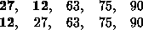
//selection sort
#include<stdio.h>
void select();
int a[99];
main()
{
int n,ch,m,n1;
char z='y';
while(z == 'y')
{
printf("Enter the choice\n");
printf("\n1:selection sort\n2:Exit");
scanf("%d",&ch);
switch(ch)
{
case 1:select();
break;
case 2:break;
default :printf("\ninvalid choice\n");
}
printf("\nEnter y to continue and n to exit\n");
scanf("%s",&z);
}
}
void select()
{
int i,j,min,temp,n;
printf("Enter number of elements\n");
scanf("%d",&n);
printf("Enter the numbers to be sorted\n");
for(i=0;i<n;i++)
scanf("%d",&a[i]);
for(i=0;i<n-1;i++)
{
min=i;
for(j=i+1;j<n;j++)
if(a[min]>a[j])
min=j;
temp=a[i];
a[i]=a[min];
a[min]=temp;
}
printf("\nsorted array\n");
for(i=0;i<n;i++)
printf("%d\t",a[i]);
printf("\n");
}
complexity
The worst case occurs if the array is already sorted in descending order. Nonetheless, the time require by selection sort algorithm is not very sensitive to the original order of the array to be sorted: the test "if A[j] < min x" is executed exactly the same number of times in every case. The variation in time is only due to the number of times the "then" part (i.e., min j ← j; min x ← A[j] of this test are executed.
The Selection sort spends most of its time trying to find the minimum element in the "unsorted" part of the array. It clearly shows the similarity between Selection sort and Bubble sort. Bubble sort "selects" the maximum remaining elements at each stage, but wastes some effort imparting some order to "unsorted" part of the array. Selection sort is quadratic in both the worst and the average case, and requires no extra memory.
For each i from 1 to n - 1, there is one exchange and n - i comparisons, so there is a total of n -1 exchanges and (n -1) + (n -2) + . . . + 2 + 1 = n(n -1)/2 comparisons. These observations hold no matter what the input data is. In the worst case, this could be quadratic, but in the average case, this quantity is O(n log n). It implies that the running time of Selection sort is quite insensitive to the input.
Or
Time Complexity of selection sort
Line 2: Executed ( n- 1) times.
Lines 3 & 4: Executed ( n - 1) + ( n - 2) + ... + 1 = n( n - 1) / 2 times.
Lines 6, 7 & 8: Executed between 0 and n( n - 1) / 2 times depending on how often
a[ i ] > a[ j ].

Value of i | No. of comparisons
0 | n-1
1 | n-2
. | .
. | .
n-2 | 1

T(n)= (n-1) + (n-2) + … + 1
= n(n-1)/2 = O(n²)

Insertion Sort
The insertion sort works just like its name suggests - it inserts each item into its proper place in the final list. The simplest implementation of this requires two list structures - the source list and the list into which sorted items are inserted. To save memory, most implementations use an in-place sort that works by moving the current item past the already sorted items and repeatedly swapping it with the preceding item until it is in place.
Algorithm
- Start
- Read the number of elements in the array say n
- Read the number of elements in the array A
- Initialize I=0
- Repeat step 6 to 10 until I<n
- Assign j=0
- Repeat step 8 to 9 until j<n-(I+1)
- If(a[j]>a[j+1])
  - Assign temp=x[j]
  - Assign A[j]=A[j+1]
  - Assign A{j+1]=temp
- Increment j by 1
- Increment I by 1
- Stop

//pseudo code
void insertionSort(int numbers[], int array_size)
{
int i, j, index;

for (i=1; i < array_size; i++)
{
index = numbers[i];
j = i;
while ((j > 0) && (numbers[j-1] > index))
{
numbers[j] = numbers[j-1];
j = j - 1;
}
numbers[j] = index;
}
}
Example: The following table shows the steps for sorting the sequence 5 7 0 3 4 2 6 1. On the left side the sorted part of the sequence is shown in red. For each iteration, the number of positions the inserted element has moved is shown in brackets. Altogether this amounts to 17 steps.

5 | 7 | 0 | 3 | 4 | 2 | 6 | 1 |  | (0)
5 | 7 | 0 | 3 | 4 | 2 | 6 | 1 |  | (0)
0 | 5 | 7 | 3 | 4 | 2 | 6 | 1 |  | (2)
0 | 3 | 5 | 7 | 4 | 2 | 6 | 1 |  | (2)
0 | 3 | 4 | 5 | 7 | 2 | 6 | 1 |  | (2)
0 | 2 | 3 | 4 | 5 | 7 | 6 | 1 |  | (4)
0 | 2 | 3 | 4 | 5 | 6 | 7 | 1 |  | (1)
0 | 1 | 2 | 3 | 4 | 5 | 6 | 7 |  | (6)

Best, worst, and average cases
The best case input is an array that is already sorted. In this case insertion sort has a linear running time (i.e., O(n)). During each iteration, the first remaining element of the input is only compared with the right-most element of the sorted subsection of the array.
The worst case input is an array sorted in reverse order. In this case every iteration of the inner loop will scan and shift the entire sorted subsection of the array before inserting the next element. For this case insertion sort has a quadratic running time (i.e., O(n²)).
The average case is also quadratic, which makes insertion sort impractical for sorting large arrays. However, insertion sort is one of the fastest algorithms for sorting arrays containing fewer than ten elements.
Or
Time Complexity
Case I (Best case – List is already sorted):
Only One comparison is needed on each pass. Hence the complexity is O(n).

Case II (Worse case – List is sorted in reverse order):
No. of comparison = n + (n-1) + (n-2) + … + 2
= n(n+1)/2 – 1
= O(n²).

//insertion sort

#include<stdio.h>
void insert();
int a[99];
main()
{
int n,ch,m,n1;
char z='y';
while(z == 'y')
{
printf("Enter the choice\n");
printf("\n1:insertion sort\n2:Exit\n");
scanf("%d",&ch);
switch(ch)
{
case 1:insert();
break;
case 2: break;
default :printf("\ninvalid choice\n");
}
printf("\nEnter y to continue and n to exit\n");
scanf("%s",&z);
}
}

void insert()
{
int in,out,temp,i,j,n;
printf("Enter the number of elements\n");
scanf("%d",&n);
printf("Enter the numbers to be sorted\n");
for(i=0;i<n;i++)
scanf("%d",&a[i]);
for(out=1;out<n;out++)
{
in=out;
temp=a[out];
while((in>0) && (a[in-1]>=temp))
{
a[in]=a[in-1];
in--;
}
a[in]=temp;
}
printf("\nsorted array\n");
for(i=0;i<n;i++)
printf("\t%d",a[i]);
}

Bubble sort
This algorithm compares the key to the data elements and swaps the elements if they are not in the desired order. Since, swapping occurs only among successive elements of the data structure only one element is placed in its sorted place after each pass. Once the elements area sorted they are considered for comparison in successive pass.
In this we can fix the last element by comparing 1st element with 2nd, 2nd with 3rd … (n-1)^{st} with n^{th} . Repeat the procedure to fix all the remaining elements.

Algorithm
Steps:
- Start
- Read the number of elements in the array say n
- Read the number of elements in the array A
- Initialize I=0
- Repeat step 6 to 10 until I<n
- Assign j=0
- Repeat step 8 to 9 until j<n-(I+1)
- If(a[j]>a[j+1])
  - Assign temp=x[j]
  - Assign A[j]=A[j+1]
  - Assign A{j+1]=temp
- Increment j by 1
- Increment I by 1
- Stop
Example

Step-by-step example
Let us take the array of numbers "5 1 4 2 8", and sort the array from lowest number to greatest number using bubble sort algorithm. In each step, elements written in bold are being compared.
First Pass:
( 5 1 4 2 8 ) ( 1 5 4 2 8 ), Here, algorithm compares the first two elements, and swaps them.
( 1 5 4 2 8 ) ( 1 4 5 2 8 ), Swap since 5 > 4
( 1 4 5 2 8 ) ( 1 4 2 5 8 ), Swap since 5 > 2
( 1 4 2 5 8 ) ( 1 4 2 5 8 ), Now, since these elements are already in order (8 > 5), algorithm does not swap them.
Second Pass:
( 1 4 2 5 8 ) ( 1 4 2 5 8 )
( 1 4 2 5 8 ) ( 1 2 4 5 8 )
( 1 2 4 5 8 ) ( 1 2 4 5 8 )
( 1 2 4 5 8 ) ( 1 2 4 5 8 )
Now, the array is already sorted, but our algorithm does not know if it is completed. Algorithm needs one whole pass without any swap to know it is sorted.
Third Pass:
( 1 2 4 5 8 ) ( 1 2 4 5 8 )
( 1 2 4 5 8 ) ( 1 2 4 5 8 )
( 1 2 4 5 8 ) ( 1 2 4 5 8 )
( 1 2 4 5 8 ) ( 1 2 4 5 8 )
Finally, the array is sorted, and the algorithm can terminate.
//bubble sort

void bubbleSort(int numbers[], int array_size)
{
int i, j, temp;

for (i = (array_size - 1); i >= 0; i--)
{
for (j = 1; j <= i; j++)
{
if (numbers[j-1] > numbers[j])
{
temp = numbers[j-1];
numbers[j-1] = numbers[j];
numbers[j] = temp;
}
}
}
}

Time Complexity
Value of i | No. of comparisons
1 | n-1
2 | n-2
.
.
n-1 | 1
i.e., (n-1) + (n-2) + … + 1
= n(n-1)/2
= O(n²)

Merge Sort
Merge-sort is based on the divide-and-conquer paradigm. The Merge-sort algorithm can be described in general terms as consisting of the following three steps:
1. Divide Step
If given array A has zero or one element, return S; it is already sorted. Otherwise, divide A into two arrays, A₁ and A₂, each containing about half of the elements of A.
2. Recursion Step
Recursively sort array A₁ and A₂.
3. Conquer Step
Combine the elements back in A by merging the sorted arrays A₁ and A₂ into a sorted sequence.
We can visualize Merge-sort by means of binary tree where each node of the tree represents a recursive call and each external nodes represent individual elements of given array A. Such a tree is called Merge-sort tree. The heart of the Merge-sort algorithm is conquer step, which merge two sorted sequences into a single sorted sequence.
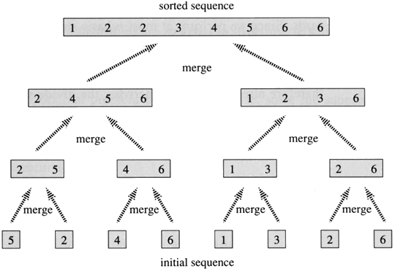
To begin, suppose that we have two sorted arrays A₁[1], A₁[2], . . , A₁[M] and A₂[1], A₂[2], . . . , A₂[N]. The following is a direct algorithm of the obvious strategy of successively choosing the smallest remaining elements from A₁ to A₂ and putting it in A.
MERGE (A₁, A₂, A)
i.← j 1
A₁[m+1], A₂[n+1] ← INT_MAX
For k ←1 to m + n do
if A₁[i] < A₂[j]
then A[k] ← A₁[i]
i ← i +1
else
A[k] ← A₂[j]
j ← j + 1
Merge Sort Algorithm
MERGE_SORT (A)
A₁[1 . . n/2] ← A[1 . . n/2]
A₂[1 . . n/2] ← A[1 + n/2 . . n]
Merge Sort (A₁)
Merge Sort (A₂)
Merge (A₁, A₂, A)

Analysis
Let T(n) be the time taken by this algorithm to sort an array of n elements dividing A into subarrays A₁ and A₂ takes linear time. It is easy to see that the Merge (A₁, A₂, A) also takes the linear time. Consequently,
T(n) = T(n/2) + T(n/2) + θ(n)
for simplicity
T(n) = 2T (n/2) + θ(n)
The total running time of Merge sort algorithm is O(n lg n), which is asymptotically optimal like Heap sort, Merge sort has a guaranteed n lg n running time. Merge sort required (n) extra space. Merge is not in-place algorithm. The only known ways to merge in-place (without any extra space) are too complex to be reduced to practical program.
Or
cn
2 × cn/2 = cn
4 × cn/4 = cn
n/2 × 2c = cn
log n levels
Total running time: Θ(nlogn)
Total Space: Θ (n)
Total: cn log n
n
n/2
n/2
n/4
n/4
n/4
n/4
2
2
2
//merge sort

void mergeSort(int numbers[], int temp[], int array_size)
{
m_sort(numbers, temp, 0, array_size - 1);
}
void m_sort(int numbers[], int temp[], int left, int right)
{
int mid;
if (right > left)
{
mid = (right + left) / 2;
m_sort(numbers, temp, left, mid);
m_sort(numbers, temp, mid+1, right);
merge(numbers, temp, left, mid+1, right);
}
}
void merge(int numbers[], int temp[], int left, int mid, int right)
{
int i, left_end, num_elements, tmp_pos;
left_end = mid - 1;
tmp_pos = left;
num_elements = right - left + 1;
while ((left <= left_end) && (mid <= right))
{
if (numbers[left] <= numbers[mid])
{
temp[tmp_pos] = numbers[left];
tmp_pos = tmp_pos + 1;
left = left +1;
}
else
{
temp[tmp_pos] = numbers[mid];
tmp_pos = tmp_pos + 1;
mid = mid + 1;
}
}
while (left <= left_end)
{
temp[tmp_pos] = numbers[left];

left = left + 1;
tmp_pos = tmp_pos + 1;
}
while (mid <= right)
{
temp[tmp_pos] = numbers[mid];
mid = mid + 1;
tmp_pos = tmp_pos + 1;
}
for (i=0; i <= num_elements; i++)
{
numbers[right] = temp[right];
right = right - 1;
}
}
Quick sort

Quick sort is a very popular sorting algorithm. The name comes from the fact that, quick sort can sort a list of data elements significantly faster than any of the common sorting algorithms. This algorithm is based on the fact that it is faster and easier to sort two small arrays than one larger one. The basic strategy of quick sort is to divide and conquer. It is based on recursion and quick sort is also known as partition exchange sort.
algorithm
    - set i=0,j=1, and a is an array,p as pivot element, set p in the first position
    - if(a[0]>a[j]) then
i increment i by 1
ii Then exchange a[i] and a[j] th position.
iii increment j each time and compare with pivot value ,ie a[0] th position and continue loop 2 till j>array size
3. Interchange pivot value with the present I th lication
4. Stop
or
Quick (A, left, right)
if left ≥ right return
else
middle ← Partition(A, left, right)
Quick (A, left, middle–1 )
Quick (A, middle+1, right)
end if

Partition(A, left, right)
- x ← A[left]
- i ← left
- for j ← left+1 to right
- if A[j] < x then
- i ← i + 1
- swap(A[i], A[j])
- end if
- end for j
- swap(A[i], A[left])
- return i

//Quick sort
Void quick sort(int a[],int i,int j)
{
for(int i=0,i<=n;i++)
{
for(int j=1;j<=n;j++)
{
if(a[0]>a[j])
{
i++;
Int temp=a[0];
a[0]=a[j];
a[j]=temp;
}
}
int t=a[0];
a[0]=a[i];
a[i]=t;
}
Partition Example
A:
4
8
6
3
5
1
7
2

A:
4
8
6
3
5
1
7
2
i=0
j=1
A:
j=1
4
8
6
3
5
1
7
2
i=0
8
A:
4
8
6
3
5
1
7
2
6
i=0
j=2
8
3
i=1
A:
4
8
6
3
5
1
7
2
i=0
3
j=3
i=1
A:
4
3
6
8
5
1
7
2
5
j=4
i=1
A:
4
3
6
8
5
1
7
2
1
j=5
i=2
1
6
A:
4
3
6
8
5
1
7
2
j=5
i=2
A:
4
3
8
5
7
2
1
6
7
j=6
i=2
i=3
A:
4
3
8
5
7
2
1
6
2
2
8
j=7
i=3
4
3
2
6
7
8
1
5
A:
i=3
A:
4
1
6
7
8
2
5
4
2
3

x < 4
4 ≤ x
pivot in
correct position
A:
3
6
7
8
1
5
4
2
Time Complexity

Case1: Avearage case

Assume that the file is of size n ie power of 2,say n=2^m,so that m=log₂n .Assume also that the proper position for the pivot always turns out to be the middle of the sub array. In that case there will be approximately n comparisons ( (actually n-1) on the first pass, after which the file is split into 2 sub files each of size n/2 approximately. For each of these 2 files there are approximately n/2 comparisons, and a total of four files each of size n/4 are formed.. Each of these files requires n/4 comparisons yielding a total of n/8 sub files. After halving the sub files m times, there are n files of size 1. Thus the total number of comparisons for the entire sort is:

n+2*(n/2)+4*(n/4)+8*(n/8)+………………..+n*(n/n)
or
n+n+n+…………………………….+n(m terms).

comparisons. There are m terms because the file is sub-divided m times. Thus the total no: of comparisons is O(n*m) or O(n logn).

CaseI1 (worse case):

Assume that each time after fixing an element the file is divided into a smaller partition and a bigger partition. Say, during i^{th} partition it is divided into 1 and (i-1).
No. of comparison = n + (n-1) + (n-2) + … + 2
= n(n+1)/2 – 1
= O(n²)
Or
Quick-Sort: Best Case
- Even Partition

cn
2 × cn/2 = cn
4 × c/4 = cn
n/3 × 3c = cn
log n levels
n
n/2
n/2
n/4
3
3
3
n/4
n/4
n/4
Total time: Θ(nlogn)
Quick-Sort: Worst Case
Unbalanced Partition
cn
c(n-1)
3c
2c
n
n-1
n-2
3
2
c(n-2)
Total time: Θ(n²)
Happens only if
input is sortd
input is reversely sorted
Quick-Sort: an Average Case
- Suppose the split is 1/10 : 9/10
cn
cn
cn
≤cn
n
0.1n
0.9n
0.01n
0.09n
0.09n
Total time: Θ(nlogn)
0.81n
2
2
log₁₀n
log_{10/9}n
≤cn
- Time
  - Most of the work done in partitioning.
  - Average case takes Θ(n log(n)) time.
  - Worst case takes Θ(n2) time
Space
  - Sorts in-place, i.e., does not require additional space
Radix Sort
- Based on the values of the actual digits in the positional representation of the numbers being considered.
- Partition the numbers into 10 groups depending on the least significant positional value in the order of there arrival. Place the element in the queue for the corresponding digit.
- Restore the elements in each queue to the original file starting with queue for number 0.
- Continue the process till the most significant position.

Program 5.7
Void Radix_sort ( int x[], int n)
{
int front[10],rear[10];
struct{
int info;
int next;
}node[10];
int exp,first,i,j,k,p,q,y;

for(i=0; i<n-1; i++)
{
node[i].info = x[i];
node[i].next = i+1;
}

node[n-1].info = x[n-1];
node[n-1].next = -1;
first = 0;
for(k=1; k<3; k++)
{
for(i=0; i<n; i++)
{
front[i] = -1;
rear[i] = -1;
}

while(first != -1)
{
p = first;
first = node[first].next;
y = node[p].info;
exp = power(10,k-1);
j = (y/exp)%10;
q = rear[j];
if(q==-1)
front[j] = p;
else
node[q].next = p;
rear[j] = p;
}
for(j=0; j<10 && front[j]==-1; j++);
first = front[j];
while(j<=9)
{
for(i=j+1; i<10 && front[i]==-1; i++);
if(i<=9)
{
p=i;
node[rear[j]].next = front[i];
}
j=i;
}
node[rear[p]].next = -1;
}
for(i=0; i<n; i++)
{
x[i] = node[first].info;
first = node[first].next;
}
}

Example:
Consider the array of elements 624 852 426 987 269 146 415 301 730 78 593

Queue | pass 1 | pass 2 | pass 3
0 | 730 | 301 | 78
1 | 301 | 415 | 146
2 | 852 | 624, 426 | 269
3 | 593 | 730 | 301
4 | 624 | 146 | 415, 426
5 | 415 | 852 | 593
6 | 426, 146 | 269 | 624
7 | 987 | 78 | 730
8 | 78 | 987 | 852
9 | 269 | 593 | 987

Time Complexity
- Depends on number of digits in the numbers (m) and number of elements ion the array (n).
Outer loop executes m times and the inner loop executes n times, once for each element. Hence the complexity on O(mn) or m is approximately equal to log₂n.
- So time complexity of Radix sort is O (nlog₂n).

Heap Sort
HEAP

Heap is another data structure basically used for sorting the particular elements. The beauty of this sort is that it generally takes less time to sort the elements as compared to other sorting algorithms.
It is another variation of binary tree. Heap is a complete binary tree where all the levels except the last level must be completely filled. In the last level all the nodes must be filled in from left side, without spacing between them. However, it does not have to be filled to the end. This property of heap is called structure property.

Heap is a complete binary tree that is partially ordered with either the MAX-heap or MIN-heap properties. A heap s said to be max-heap. Then the children of every node have a value less than that node and heap is called as min-heap when the children of every node are greater than the node itself. In such a tree, the main root always has either the highest or the lowest value in tree. This property of heap is called Heap-order property.

Basic heap operations
Insertion-
- Insert the node A at the end of the heap so that the tree is still complete but not necessarily heap.
- Now raise the node A to its appropriate position so that the tree finally becomes the heap by changing the position of a node with the parent node
Deletion-Any operation performed on heap should ensure that the heap order property is maintained.
- Replace the root in a heap with last node and delete the last node.
- Now again adjust the elements so that the node sinks to its correct position.
Heap Sort
- Create a complete binary tree for the elements given.
- Convert the tree to a heap. i.e., a complete binary tree with the property that value of each node is at least as large as value of the child nodes.
- Output sequence is generates in decreasing order by successively outputting the root and reconstructing the remaining into a heap.
- Time complexity of heap sort is O(nlog₂n)

Heapsort algorithm
The following description of heapsort refers to Figure 2 (a) - (e).
A)
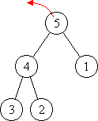
B)
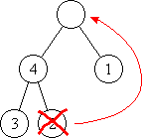
C)
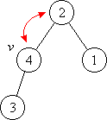
D)
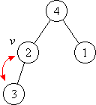

E)
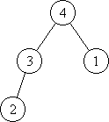
Retrieving the maximum element and restoring the heap

If the sequence to be sorted is arranged as a heap, the greatest element of the sequence can be retrieved immediately from the root (a). In order to get the next-greatest element, the rest of the elements have to be rearranged as a heap.
The rearrangement is done in the following way:
Let b be a leaf of maximum depth. Write the label of b to the root and delete leaf b (b). Now the tree is a semi-heap, since the root possibly has lost its heap property.
Making a heap from a semi-heap is simple:
Do nothing if the root already has the heap property, otherwise exchange its label with the maximum label of its direct descendants (c). Let this descendant be v. Now possibly v has lost its heap property. Proceed further with v, i.e. make a heap from the semi-heap rooted at v (d). This process stops when a vertex is reached that has the heap property (e). Eventually this is the case at a leaf.
Making a heap from a semi-heap can conceptionally be implemented by the following procedure downheap:
procedure downheap (v)
Input: semi-heap with root v
Output: heap (by rearranging the vertex labels)
Method: while v does not have the heap property do
choose direct descendant w with maximum label a(w)
exchange a(v) and a(w)
set v := w
Procedure downheap can be used to build a heap from an arbitrarily labelled tree. By proceeding bottom-up, downheap is called for all subtrees rooted at inner vertices. Since leaves are already heaps they may be omitted.
procedure buildheap
Input: almost complete binary tree T of depth d(T) with vertex labelling a
- Output: heap (by rearranging the vertex labels)
Method: for i := d(T) – 1 downto 0 do
  - for all inner vertices v of depth d(v) = i do
    - downheap (v)

procedure heapsort
Input: almost complete binary tree with root r and vertex labelling a
Output: vertex labels in descending order
Method: buildheap
while r is not a leaf do
output a(r)
choose leaf b of maximum depth
write label a(b) to r
delete leaf b
downheap (r)
output a(r)
//Heap sort
#include<stdio.h>
#include<conio.h>
int a[99],b[99],i,n,j;
void create();
void rearrange(int);
void main()
{
int k,l,m;
clrscr();
printf("Enter the no:of elements");
scanf("%d",&n);
printf("Enter elements");
a[0]=0;
b[0]=0;
for(i=1;i<=n;i++)
{
scanf("%d",&a[i]);
}

create();
for(i=n;i>=2;i--)
{
l=b[1];
b[1]=b[i];
b[i]=l;

rearrange(i-1);
}
printf("Sorted array\n");
for(i=1;i<=n;i++)
printf("%d\t",b[i]);
getch();
}
void create()
{

int l,x,i1,s;
i1=1;
while(i1<=n)
{ x=a[i1];
b[i1]=x;
j=i1;
while(j>1)
{
s=j/2;
if(b[j]>b[s])
{
l=b[j];
b[j]=b[s];
b[s]=l;
j=j/2;
}
else
j=1;

}
i1++;
}
}
void rearrange(int k)
{
int f=1;
int rc,lc,l;
if(k==1)
return;
j=1;
while(f==1)
{
rc=(2*j)+1;
lc=2*j;
if(rc<=k)
{
if((b[j]<=b[lc])&&(b[rc]<=b[lc]))
{
l=b[j];
b[j]=b[lc];
b[lc]=l;
j=lc;
}
else if((b[j]<=b[rc])&&(b[rc]>=b[lc]))
{
l=b[j];
b[j]=b[rc];
b[rc]=l;
j=rc;
}

}
else
f=0;

if(lc<=k)

if(b[j]<=b[lc])
{
l=b[j];
b[j]=b[lc];
b[lc]=l;
j=lc;
}

else
f=0;
}
}
Radix Sort
- Based on the values of the actual digits in the positional representation of the numbers being considered.
- Partition the numbers into 10 groups depending on the least significant positional value in the order of there arrival. Place the element in the queue for the corresponding digit.
- Restore the elements in each queue to the original file starting with queue for number 0.
- Continue the process till the most significant position.

Program 5.7
Void Radix_sort ( int x[], int n)
{
int front[10],rear[10];
struct{
int info;
int next;
}node[10];
int exp,first,i,j,k,p,q,y;

for(i=0; i<n-1; i++)
{
node[i].info = x[i];
node[i].next = i+1;
}

node[n-1].info = x[n-1];
node[n-1].next = -1;
first = 0;
for(k=1; k<3; k++)
{
for(i=0; i<n; i++)
{
front[i] = -1;
rear[i] = -1;
}

while(first != -1)
{
p = first;
first = node[first].next;
y = node[p].info;
exp = power(10,k-1);
j = (y/exp)%10;
q = rear[j];
if(q==-1)
front[j] = p;
else
node[q].next = p;
rear[j] = p;
}
for(j=0; j<10 && front[j]==-1; j++);
first = front[j];
while(j<=9)
{
for(i=j+1; i<10 && front[i]==-1; i++);
if(i<=9)
{
p=i;
node[rear[j]].next = front[i];
}
j=i;
}
node[rear[p]].next = -1;
}
for(i=0; i<n; i++)
{
x[i] = node[first].info;
first = node[first].next;
}
}

Example:
Consider the array of elements 624 852 426 987 269 146 415 301 730 78 593

Queue | pass 1 | pass 2 | pass 3
0 | 730 | 301 | 78
1 | 301 | 415 | 146
2 | 852 | 624, 426 | 269
3 | 593 | 730 | 301
4 | 624 | 146 | 415, 426
5 | 415 | 852 | 593
6 | 426, 146 | 269 | 624
7 | 987 | 78 | 730
8 | 78 | 987 | 852
9 | 269 | 593 | 987

Time Complexity
- Depends on number of digits in the numbers (m) and number of elements ion the array (n).
Outer loop executes m times and the inner loop executes n times, once for each element. Hence the complexity on O(mn) or m is approximately equal to log₂n.
- So time complexity of Radix sort is O (nlog₂n).

External Sorting

Why External Sort?

- A classic problem in computer science!
- Data requested in sorted order
  - e.g., find students in increasing gpa order
- First step in bulk loading B+ tree index.
- Useful for eliminating duplicate copies in a collection of records (Why?)
- Sort-merge join algorithm involves sorting.
- The Problem: sort 1Gb of data with 1Mb of RAM.

2-Way Sort: Requires 3 Buffers

- Buffer: the memory space (at least 1 page) for holding the pages read or to be written to disk (An important, not always easy concept).
- Pass 1: Read a page, sort it, write it: only one buffer page used
- Pass 2, 3, …, etc.: three buffer pages used.

Main memory buffers
INPUT 1
INPUT 2
OUTPUT
Disk
Disk
- Each pass we read + write each page in file.
- N pages in the file => the number of passes
- So total cost is:
Idea: Divide and conquer: sort subfiles and merge
Input file
1-page runs
2-page runs
4-page runs
8-page runs
PASS 0
PASS 1
PASS 2
PASS 3
9
3,4
6,2
9,4
8,7
5,6
3,1
2
3,4
5,6
2,6
4,9
7,8
1,3
2
2,3
4,6
4,7
8,9
1,3
5,6
2
2,3
4,4
6,7
8,9
1,2
3,5
6
1,2
2,3
3,4
4,5
6,6
7,8

General External Merge Sort

More than 3 buffer pages. How can we utilize them?

- To sort a file with N pages using B buffer pages:
  - Pass 0: use B buffer pages. Produce sorted runs of B pages each.
  - Pass 1, 2, …, etc.: merge B-1 runs.

B Main memory buffers
INPUT 1
INPUT B-1
OUTPUT
Disk
Disk
INPUT 2
. . .
. . .
. . .

Threaded Binary Tree

- Consider linked representation of a binary tree T.nearly half of the pointers in left and right will contain null elements.
- Space may be efficiently used by replacing null entries by some other information
- We can replace null entries by special pointers which point to nodes higher in the tree. These special pointers are called threads and binary trees with such pointers are called threaded trees.

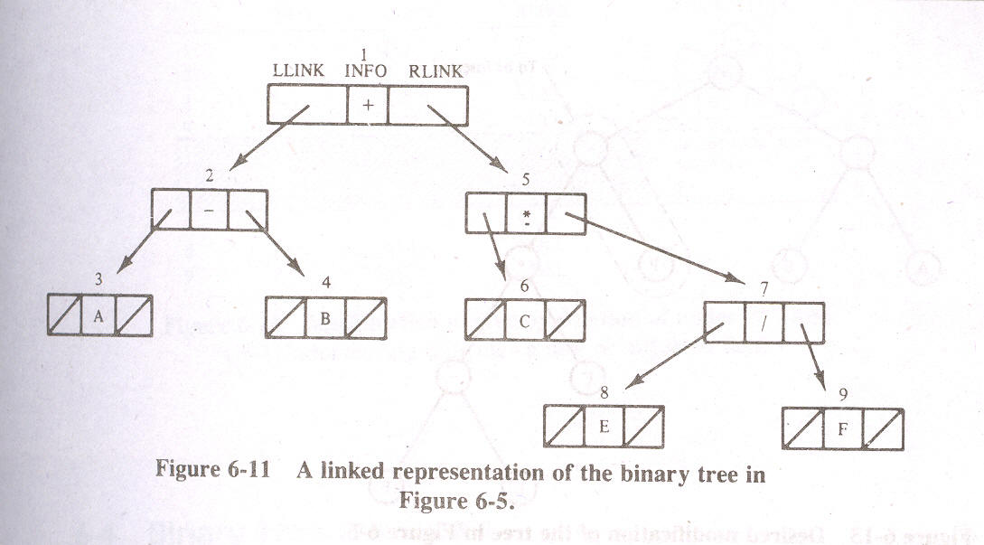

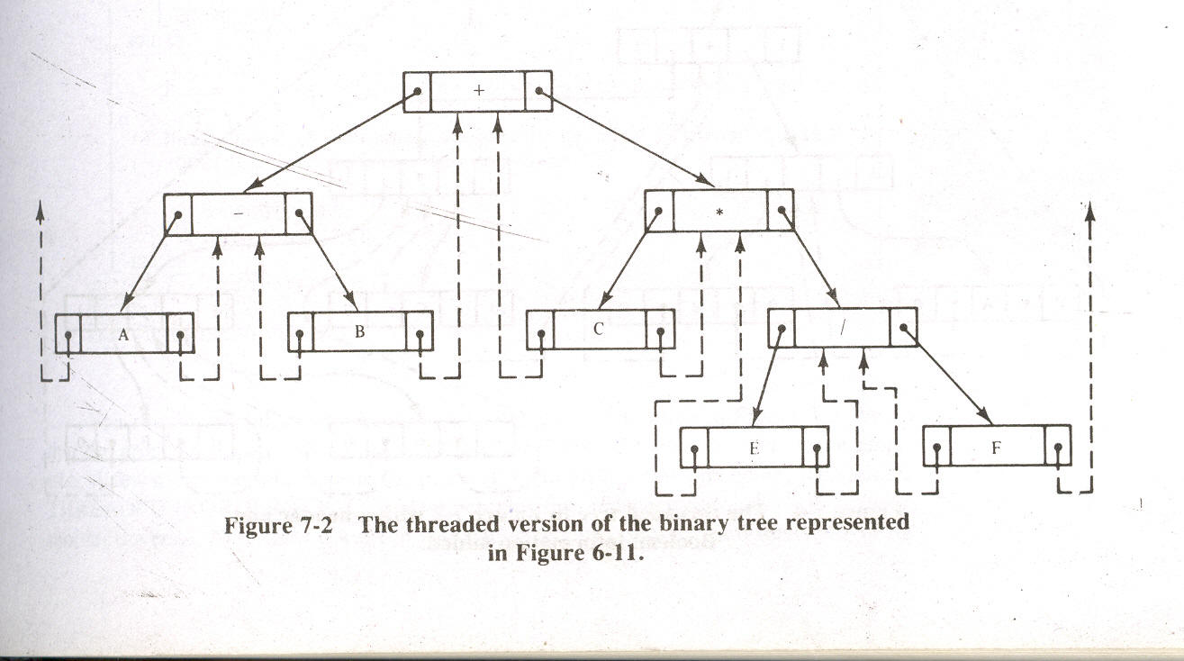

- In order to keep track of which pointers are threads, we shall include 2 additional boolean fields in each node.
- TLPOINT used to indicate whether the left link of the node is a normal pointer or a thread.
- TRPOINT is used analogously for the right link.

- TLPOINT(N)=FALSE
means that LLINK(N) is a normal pointer
Similarly
- TLPOINT(N)=TRUE
means that left link of N is a thread pointer.

- To achieve an inorder traversal of tree we must proceed from each node to its inorder successor
- If it is a thread, then it leads us directly to inorder successor.
- If it is not a thread, then we must follow the right child pointer to the node it references and from there, follow the left child pointers until we encounter a left thread.

Hashing
The search algorithm for searching depends on the number n of elements in the collection S of data.
Hashing is an searching technique which is independent of the number n.
Terminology which we use is based on file management.
First of all we assume that there is a file F of n records with a set K of keys which uniquely determine the records in F.

The general idea of using the key to determine the address of a record is an excellent idea,but it must be modified so that a great deal of space is not wasted.
This modification takes the form of a function H from the set K of keys into the set L of memory addresses.such a function ,
H:K->L
is called a hash function or hashing function .unfortunately,such a function H may not yield distinct values.it is possible that two different k1 and k2 will yield the same hash address.
This situation is called collision and some method must be used to resolve it.

The topic of hashing is divided into two parts
1.hash functions
2.collision resolutions

Hash Functions
The two principle criteria used in selecting a hash function H:K->L are as follows
First of all the function H should be very easy and quick to compute.
Second the function H should uniformly distribute the hash addresses throughout the set L so that there are minimum number of collisions.

a, Division Method.
Chose a number m larger than the number n of keys in K.
H(k)=k (mod m)
Here k (mod m) denotes the remainder when k is divided by m.
b,Midsquare method.
The key k is squared .then the hash function H is defined by H(k)=l.
C,Folding Method.
The key k is partitioned into a number of parts k1….kr
Where each part ,except the last has the same number of digits as the required address.
H(k)=k1+k2+ ………..+kr

Collision Resolution
Suppose we want to add a new record R with key k to our file F but suppose the memory location address H(k) is already occupied. This situation is called collision.
One important factor is the ratio of the number n of keys in k to the number m of hash addresses in L. This ratio
λ=n/m is called the load factor.
The efficiency of a hash function with a collision resolution procedure is measured by the average number of probes needed to find the location of the record with a given key k. the efficiency depends mainly on the load factor λ.
We consider two quantities
S(λ)=average number of probes for a successful search
U(λ)=average number of probes for an unsuccessful search.

Open Addressing:Linear Probing
Suppose that a new record R with key k is to be added to the memory table T ,but that the memory location with hash address H(k)=h is already filled.
One natural way to resolve the collision is to assign R to the first available location following T[h].
The above collision resolution is called linear probing .
The average number of probes for a successful search and for unsuccessful search are following quantities.
S(λ)=1/2(1+1/1-λ)
U(λ)=1/2(1+1/(1-λ)2)

One main disadvantage of linear probing is that records tend to cluster ,that is appear next to one another.such a clustering increases the average search time.
Two techniques to minimize clustering is as follows
1.Quadratic probing:
2.Double Hashing

Minimum Spanning Tree
What is a Minimum Spanning Tree?

- Let G = (V, E) be a simple, connected, undirected graph that is not edge-weighted.

- A spanning tree of G is a free tree (i.e., a tree with no root) with | V | - 1 edges that connects all the vertices of the graph.

- Thus a minimum spanning tree for G is a graph, T = (V’, E’) with the following properties:
  - V’ = V
  - T is connected
  - T is acyclic.

- A spanning tree is called a tree because every acyclic undirected graph can be viewed as a general, unordered tree. Because the edges are undirected, any vertex may be chosen to serve as the root of the tree.

Constructing Minimum Spanning Trees

- Any traversal of a connected, undirected graph visits all the vertices in that graph. The set of edges which are traversed during a traversal forms a spanning tree.
- 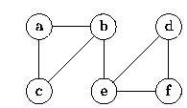
(a) Graph G

- For example, Fig:(b) shows the spanning tree obtained from a breadth-first traversal starting at vertex b.
(b) Breadth-first spanning tree of G rooted at b
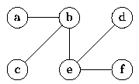

- Similarly, Fig:(c) shows the spanning tree obtained from a depth-first traversal starting at vertex c.
(c) Depth-first spanning tree of G rooted at c
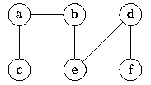

What is a Minimum-Cost Spanning Tree

- For an edge-weighted , connected, undirected graph, G, the total cost of G is the sum of the weights on all its edges.
- A minimum-cost spanning tree for G is a minimum spanning tree of G that has the least total cost.
- Example: The graph

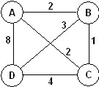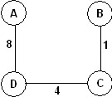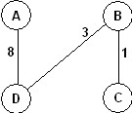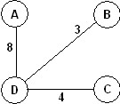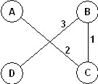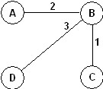
Has 16 spanning trees. Some are:
The graph has two minimum-cost spanning trees, each with a cost of 6:

Applications of Minimum-Cost Spanning Trees

Minimum-cost spanning trees have many applications. Some are:
- Building cable networks that join n locations with minimum cost.
- Building a road network that joins n cities with minimum cost.
- Obtaining an independent set of circuit equations for an electrical network.
- In pattern recognition minimal spanning trees can be used to find noisy pixels.
Example

Prim’s Algorithm

Kruskal’s algorithm.

comparison
Name | Average | Worst | Memory | Stable | Method
Bubble sort |  |  |  | Yes | Exchanging
Selection sort |  |  |  | No | Selection
Insertion sort |  |  |  | Yes | Insertion
Shell sort | — |  |  | No | Insertion
Binary tree sort |  |  |  | Yes | Insertion
Merge sort |  |  |  | Yes | Merging
Heapsort |  |  |  | No | Selection
Quicksort |  |  |  | No | Partitioning

