**Practical-7**

**Q7) Construct an app to display the image on date wise.**

**Ans:-**

**Activity_main.xml**

<?xml version="1.0" encoding="utf-8"?>  
<RelativeLayout xmlns:android="http://schemas.android.com/apk/res/android"  
 xmlns:tools="http://schemas.android.com/tools"  
 android:id="@+id/activity_main"  
 android:layout_width="match_parent"  
 android:layout_height="match_parent">  
  
 <ImageView  
 android:id="@+id/img1"  
 android:layout_width="200dp"  
 android:layout_height="200dp"  
 android:layout_centerHorizontal="true" />  
  
 <Button  
 android:id="@+id/button"  
 android:layout_width="wrap_content"  
 android:layout_height="wrap_content"  
 android:layout_below="@+id/img1"  
 android:layout_centerHorizontal="true"  
 android:text="Change Image" />  
</RelativeLayout>

**MainActivity.java**

package com.example.pratical7_1;  
  
import android.support.v7.app.AppCompatActivity;  
import android.os.Bundle;  
import android.view.View;  
import android.widget.Button;  
import android.widget.ImageView;  
  
public class MainActivity extends AppCompatActivity {  
  
 Button b1;  
 ImageView iv;  
 boolean flag;  
 int images[]={R.drawable.*ic1*,R.drawable.*ic2*,R.drawable.*ic3* };  
 int i=0;  
  
 @Override  
 protected void onCreate(Bundle savedInstanceState) {  
 super.onCreate(savedInstanceState);  
 setContentView(R.layout.*activity_main*);  
  
 iv=(ImageView) findViewById(R.id.*img1*);  
 b1=(Button) findViewById(R.id.*button*);  
  
 flag=true;  
  
 b1.setOnClickListener(new View.OnClickListener(){  
 @Override  
 public void onClick(View v) {  
 iv.setImageResource(images[i]);  
 i++;  
 if(i==1)  
 i=0;  
 }  
 });  
 }  
}

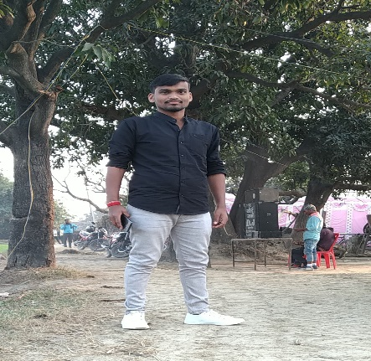 **Image add**



**Output:-**

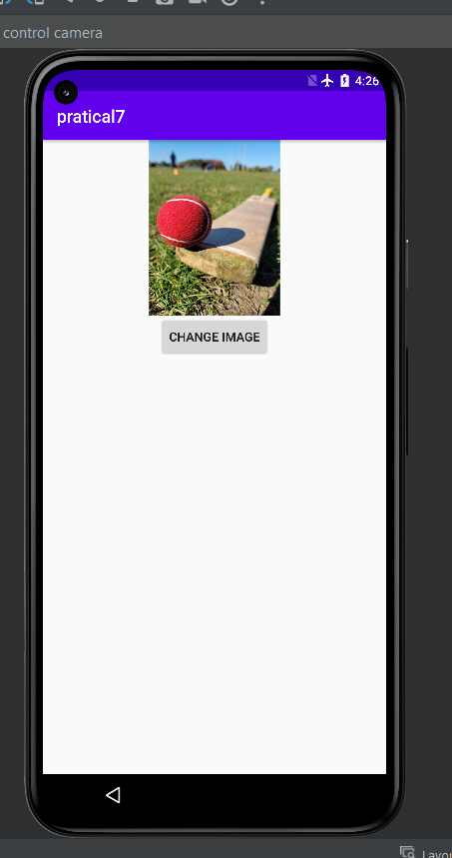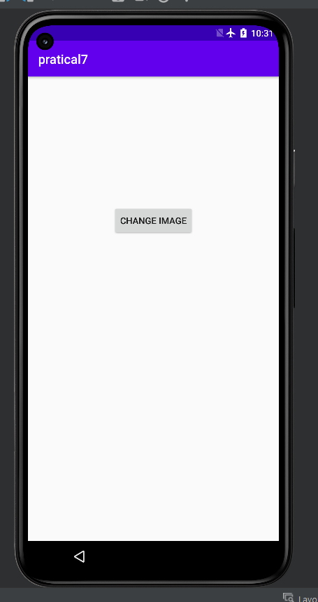

**Practical-8**

**Q8). Construct image switcher using setFactory().**

**Ans:-**

**Activity_main.xml**

<?xml version="1.0" encoding="utf-8"?>  
<LinearLayout xmlns:android="http://schemas.android.com/apk/res/android"  
 android:layout_width="match_parent"  
 android:layout_height="match_parent"  
 android:orientation="vertical">  
  
  
 <ImageSwitcher  
 android:id="@+id/simpleImageSwitcher"  
 android:layout_width="match_parent"  
 android:layout_height="200dp"  
 android:layout_gravity="center_horizontal"  
 android:layout_marginTop="50dp" />  
  
  
 <Button  
 android:id="@+id/buttonNext"  
 android:layout_width="wrap_content"  
 android:layout_height="wrap_content"  
 android:layout_marginTop="150dp"  
 android:layout_gravity="center"  
 android:background="#050"  
 android:textColor="#fff"  
 android:textStyle="bold"  
 android:text="NEXT" />  
  
</LinearLayout>

**MainActivity.java**

package com.example.pratical8;  
  
import android.os.Bundle;  
import android.support.v7.app.AppCompatActivity;  
import android.view.View;  
import android.view.animation.Animation;  
import android.view.animation.AnimationUtils;  
import android.widget.Button;  
import android.widget.ImageSwitcher;  
import android.widget.ImageView;  
import android.widget.LinearLayout;  
import android.widget.ViewSwitcher;  
  
public class MainActivity extends AppCompatActivity {  
 private ImageSwitcher simpleImageSwitcher;  
 Button btnNext;  
  
  
 // Array of Image IDs to Show In ImageSwitcher  
 int imageIds[] = {R.drawable.*image1*, R.drawable.*images2*, R.drawable.*image3*, R.drawable.*images4*, R.drawable.*images5*};  
 int count = imageIds.length;  
 // to keep current Index of ImageID array  
 int currentIndex = -1;  
  
 @Override  
 protected void onCreate(Bundle savedInstanceState) {  
 super.onCreate(savedInstanceState);  
  
 setContentView(R.layout.*activity_main*);  
  
 // get The references of Button and ImageSwitcher  
 btnNext = (Button) findViewById(R.id.*buttonNext*);  
 simpleImageSwitcher = (ImageSwitcher) findViewById(R.id.*simpleImageSwitcher*);  
 // Set the ViewFactory of the ImageSwitcher that will create ImageView object when asked  
 simpleImageSwitcher.setFactory(new ViewSwitcher.ViewFactory() {  
  
 public View makeView() {  
 // *TODO Auto-generated method stub* // Create a new ImageView and set it's properties  
 ImageView imageView = new ImageView(getApplicationContext());  
 // set Scale type of ImageView to Fit Center  
 imageView.setScaleType(ImageView.ScaleType.*FIT_CENTER*);  
 // set the Height And Width of ImageView To FIll PARENT  
 imageView.setLayoutParams(new ImageSwitcher.LayoutParams(LinearLayout.LayoutParams.*FILL_PARENT*, LinearLayout.LayoutParams.*FILL_PARENT*));  
 return imageView;  
 }  
 });  
  
 // Declare in and out animations and load them using AnimationUtils class  
 Animation in = AnimationUtils.*loadAnimation*(this, android.R.anim.*slide_in_left*);  
 Animation out = AnimationUtils.*loadAnimation*(this, android.R.anim.*slide_out_right*);  
  
 // set the animation type to ImageSwitcher  
 simpleImageSwitcher.setInAnimation(in);  
 simpleImageSwitcher.setOutAnimation(out);  
  
  
 // ClickListener for NEXT button  
 // When clicked on Button ImageSwitcher will switch between Images  
 // The current Image will go OUT and next Image will come in with specified animation  
 btnNext.setOnClickListener(new View.OnClickListener() {  
  
 public void onClick(View v) {  
 // *TODO Auto-generated method stub* currentIndex++;  
 // Check If index reaches maximum then reset it  
 if (currentIndex == count)  
 currentIndex = 0;  
 simpleImageSwitcher.setImageResource(imageIds[currentIndex]); // set the image in ImageSwitcher  
 }  
 });  
  
 }  
  
}

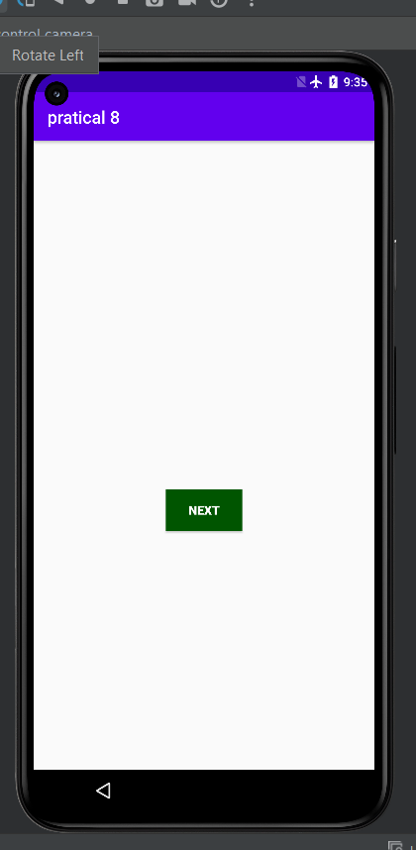**Output:-**

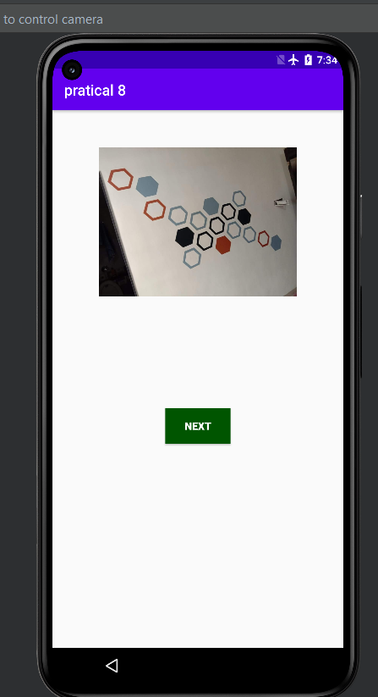

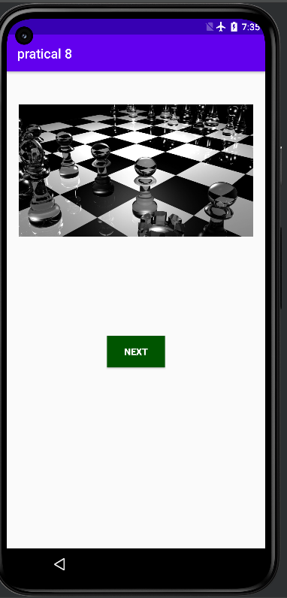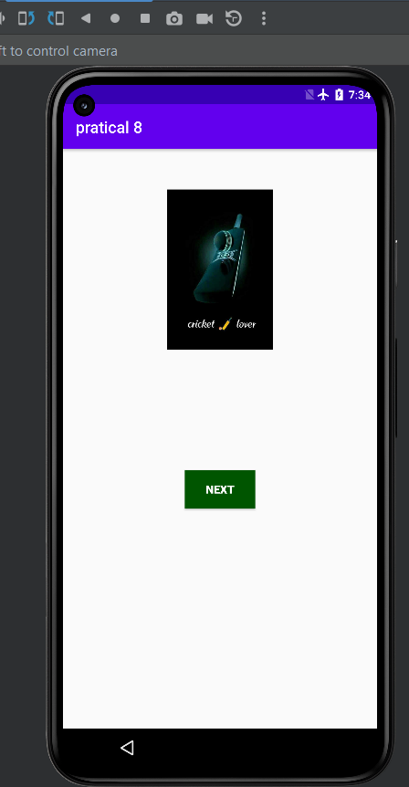

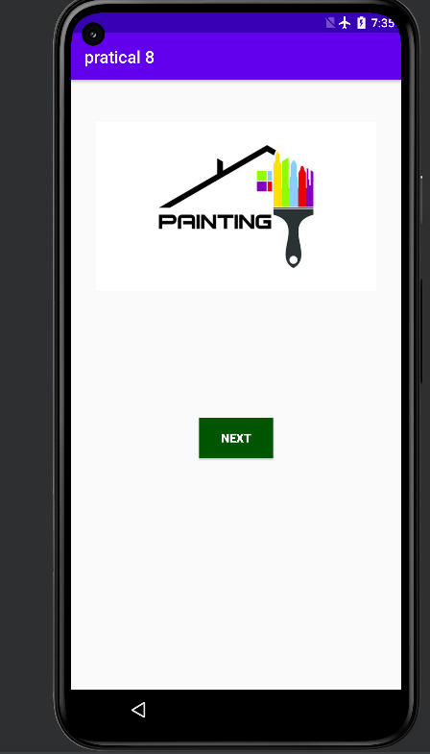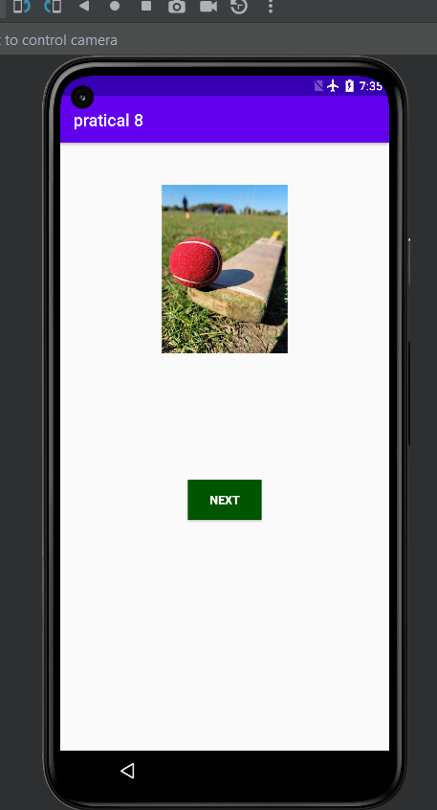

**Practical-9**

**Q9).** **Construct a bank app to display different menu like windrow, deposite etc.**

**Ans:-**

**Activity_main.xml**

<?xml version="1.0" encoding="utf-8"?>  
  
<LinearLayout  
 xmlns:android="http://schemas.android.com/apk/res/android"  
 xmlns:tools="http://schemas.android.com/tools"  
 android:layout_width="match_parent"  
 android:layout_height="match_parent"  
 android:orientation="vertical"  
 tools:context=".MainActivity">  
  
 <!--heading text view-->  
 <TextView  
 android:layout_width="match_parent"  
 android:layout_height="wrap_content"  
 android:layout_margin="20dp"  
 android:text="IFSC Code Validator"  
 android:textAlignment="center"  
 android:textColor="@color/purple_500"  
 android:textSize="30sp" />  
  
 <!-- edit text for entering our IFSC code  
 we are specifying input type as number  
 and we are also mentioning our input type  
 as textcapCharacters because IFSC code is  
 having all capital characters-->  
 <EditText  
 android:id="@+id/idedtIfscCode"  
 android:layout_width="match_parent"  
 android:layout_height="wrap_content"  
 android:layout_margin="20dp"  
 android:hint="Enter IFSC code"  
 android:importantForAutofill="no"  
 android:inputType="textCapCharacters"  
 android:maxLines="1"  
 android:singleLine="true"  
 android:textAllCaps="true" />  
 <Button  
 android:id="@+id/idBtnGetBankDetails"  
 android:layout_width="wrap_content"  
 android:layout_height="wrap_content"  
 android:layout_gravity="center_horizontal"  
 android:layout_marginTop="50dp"  
 android:text="Get Bank Details"  
 android:textAllCaps="false" />  
 <EditText  
 android:id="@+id/idedtIfscCode1"  
 android:layout_width="match_parent"  
 android:layout_height="wrap_content"  
 android:layout_margin="20dp"  
 android:hint="windrow"  
 android:importantForAutofill="no"  
 android:inputType="textCapCharacters"  
 android:maxLines="1"  
 android:singleLine="true"  
 android:textAllCaps="true" />  
  
 <!--button to get the data from IFSC code-->  
 <Button  
 android:id="@+id/idBtnGetBankDetails1"  
 android:layout_width="wrap_content"  
 android:layout_height="wrap_content"  
 android:layout_gravity="center_horizontal"  
 android:layout_marginTop="50dp"  
 android:text="Get Bank windrow"  
 android:textAllCaps="false" />  
 <EditText  
 android:id="@+id/idedtIfscCode2"  
 android:layout_width="match_parent"  
 android:layout_height="wrap_content"  
 android:layout_margin="20dp"  
 android:hint="deposite"  
 android:importantForAutofill="no"  
 android:inputType="textCapCharacters"  
 android:maxLines="1"  
 android:singleLine="true"  
 android:textAllCaps="true" />  
  
 <!--button to get the data from IFSC code-->  
 <Button  
 android:id="@+id/idBtnGetBankDetails2"  
 android:layout_width="wrap_content"  
 android:layout_height="wrap_content"  
 android:layout_gravity="center_horizontal"  
 android:layout_marginTop="50dp"  
 android:text="Get Money Deposite Bank "  
 android:textAllCaps="false" />  
  
 <!--text view to display the  
 data received from IFSC code-->  
 <TextView  
 android:id="@+id/idTVBankDetails"  
 android:layout_width="match_parent"  
 android:layout_height="wrap_content"  
 android:layout_margin="20dp"  
 android:padding="10dp"  
 android:textAlignment="center"  
 android:textAllCaps="false"  
 android:textColor="@color/purple_500"  
 android:textSize="15sp" />  
  
</LinearLayout>

**MainActivity.java**

package com.example.bank;  
  
import android.support.v7.app.AppCompatActivity;  
import android.os.Bundle;  
import android.text.TextUtils;  
import android.view.View;  
import android.widget.Button;  
import android.widget.EditText;  
import android.widget.TextView;  
import android.widget.Toast;  
  
  
  
import org.json.JSONException;  
import org.json.JSONObject;  
  
public class MainActivity extends AppCompatActivity {  
  
 // creating variables for edit text  
 // and our text views.  
 private EditText ifscCodeEdt;  
 private TextView bankDetailsTV;  
  
 // creating a variable for  
 // our ifsc code string.  
 String ifscCode;  
  
 // creating a variable for request queue.  
 private RequestQueue mRequestQueue;  
  
 @Override  
 protected void onCreate(Bundle savedInstanceState) {  
 super.onCreate(savedInstanceState);  
 setContentView(R.layout.*activity_main*);  
  
 // initializing our variables.  
 ifscCodeEdt = findViewById(R.id.*idedtIfscCode*);  
 Button getBankDetailsBtn = findViewById(R.id.*idBtnGetBankDetails*);  
 bankDetailsTV = findViewById(R.id.*idTVBankDetails*);  
  
 // initializing our request queue variable with request queue  
 // and passing our context to it.  
 mRequestQueue = Volley.newRequestQueue(MainActivity.this);  
  
 // initializing on click listener for our button.  
 getBankDetailsBtn.setOnClickListener(new View.OnClickListener() {  
 @Override  
 public void onClick(View v) {  
 // getting string from edittext.  
 ifscCode = ifscCodeEdt.getText().toString();  
  
 // validating if the edit text  
 // is empty or not.  
 if (TextUtils.*isEmpty*(ifscCode)) {  
 // displaying a toast message if the text field is empty  
 Toast.*makeText*(MainActivity.this, "Please enter valid IFSC code", Toast.*LENGTH_SHORT*).show();  
 } else {  
 // calling a method to display  
 // our ifsc code details.  
 getDataFromIFSCCode(ifscCode);  
 }  
 }  
 });  
 }  
  
 private void getDataFromIFSCCode(String ifscCode) {  
  
 // clearing our cache of request queue.  
 mRequestQueue.getCache().clear();  
  
 // below is the url from where we will be getting  
 // our response in the json format.  
 String url = "http://api.techm.co.in/api/v1/ifsc/" + ifscCode;  
  
 // below line is use to initialize our request queue.  
 RequestQueue queue = Volley.newRequestQueue(MainActivity.this);  
  
 // creating a json object request for our API.  
 JsonObjectRequest objectRequest = new JsonObjectRequest(Request.Method.GET, url, null, new Response.Listener<JSONObject>() {  
 @Override  
 public void onResponse(JSONObject response) {  
 // this method is used to get  
 // the response from the API.  
 try {  
 if (response.getString("status").equals("failed")) {  
 // checking if the response is not loaded and  
 // status for the repose is fail.  
 // if response status is failure we are displaying  
 // an invalid IFSC code in our text view.  
 bankDetailsTV.setText("Invalid IFSC Code");  
 } else {  
 // if the status is successful we are  
 // extracting data from JSON file  
 JSONObject dataObj = response.getJSONObject("data");  
 String state = dataObj.optString("STATE");  
 String bankName = dataObj.optString("BANK");  
 String branch = dataObj.optString("BRANCH");  
 String address = dataObj.optString("ADDRESS");  
 String contact = dataObj.optString("CONTACT");  
 String micrcode = dataObj.optString("MICRCODE");  
 String city = dataObj.optString("CITY");  
  
 // after extracting this data we are displaying  
 // that data in our text view.  
 bankDetailsTV.setText("Bank Name : " + bankName + "\nBranch : " + branch + "\nAddress : " + address + "\nMICR Code : " + micrcode + "\nCity : " + city + "\nState : " + state + "\nContact : " + contact);  
 }  
 } catch (JSONException e) {  
 // if we get any error while loading data  
 // we are setting our text as invalid IFSC code.  
 e.printStackTrace();  
 bankDetailsTV.setText("Invalid IFSC Code");  
 }  
 }  
 }, new Response.ErrorListener() {  
 @Override  
 public void onErrorResponse(VolleyError error) {  
 // if we get any error while loading json  
 // data we are setting our text to invalid IFSC code.  
 bankDetailsTV.setText("Invalid IFSC Code");  
 }  
 });  
 // below line is use for adding object  
 // request to our request queue.  
 queue.add(objectRequest);  
 }  
}

**Output:-**

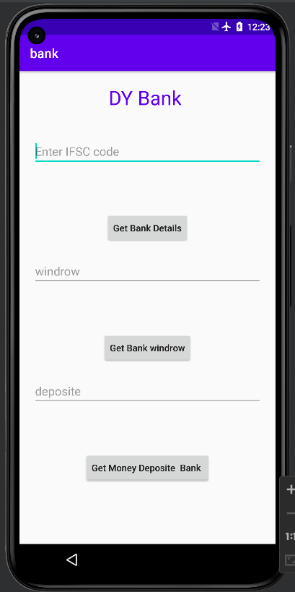

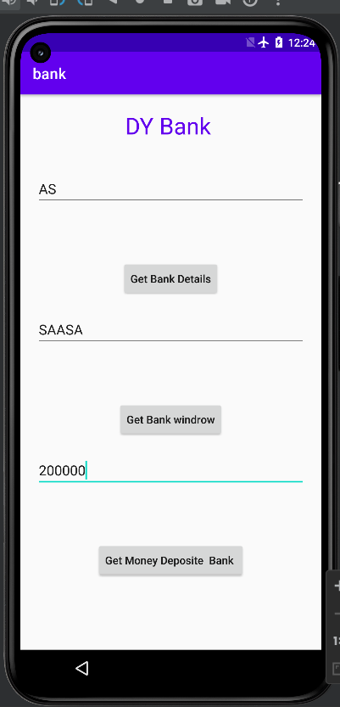

**Practical-10**

**Q10). Create an Android application, where the user can enter player name and points in one view and display it in another view**.

**Ans:-**

**Activity_main.xml**

?xml version="1.0" encoding="utf-8"?>  
<LinearLayout xmlns:android="http://schemas.android.com/apk/res/android"  
 xmlns:app="http://schemas.android.com/apk/res-auto"  
 xmlns:tools="http://schemas.android.com/tools"  
 android:layout_width="match_parent"  
 android:layout_height="match_parent"  
 android:orientation="vertical"  
 >  
 <EditText  
 android:layout_width="match_parent"  
 android:layout_height="wrap_content"  
 android:hint="player name"  
 android:id="@+id/message_text"  
 />  
 <EditText  
 android:layout_width="match_parent"  
 android:layout_height="wrap_content"  
 android:hint="player score"  
 android:id="@+id/message_text1"  
  
 />  
  
  
 <Button  
 android:layout_width="wrap_content"  
 android:layout_height="wrap_content"  
 android:layout_gravity="bottom"  
 android:text="send"  
 android:onClick="sendmessage"  
 />  
</LinearLayout>

**MainActivity.java**

1package com.example.pratical1010;  
  
import android.content.Intent;  
import android.support.v7.app.AppCompatActivity;  
import android.os.Bundle;  
import android.view.View;  
import android.widget.EditText;  
  
public class MainActivity extends AppCompatActivity {  
  
 EditText message_text;  
 EditText message_text1;  
 public final static String *MESSAGE_KEY* = ".message_key";  
  
 protected void onCreate(Bundle savedInstanceState) {  
 super.onCreate(savedInstanceState);  
 setContentView(R.layout.*activity_main*);  
 }  
  
 public void sendmessage(View view) {  
 message_text = (EditText) findViewById(R.id.*message_text*);  
  
  
 String message = message_text.getText().toString();  
  
  
 Intent intent = new Intent(this, secondActivity.class);  
  
 intent.putExtra(*MESSAGE_KEY*, message);  
  
 startActivity(intent);  
 }  
  
}

2<?xml version="1.0" encoding="utf-8"?>  
<android.support.constraint.ConstraintLayout xmlns:android="http://schemas.android.com/apk/res/android"  
 xmlns:app="http://schemas.android.com/apk/res-auto"  
 xmlns:tools="http://schemas.android.com/tools"  
 android:layout_width="match_parent"  
 android:layout_height="match_parent"  
 tools:context=".secondActivity">  
  
</android.support.constraint.ConstraintLayout>

2

package com.example.pratical1010;  
  
import android.app.Activity;  
import android.content.Intent;  
import android.os.Bundle;  
import android.widget.TextView;  
  
public class secondActivity extends Activity {  
  
 public final static String *MESSAGE_KEY* =".message_key";  
  
 @Override  
 protected void onCreate(Bundle savedInstanceState) {  
 super.onCreate(savedInstanceState);  
 Intent intent = getIntent();  
 String message = intent.getStringExtra(*MESSAGE_KEY*);  
 TextView textView = new TextView(this);  
 textView.setTextSize(45);  
 textView.setText(message);  
  
  
 }  
  
}

**Output:-**

**Practical-11**

**Q11). Create an Android application, the user can enter 10 students information and stored it in file and display student information in second view and also search the particular student information.**

**Ans:-**

**Activity_main.xml**

**MainActivity.java**

**Practical-12**

**Q12). Write an application to accept two numbers from the user, and displays them, but reject input if both numbers are greater than 10 and asks for two new numbers**.

**Ans:-**

**Activity_main.xml**

**MainActivity.java**

**Practical-13**

**Q13). Create table Customer (id, name, address, phno). Create Application for Performing the following operation on the table. (using sqlite database) i) Insert New Customer Details. ii) Show All the Customer Details**

**Ans:-**

**Activity_main.xml**

<?xml version="1.0" encoding="utf-8"?>  
<AbsoluteLayout xmlns:android="http://schemas.android.com/apk/res/android"  
 android:layout_width="match_parent"  
 android:layout_height="match_parent">  
 <TextView  
 android:layout_width="wrap_content"  
 android:layout_height="wrap_content"  
 android:layout_x="50dp"  
 android:layout_y="20dp"  
 android:text="Student Details"  
 android:textSize="30sp" />  
  
 <TextView  
 android:layout_width="wrap_content"  
 android:layout_height="wrap_content"  
 android:layout_x="20dp"  
 android:layout_y="110dp"  
 android:text="Enter Rollno:"  
 android:textSize="20sp" />  
  
 <EditText  
 android:id="@+id/Rollno"  
 android:layout_width="150dp"  
 android:layout_height="wrap_content"  
 android:layout_x="175dp"  
 android:layout_y="100dp"  
 android:inputType="number"  
 android:textSize="20sp" />  
  
 <TextView  
 android:layout_width="wrap_content"  
 android:layout_height="wrap_content"  
 android:layout_x="20dp"  
 android:layout_y="160dp"  
 android:text="Enter Name:"  
 android:textSize="20sp" />  
  
 <EditText  
 android:id="@+id/Name"  
 android:layout_width="150dp"  
 android:layout_height="wrap_content"  
 android:layout_x="175dp"  
 android:layout_y="150dp"  
 android:inputType="text"  
 android:textSize="20sp" />  
  
 <TextView  
 android:layout_width="wrap_content"  
 android:layout_height="wrap_content"  
 android:layout_x="20dp"  
 android:layout_y="210dp"  
 android:text="Enter Marks:"  
 android:textSize="20sp" />  
  
 <EditText  
 android:id="@+id/Marks"  
 android:layout_width="150dp"  
 android:layout_height="wrap_content"  
 android:layout_x="175dp"  
 android:layout_y="200dp"  
 android:inputType="number"  
 android:textSize="20sp" />  
  
 <Button  
 android:id="@+id/Insert"  
 android:layout_width="150dp"  
 android:layout_height="wrap_content"  
 android:layout_x="25dp"  
 android:layout_y="300dp"  
 android:text="Insert"  
 android:textSize="30dp" />  
  
 <Button  
 android:id="@+id/Delete"  
 android:layout_width="150dp"  
 android:layout_height="wrap_content"  
 android:layout_x="200dp"  
 android:layout_y="300dp"  
 android:text="Delete"  
 android:textSize="30dp" />  
  
 <Button  
 android:id="@+id/Update"  
 android:layout_width="150dp"  
 android:layout_height="wrap_content"  
 android:layout_x="25dp"  
 android:layout_y="400dp"  
 android:text="Update"  
 android:textSize="30dp" />  
  
 <Button  
 android:id="@+id/View"  
 android:layout_width="150dp"  
 android:layout_height="wrap_content"  
 android:layout_x="200dp"  
 android:layout_y="400dp"  
 android:text="View"  
 android:textSize="30dp" />  
  
 <Button  
 android:id="@+id/ViewAll"  
 android:layout_width="200dp"  
 android:layout_height="wrap_content"  
 android:layout_x="100dp"  
 android:layout_y="500dp"  
 android:text="View All"  
 android:textSize="30dp" />  
  
</AbsoluteLayout>

**MainActivity.java**

package com.example.practical13;  
  
import android.app.Activity;  
import android.app.AlertDialog.Builder;  
import android.content.Context;  
import android.database.Cursor;  
import android.database.sqlite.SQLiteDatabase;  
import android.os.Bundle;  
import android.view.View;  
import android.view.View.OnClickListener;  
import android.widget.Button;  
import android.widget.EditText;  
  
public class MainActivity extends Activity implements OnClickListener  
{  
 EditText Rollno,Name,Marks;  
 Button Insert,Delete,Update,View,ViewAll;  
 SQLiteDatabase db;  
 */** Called when the activity is first created. */* @Override  
 public void onCreate(Bundle savedInstanceState)  
 {  
 super.onCreate(savedInstanceState);  
 setContentView(R.layout.*activity_main*);  
  
 Rollno=(EditText)findViewById(R.id.*Rollno*);  
 Name=(EditText)findViewById(R.id.*Name*);  
 Marks=(EditText)findViewById(R.id.*Marks*);  
 Insert=(Button)findViewById(R.id.*Insert*);  
 Delete=(Button)findViewById(R.id.*Delete*);  
 Update=(Button)findViewById(R.id.*Update*);  
 View=(Button)findViewById(R.id.*View*);  
 ViewAll=(Button)findViewById(R.id.*ViewAll*);  
  
 Insert.setOnClickListener(this);  
 Delete.setOnClickListener(this);  
 Update.setOnClickListener(this);  
 View.setOnClickListener(this);  
 ViewAll.setOnClickListener(this);  
  
 // Creating database and table  
 db=openOrCreateDatabase("StudentDB", Context.*MODE_PRIVATE*, null);  
 db.execSQL("CREATE TABLE IF NOT EXISTS student(rollno VARCHAR,name VARCHAR,marks VARCHAR);");  
 }  
 public void onClick(View view)  
 {  
 // Inserting a record to the Student table  
 if(view==Insert)  
 {  
 // Checking for empty fields  
 if(Rollno.getText().toString().trim().length()==0||  
 Name.getText().toString().trim().length()==0||  
 Marks.getText().toString().trim().length()==0)  
 {  
 showMessage("Error", "Please enter all values");  
 return;  
 }  
 db.execSQL("INSERT INTO student VALUES('"+Rollno.getText()+"','"+Name.getText()+  
 "','"+Marks.getText()+"');");  
 showMessage("Success", "Record added");  
 clearText();  
 }  
 // Deleting a record from the Student table  
 if(view==Delete)  
 {  
 // Checking for empty roll number  
 if(Rollno.getText().toString().trim().length()==0)  
 {  
 showMessage("Error", "Please enter Rollno");  
 return;  
 }  
 Cursor c=db.rawQuery("SELECT * FROM student WHERE rollno='"+Rollno.getText()+"'", null);  
 if(c.moveToFirst())  
 {  
 db.execSQL("DELETE FROM student WHERE rollno='"+Rollno.getText()+"'");  
 showMessage("Success", "Record Deleted");  
 }  
 else  
 {  
 showMessage("Error", "Invalid Rollno");  
 }  
 clearText();  
 }  
 // Updating a record in the Student table  
 if(view==Update)  
 {  
 // Checking for empty roll number  
 if(Rollno.getText().toString().trim().length()==0)  
 {  
 showMessage("Error", "Please enter Rollno");  
 return;  
 }  
 Cursor c=db.rawQuery("SELECT * FROM student WHERE rollno='"+Rollno.getText()+"'", null);  
 if(c.moveToFirst()) {  
 db.execSQL("UPDATE student SET name='" + Name.getText() + "',marks='" + Marks.getText() +  
 "' WHERE rollno='"+Rollno.getText()+"'");  
 showMessage("Success", "Record Modified");  
 }  
 else {  
 showMessage("Error", "Invalid Rollno");  
 }  
 clearText();  
 }  
 // Display a record from the Student table  
 if(view==View)  
 {  
 // Checking for empty roll number  
 if(Rollno.getText().toString().trim().length()==0)  
 {  
 showMessage("Error", "Please enter Rollno");  
 return;  
 }  
 Cursor c=db.rawQuery("SELECT * FROM student WHERE rollno='"+Rollno.getText()+"'", null);  
 if(c.moveToFirst())  
 {  
 Name.setText(c.getString(1));  
 Marks.setText(c.getString(2));  
 }  
 else  
 {  
 showMessage("Error", "Invalid Rollno");  
 clearText();  
 }  
 }  
 // Displaying all the records  
 if(view==ViewAll)  
 {  
 Cursor c=db.rawQuery("SELECT * FROM student", null);  
 if(c.getCount()==0)  
 {  
 showMessage("Error", "No records found");  
 return;  
 }  
 StringBuffer buffer=new StringBuffer();  
 while(c.moveToNext())  
 {  
 buffer.append("Rollno: "+c.getString(0)+"\n");  
 buffer.append("Name: "+c.getString(1)+"\n");  
 buffer.append("Marks: "+c.getString(2)+"\n\n");  
 }  
 showMessage("Student Details", buffer.toString());  
 }  
 }  
 public void showMessage(String title,String message)  
 {  
 Builder builder=new Builder(this);  
 builder.setCancelable(true);  
 builder.setTitle(title);  
 builder.setMessage(message);  
 builder.show();  
 }  
 public void clearText()  
 {  
 Rollno.setText("");  
 Name.setText("");  
 Marks.setText("");  
 Rollno.requestFocus();  
 }  
}

**Output:-**

