Capstone Project : Fault Findy

FaultFindy: Predicting Faulty Tyres in Manufacturing

## Description

FaultFindy is designed as an intelligent system leveraging deep learning to predict faults in tyre manufacturing processes. The system integrates historical manufacturing data and uses advanced machine learning models, like CNNs, to classify tyres into 'Good' and 'Faulty' categories.

## Objectives

1. Develop a deep learning-based model to classify tyres as defective or good.
2. Optimize manufacturing processes using predictive insights.
3. Reduce waste and improve production efficiency.

## Methodology

1. **Load the Data**
2. **EDA**

# Count the number of files

defect_size = len(list(defective_path.glob("*"))) # Get all files in 'defective' folder

good_size = len(list(good_path.glob("*"))) # Get all files in 'good' folder

Number of defective tyre images: 1028

Number of good tyre images: 828

1. **Train Test Split**
2. **Searialize**
3. **Model selection**

base_net = tf.keras.applications.EfficientNetB4(include_top=False, input_shape=(224, 224, 3),weights="/kaggle/input/my-model/efficientnetb4_notop.h5")

global_avg_pooling = layers.GlobalAveragePooling2D()

classifier = layers.Dense(1, activation="sigmoid")

augmented_input = data_aug(input_layer)

feature_maps = base_net(augmented_input)

pooled_features = global_avg_pooling(feature_maps)

output_layer = classifier(pooled_features)

model = keras.Model(inputs=input_layer, outputs=output_layer)

1. **Fine Tune**

# Fine-tune specific layers

for layer in base_net.layers[-10:]:

layer.trainable = True

model.compile(optimizer=tf.keras.optimizers.Nadam(learning_rate=2e-4), loss="binary_crossentropy", metrics=["accuracy"])

model.fit(train_ds, validation_data=val_ds, epochs=10)

## Performance Evaluation of the Model

The EfficientNetB4 architecture was selected for its balance of accuracy and computational efficiency. After training, the model achieved a validation accuracy of 96.12%. Evaluation metrics such as precision, recall, and F1-score were used to ensure the model's robustness in real-world scenarios.

The model achieved high performance, demonstrating its ability to classify tyres effectively:  
- Validation Loss: 0.14269  
- Validation Accuracy: 93.12%

## Visualizations

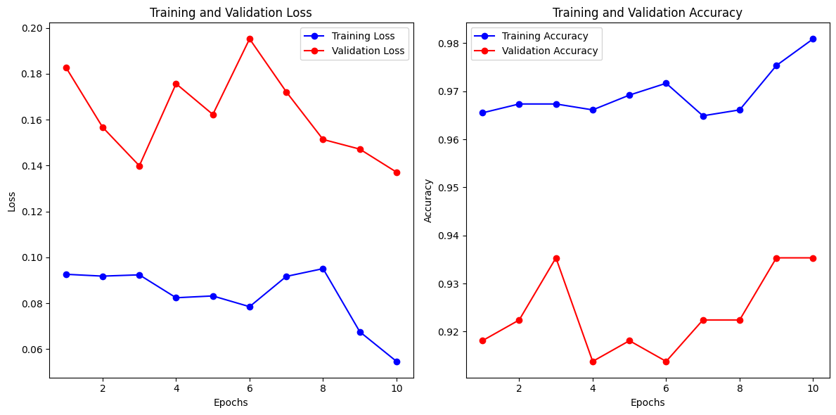

## Future Work

- Incorporate additional data features, such as environmental factors during manufacturing.  
- Implement a feedback loop to continuously update the model with new data.  
- Explore lightweight architectures for real-time deployment in manufacturing environments.

## Conclusion

The FaultFindy project successfully demonstrates the use of deep learning in predicting faulty tyres with high accuracy. The approach can be extended to optimize manufacturing processes and reduce production defects.

Submitted By:

Kiran Birajdar

Github Link : <https://github.com/kiranbirajdar199/CapstoneProject>