Superstore Pivot Report - Insights
1) West is the top region by sales, contributing 31.6% of total sales.
2) Technology is the largest category, driving 36.4% of total sales.
3) Consumer is the largest customer segment, contributing 50.6% of total sales.
4) The highest sales combination is Region=West and Segment=Consumer with sales of 362880.77.
5) Profitability differs by category: best profit margin is Technology while the weakest is Furniture (weighted by sales).

Included Charts
Total Sales by Category
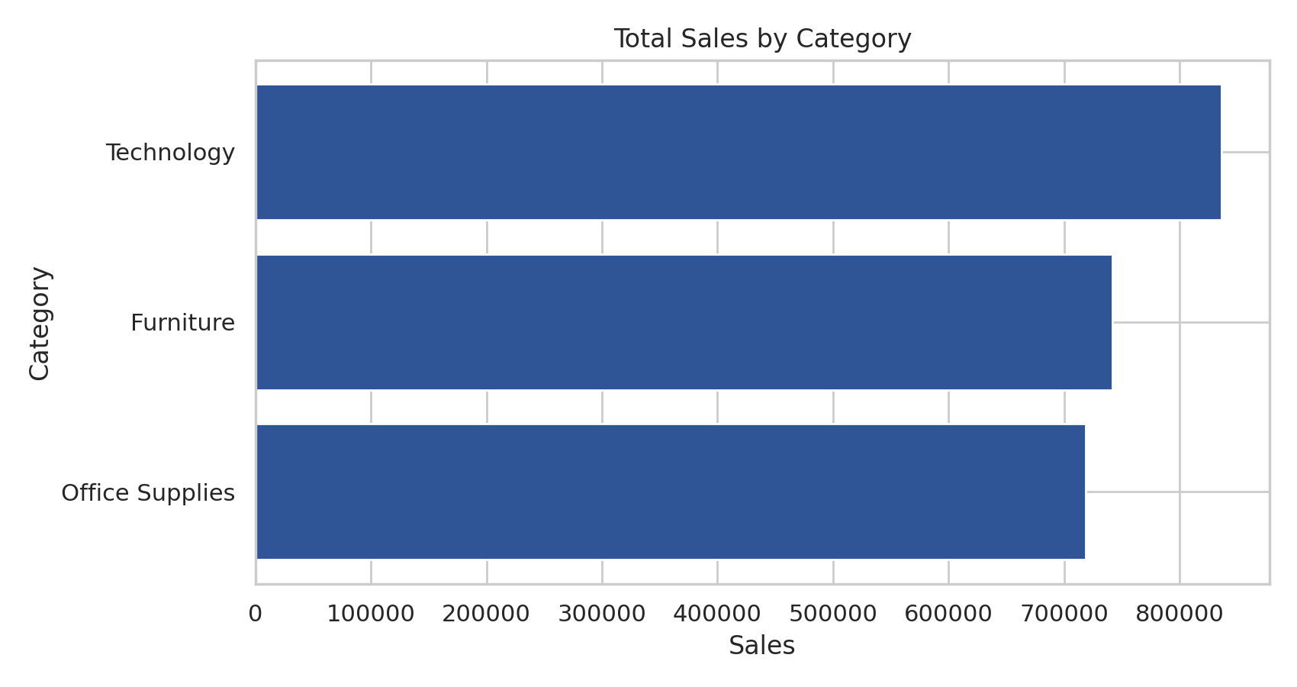
Sales by Region and Segment
