**To check if you have python installed on a Windows PC,**

Search in the start bar for Python or run the following on the Command Line (cmd.exe):

C:\Users\Your Name>**python --version**

-----------------------------------------------------------------------------------------------------------------------

To check if you have python installed on a Linux or Mac, then on linux open the command line or on Mac

open the Terminal and type:

**python --version**

------------------------------------------------------------------------------------------------------------------------

If you find that you do not have Python installed on your computer, then you can download it for free from the following website:

**https://www.python.org/**

------------------------------------------------------------------------------------------------------------------------

Let's write our first Python file, called

helloworld.py, which can be done in any text editor.

**helloworld.py**

**print("Hello, World!")**

----------------------------------------------------------------------------------------------------------------------------

Simple as that. Save your file. Open your command line, navigate to the

directory where you saved your file, and run:

C:\Users\Your Name>**python helloworld.py**

The Python Command Line

To test a short amount of code in python sometimes it is quickest and easiest not to write the code in a file. This is made possible because Python can be run as a command line itself.

Type the following on the Windows, Mac or Linux command line:

C:\Users\Your Name>python

Or, if the "python" command did not work, you can try "py":

C:\Users\Your Name>py

From there you can write any python, including our hello world example from earlier in the tutorial:

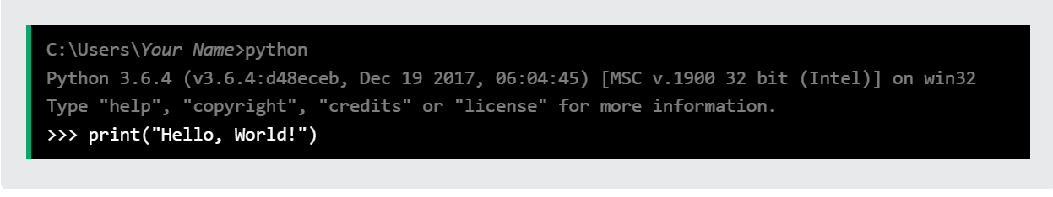

print("Hello, World!")

Which will write "Hello, World!" in the command line:

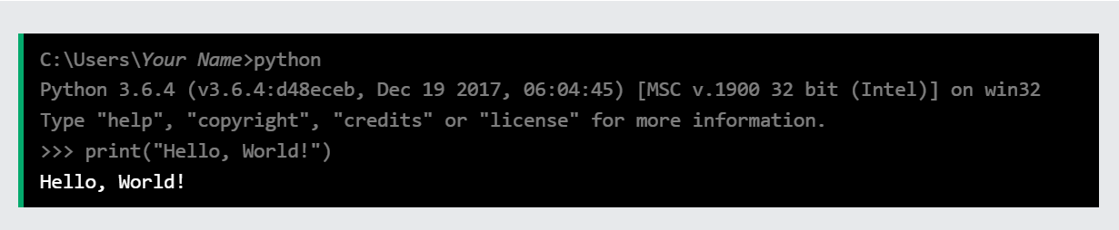

Whenever you are done in the python command line, you can simply type the following to quit the python command line interface:

exit()

## Python Indentation

## Indentation refers to the spaces at the beginning of a code line.

Where in other programming languages the indentation in code is for readability only, the indentation in Python is very important.

**Python uses indentation to indicate a block of code.**

if 5 > 2:  
  print("Five is greater than two!")

Syntax Error:

if 5 > 2:  
print("Five is greater than two!")

The number of spaces is up to you as a programmer, the most common use is four, but it has to be at least one.

### **Example**

if 5 > 2:  
 print("Five is greater than two!")   
if 5 > 2:  
        print("Five is greater than two!")

You have to use the same number of spaces in the same block of code, otherwise Python will give you an error:

### **Example**

Syntax Error:

if 5 > 2:  
 print("Five is greater than two!")  
        print("Five is greater than two!")

# **Python Comments**

Comments can be used to explain Python code.

Comments can be used to make the code more readable.

Comments can be used to prevent execution when testing code.

## Creating a Comment

#This is a comment  
print("Hello, World!")

---------------------------------

print("Hello, World!") #This is a comment

---------------------------------

A comment does not have to be text that explains the code, it can also be used to prevent Python from executing code:

#print("Hello, World!")  
print("Cheers, Mate!")

--------------------------------

## Multi Line Comments

#This is a comment  
#written in  
#more than just one line  
print("Hello, World!")

--------------------------------

Since Python will ignore string literals that are not assigned to a variable, you can add a multiline string (triple quotes) in your code, and place your comment inside it:

"""  
This is a comment  
written in  
more than just one line  
"""  
print("Hello, World!")

--------------------------------