1. Group the items and categories and identify if there are misspellings or errors. This would most easily be done by creating a pivot table

2. Are there duplicates of the groups and are they valid?

3. Identify data with the wrong data type.

4. Calculate the actual profit based on the profit %.

5. Complete a Vlookup to see what the calories for each item are by using the Calories tab.

Group the items and categories and identify if there are misspellings or errors. This would most easily be done by creating a pivot table.

There some misspellings in items like Gumy Bears(actual is Gummy Bears), Hmburger(Actual is Hamburger), Licorce Rope(Actual is Licorice Rope),pizzaa(Actual is Pizza), Popcrn(Actual is Popcorn), popsile(Actual is Popsicle).

**Misspelling in categories:**

1. The category “Beverages” is entered in 3 different ways Beerages, Beverages, Beverags. Beerages and Beverags are incorrect.
2. “Candy” is entered as Cand and Candy. Cand is incorrect.
3. “Frozen Treats” is entered in two different ways Frozen Treat, Frozen Treats.
4. “Hot Food” is entered as Hot Fod, Hot Food. Hot Fod is incorrect.

Also based on the revenue tab and the sales tab, below are some errors noticed.

1. Sales tab has beer totaled to 77 whereas in the revenue tab, it is mentioned as 80. The difference in $3 is attributed to the line items 12 and 100 where the price was $2 and $3 respectively instead of $4.
2. In line item 106, Licorice is priced as $20 whereas all others are priced at $2 this has caused the total in the sales tab to 44 whereas in the revenue tab it is 26.
3. For pizza, there is a dollar difference between sales and revenue tab because of the line item 17 where the price is entered as $1. Remaining are entered as $2.
4. For line item 62, the price is incorrectly entered as $25.00 instead of $2.50. This has caused the difference in Revenue Vs Sales which is 32.5 Vs 55

Are there duplicates of the groups and are they valid?

Yes. There are duplicates because of the misspelling. Duplicates are highlighted below in yellow whereas the original is not highlighted.

|  |
| --- |
| **Category** |
| Beerages |
| Beverages |
| Beverags |
| Cand |
| Candy |
| Frozen Treat |
| Frozen Treats |
| Hot Fod |
| Hot Food |

|  |
| --- |
| **Items** |
| Beer |
| Bottled Water |
| Chocolate Bar |
| Chocolate Dipped Cone |
| Gummy Bears |
| Gumy Bears |
| Hamburger |
| Hmburger |
| Hot Dog |
| Ice Cream Sandwich |
| Licorce Rope |
| Licorice Rope |
| Nachos |
| Pizza |
| Pizzaa |
| Popcorn |
| Popcrn |
| Popsicle |
| Popsile |
| Soda |

Identify data with the wrong data type.

Line items 178 till 182. The data is entered in plain text whereas in other rows, it is entered as a dollar amount. (highlighted in “Basketball Game Sales” tab).

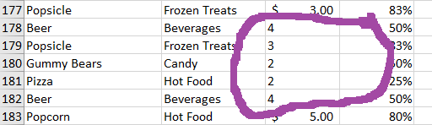

Similarly, line items 197,198,199 are entered as a percentage value.

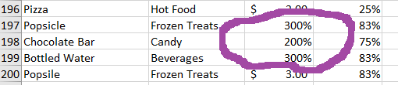

4.Calculate the actual profit based on the profit %.

Please check the “Basketball Game Sales-corrected” tab.

5.Complete a Vlookup to see what the calories for each item are by using the Calories tab.

Please check the “Basketball Game Sales-corrected” tab.