Kirandeep Kaur 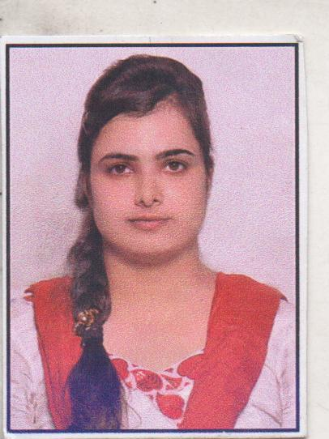
E-mail:kiransraa1993@gmail.com
Contact no: 9896465532

Summary statement

Pursuing B.Tech(4th year) In Computer Science and Engineering from Geeta Institute of Management and Technology (Haryana,India).Able to work under pressure and possess, effective communication skills, willing to face challenges and commitment and drive to succeed.

Objective

To become an asset of an organization with the ability of a good team member.

Computer Skill

- Languages - C, C++, Java, HTML
- Software Package - MS Office(2007,2010&2013).
- Operating System - Windows7,Windows XP.
- Good knowledge of Computer Hardware & Internet.

Educational Programs

- 6 weeks training in Core java from Abacasys, Chandigarh(India).
- 3 months training in Java from OOPS Info Technology Pvt. Ltd, Kurukshtera(India).
- Online course of Java from MASSACHUSETTS Institute of Technology, USA (UDACITY).
- 2 months training in ORACLE DATABASE (Sql Expert) from Steller edge solutions Pvt.Ltd, Chandigarh (India).
- 3 weeks training in Advanced Java from OOPS Info Technology Pvt. Ltd, Kurukshetra (India).

Projects Done

Project Title Car insurance
Language used : Java
Role : Worked on front end and manages coding part .
Team Members : 02
Description: This is a Desktop application for vehicle insurance. Users can register their vehicle for insurance.

Project Title: Exam Suite Application
Language used : Java
Role : Worked on back end (Mysql) and handles coding part.
Team Members : 02
Description : This Project is based on conducting examination and displaying their result. In this online exams are conducted which are based on multiple choice pattern. The paper can be used for multiple subjects like G.K, Aptitude and Science etc.

Project Title: Coaching Center Management System
Language used : Java
Role : Worked on Designing and Coding.
Description : This Project is based overall management of an institute. This project includes different activities of an institute like User queries and their resolutions, Funds details (income and expenses) and Saving/Updating information.

Project Title: Oracle Streams
Technology used: Oracle database
Role : Individual
Description: This project basically represents the databases linkage i.e. changes made in one database are automatically updated in another database.
Operating system used: Linux

Project Title: Clinic Management System
Technology Used : Java
Team Members : 3
Role : Handles Coding part
Description : This Project basically manages the Clinic staff, patients, Queries by the patients. In addition to these, Patients can give their reviews and complain about any inconvenience occurred during the treatment and best part is they can make online appointments.

Education

- B.Tech in Computer Science and Engineering from Geeta Institute of Management and Technology (Haryana), with 76% (till 7th semester)
- 12thwith 84% marks from CBSE Board in 2011.
- 10th with 76% marks from CBSE Board in 2009.

Special Skills And Certfications.

- Udacity certified (java certification).
- Oracle certified SQL Expert (Oracle database)
- IBM Rational Application Developer.

Personal Detail

Date of Birth : 28th October, 1993
Address : D/O Tarjit Singh, Pehalwan colony, Ward number 15, Taraori
Distt - Karnal (Haryana,India).
Sex : Female
Marital Status : Single
Languages : English, Hindi and Punjabi
Nationality : Indian

