INTERVIEW ASSESSMENT FORM
Candidate Name | Prasath Jayaraman | Panel Member Name | Johnsy Metilda T L
Candidate Mobile Number |  | Level of Interview | L1
Candidate Overall Exp | 7+ | Mode of Interview
Recruiter/Schedular Name | Dhivya Krishnan | Date of Interview | 08-04-2026

Panel Members to share the Rating against the Each skill Interviewed.
- All the Fields are mandatory – if not applicable (mark as NA).
- Overall Feedback - Detailed feedback about the candidate and suggestion from the panel members.
- Interview Screenshot – Panel members to attach/share the Interview screenshot with Video on.
5 – EXCEPTIONAL | 4 – GOOD | 3 – AVERAGE | 2 – BELOW AVERAGE | 1 – POOR

Fields | Technical Skills | Self-Rating | Rating | Feedback/Remarks
SKILL 1: | Core Java | 4 | 4 | Good, Strong hands-on experience in Java/J2EE, good understanding of OOPs, collections, exception handling, and enterprise application development.
SKILL 2: | Springboot,API | 4 | 4 | Good, Solid experience in developing REST controllers, service layers, DAO layers using Spring Boot; good understanding of dependency injection and layered architecture.  Strong exposure in REST API development, Postman testing
SKILL 3: | Microservices | 4 | 4 | Good, Experience in building RESTful microservices, inter-service communication using JSON/HTTP; limited exposure to advanced patterns like circuit breakers or service mesh
SKILL 4: | SQL | 4 | 4 | Good in sql queries
SKILL 5: | Coding | 4 | 4 | Good in coding
SKILL 6: | Design patterns | 3 | 3 | Need to improve
SKILL 7:
Domain knowledge (Mention the domain name & Feedback) | Banking, Logistics & Supply Chain | Current role of the candidate |  | Software Developer
Communication & Working with Distributed Teams | Clear technical articulation |  | Final Rating | 4

Overall Assessment (Share the detailed feedback) | The candidate is good in java concepts and good in coding
Panel Recommendation | L1 Selected

Interview Screenshot: 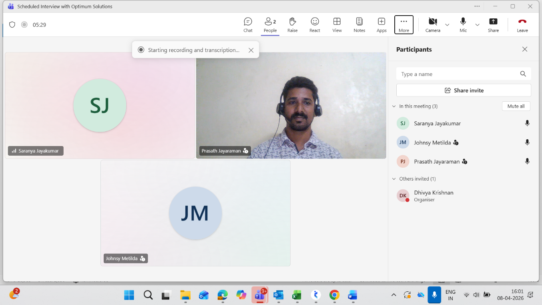

- Coding Details:
No of Coding questions | Skill | Time Taken (mins) | Test Complexity (Low/ Medium/ High) | Coding Status (Completed/ Not Completed) | Remarks
1 | Java | 4 mins | Medium | Completed | used streams and latest methods

TO BE FILLED BY CLIENT TECHNICAL PANEL
5 – EXCEPTIONAL | 4 – GOOD | 3 – AVERAGE | 2 – BELOW AVERAGE | 1 – POOR

Fields | Technical Skills | Rating | Feedback/Remarks
SKILL 1: *
SKILL 2: *
SKILL 3: *
SKILL 4:
SKILL 5:
Domain knowledge (Mention the domain name & Feedback) |  | Assignment  Status
Communication |  | Final Rating

Overall Assessment (Share the detailed feedback)
Panel Recommendation

