WEEK 3 TASK
Advanced Data Analysis and Visualization in Logistics
Python Exploratory Data Analysis, Visualization & Operational Insights
Dataset: Delivery_Logistics_cleaned.csv | Records analyzed: 25,000
Project: Logistics Delivery Analysis
Primary Week 3 focus: Python EDA and visualization

MAIN TASK FOCUS: Python Exploratory Data Analysis (EDA), visualization, interpretation of logistics performance metrics, and evidence-based recommendations. SQL, Excel, and Power BI have been removed from this main Week 3 report so the submission directly matches the Week 3 Advanced Data Analysis and Visualization objective.

1. Objective
The objective of Week 3 is to deepen analytical skills through exploratory data analysis, statistical analysis, and visualization of logistics data. The work examines distributions, relationships, correlations, operational performance, potential bottlenecks, and cost drivers, then converts the evidence into practical recommendations.

2. Dataset and Analytical Context
The task describes a hypothetical logistics dataset. In this project, the hypothetical scenario is represented by the realistic simulated/cleaned dataset prepared during Week 2. The same cleaned source is reused so that all Week 3 calculations and visualizations are traceable to actual records rather than invented numbers.
The dataset contains delivery partner, package type, vehicle type, delivery mode, region, weather condition, distance, package weight, actual delivery time, expected delivery time, delay status, delivery status, customer rating, and delivery cost.

3. Data Preparation for EDA
The cleaned Week 2 CSV was loaded with Pandas. Analytical numeric columns were converted to numeric types where necessary, and a binary delay flag was derived from the delayed field. No additional business observations were fabricated.

4. Python EDA and Visualization

4.1 Python EDA methodology
The Python EDA sequence was: load the cleaned CSV → inspect and prepare analytical fields → run describe() for central tendency and spread → calculate group summaries → calculate the Pearson correlation matrix → generate distribution plots → generate relationship plots → interpret the results in an operational logistics context.
Matplotlib was used for consistency and reproducibility. Seaborn could be used for more statistical styling, while Plotly could extend the project with interactive visual exploration.

4.2 Descriptive statistics
Metric | Mean | Median | Minimum | Maximum
distance_km | 150.39 | 151.00 | 3.60 | 297.10
package_weight_kg | 25.15 | 25.14 | 0.67 | 49.52
delivery_time_hours | 6.25 | 6.00 | 0.00 | 19.00
expected_time_hours | 13.11 | 8.00 | 2.00 | 24.00
delivery_cost | 864.94 | 867.54 | 95.67 | 1632.72
delivery_rating | 3.67 | 4.00 | 1.00 | 5.00
Across 25,000 records, average delivery time is 6.25 hours versus a median of 6.00 hours. Average delivery cost is 864.94 versus a median of 867.54. Average customer rating is 3.67/5.

4.3 Delivery-time distribution
Why this visualization was selected: A histogram is appropriate because delivery time is a continuous numerical variable and the analysis needs to see how observations are distributed across time intervals. It reveals concentration, spread, and the tail of slower deliveries, information that a single average cannot provide.
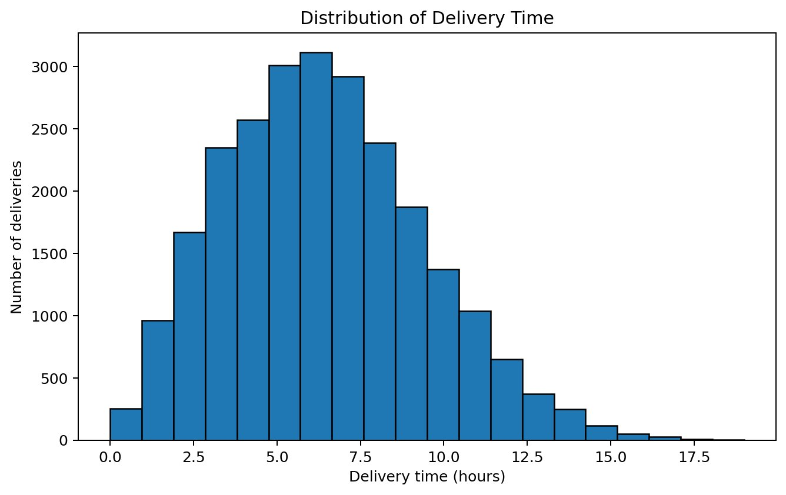
What it shows and how it helps: The mean is 6.25 hours and the median is 6.00 hours. The visual helps operations teams assess service consistency and identify unusually slow delivery observations.

4.4 Delivery-cost distribution
Why this visualization was selected: A histogram is suitable because delivery cost is numerical and managers need to understand the frequency of different cost ranges. It can reveal whether costs are tightly grouped or whether a smaller set of expensive shipments creates a high-cost tail.
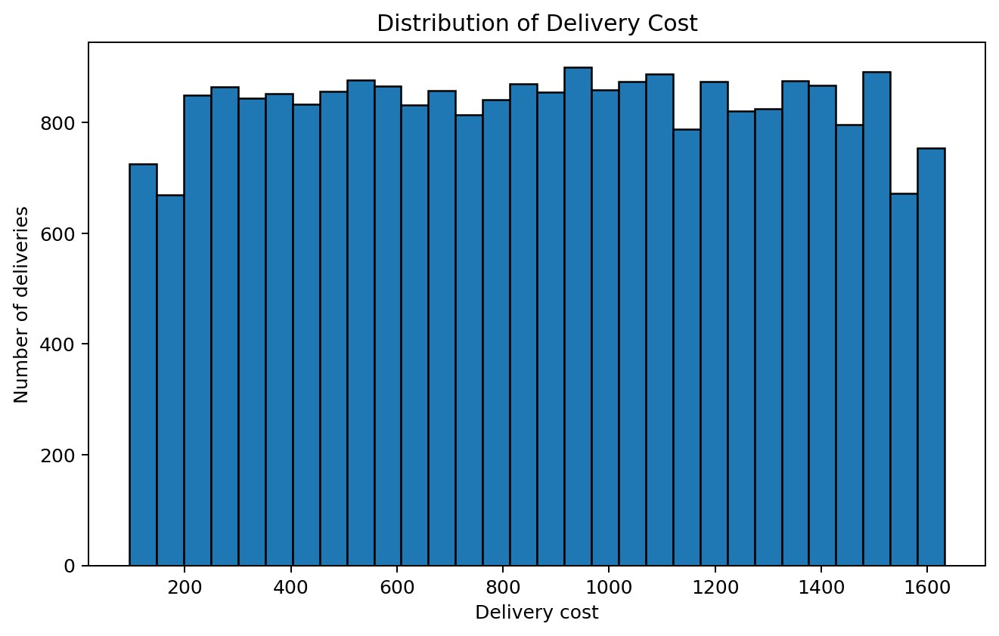
What it shows and how it helps: The mean cost is 864.94, while the median is 867.54. The distribution helps identify the typical cost range and potential high-cost exceptions for further investigation.

4.5 Distance versus delivery cost
Why this visualization was selected: A scatter plot is selected because both distance and cost are numerical and the objective is to examine their pairwise relationship. It preserves individual shipment variation and makes clusters, spread, and possible linear association visible.
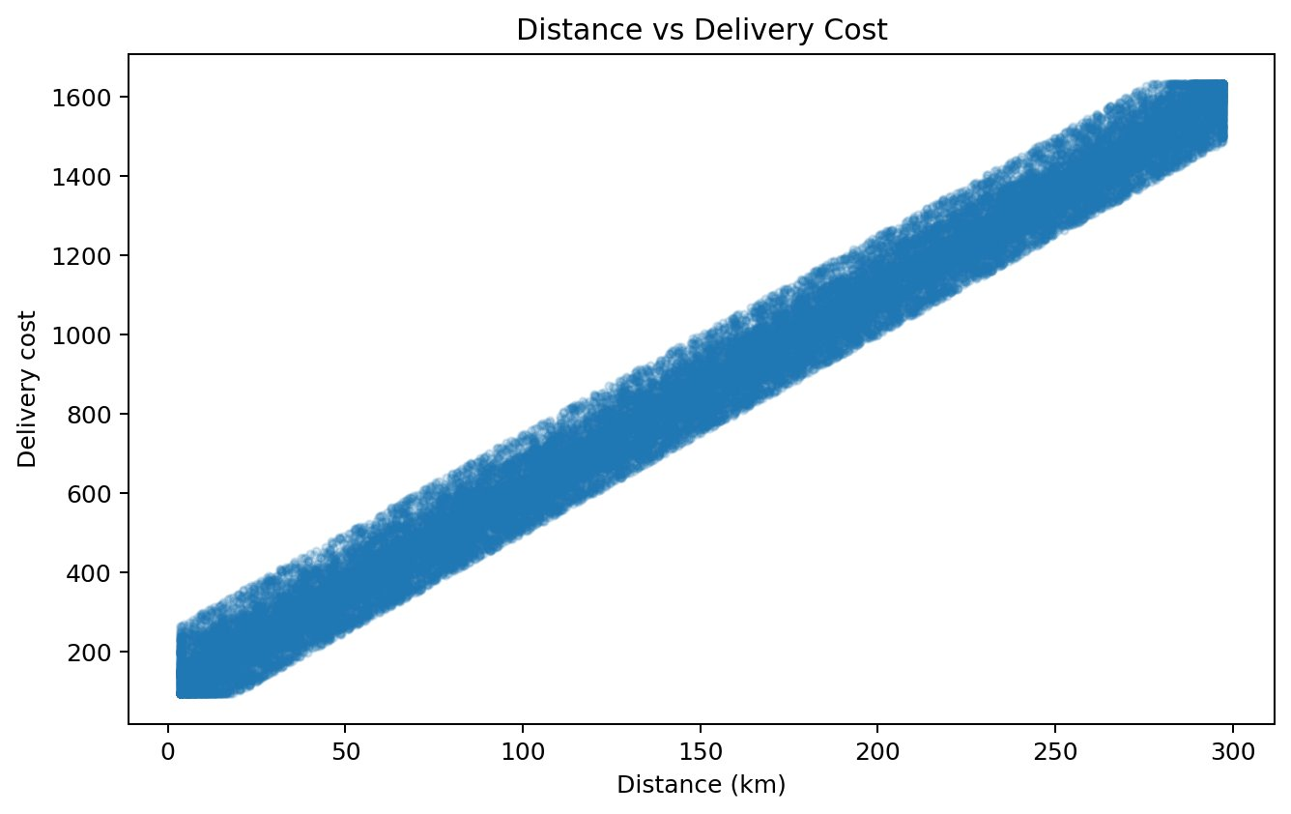
What it shows and how it helps: The Pearson correlation is 0.991. The visual helps assess whether longer routes are associated with higher costs and whether route distance should be considered when reviewing expensive shipments.

4.6 Distance versus delivery time
Why this visualization was selected: A scatter plot is appropriate because the question is whether route distance is associated with actual delivery time. It shows both the overall pattern and variation among shipments with similar distances, which a simple average comparison would hide.
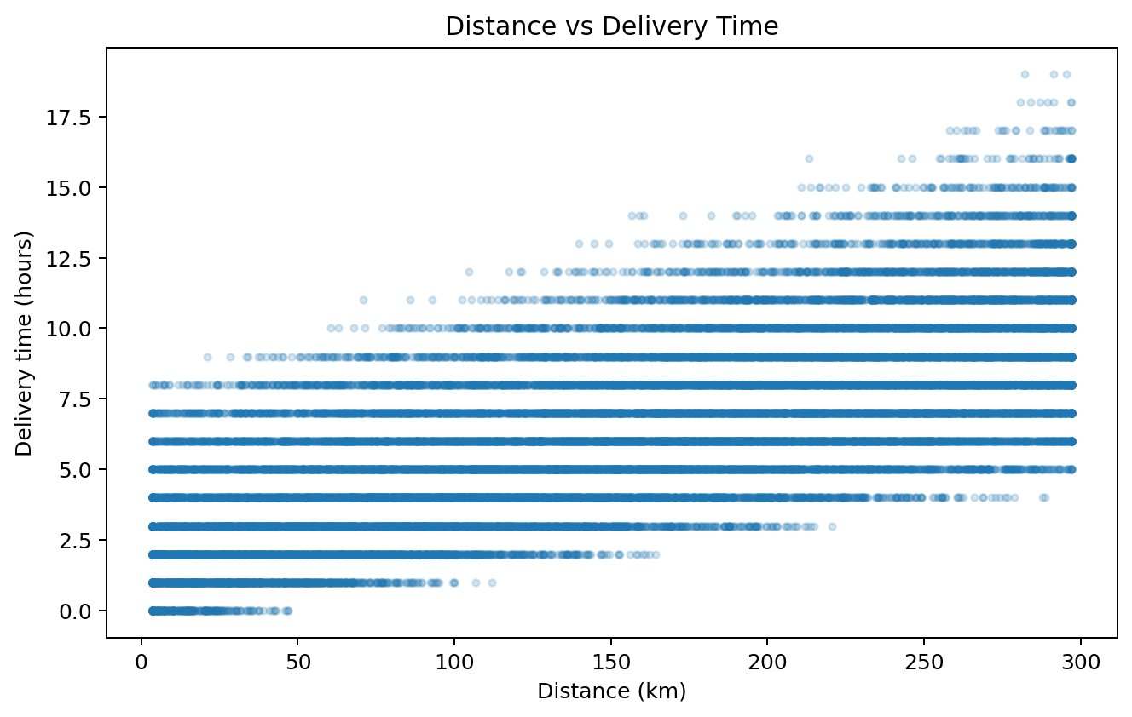
What it shows and how it helps: The Pearson correlation is 0.686. The chart helps evaluate whether longer routes tend to require more time while showing that other operational factors may also influence delivery time.

4.7 Package weight versus delivery cost
Why this visualization was selected: A scatter plot is suitable because package weight and delivery cost are both numerical variables. It allows shipment-level variation to be examined and tests whether heavier packages tend to be associated with higher costs.
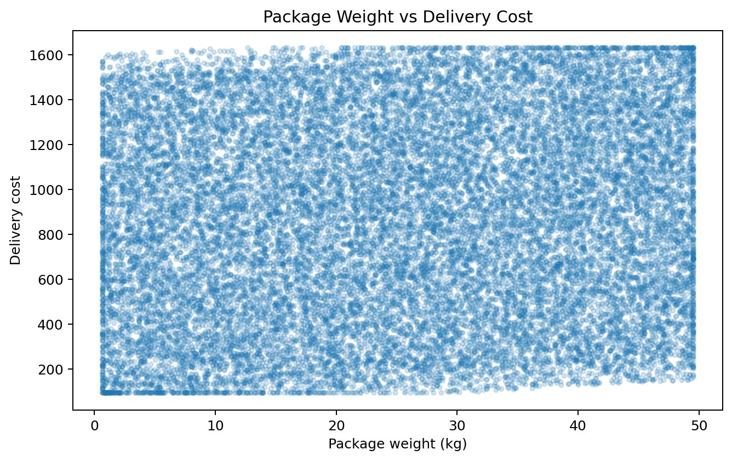
What it shows and how it helps: The Pearson correlation is 0.099. The visual helps evaluate package weight as a possible cost-related factor and highlights whether weight alone provides a strong or weak explanation of cost variation.

4.8 Correlation heatmap
Why this visualization was selected: A correlation heatmap is selected because several numerical logistics metrics must be compared simultaneously. The matrix provides a compact visual summary of positive, negative, and weak linear relationships and helps prioritize relationships for deeper analysis.
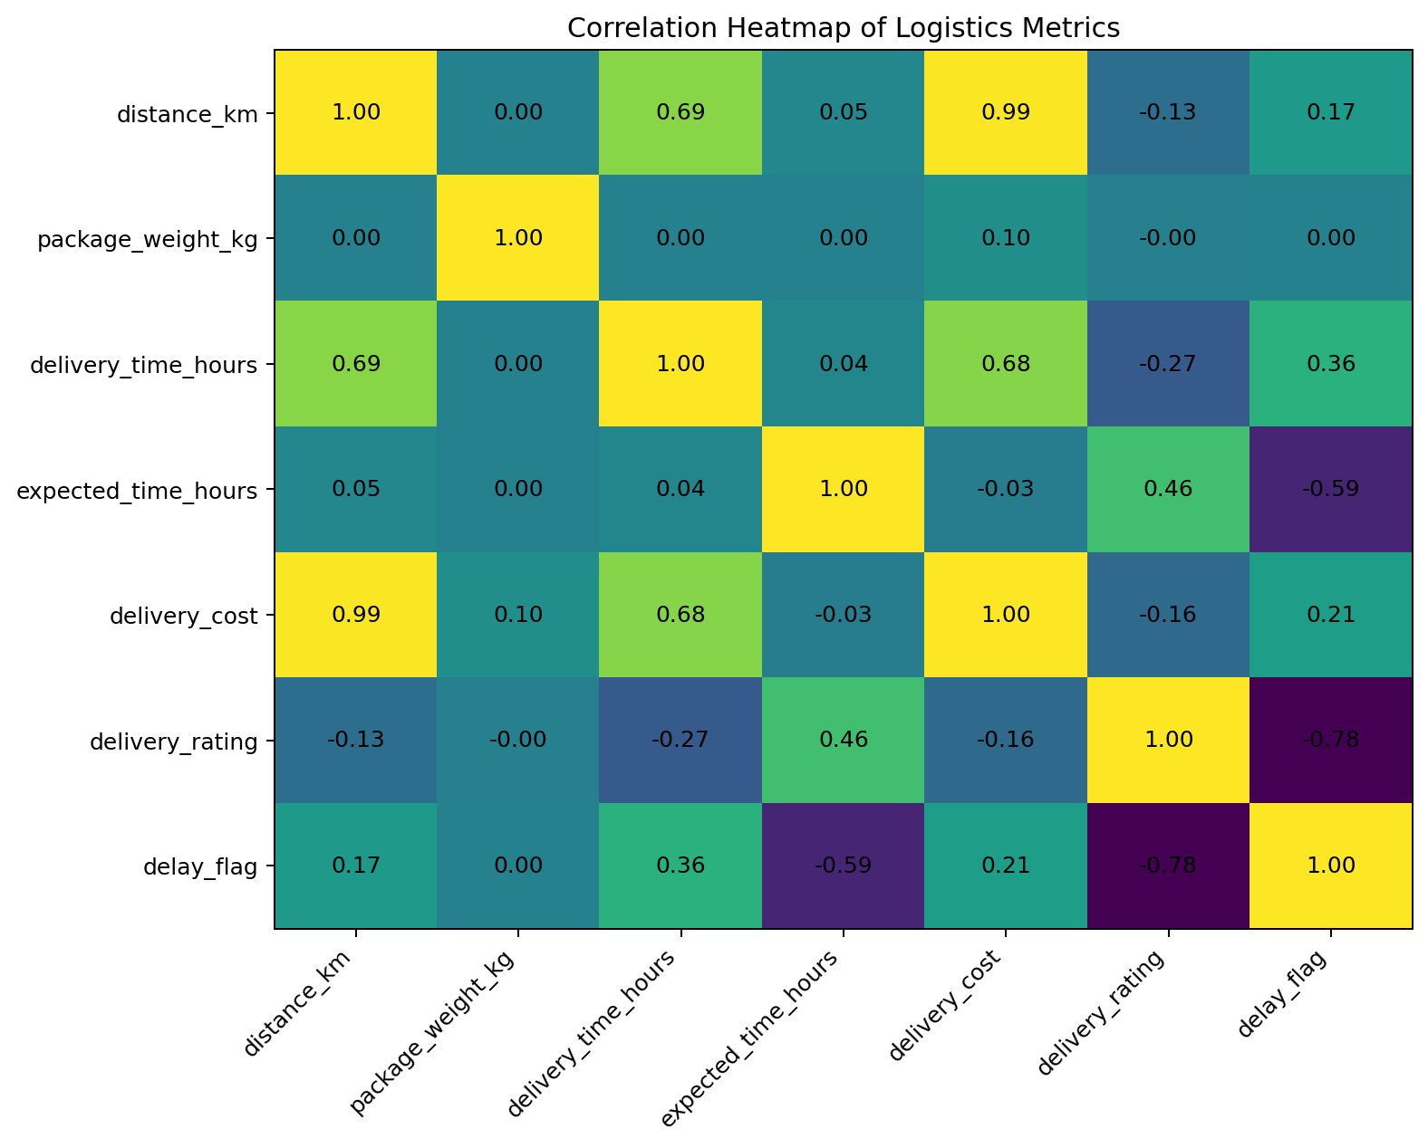
What it shows and how it helps: The heatmap helps identify which metrics move together, supporting analysis of cost, time, rating, distance, weight, and delay relationships. It is a screening tool and does not prove causation.

5. How Visualizations Help Interpret Logistics Performance Metrics
The six visuals work together to convert raw logistics records into operational evidence. The two histograms assess the distribution and consistency of delivery time and cost. The three scatter plots investigate relationships involving route distance and package weight, which can help explain variation in cost and service time. The heatmap provides a broader view of how the main numerical KPIs relate to one another.
This combination supports practical questions such as: Are delivery times stable or highly variable? Are costs concentrated or dominated by expensive exceptions? Does distance appear related to cost or delivery time? Does package weight show a meaningful cost relationship? Which variables deserve deeper investigation? These answers help identify operational efficiency issues, potential cost drivers, and bottlenecks before management decisions are made.
Visualizations should be interpreted together with business context. Correlation indicates association rather than causation, so high-delay regions, partners, weather conditions, or shipment characteristics should be investigated further before being treated as root causes.

6. Supporting Operational Analysis

6.1 Overall delay performance
6,669 of 25,000 deliveries were flagged as delayed, giving a delay rate of 26.68% and an on-time rate of 73.32%.

6.2 Delivery-mode comparison
- express: 6,233 deliveries; average time 6.23 h; average cost 880.43; delay rate 73.78%.
- standard: 6,186 deliveries; average time 6.24 h; average cost 819.34; delay rate 0.00%.
- same day: 6,279 deliveries; average time 6.24 h; average cost 929.87; delay rate 32.54%.
- two day: 6,302 deliveries; average time 6.28 h; average cost 829.71; delay rate 0.43%.

6.3 Operational comparison findings
- Highest observed regional delay rate: central at 27.25%.
- Highest observed partner delay rate: xpressbees at 28.27%.
- Highest observed weather-category delay rate: stormy at 41.45%.
- Fastest mode by average delivery time: express at 6.23 hours.
- Highest-cost mode by average delivery cost: same day at 929.87.

7. Analytical Insights and Recommendations

7.1 Key insights
- The overall delay rate is 26.68%, providing a baseline for service improvement.
- Distance-cost correlation is 0.991; distance should be considered alongside other shipment factors when reviewing cost.
- Distance-time correlation is 0.686; route length may contribute to delivery time, but it does not explain all variation.
- Weight-cost correlation is 0.099; package weight can be evaluated as one potential cost-related variable.
- Region, partner, and weather comparisons identify candidates for operational investigation, not automatic causal explanations.

7.2 Recommendations
- Investigate high-delay regions and partners at route and shipment level before changing operational policies.
- Review high-cost deliveries using distance, package weight, mode, and partner together.
- Use a balanced partner scorecard covering average cost, average delivery time, delay rate, and customer rating.
- Create exception monitoring for delayed shipments and unusually high delivery costs.
- Use Python visuals for diagnosis and Power BI for interactive filtering and drill-through.
- Collect reliable date/time and latitude/longitude fields in future datasets to enable time-series and map analysis.

8. Python Visualization Code Appendix
All six visualization methods used in the report are included below.

8.1 Delivery-time histogram
import pandas as pd
import matplotlib.pyplot as plt
df = pd.read_csv("data/Delivery_Logistics_cleaned.csv")
plt.figure(figsize=(8.5, 5))
plt.hist(df["delivery_time_hours"].dropna(), bins=20, edgecolor="black")
plt.title("Distribution of Delivery Time")
plt.xlabel("Delivery time (hours)")
plt.ylabel("Number of deliveries")
plt.tight_layout()
plt.show()

8.2 Delivery-cost histogram
plt.figure(figsize=(8.5, 5))
plt.hist(df["delivery_cost"].dropna(), bins=30, edgecolor="black")
plt.title("Distribution of Delivery Cost")
plt.xlabel("Delivery cost")
plt.ylabel("Number of deliveries")
plt.tight_layout()
plt.show()

8.3 Distance vs delivery cost
plt.figure(figsize=(8.5, 5))
plt.scatter(df["distance_km"], df["delivery_cost"], alpha=0.18, s=10)
plt.title("Distance vs Delivery Cost")
plt.xlabel("Distance (km)")
plt.ylabel("Delivery cost")
plt.tight_layout()
plt.show()

8.4 Distance vs delivery time
plt.figure(figsize=(8.5, 5))
plt.scatter(df["distance_km"], df["delivery_time_hours"], alpha=0.18, s=10)
plt.title("Distance vs Delivery Time")
plt.xlabel("Distance (km)")
plt.ylabel("Delivery time (hours)")
plt.tight_layout()
plt.show()

8.5 Package weight vs delivery cost
plt.figure(figsize=(8.5, 5))
plt.scatter(df["package_weight_kg"], df["delivery_cost"], alpha=0.18, s=10)
plt.title("Package Weight vs Delivery Cost")
plt.xlabel("Package weight (kg)")
plt.ylabel("Delivery cost")
plt.tight_layout()
plt.show()

8.6 Correlation heatmap
metrics = [
"distance_km", "package_weight_kg",
"delivery_time_hours", "expected_time_hours",
"delivery_cost", "delivery_rating", "delay_flag"
]
correlation_matrix = df[metrics].corr()
plt.figure(figsize=(9, 7))
plt.imshow(correlation_matrix.values, aspect="auto")
plt.xticks(range(len(correlation_matrix.columns)),
correlation_matrix.columns, rotation=45, ha="right")
plt.yticks(range(len(correlation_matrix.columns)),
correlation_matrix.columns)
for i in range(len(correlation_matrix.columns)):
for j in range(len(correlation_matrix.columns)):
plt.text(j, i, f"{correlation_matrix.iloc[i, j]:.2f}",
ha="center", va="center")
plt.title("Correlation Heatmap of Logistics Metrics")
plt.tight_layout()
plt.show()

8.7 Complete EDA sequence
# 1. Load
df = pd.read_csv("data/Delivery_Logistics_cleaned.csv")
# 2. Describe
print(df.describe())
# 3. Create delay indicator
df["delay_flag"] = (df["delayed"].str.lower() == "yes").astype(int)
# 4. Correlation analysis
metrics = [
"distance_km", "package_weight_kg",
"delivery_time_hours", "expected_time_hours",
"delivery_cost", "delivery_rating", "delay_flag"
]
correlation_matrix = df[metrics].corr()
print(correlation_matrix)
# 5. Generate the six visualizations shown above.

9. Conclusion
Week 3 transformed the cleaned simulated logistics dataset into a practical Python EDA and visualization study covering 25,000 deliveries. The analysis established an average delivery time of 6.25 hours, average delivery cost of 864.94, and delay rate of 26.68%. Six complementary visualizations examined distributions, relationships, and correlations. The results provide evidence for investigating operational efficiency, cost drivers, and bottlenecks while avoiding unsupported causal claims.

10. Submission Checklist
- Realistic simulated/cleaned Week 2 dataset used as the Week 3 source.
- Python EDA methodology documented in sequence.
- Descriptive statistics with actual values.
- Delivery-time histogram with chart-type justification and interpretation.
- Delivery-cost histogram with chart-type justification and interpretation.
- Distance vs cost scatter plot with chart-type justification and interpretation.
- Distance vs time scatter plot with chart-type justification and interpretation.
- Package weight vs cost scatter plot with chart-type justification and interpretation.
- Correlation heatmap with chart-type justification and interpretation.
- Dedicated section explaining how all visualizations help interpret logistics performance metrics.
- Python code for all six visualizations.
- Analytical insights and evidence-based recommendations.
- Seaborn and Plotly mentioned as possible extensions.

