WEEK 4 TASK
Predictive Modeling and Optimization in Logistics Systems
Python Predictive Modeling, Validation & Operational Optimization

Project | Details
Project | Logistics Delivery Analysis
Dataset | Delivery_Logistics_cleaned.csv
Records analyzed | 25,000
Prediction target | Delivery time (hours)
Primary model | Ridge Regression
Validation | 80/20 hold-out test + 5-fold cross-validation
Optimization layer | Model-based delivery-mode scenario analysis and risk prioritization

Executive Summary
This Week 4 project develops a predictive model for actual delivery time using the cleaned logistics dataset from the earlier project phase. The objective is to estimate delivery duration at the planning/dispatch stage so that operations teams can identify potentially slow shipments before service performance is finalized.
The dataset contains 25,000 records. The model uses pre-dispatch operational variables such as delivery partner, package type, vehicle type, delivery mode, region, weather condition, distance, package weight, and expected delivery time. Post-delivery fields such as delay status, delivery status, customer rating, and the final delivery time are excluded from predictors. Final delivery cost is also excluded so that the model does not depend on a cost value that may only be known after the delivery.
Several candidate models were compared. On the fixed 20% test set, Ridge Regression achieved MAE 1.283 hours, RMSE 1.622 hours, and R² 0.728. Five-fold cross-validation produced mean MAE 1.284 hours, mean RMSE 1.617 hours, and mean R² 0.735. The results indicate useful predictive signal while also showing that the model should be treated as a planning aid rather than a guarantee of exact delivery time.

1. Objective
- Define a logistics forecasting problem with a measurable target variable.
- Prepare the cleaned dataset for supervised machine learning.
- Compare multiple regression approaches and select a suitable baseline model.
- Evaluate predictions using MAE, RMSE, and R².
- Use cross-validation and hyperparameter tuning to test model stability.
- Translate predictions into practical operational optimization strategies.

2. Problem Definition
Business question: Given the information available when a shipment is being planned or dispatched, can the expected actual delivery time be predicted accurately enough to support prioritization, resource allocation, and service planning?
Item | Definition
Target | delivery_time_hours
Problem type | Supervised regression
Prediction unit | Delivery record
Prediction timing | Planning/dispatch stage
Primary business use | Identify potentially slow deliveries before completion
Decision support | Prioritize monitoring, staffing, mode selection, and route review

3. Dataset and Feature Design
The project reuses the cleaned Week 2 logistics dataset so the predictive analysis remains traceable to the same operational scenario. The dataset contains categorical and numerical attributes describing delivery operations.
Feature group | Variables used | Role
Categorical | delivery_partner, package_type, vehicle_type, delivery_mode, region, weather_condition | Encode operational categories
Numerical | distance_km, package_weight_kg, expected_time_hours | Represent measurable shipment characteristics
Target | delivery_time_hours | Predicted outcome
Excluded identifiers | delivery_id, delivery_id_original | Not predictive business features
Excluded post-outcome fields | delayed, delivery_status, delivery_rating | Avoid target leakage
Excluded final-cost field | delivery_cost | Keep model usable before final cost is known

4. Data Preparation
Pandas is used to load the CSV. Numerical variables are imputed with their median when required and standardized for the linear models. Categorical variables are imputed with the most frequent category and one-hot encoded. The complete transformation is placed inside a scikit-learn pipeline so that preprocessing is learned only from the training data during validation.
import pandas as pd
df = pd.read_csv("data/Delivery_Logistics_cleaned.csv")
target = "delivery_time_hours"
exclude = [
"delivery_id", "delivery_id_original",
"delayed", "delivery_status", "delivery_rating",
"delivery_cost", target
]
X = df.drop(columns=exclude)
y = df[target]

5. Train/Test Split and Validation Design
An 80/20 train-test split with random_state=42 was used. The training set is used for model fitting and tuning, while the test set is held out until final performance measurement. Five-fold shuffled cross-validation is then applied to the selected Ridge pipeline to check whether performance is stable across different partitions of the data.
from sklearn.model_selection import train_test_split, KFold, GridSearchCV
X_train, X_test, y_train, y_test = train_test_split(
X, y, test_size=0.20, random_state=42
)
cv = KFold(n_splits=5, shuffle=True, random_state=42)

6. Model Selection
The candidate models were chosen to provide a meaningful progression from a simple baseline to linear and nonlinear methods. Linear Regression provides an interpretable benchmark. Ridge Regression adds L2 regularization, which is useful after one-hot encoding creates many correlated predictor columns. Gradient Boosting and Random Forest test whether nonlinear ensemble methods materially improve the result.
Model | Test MAE (h) | Test RMSE (h) | Test R²
Ridge Regression | 1.283 | 1.622 | 0.728
Linear Regression | 1.283 | 1.622 | 0.728
Gradient Boosting | 1.283 | 1.625 | 0.728
Random Forest | 1.293 | 1.635 | 0.724
Mean Baseline | 2.514 | 3.112 | -0.000
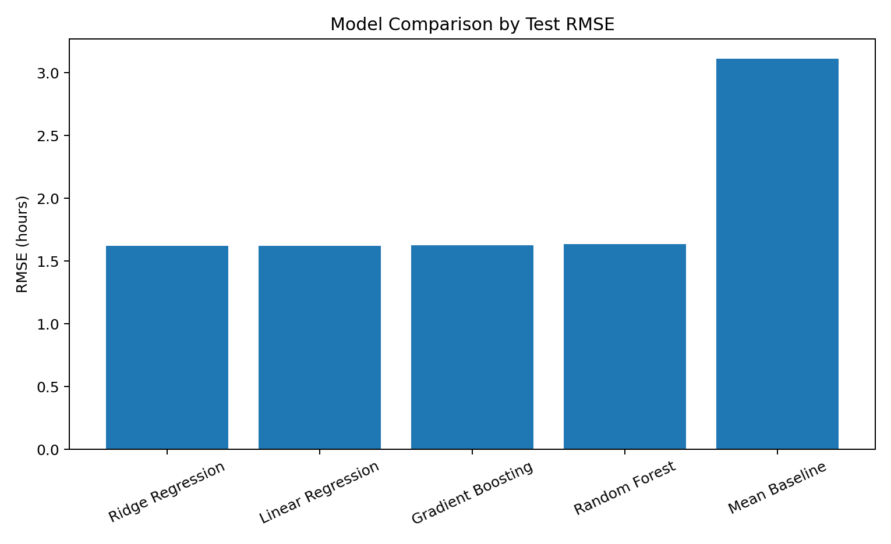
Figure 1. Test-set RMSE comparison. Lower RMSE means smaller typical squared prediction error.

7. Model Selection Rationale
Ridge Regression was selected as the primary model because it produced very low test error while remaining compact and interpretable. Its test RMSE was 1.622 hours and its MAE was 1.283 hours. The five-fold cross-validation results were close to the hold-out results, which supports reasonable stability.
The ensemble models did not provide a meaningful improvement over Ridge on this dataset. The Random Forest test RMSE was approximately 1.645 hours, while Gradient Boosting was approximately 1.625 hours. Because predictive performance was similar, the simpler regularized linear model provides a transparent baseline for operational decision support.

8. Hyperparameter Tuning
Ridge alpha was tuned over [0.01, 0.1, 1, 10, 50, 100] using five-fold cross-validation. The selected value was alpha=10. This controls the strength of L2 regularization and helps prevent unstable coefficients when categorical variables are encoded.
ridge_pipeline = Pipeline([
("preprocessor", preprocessor),
("model", Ridge())
])
grid = GridSearchCV(
ridge_pipeline,
{"model__alpha": [0.01, 0.1, 1, 10, 50, 100]},
cv=5,
scoring="neg_root_mean_squared_error",
n_jobs=-1
)
grid.fit(X_train, y_train)
best_model = grid.best_estimator_

9. Performance Evaluation
Metric | Test result | 5-fold CV mean | Interpretation
MAE | 1.283 h | 1.284 h | Average absolute prediction error
RMSE | 1.622 h | 1.617 h | Penalizes larger errors more strongly
R² | 0.728 | 0.735 | Share of target variance explained by the model
Interpretation: the final Ridge model's MAE of 1.283 hours is roughly 77 minutes. RMSE is higher at 1.622 hours because larger errors receive greater weight. R² of 0.728 indicates that the model captures a substantial portion of the variation in delivery time, while the remaining variation shows that unobserved operational factors still matter.

10. Actual vs Predicted Delivery Time
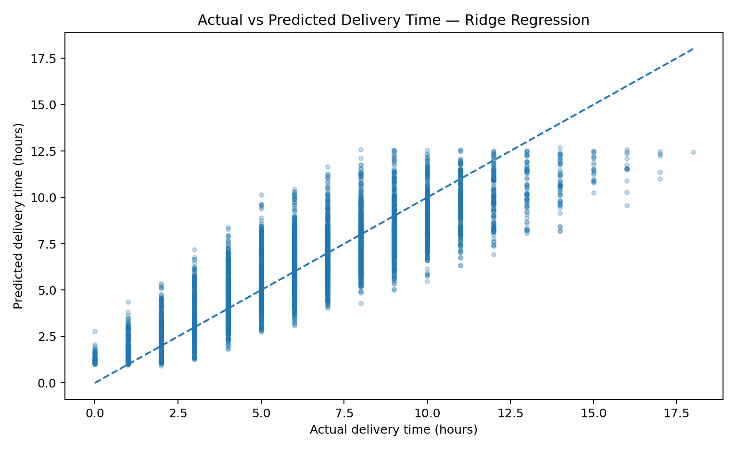
Figure 2. Actual versus predicted delivery time. Points closer to the dashed diagonal indicate smaller prediction errors.
This scatter plot is used to assess calibration visually. A strong predictive model should place observations reasonably close to the diagonal line; systematic departures can reveal underprediction or overprediction at different delivery-time levels.

11. Residual Analysis
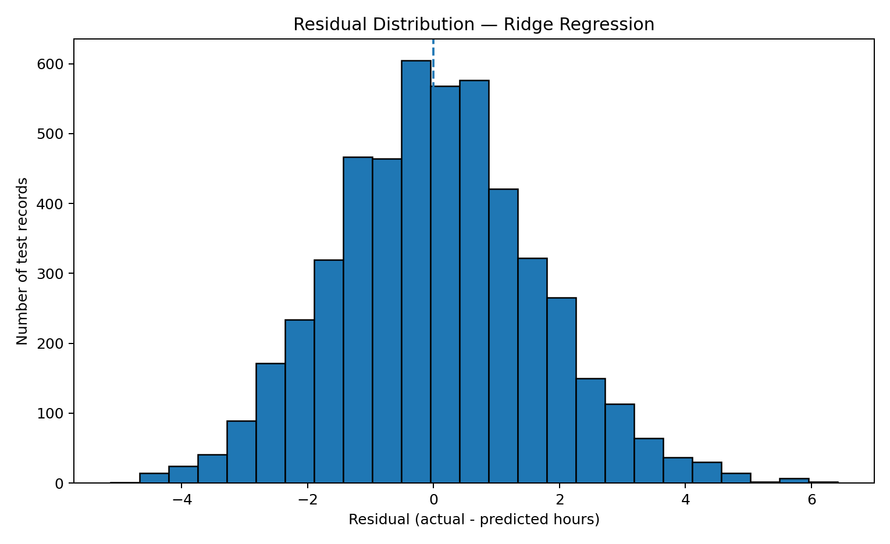
Figure 3. Residual distribution. Residual = actual delivery time − predicted delivery time.
Residual analysis checks whether errors are concentrated around zero and whether the model has unusually large errors. Operations should pay particular attention to large positive residuals because they represent deliveries that took substantially longer than predicted.

12. Predictive Risk Segmentation
The 90th percentile of the test-set predicted delivery time was 9.86 hours. This creates a practical high-predicted-time monitoring segment containing 500 test records. Within this segment, the average actual delivery time was 10.91 hours compared with an average prediction of 10.99 hours.
This segmentation is not a claim that every high-risk shipment will be late. It is a prioritization mechanism: shipments with higher predicted duration can receive earlier review, additional monitoring, or contingency planning.

13. Optimization Strategy 1 — Predictive Dispatch Prioritization
- Score incoming delivery records using the trained model before dispatch.
- Place records in operational bands such as normal, watch, and high predicted-time.
- Review high predicted-time records for route length, weather exposure, vehicle suitability, and service-mode requirements.
- Escalate only the records whose predicted duration conflicts with the promised service window.
This approach uses prediction to focus human attention where it is most useful instead of applying extra resources to every shipment.

14. Optimization Strategy 2 — Delivery Mode Scenario Analysis
The trained model can be used for scenario testing by changing the delivery_mode field while keeping the other shipment characteristics fixed. On a random sample of 1,000 records, the mean predicted delivery times under the modeled mode scenarios were:
Delivery mode | Mean predicted time (hours)
express | 6.169
same day | 6.194
two day | 6.215
standard | 6.264
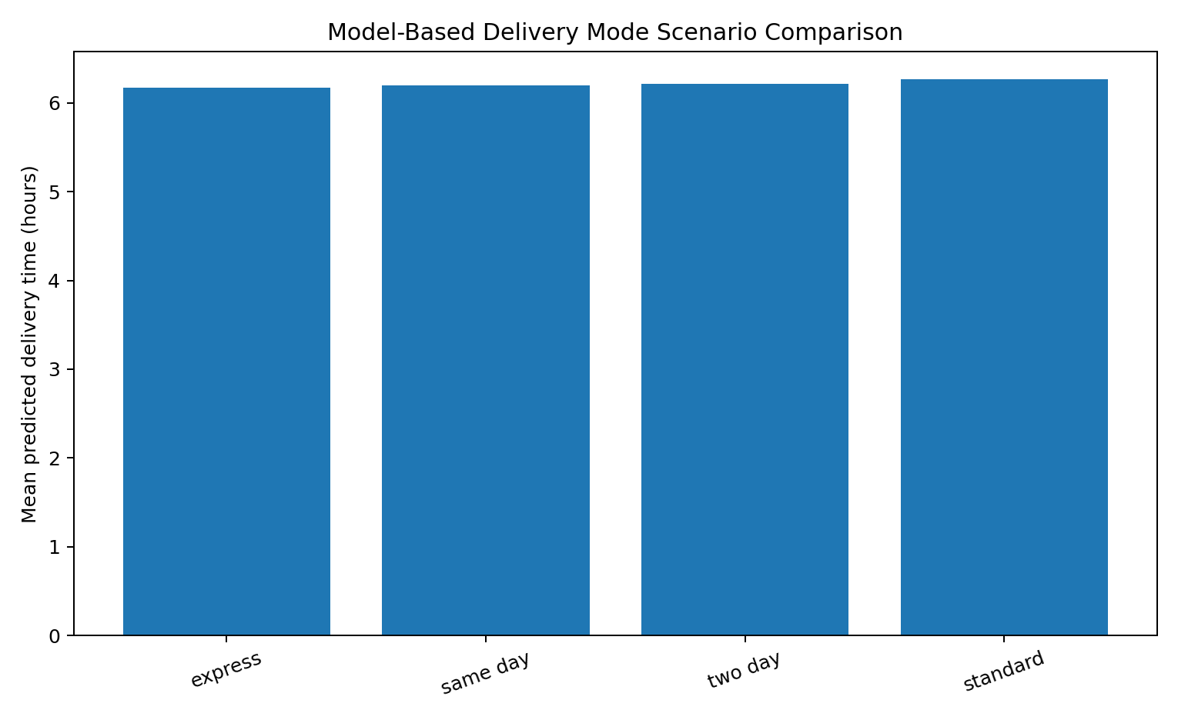
Figure 4. Model-based delivery-mode scenario comparison for a 1,000-record sample.
The scenario results can support a rule-based planning process: when a shipment has a tight service window, planners can compare modeled delivery-time scenarios before assigning a mode. These are model-based what-if estimates, not causal experiments; changing the mode in the dataset does not prove that the operational change alone would produce the predicted difference.

15. Optimization Strategy 3 — Route and Distance Review
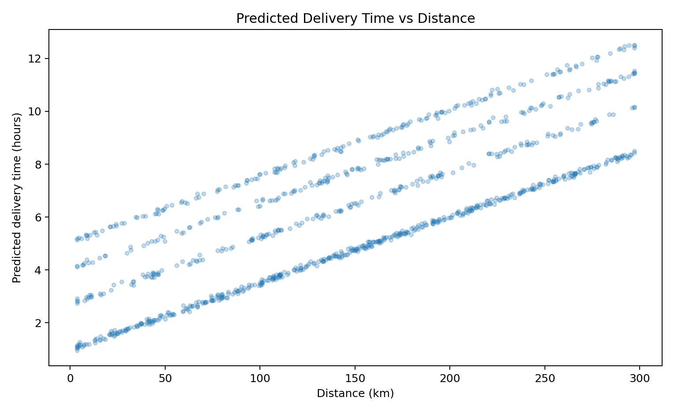
Figure 5. Predicted delivery time versus shipment distance for a 1,000-record sample.
Distance is an important measurable operational input. A route-planning process should therefore review unusually long planned distances and compare alternative feasible routes where route-level coordinates and network travel times are available. The current dataset does not contain road-network geometry, so a true vehicle-routing optimization is outside the evidence available here.

16. Optimization Strategy 4 — Resource Allocation
- Use predicted delivery time to estimate workload by time band and region.
- Increase monitoring or dispatch capacity for periods/segments with many high predicted-time shipments.
- Use vehicle-type and delivery-mode information to check whether high-duration shipments are assigned to suitable resources.
- Measure the effect of any intervention using actual delivery time, delay rate, cost, and service quality after implementation.

17. Python Training and Evaluation Code
from sklearn.compose import ColumnTransformer
from sklearn.pipeline import Pipeline
from sklearn.preprocessing import OneHotEncoder, StandardScaler
from sklearn.impute import SimpleImputer
from sklearn.linear_model import Ridge
from sklearn.metrics import mean_absolute_error, mean_squared_error, r2_score
preprocessor = ColumnTransformer([
("num", Pipeline([
("imputer", SimpleImputer(strategy="median")),
("scaler", StandardScaler())
]), num_cols),
("cat", Pipeline([
("imputer", SimpleImputer(strategy="most_frequent")),
("onehot", OneHotEncoder(handle_unknown="ignore"))
]), cat_cols)
])
model = Pipeline([
("preprocessor", preprocessor),
("model", Ridge(alpha=10))
])
model.fit(X_train, y_train)
pred = model.predict(X_test)
mae = mean_absolute_error(y_test, pred)
rmse = mean_squared_error(y_test, pred) ** 0.5
r2 = r2_score(y_test, pred)
print("MAE:", mae)
print("RMSE:", rmse)
print("R2:", r2)

18. Python Scenario-Optimization Code
# Model-based what-if analysis; not a causal estimate
sample = df.sample(1000, random_state=42)
sample_X = sample.drop(columns=exclude)
for mode in sorted(df["delivery_mode"].unique()):
scenario_X = sample_X.copy()
scenario_X["delivery_mode"] = mode
predicted = final_model.predict(scenario_X)
print(mode, predicted.mean())

19. How Predictive Modeling Supports Logistics Decisions
Predictive output | Operational interpretation | Potential decision
Predicted delivery time | Expected service duration | Prioritize monitoring and planning
High predicted-time segment | Potentially resource-intensive records | Early review and contingency planning
Mode scenario prediction | Estimated duration under alternative modes | Compare feasible dispatch options
Distance relationship | Longer journeys can require more planning | Review route alternatives and assignment
Prediction error | Model uncertainty / unusual operations | Investigate recurring error causes
The key value of the model is not simply producing a number. It creates a repeatable decision-support step between raw shipment information and operational action. The model can be rerun for new records, while actual outcomes can later be compared with predictions to monitor model drift and identify new operational factors.

20. Limitations and Risk Controls
- The dataset is a simulated/cleaned logistics dataset, so results should be validated on live operational data before deployment.
- The model predicts delivery duration, not causality. A feature with a positive coefficient does not automatically mean changing that feature will cause delivery time to change.
- Weather, route congestion, traffic, hub workload, driver availability, and road-network travel time are not fully represented.
- The delivery_mode scenario comparison is a what-if model exercise, not a randomized experiment.
- Model performance should be monitored over time using rolling validation when real chronological data becomes available.
- Operational interventions should be evaluated using before/after KPIs such as delay rate, delivery time, cost, and customer service metrics.

21. Recommendations
- Deploy the Ridge model first as a transparent planning baseline and compare its predictions with actual delivery times.
- Create a high-predicted-time queue for early operational review rather than treating every shipment equally.
- Use delivery-mode scenario predictions to compare feasible service options for time-sensitive shipments.
- Collect route-level data such as coordinates, road distance, traffic, and travel time to enable stronger route optimization.
- Record hub workload and vehicle availability because these factors can explain prediction errors not captured by the current dataset.
- Retrain and validate the model periodically when new delivery records are available.
- Track MAE, RMSE, and prediction error by region, mode, weather condition, and partner to detect segments where the model is weaker.
- Measure every optimization intervention against actual operational KPIs before scaling it.

22. Conclusion
This Week 4 project converts the cleaned logistics dataset into a predictive analytics workflow. The selected Ridge Regression model achieved a test MAE of 1.283 hours, RMSE of 1.622 hours, and R² of 0.728. Five-fold cross-validation produced similar results, supporting the use of the model as a repeatable baseline.
The project also demonstrates how prediction can feed operational optimization. High predicted-time shipments can be prioritized for review, alternative delivery modes can be evaluated through what-if scenarios, and long-distance shipments can be flagged for route planning. These recommendations are designed as decision-support strategies and should be validated with real operational experiments before claiming business impact.

23. Submission Checklist
- ✓ Clear logistics forecasting problem defined.
- ✓ Target variable and prediction timing documented.
- ✓ Dataset and feature roles documented.
- ✓ Post-outcome leakage fields excluded.
- ✓ Train/test split documented.
- ✓ Multiple predictive models compared.
- ✓ MAE, RMSE, and R² reported.
- ✓ Five-fold cross-validation completed.
- ✓ Ridge hyperparameter tuning completed.
- ✓ Actual-vs-predicted and residual charts included.
- ✓ Optimization strategies linked to model outputs.
- ✓ Python training, validation, and optimization code included.
- ✓ Limitations and validation controls documented.
- ✓ Actionable recommendations included.

24. Reproducibility / Project Files
Recommended project structure for submission:
Logistics-Delivery-Analysis/
├── data/
│ └── Delivery_Logistics_cleaned.csv
├── src/
│ └── week4_predictive_modeling.py
├── outputs/
│ ├── charts/
│ └── results/
└── Week_4_Predictive_Modeling_and_Optimization_Logistics.docx

25. References
- Python Documentation — Python Software Foundation.
- Pandas Documentation — pandas development team.
- Scikit-learn User Guide — model selection, preprocessing, pipelines, linear models, ensemble methods, and metrics.
- Matplotlib Documentation — plotting and visualization.

