WEEK 2 TASK REPORT
Data Collection, Cleaning, and Preprocessing for Logistics Analysis
Project: Logistics Delivery Analysis
Preprocessing implemented using Python, Pandas, and Matplotlib

1. Introduction
This report documents the data collection simulation, cleaning, outlier detection, type correction, and normalization performed on a logistics delivery dataset. The purpose of preprocessing is to transform raw operational records into a reliable dataset suitable for descriptive analytics, KPI monitoring, and future predictive modeling.

2. Dataset Description
The project uses a logistics delivery dataset containing 25,000 records after preprocessing. The dataset includes delivery identifiers, delivery partners, package types, vehicle types, delivery modes, regions, weather conditions, distance, package weight, delivery time, expected time, delay status, delivery status, rating, and delivery cost. A cleaned CSV file was produced for downstream analysis.
Data Item | Result | Purpose
Records | 25,000 | Number of delivery observations
Columns after preprocessing | 16 | Includes processed/original ID tracking
Missing values after preprocessing | 0 | Complete analytical dataset
Exact duplicate rows | 0 | No identical rows remained
Repeated delivery IDs detected initially | 498 | Data-quality issue reviewed

3. Data Collection Simulation
Dataset Source/Reference: The project uses a publicly available/reference logistics delivery dataset processed locally as Delivery_Logistics.csv. The dataset contains operational delivery, timing, distance, package, rating, weather, and cost attributes.
The logistics dataset represents delivery transactions collected from a simulated logistics operation. Each record represents a delivery event. Data collection fields cover operational, geographical, environmental, timing, service-quality, and cost dimensions. The dataset can therefore support analysis of delivery performance, delays, cost behavior, and operational efficiency.
import pandas as pd
df = pd.read_csv("data/Delivery_Logistics.csv")
print(df.shape)
print(df.head())
print(df.isnull().sum())

4. Initial Data Quality Assessment
The initial inspection showed 25,000 records and 15 original columns. The first rows were examined to understand field structure. Data types were also checked. Several time-related fields were stored as object/string values rather than numeric hour values, so they required conversion before statistical analysis and normalization.
print(df.shape)
print(df.head())
print(df.dtypes)
print(df.isnull().sum())
print(df.duplicated().sum())

5. Data Cleaning and Preprocessing Methodology

5.1 Missing-Value Handling
Missing values were checked column by column. The final preprocessing output contains zero missing values. Numeric fields can be imputed with a median when appropriate because the median is less sensitive to extreme values. Categorical fields can be filled using the mode or an explicit 'Unknown' category when business meaning requires it.
numeric_cols = df.select_dtypes(include="number").columns
for col in numeric_cols:
df[col] = df[col].fillna(df[col].median())
categorical_cols = df.select_dtypes(include="object").columns
for col in categorical_cols:
df[col] = df[col].fillna(df[col].mode()[0])

5.2 Duplicate and Identifier Checks
Exact duplicate rows were checked and the final result was zero. The initial data-quality inspection also identified 498 repeated delivery IDs among 25,000 records. This is important because a repeated identifier does not necessarily mean an identical transaction; it should be investigated before using the identifier as a unique key. The preprocessing workflow retained the records for traceability while checking exact duplicate rows separately.
duplicate_rows = df.duplicated().sum()
duplicate_ids = df["delivery_id"].duplicated().sum()
print("Duplicate rows:", duplicate_rows)
print("Duplicate delivery IDs:", duplicate_ids)

5.3 Data-Type Correction
The raw delivery_time_hours and expected_time_hours fields were stored as strings representing very small datetime-like values. They were converted to usable integer hour values in the cleaned dataset. This correction makes statistical summaries, outlier analysis, and normalization meaningful.
df["delivery_time_hours"] = (
pd.to_datetime(df["delivery_time_hours"]).dt.hour
)
df["expected_time_hours"] = (
pd.to_datetime(df["expected_time_hours"]).dt.hour
)

6. Outlier Detection Using IQR
The Interquartile Range (IQR) method was used to identify potential outliers. The method calculates Q1, Q3 and IQR = Q3 − Q1. The lower boundary is Q1 − 1.5×IQR and the upper boundary is Q3 + 1.5×IQR. Values outside these boundaries are flagged for review. Potential outliers were not automatically deleted because an unusual logistics event can be a genuine business observation, such as a long delivery caused by traffic or operational disruption.
for col in numerical_features:
Q1 = df[col].quantile(0.25)
Q3 = df[col].quantile(0.75)
IQR = Q3 - Q1
lower = Q1 - 1.5 * IQR
upper = Q3 + 1.5 * IQR
outliers = df[(df[col] < lower) | (df[col] > upper)]
print(col, "Outliers:", len(outliers))

7. Actual Outlier Analysis Results
Variable | Q1 | Q3 | IQR | Lower | Upper | Outliers
Distance | 75.90 | 224.90 | 149.00 | -147.60 | 448.40 | 0
Package Weight | 12.68 | 37.66 | 24.98 | -24.79 | 75.13 | 0
Delivery Time | 4.00 | 8.00 | 4.00 | -2.00 | 14.00 | 203
Expected Time | 8.00 | 16.00 | 8.00 | -4.00 | 28.00 | 0
Delivery Cost | 490.80 | 1237.91 | 747.11 | -629.87 | 2358.58 | 0
The calculations show that distance, package weight, expected delivery time, and delivery cost have no IQR outliers. Delivery time has 203 potential outliers. These 203 observations should be investigated as possible delayed or unusual deliveries rather than removed blindly.

8. Boxplot Visualizations
Figure 1: Distance Boxplot
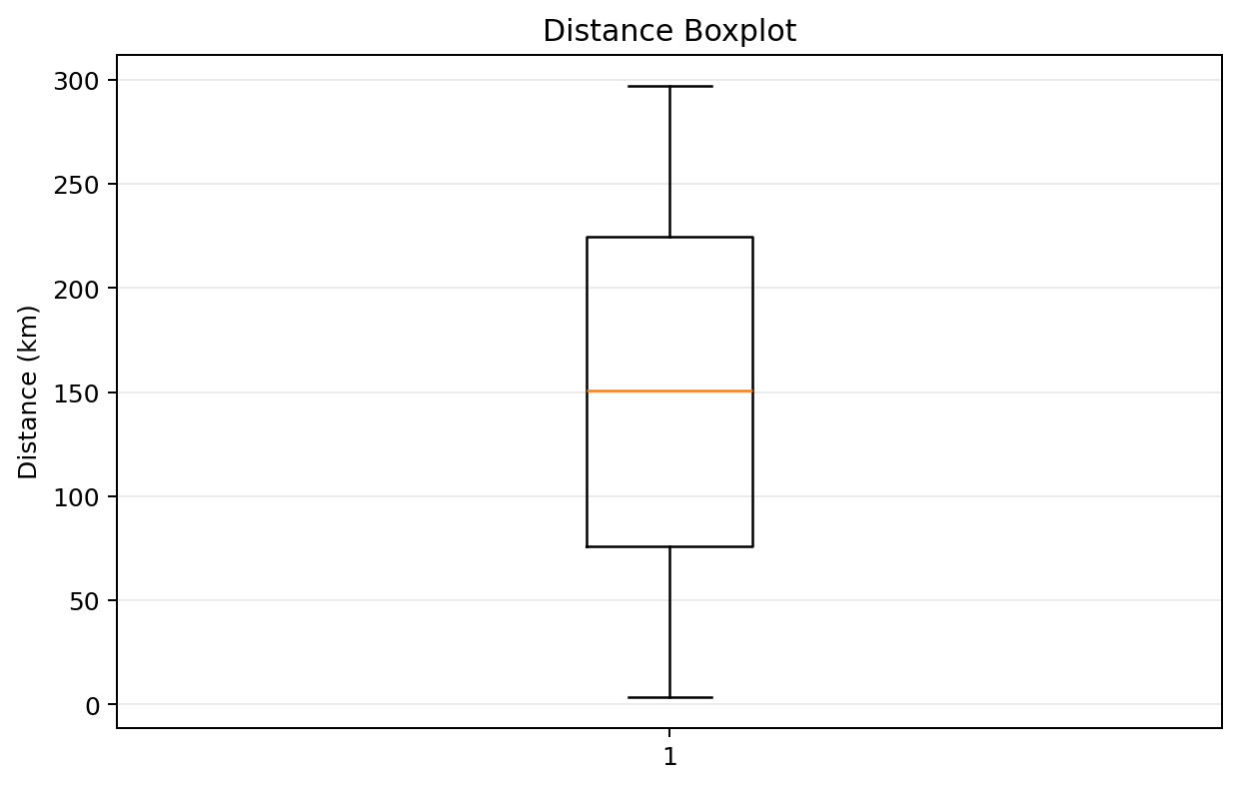
Distribution of delivery distance.
Figure 2: Package Weight Boxplot
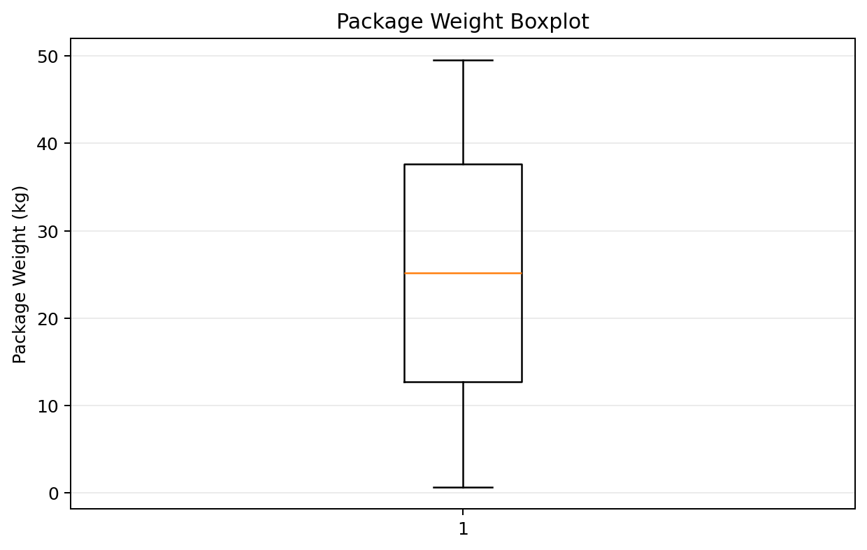
Distribution of package weight.
Figure 3: Delivery Time Boxplot
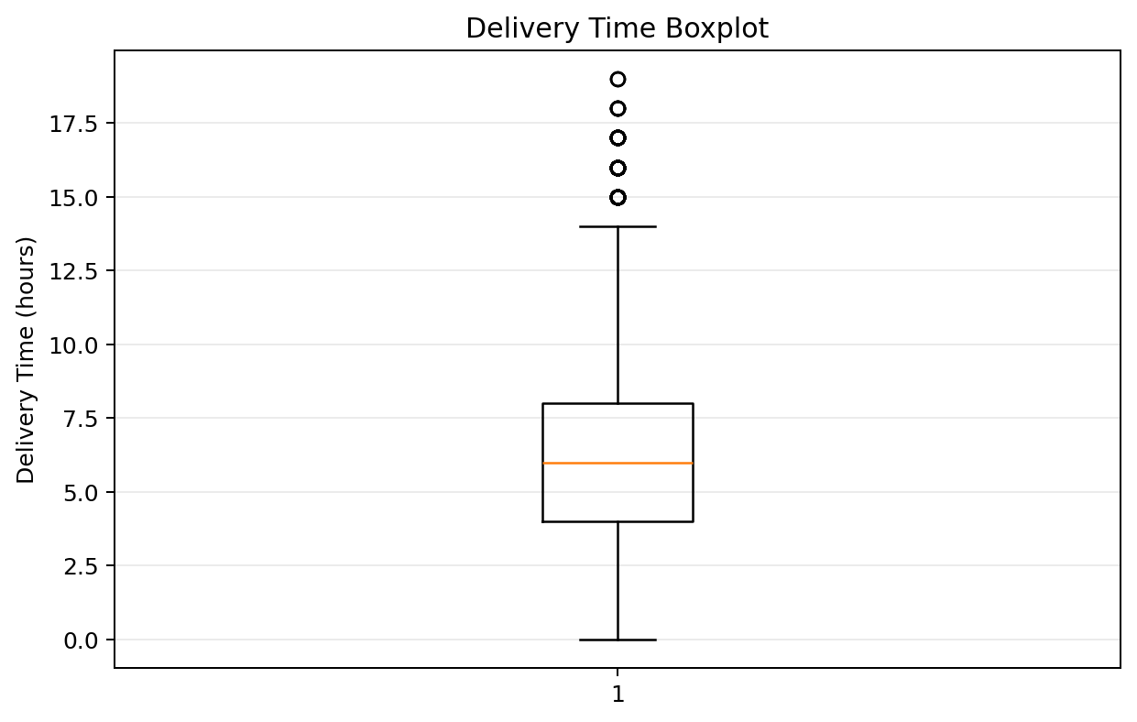
Potential unusual delivery-time observations.
Figure 4: Delivery Cost Boxplot
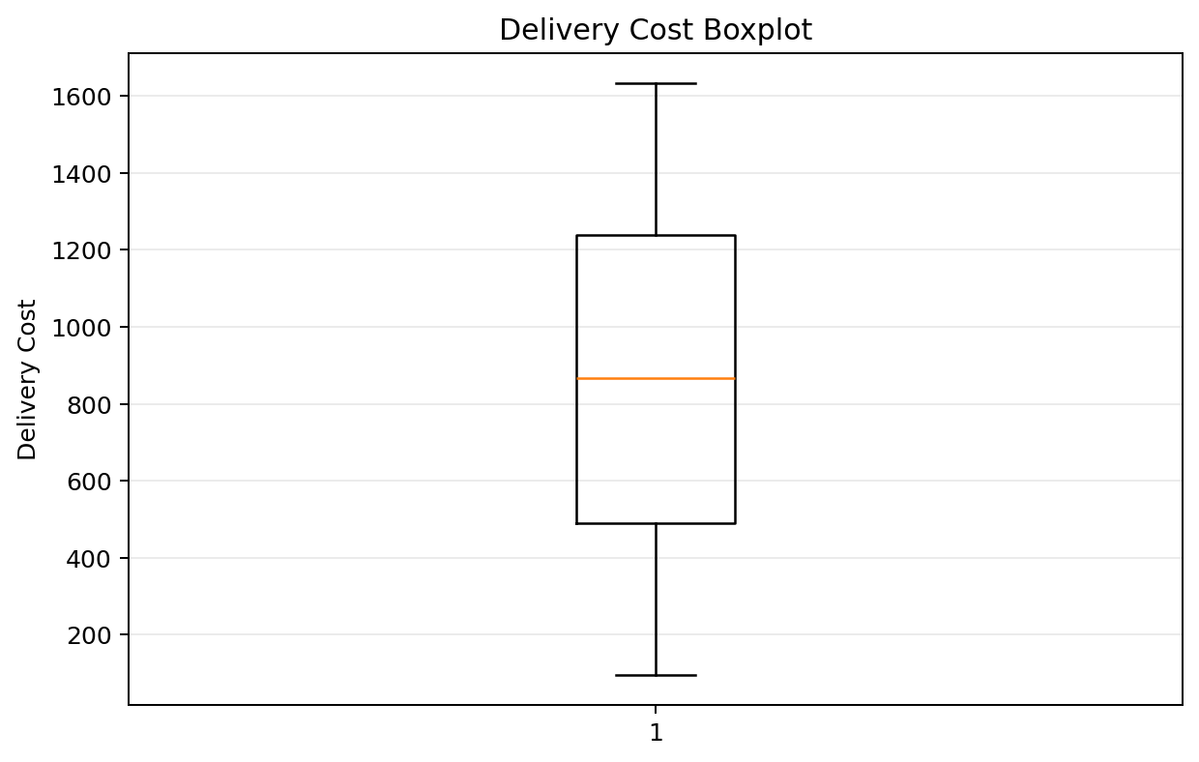
Distribution of delivery cost.

9. Normalization
Min-Max normalization was applied to selected numerical variables so that their values are placed on a comparable 0–1 scale. This is useful when variables have very different units and ranges. For example, distance is measured in kilometres while delivery cost is measured in currency units.
from sklearn.preprocessing import MinMaxScaler
features = [
"distance_km",
"package_weight_kg",
"delivery_cost"
]
scaler = MinMaxScaler()
df[features] = scaler.fit_transform(df[features])
A successful normalization output is expected to contain values between 0 and 1. For example, the displayed processed output showed normalized distance, package weight, and delivery cost values in this range.

10. Final Preprocessing Validation
print("Final Dataset Shape:", df.shape)
print("Final Missing Values:", df.isnull().sum().sum())
print("Final Duplicate Rows:", df.duplicated().sum())
df.to_csv("data/Delivery_Logistics_cleaned.csv", index=False)
Final validation confirmed a dataset shape of 25,000 rows and 16 columns, zero missing values, and zero exact duplicate rows. The cleaned dataset was saved as Delivery_Logistics_cleaned.csv.

11. Practical Analytical Insights
- Delivery distance has a wide operational range, but the IQR method did not identify extreme outliers.
- Package weights also remained within the IQR boundaries, suggesting that extreme package weights are not a major data-quality problem in this dataset.
- Delivery time produced 203 potential outliers. This is the most important outlier finding because unusual delivery duration may indicate delays, traffic, weather effects, or operational issues.
- Expected delivery time and delivery cost did not show IQR outliers, so these variables can be used in further analysis after scaling where required.
- Zero final missing values improves reliability for KPI calculations and machine-learning workflows.

12. Reflection
Data quality directly affects logistics decision-making. Missing values can distort averages and KPIs, incorrect data types can prevent valid calculations, duplicates can lead to double counting, and untreated outliers can influence statistical models. In this project, systematic inspection, cleaning, type correction, IQR-based outlier detection, and normalization created a more reliable analytical dataset. The preprocessing stage therefore provides a strong foundation for later tasks such as delay analysis, KPI dashboards, cost optimization, and predictive modeling.

13. Conclusion
The Week 2 preprocessing pipeline successfully demonstrated the major steps required to prepare logistics data for analysis. The final dataset is complete, exact duplicate-free, correctly typed for key numerical analysis, and supported by documented outlier calculations and four boxplot visualizations. The workflow can now be extended to exploratory analysis and predictive logistics applications.

14. Project Output Structure
Logistics-Delivery-Analysis/
├── data/
│ ├── Delivery_Logistics.csv
│ └── Delivery_Logistics_cleaned.csv
├── notebooks/
├── outputs/
│ ├── charts/
│ │ ├── distance_boxplot.png
│ │ ├── package_weight_boxplot.png
│ │ ├── delivery_time_boxplot.png
│ │ └── delivery_cost_boxplot.png
│ └── results/
├── src/
│ ├── data_exploration.py
│ ├── data_preprocessing.py
│ └── create_charts.py
├── requirements.txt
└── README.md

