# Principles Of Embedded Software - Spring 2023 Final Project Proposal

# Title

# “Home-Care” *A Temperature & Humidity Monitoring System with Multi-Mode Control, Energy Efficiency and Custom Alerts*

# Author Professor

# Kiran Jojare Prof. Lalit Pandit

# Introduction

The “Home-Care” project is a smart home monitoring system that allows users to monitor temperature and humidity levels in their home using the SHT21 sensor. The project includes multiple modes of operation and low power mode to conserve energy when not in use. The system is also designed to provide error checking and reporting to ensure data accuracy and reliability. In addition, we will be adding a slider to allow users to set the threshold values of the sensor.

# Objectives

* Design a system that monitors temperature and humidity levels in a smart home using the SHT21 sensor
* Implement multiple modes of operation to allow users to customize their monitoring preferences
* Implement low power mode to conserve energy when not in use
* Provide error checking and reporting to ensure data accuracy and reliability
* Design a user interface using UART and LCD for easy interaction with the system
* Implement LED feedback with different intensities to indicate different modes of operation
* Use the slider to set the threshold values of the sensor

# Features

* SHT21 temperature and humidity sensor
* KL25Z board
* Circular buffers for data storage
* State machines for multi-mode control
* I2C protocol for sensor communication
* UART for user interface and command processing
* Watchdog timer for system reliability
* Low power mode using low power timer
* ADC for analog input
* DAC for LED intensity control
* GPIO for LED and slider control
* Interrupts for sensor data acquisition
* Detailed configuration of the system clock
* Pulse width modulation for LED intensity control
* LCD Display
* uCUnit test framework for system testing

# Block Diagram

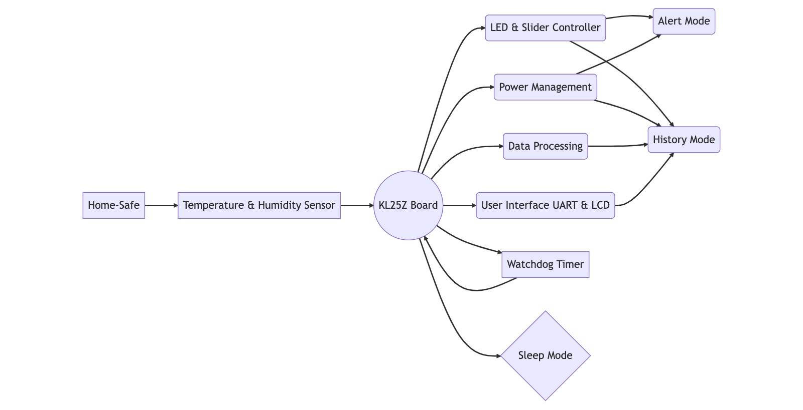

This block diagram shows the different components of your monitoring system and how they interact with each other. The diagram represents a system called Home-Care, which includes a temperature and humidity sensor, a KL25Z board, a LED and slider controller, power management, data processing, and user interface with UART & LCD. The KL25Z board serves as a central hub that receives sensor data and sends control signals to other components. The LED and slider controller can be used to set alert thresholds and activate alert mode if temperature or humidity is out of range. The power management module manages power consumption and can activate sleep mode if the system is not in use. The data processing module stores and processes historical sensor data, while the user interface and UART allow users to interact with the system and view data.

# Modes of Operation

* Normal Mode: Displays real-time temperature and humidity values on the UART and LCD interface.
* Alert Mode: Triggers an RGB LED alert when temperature or humidity levels exceed user-defined thresholds. The alert is notified over LCD.
* History Mode: Displays the historical temperature and humidity data in the past 1 hour time frame
* Sleep Mode: Puts the system into low power mode and wakes up periodically to take temperature and humidity measurements. The period can be decided based on user input received from UART interface.
* Slider Mode: Allows users to set the threshold values of the sensor using the slider. The same threshold value set by user from UART will act as a threshold onwards.

# Command Processing

The UART interface allows users to interact with the system using the following commands:

* "temp" or "humi" to display the current temperature or humidity values
* "alert" to enable or disable the alert mode and set the threshold values for temperature and humidity
* "history" to display the historical temperature and humidity data in the past 24 hours
* "sleep" to enable or disable the sleep mode and set the sleep interval
* “wdt-on” to enable watch dog timer feature
* “wdt-off” to disable watchdog timer feature
* "help" to display a list of available commands and their usage instructions
* "reset" to reset the system to its default state
* "test" to perform system testing using the uCUnit test framework

# LED Feedback

The LED feedback system is designed to provide users with visual feedback on the current mode of operation:

* Normal Mode: RGB LED is off
* Alert Mode: RGB LED flashes red at a high intensity
* History Mode: RGB LED flashes green at a medium intensity
* Sleep Mode: RGB LED flashes blue at a low intensity

# Slider Mode

The slider mode allows users to set the threshold values of the sensor. The slider can be controlled using the GPIO pins and ADC module of the KL25Z board. When the slider is moved, the new threshold values are updated and used for alert mode.

# State Machine

This state diagram outlines the various states and transitions that a temperature and humidity monitoring system can go through. The system starts in the sleep mode and will transition to the alert mode if the temperature or humidity readings are out of range. The system will continue to be in alert mode until the readings come back within the range. The user can interact with the system using the UI or UART to change the alert thresholds or view historical data. When the user exits the history mode or changes the alert thresholds, the system will transition back to the appropriate mode.

In addition, the state diagram incorporates a watch dog timer that runs continuously in parallel to other functions. The watch dog timer is a safety mechanism that is used to detect and recover from software errors or malfunctions that may cause the system to hang or crash. If the watch dog timer expires, it will reset the system and bring it back to the sleep mode. Overall, the state diagram provides a clear visualization of the various states and transitions that the system can go through, and the incorporation of the watch dog timer ensures that the system can operate safely and reliably.

# Project Approval Questions

* What functionality will your project demonstrate?

This project will demonstrate the functionality of a Home-Care device which monitors temperature and humidity in a home and alerts the user via UART, LED and LCD display if certain thresholds are exceeded. It will also feature a history mode for reviewing past temperature and humidity data. Functionality contains an low power mode for system as well as a watch dog timer continuously running to observe hardware feasibility.

* What technologies will you use? For those areas we have covered in class, how will you demonstrate deeper knowledge than what we covered in the biweekly homework assignments?

The technologies used will include a KL25Z development board, temperature and humidity sensor, LED and slider controller, power management module, data processing module, and a user interface module with UART and LCD display. To demonstrate deeper knowledge than what was covered in biweekly homework assignments, the project will involve implementing low power sleep modes, interrupt handling, and efficient data processing algorithms.

* What do you anticipate needing to learn in order to develop your project? What sources (KL25Z Reference Manual, Internet sites, etc.) do you plan to use to figure out how to do whatever it is you are attempting?

To progress with this project, I expect to need to learn more about the KL25Z board's low power modes and interrupt handling, as well as implement more complex data processing algorithms. To figure out how to do these things, I intend to use resources such as the KL25Z Reference Manual, online tutorials, and community forums. Furthermore, I believe that additional efforts will be required for sensor and LCD integration. Furthermore, implementing watchdog timer functionality may necessitate additional knowledge of the KL25Z reference manual.

* Does your project require any additional hardware? If so, what will you acquire, and what is your plan for assembly? (Again, my focus is on the software you develop. I am asking about your hardware plans just so I can ensure that whatever you are planning in this area is relatively straightforward.)

The project will require additional hardware such as a temperature and humidity sensor, as well as an LCD display. I plan to acquire these components and assemble them onto the KL25Z board following the instructions provided by the manufacturer.

* Finally, what is your testing strategy for your project? Will you develop automated tests, will you use manual tests, or will you use a mixture of both?

The testing strategy for the project will involve both manual and automated tests. Manual tests will be used to verify that the LED and LCD display are functioning correctly, as well as to test the user interface and history modes. Automated tests will be developed to test the data processing algorithms and ensure that the device is accurately detecting temperature and humidity thresholds.

# Conclusion

The Home-Care project is a smart home monitoring system that allows users to monitor temperature and humidity levels in their home using the SHT21 sensor. With its multi-mode control and low power mode features, the system is designed to provide a reliable and customisable monitoring solution for smart homes. The addition of RGB LED feedback and the ability to set threshold values using the slider provides an intuitive user interface for easy interaction with the system. With its advanced features and capabilities, the Home-Care project is a valuable addition to any smart home.