# Stratus Meridian Developer Portal

**Guides to follow when updating/upgrading your existing Developer Portal Installation Profile from version 2.0 to 2.1**

Before start doing the update, here are the preparations you need to perform on your existing Developer Portal:

1. Go to **Structure > Display modes -> View modes**. Under the API Doc, remove the **Cards View Mode** (Please take note that doing this will also remove the **View: API Catalog, Block: Exposed form: apigee_api_catalog-apidoc_list** which we will need to re-configure again later once the completed the update).

After performing the steps above, its time to update your existing Installation Profile by running the following composer command: **composer update**. (Please take note a new version of **Apigee API Catalog ver.2.2** will replace the old version which is used in this old installation profile.) Once the update is completed, kindly run the following drush command:

1. **drush updb or drush updatedb**
2. **drush cr or drush cache-rebuild**

By the time you have completed the update, you will notice a major changes on API Docs, wherein it is now part of a node content type (before, it is a separate Entity Type). Any custom fields you have created inside of the old API Doc entity will be converted and migrated as well to the new node content type. A new **API Catalog view** will be generated and all **API Docs content** will be converted to this new content type.

After the update, there are post update activities that needs to perform in order to re-configure and restore the same look and feel of the **API Catalog** from the old installation profile.

But first, we need to perform an update-entity, to resolve the bug issue listed on Status Report related to the API Doc.

In order to do that, please follow the steps below:

1. On Modules list (go to **Extend**), enabled the following modules:
   1. **Entity Update**
   2. **Devel Entity Updates (requires Devel module)**
2. Once installed, please run the following drush command:
   1. **drush update-entity**
   2. **drush cr or drush cache-rebuild**
3. After running the said commands, uninstall **Entity Update and Devel Entity Updates modules**

Next, we need to reconfigure the look and feel of the API Catalog as what was seen on the old installation profile. To do this, here are the steps:

**\* Reconfigure Service Type Field and associated configuration to API Doc Form and Front Display.**

1. As mentioned above, the Service Type field (and all custom field) you have added from the old API Doc entity type will be converted. To reconfigure this field, go to **Structure > Content types > API Doc > Manage Fields**.
2. The Service Type field label: **apidoc.field_service_type (machine name: field_service_type_apidoc)** is listed on. Kindly click **Edit.**
3. Please see the screenshots below for reference in reconfiguring the field.

1. On API Doc’s content type **Manage Form Display (Structure > Content type > API Doc > Manage Form Display)**, kindly re-enable and place the **Service Type field** after **URL to OpenAPI specification file field**. Use **Term reference Tree** as the field’s widget.
2. On API Doc’s content type **Manage Display (Structure > Content type > API Doc > Manage Display)**, select Hidden on the Label of **Service Type field**. Also, select Swagger UI or Redoc UI as the format for **OpenAPI specification field**.
3. On **Custom Settings Display (scroll below)**, check **Cards** option to create a new display settings for API Doc content type.
4. From here there will be two display settings / view modes for API Doc Content type: Default and Cards. We need to setup the fields that will be displayed on Cards view mode. Under the same Manage Display, click on Cards Tab.

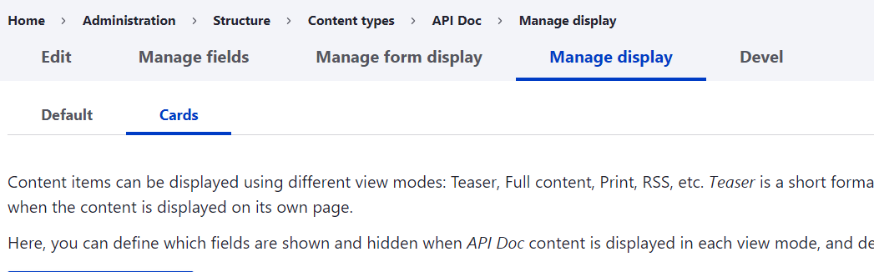

1. Disable the **OpenAPI specification field**.
2. Change the format of **Description field** to **Smart Trim**. Please follow the configuration as seen on the screenshot.

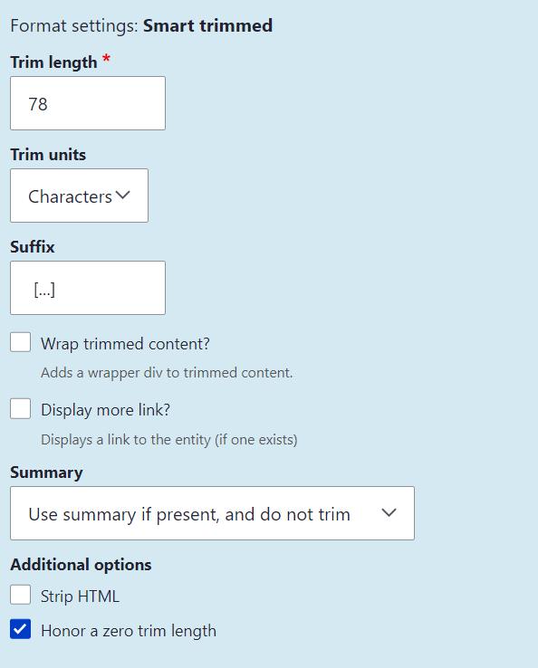

* API Catalog views configuration and exposed form block re-assigning

1. Go to Structures > View. Then, click Edit on API Catalog View.
2. Please see the screenshots below on the views configuration.A screenshot of a computer

   Description automatically generated
   * Settings for Unformatted List
     1. Uncheck **Add views row classes** options
   * Settings Exposed Field: Content: Service Type
     1. Vocabulary: API Category
     2. Selection Type: Dropdown
     3. On the Field’s filter criterion select the following configuration:
        + Filter type to expose: Single Filter
        + Label: Service Type
        + Check option – Allow multiple selections
        + **Filter Identifier - field_service_type_target_id**
        + Check Options – Reduce duplicates
   * Settings for User Pager
     1. Select Pager: Infinite Scroll
     2. Items per page: 3
   * Settings for Exposed Form
     1. Exposed Form style: Better Exposed Filters
     2. Enabled auto submit: Checked
     3. Hide submit button: Checked
     4. Exposed filter widget: Checkboxes/Radio Buttons

* Block layout configuration for Exposed Form: apigee_api_catalog-apidoc_list

1. Click **Place Block button** under **Page Hidden Region**.
2. Search for **Exposed form: apigee_api_catalog-apidoc_list** and click Place block.
3. Uncheck **Display title option.**
4. Edit the block’s machine-readable name to: **exposed_apidoc_service_type**
5. Lastly, kindly clear Drupal’s cache.