1. **Home Screen with data and action buttons (New Ticket, Edit, Delete, View)**

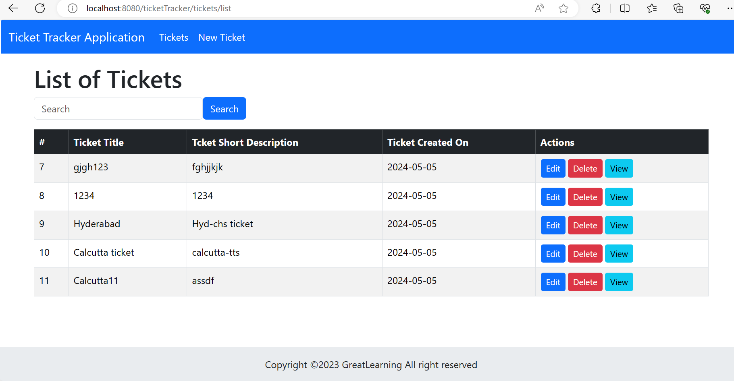

**2)Edit page**

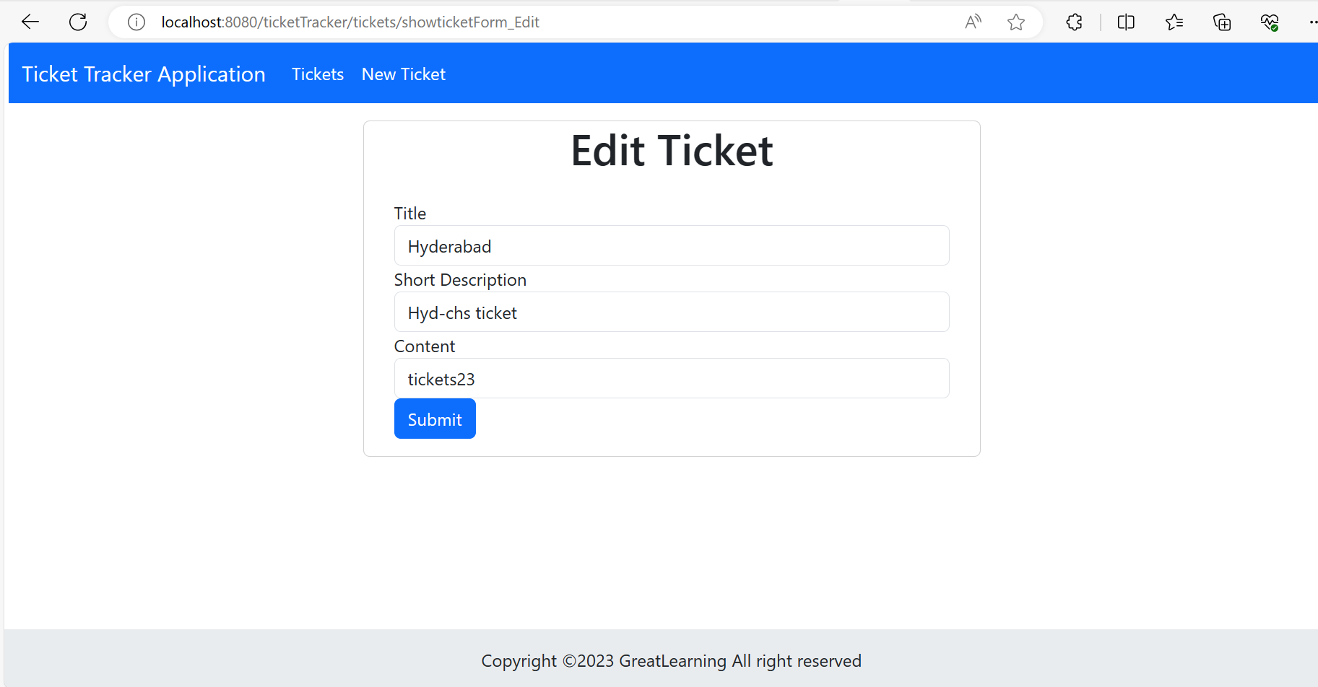

**3)Create Page**

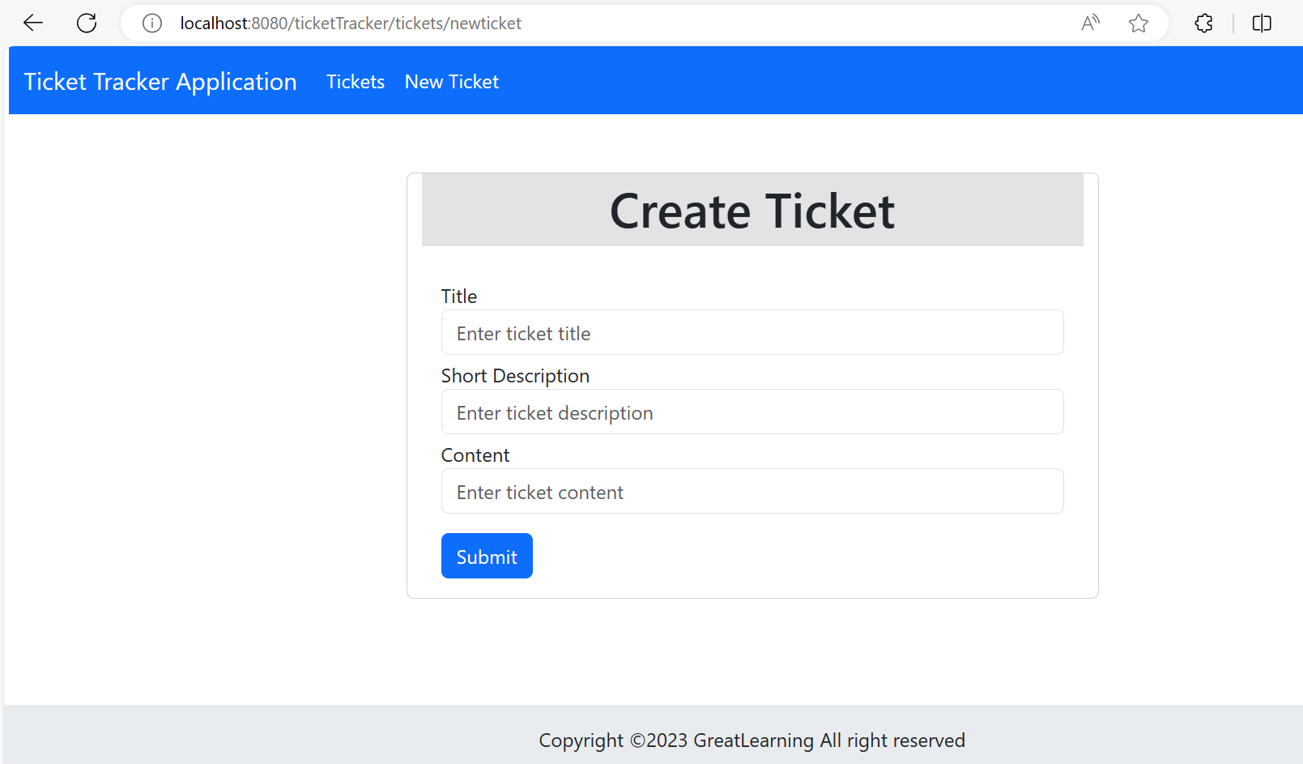

**4)Delete Page**

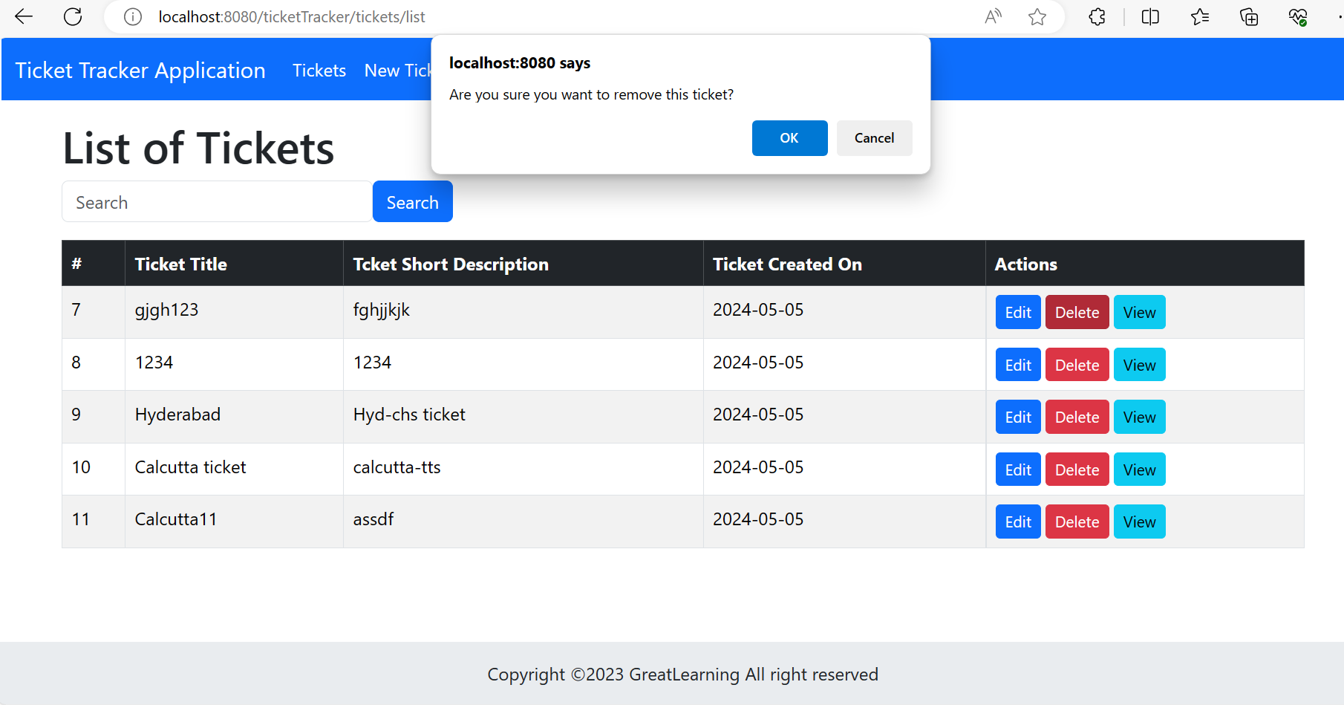

**5)Search Page**

