VIBE CODING AND SPEC-DRIVEN CODING
Northstar IT Help Desk, built two ways
Venkata Naga Kiran Katari Banner ID 916503744
Same help desk, two ways of building it. The one-file version was written directly in Python and Streamlit. The second version waited until six specification documents had been written and reviewed. In both, a ticket reaches SQLite only after the employee confirms it.
01 How the two builds differ
 | One-file build | Specification-first build
Program | One Streamlit file | Separate modules in demo2_spec/
Came first | Working code | requirements through implementation plan
Tests | 6 passed | 34 passed, with a mock model
Saved ticket | TCK-1002 | TCK-1001
Checked on screen | 4 of 4 cases, 7 ms | 14 scripted cases
02 One-file build
The chat, TF-IDF search, status check, and confirmation gate live in demo1_vibe/helpdesk_app.py. For the sample VPN outage, the reply cites DOC-VPN-002, moves the employee to the US-Central gateway, and holds the urgent ticket as a draft.
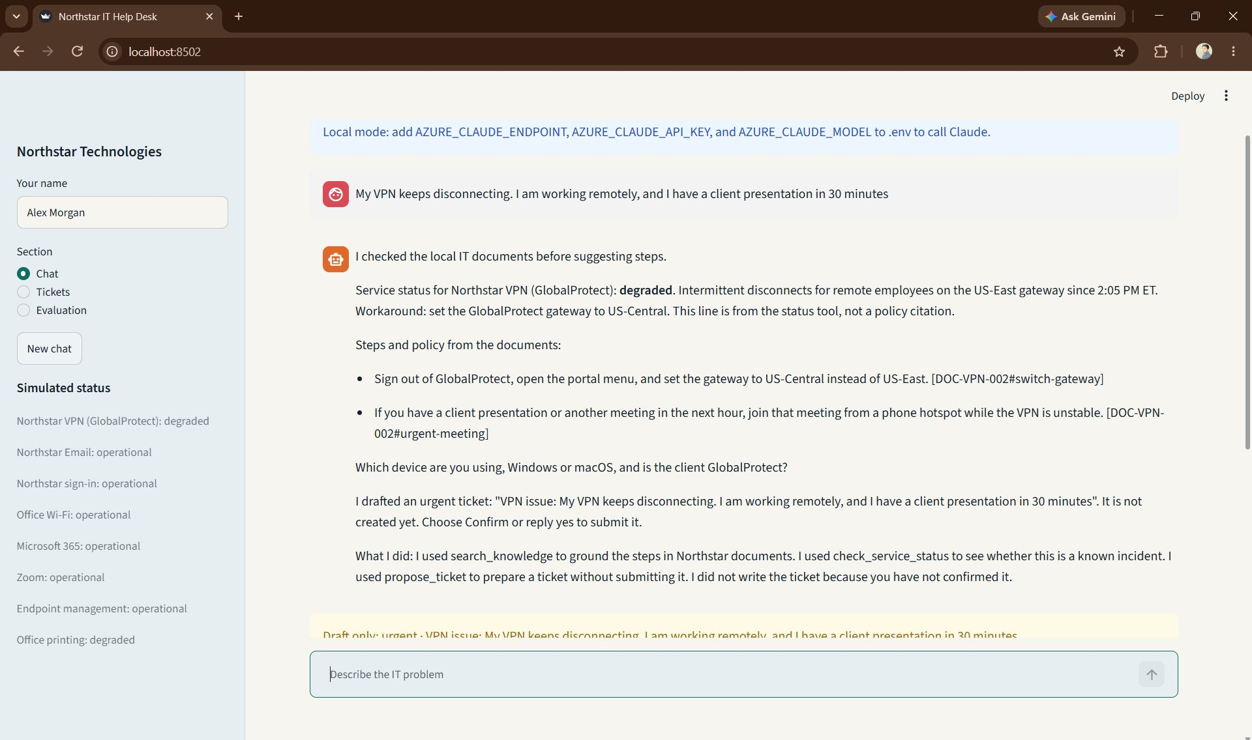
Fig. 1 Cited VPN steps, a device question, and a draft that is not in the database yet.
Tool names appear in the trace. Private model reasoning does not. An instruction-override message is refused before a tool runs. The Azure key stays in a local .env file, and this demo answers on the local path. All 6 pytest tests passed.
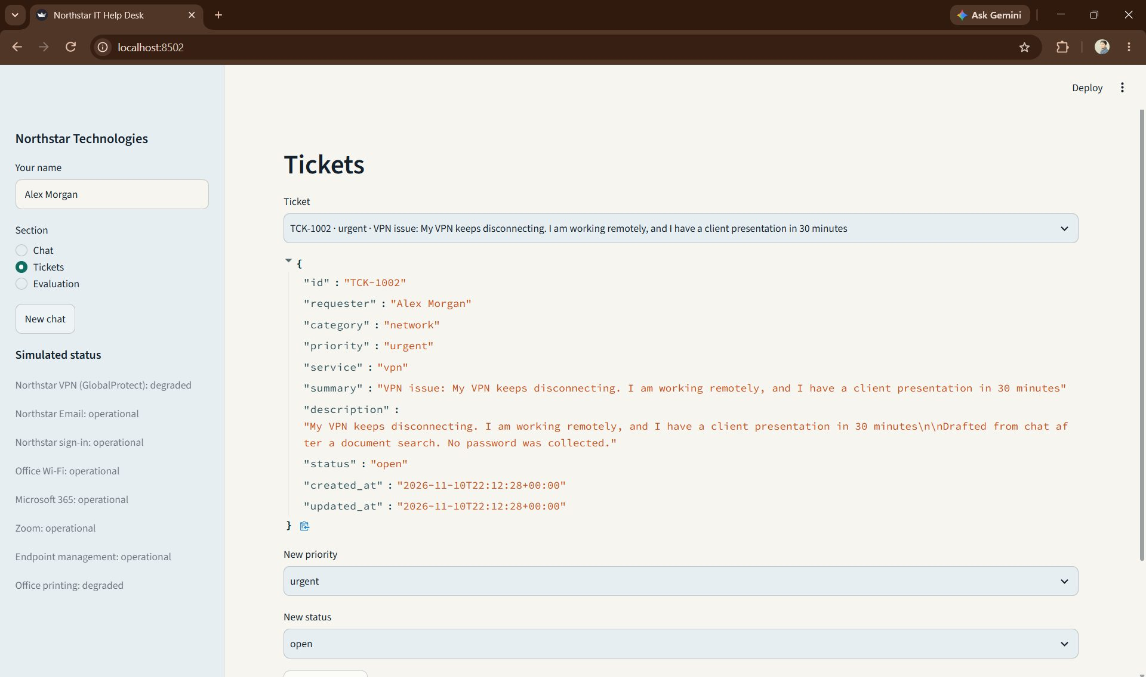
Fig. 2 After Confirm, TCK-1002 is stored with priority urgent and status open.
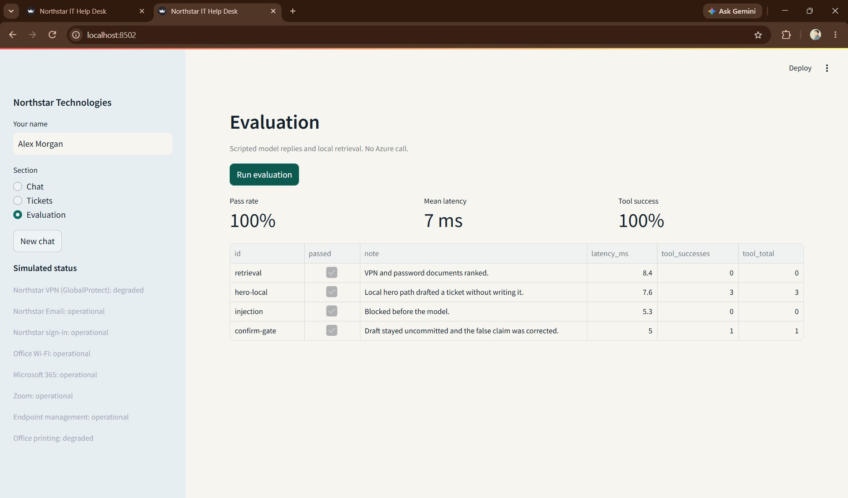
Fig. 3 Screenshot 3, evaluation dashboard: 4 of 4 passed, mean latency 7 ms, tool success 100 percent.
03 Specification-first build
This program does not import the one-file build. The specs folder came first: requirements, architecture, agent design, security, evaluation, and the implementation plan. Every feature has an identifier, acceptance criteria, tests, and error handling. specs/review.md connects each requirement to a test.
Ordinary Python, not the model, decides when a ticket can be saved. Citations must match a retrieved passage. Unknown tools are rejected. The tests call a mock model, so they never use Azure. All 34 pytest tests passed.
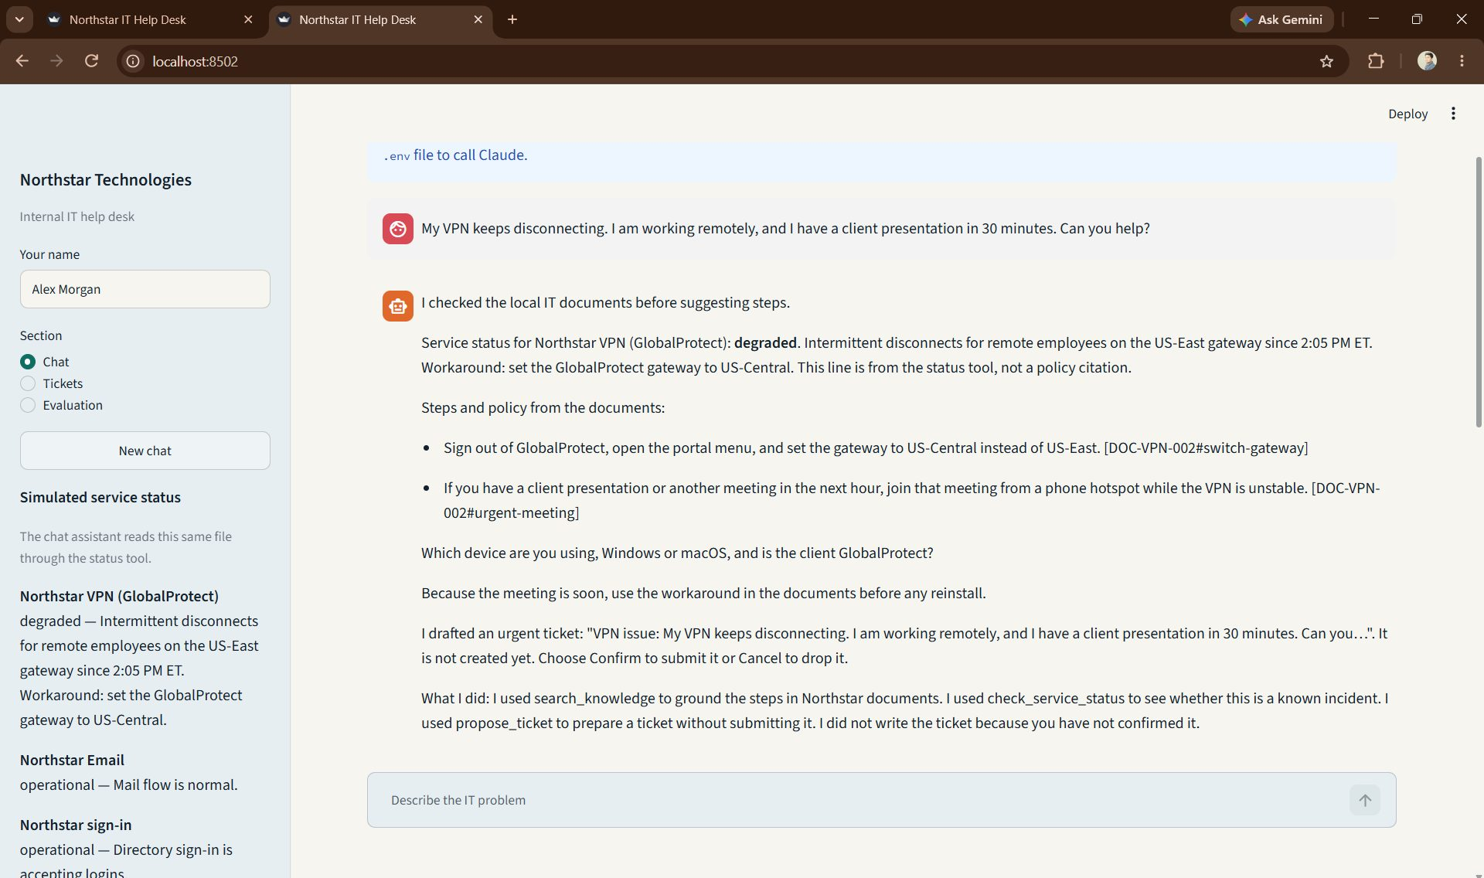
Fig. 4 The specification-first chat shows the US-Central workaround and says the draft is not created yet.
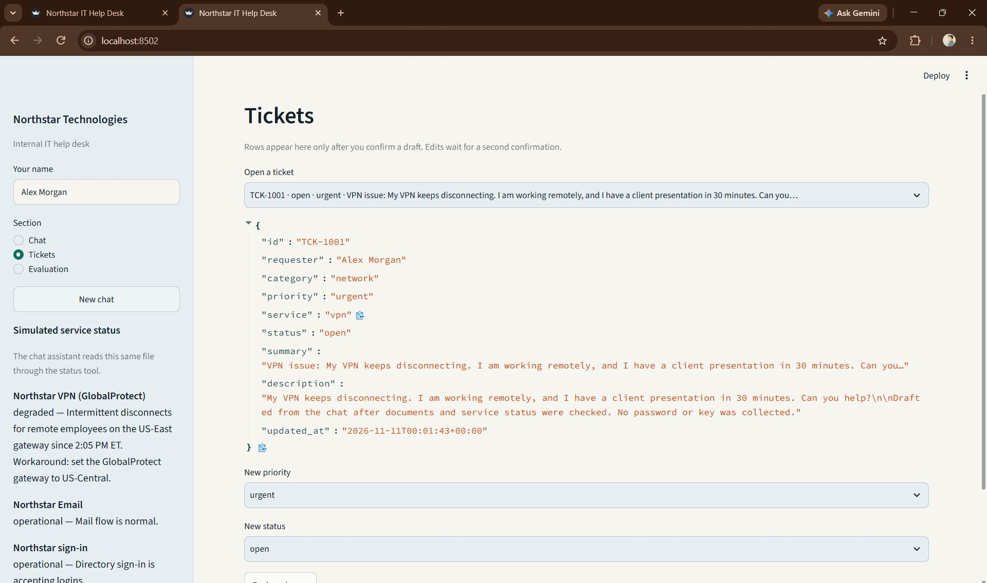
Fig. 5 TCK-1001 is listed only after confirmation. The page itself says rows appear after a draft is confirmed.
04 What I would keep
The one-file build got a working desk on screen quickly. The specification-first build is the one I would continue. Its 14 evaluation cases, 34 tests, and the review matrix all point at the same rules: cite a real passage, refuse an override, and store a ticket only after confirmation.

