- Introduction
In today’s modern educational environment, analyzing student academic performance has become an important task for schools and colleges. Educational institutions are continuously searching for smart solutions that can help in identifying weak students and improving their learning outcomes. Traditional methods of performance analysis are time-consuming and may not always provide accurate results. Therefore, the use of Artificial Intelligence and Machine Learning technologies in the education sector has increased rapidly in recent years.
The project titled “Student Performance Prediction Web Portal using Hybrid Machine Learning Algorithms” is an AI-powered web application developed to predict student academic performance using Machine Learning techniques. The system collects important academic parameters such as study hours, attendance percentage, assignment scores, and internal marks from students. Based on this data, the application generates predictions regarding student performance and provides suitable recommendations for improvement.
This project uses a Hybrid Machine Learning approach by combining Logistic Regression and Random Forest algorithms. Logistic Regression is used as a baseline classification model, while Random Forest is used for generating more accurate predictions. The system compares the performance of both algorithms and selects the better-performing model for final prediction generation. This hybrid approach improves prediction accuracy and helps in better educational analysis.
The web portal is developed using modern technologies such as React for frontend development, Node.js and Express.js for backend development, MongoDB for database management, and Python with Flask and Scikit-learn for Machine Learning integration. The system also includes features like secure authentication, dashboard analytics, graphical visualization, recommendation systems, and prediction history management, making it a complete intelligent student performance analysis platform.

  - Motivation :
In many educational institutions, student performance is still analyzed using traditional methods such as manual observation and examination results. These methods often make it difficult to identify weak students at an early stage. Because of this, many students do not receive proper guidance or support in time. This created the need for a smart system that can analyze academic data efficiently and help students improve their performance.
The main motivation behind developing the “Student Performance Prediction Web Portal using Hybrid Machine Learning Algorithms” project is to use modern technology to support students and educational institutions in academic analysis. By using Machine Learning algorithms, the system can predict student performance based on factors like study hours, attendance, assignment scores, and internal marks. Early prediction helps students understand their academic status and take necessary actions for improvement.
Another motivation for this project was to combine Full Stack Web Development with Machine Learning concepts in a real-world application. The project not only focuses on prediction but also provides recommendations and visual analytics through dashboards and graphs. This makes the system more interactive, practical, and useful for students as well as educational organizations.
The rapid growth of Artificial Intelligence in the education sector also inspired the development of this project. Intelligent systems are becoming an important part of modern education because they help in making better academic decisions using data analysis. This project aims to provide a simple, secure, and user-friendly platform that demonstrates how Machine Learning can be effectively integrated into web applications for solving real educational problems.

1.2 Objectives :
- To develop a web-based student performance prediction system.
- To predict student academic performance using Machine Learning algorithms.
- To identify weak-performing students at an early stage.
- To provide personalized recommendations for academic improvement.
- To analyze student data such as study hours, attendance, assignment scores, and internal marks.
- To implement Hybrid Machine Learning Algorithms for better prediction accuracy.
- To compare the performance of Logistic Regression and Random Forest algorithms.
- To create a secure authentication system using JWT.
- To store and manage prediction history using MongoDB database.
2 . Literature Review
2.1 Analysis of Studied Literature :
Sr. No | Paper Title | Methodology Used | Findings / Analysis
 | Hybrid ML Pipeline for Predicting & Segmenting Academic Performance at a Mexican Public University | Hybrid ML, Clustering, Predictive Analytics | The paper proposed a hybrid framework combining prediction and clustering techniques for identifying student risk patterns. The model achieved high prediction accuracy and helped in identifying at-risk students effectively.
 | Utilizing Machine Learning to Forecast a Student’s Performance | Random Forest, SVM, KNN, Extra Tree Classifier | The study focused on predicting student performance in online learning environments. Early identification of weak students helped instructors provide timely academic support.
 | Student Performance Prediction in College Using Artificial Bee Colony Algorithm and Machine Learning | Artificial Bee Colony Algorithm with ML Models | The paper improved prediction accuracy using feature selection techniques and machine learning algorithms. The system supported academic planning and student success analysis.
 | Stacking Based Machine Learning Approach for Student Performance Analysis | Stacking Ensemble Learning | Multiple ML algorithms were combined to predict student grades and analyze academic progress. The model helped educational institutions identify low-performing students at an early stage.
 | Prediction of Student Performance by Using Machine Learning Techniques | CNN, RNN, SVM, Naive Bayes, Hybrid Model | The CNN-RNN hybrid model achieved the highest accuracy in predicting student performance.
 | Machine Learning Algorithms based Student Performance Prediction based on Previous Records | Bayesian Classification | Academic records to predict student performance and placement possibilities. The model aimed to improve unsatisfactory student performance.
 | Analyzing the Student's Risk in using Electronic Gadgets using Hybrid Machine Learning Model as Case Study | Hybrid Machine Learning Approach | The study analyzed student risk factors related to excessive gadget usage during online learning using hybrid ML techniques and predictive analytics.
 | Hybrid Machine Learning Classifiers to Predict Student Performance | Hybrid Feature Selection, KNN, CNN, NB, Decision Tree | Hybrid classifiers & feature selection methods to improve prediction accuracy in educational data mining systems.
Table 2.1 : Analysis of Studied Literature
A study titled “Hybrid Machine Learning Pipeline for Predicting and Segmenting Academic Performance at a Mexican Public University” proposed a hybrid framework that combines predictive modeling and clustering techniques for student performance analysis. The research focused on identifying academic risk patterns and student profiles using real-world educational datasets. The study achieved strong predictive performance and demonstrated that hybrid learning approaches can provide interpretable and actionable educational insights [1].
Another research paper, “Utilizing Machine Learning to Forecast a Student’s Performance”, focused on predicting student performance in online learning platforms. Various machine learning models such as Random Forest, Support Vector Machine, KNN, and Extra Tree Classifier were used to identify at-risk students. The study highlighted the importance of early prediction for improving student engagement and academic success [2].
The paper titled “Student Performance Prediction in College Using Artificial Bee Colony Algorithm and Machine Learning” introduced an Artificial Bee Colony optimization algorithm combined with machine learning techniques. The proposed method improved prediction accuracy and helped educational institutions in academic planning and early intervention. The study showed that feature selection methods can significantly improve student performance prediction models [3].
A research work named “Stacking Based Machine Learning Approach for Student Performance Analysis” used multiple machine learning algorithms to predict student academic performance. The study focused on identifying students with poor academic progress at an early stage. The proposed stacking-based approach helped educational institutions optimize their teaching and learning strategies effectively [4].
The paper “Prediction of Student Performance by Using Machine Learning Techniques” explored various machine learning and deep learning algorithms such as CNN, RNN, SVM, and Naive Bayes for predicting student performance. A hybrid model was also implemented to reduce data dimensionality and improve classifier performance. The results showed that the CNN-RNN model achieved higher prediction accuracy compared to other techniques [5].
Another study titled “Machine Learning Algorithms based Student Performance Prediction based on Previous Records” focused on predicting student performance and placement possibilities using previous academic records. Bayesian classification algorithms were used for prediction purposes. The research aimed to improve student academic performance and assist institutions in identifying students requiring additional support [6].
The paper “Analyzing the Student's Risk in using Electronic Gadgets using Hybrid Machine Learning Model as Case Study” discussed the impact of excessive electronic gadget usage on students during online learning. Hybrid machine learning techniques were used to analyze student behavior and risk factors. The study emphasized the importance of predictive analytics in modern educational systems [7].
A study named “Hybrid Machine Learning Classifiers to Predict Student Performance” applied hybrid feature selection algorithms along with classifiers such as kNN, CNN, Naive Bayes, and Decision Trees. The research focused on educational data mining and predicting student marks using hybrid machine learning techniques. The obtained results demonstrated improved prediction accuracy and better performance compared to traditional approaches [8].

3 . System Design & Analysis
3.1.System Analysis :
3.1.1. Problem Definition :
In many educational institutions, student performance analysis is still performed using traditional and manual methods, which are often time-consuming and less accurate. Due to the lack of intelligent systems, it becomes difficult to identify weak-performing students at an early stage. As a result, students may not receive proper academic guidance and support for improvement.
The main problem addressed in this project is the development of a smart and automated system that can predict student academic performance using Machine Learning techniques. The system aims to analyze academic factors such as study hours, attendance, assignment scores, and internal marks to generate accurate predictions and provide useful recommendations for improving student performance.

3.1.2. Proposed Solution :
The proposed system is an AI-powered web portal developed to predict student academic performance using Hybrid Machine Learning Algorithms. The system collects important academic details such as study hours, attendance percentage, assignment scores, and internal marks from students through a user-friendly web interface.
The proposed solution uses Logistic Regression and Random Forest algorithms to analyze student data and generate performance predictions. Both algorithms are evaluated based on prediction accuracy, and the better-performing model is used for final prediction generation. The system also provides personalized recommendations to help students improve their academic performance.
The application is developed using React for frontend development, Node.js and Express.js for backend development, MongoDB for database management, and Python for Machine Learning integration. The system also includes secure authentication, dashboard analytics, graphical visualization, and prediction history management to provide a complete and intelligent educational support platform.

3.2. System Design :
3.2.1. System Architecture :
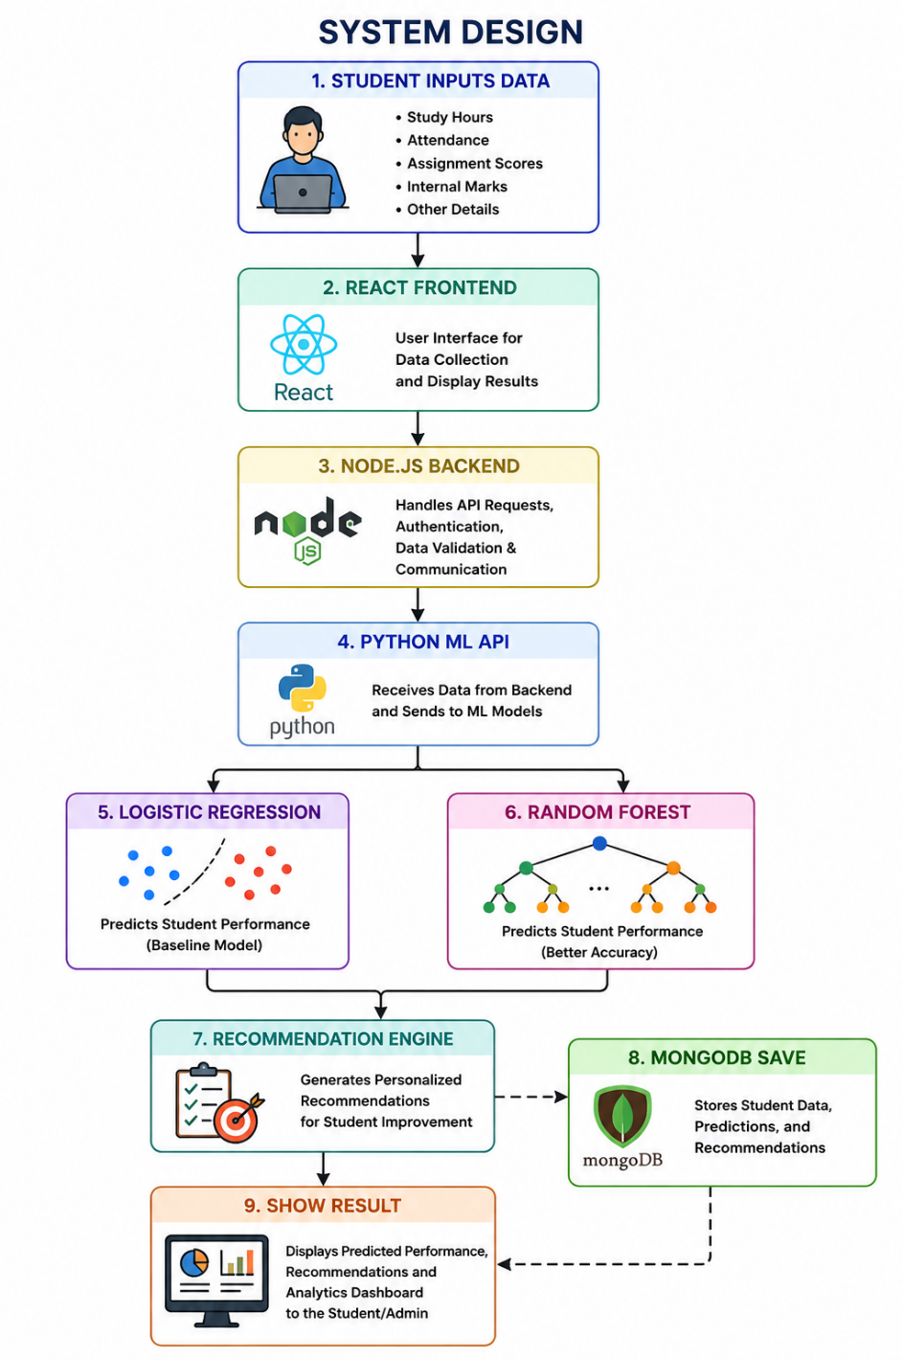
Fig 3.2.1 : System Architecture
The proposed system follows a multi-layer architecture for predicting student academic performance using Hybrid Machine Learning Algorithms.
Initially, the student enters academic details such as study hours, attendance percentage, assignment scores, and internal marks through the frontend interface developed using React. The frontend provides a responsive and user-friendly environment for interacting with the system.
After receiving the input data, the request is sent to the backend server developed using Node.js and Express.js. The backend handles API requests, authentication, validation, and communication between the frontend and the Machine Learning module.
The backend forwards the student data to the Python Flask ML API, where Machine Learning algorithms process the data. First, the Logistic Regression model performs baseline prediction, and then the Random Forest algorithm generates a more accurate prediction result. The system compares the outputs and selects the best prediction based on model performance.
After prediction generation, the recommendation engine provides suggestions such as improving attendance, increasing study hours, or focusing on assignments. Finally, the prediction results, recommendations, and student data are stored in the MongoDB database and displayed on the dashboard with analytics and visualization features.

3.2.2 User Input and Output :
Input :
- Study Hours
- Attendance Percentage
- Assignment Scores
- Internal Marks
Output :
- Predicted Student Performance
- Confidence Score
- Model Comparison Result
- Personalized Recommendations
- Dashboard Analytics
- Prediction History Display

3.2.3 Technology Stack :
1. Frontend/Interface: React JS , Tailwind CSS
2. Backend Processing : Node JS , Express JS , MongoDB
3. Visualization : Rechart JS
4. Hybrid Machine Learning Prediction : Logistic Regression , Random Forest
5. Libraries Used :
- Scikit-learn
- JWT Authentication
- Recharts
- Axios
- bcrypt.js
- Mongoose
- React Router DOM

4 . Implementation
The implementation of the “Student Performance Prediction Web Portal using Hybrid Machine Learning Algorithms” project is divided into multiple modules including frontend development, backend processing, database management, Machine Learning integration, authentication system, dashboard analytics, and recommendation generation. The system is developed using Full Stack Web Development technologies along with Machine Learning techniques to provide accurate student performance prediction.
1. Frontend Implementation
The frontend of the project is developed using React and Tailwind CSS. The frontend provides an interactive and responsive user interface for students and users.
Frontend Features
- Registration Page
- Login Page
- Dashboard Page
- Prediction Form
- Prediction Result Display
- History Page
- Graph Visualization
- Responsive Navigation Bar
Frontend Responsibilities
- Collect user input data
- Send API requests to backend
- Display prediction results
- Show dashboard analytics
- Manage user sessions
2. Backend Implementation
The backend is developed using Node.js and Express.js.
Backend Responsibilities
- Handle API requests
- User Authentication
- JWT Token Generation
- Data Validation
- Communication with ML API
- Store Prediction Results
- Manage User History
Backend Modules
- Authentication API
- Prediction API
- Dashboard API
- History API
- Recommendation API
3. Database Implementation
The project uses MongoDB Atlas for storing user and prediction data.
Users Collection :
- User Name
- Email
- Password
- Registration Details
Predictions Collection :
- User ID
- Study Hours
- Attendance
- Assignment Scores
- Internal Marks
- Prediction Result
- Recommendation
- Date and Time
4. Machine Learning Implementation
The Machine Learning module is developed using Python, Flask, and Scikit-learn.
Machine Learning Workflow
Step 1: Data Collection
Student academic data is collected from the frontend.
Step 2 : Data Preprocessing
- Data Cleaning
- Handling Missing Values
- Feature Selection
- Data Conversion
Step 3 : Model Training
Two Machine Learning algorithms are implemented:
- Logistic Regression
- Random Forest
Step 4 : Prediction Generation
The system compares both algorithm results and selects the better-performing model.
Step 5 : Recommendation Generation
Recommendations are generated based on prediction output.

5 . Results
5.1 Login & Register Student :
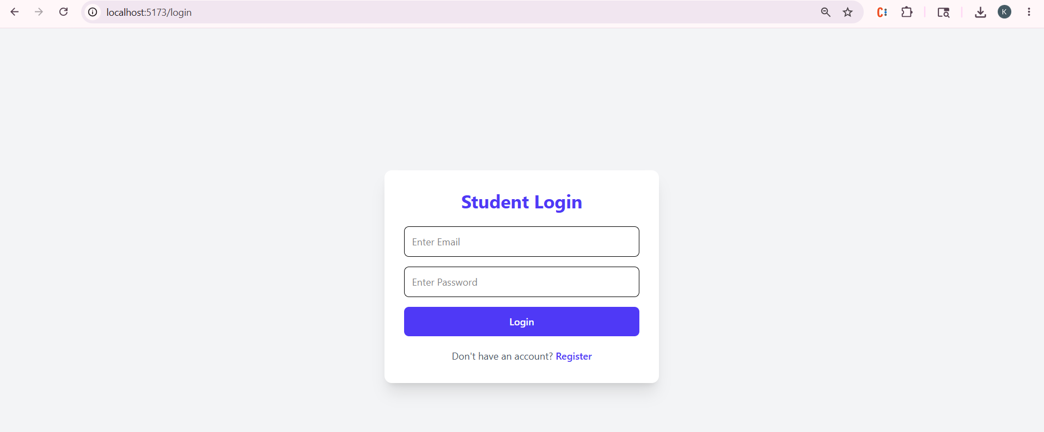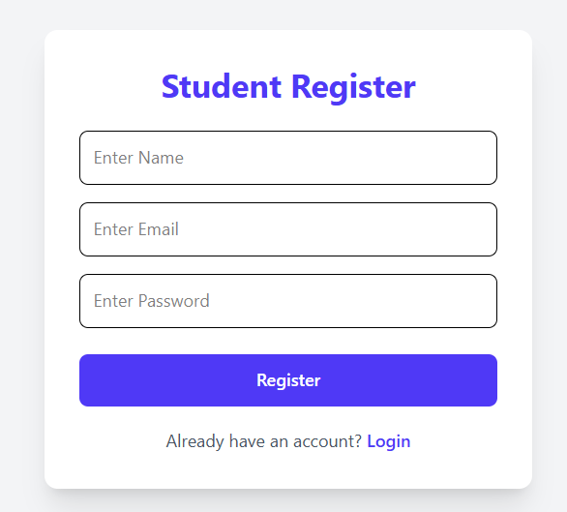
Fig 5.1 : Login & Register Student
5.2 Student Dashboard :
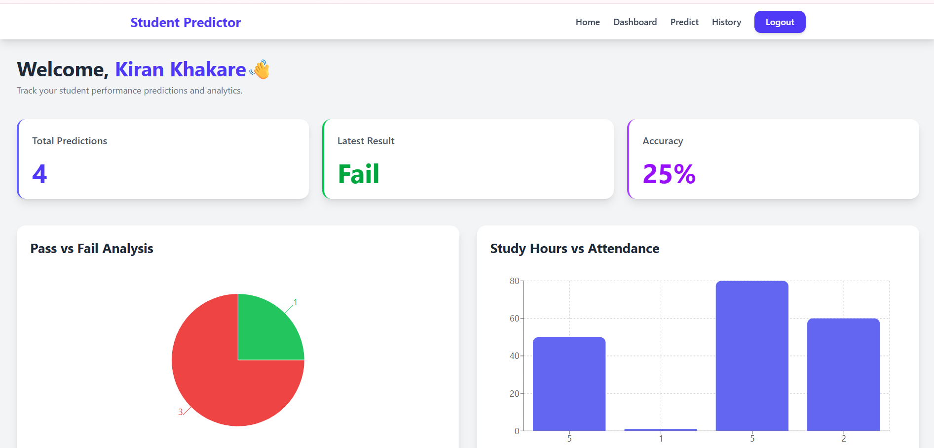
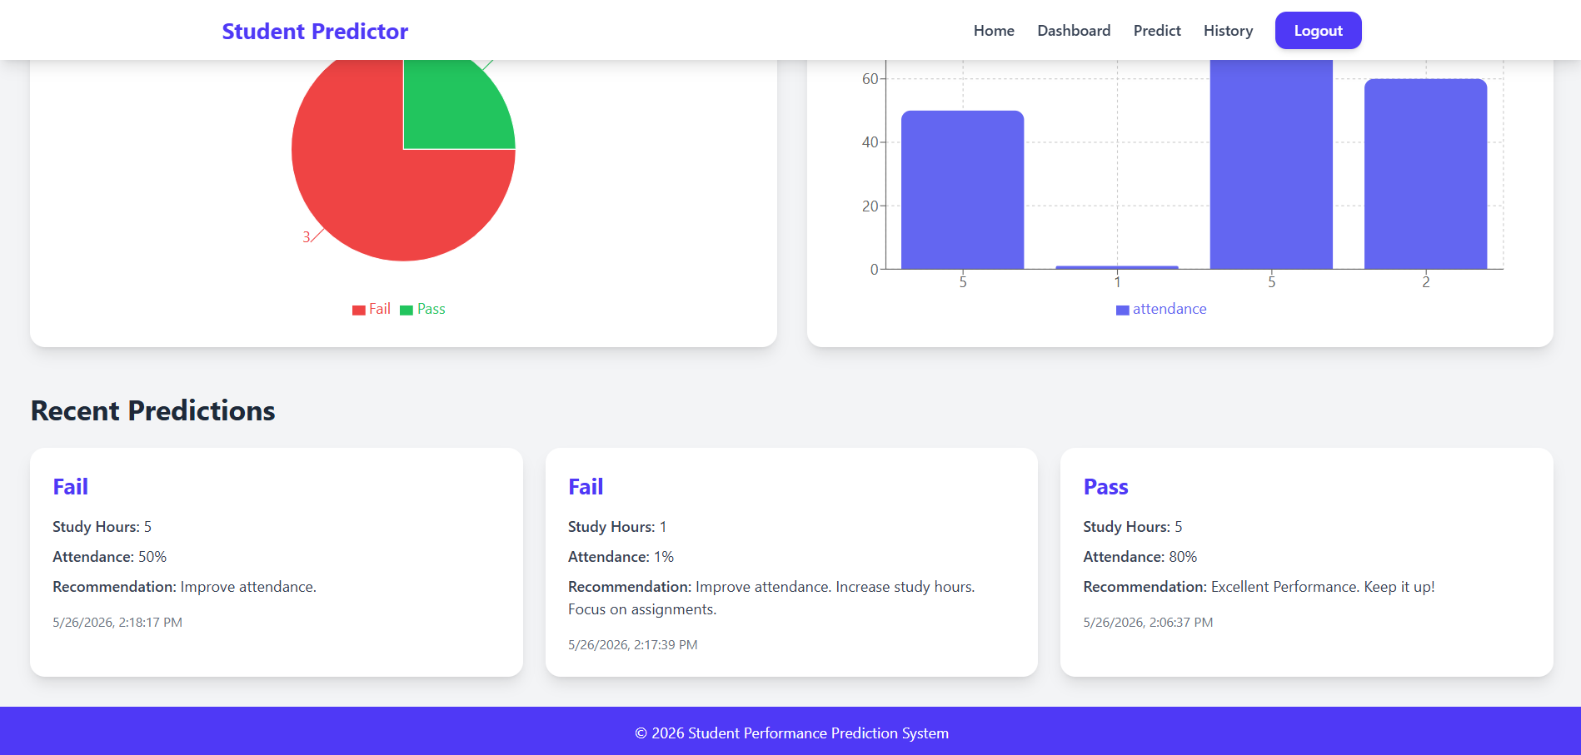
5.2 : Student Dashboard

5.3 Student Performance Prediction Page :
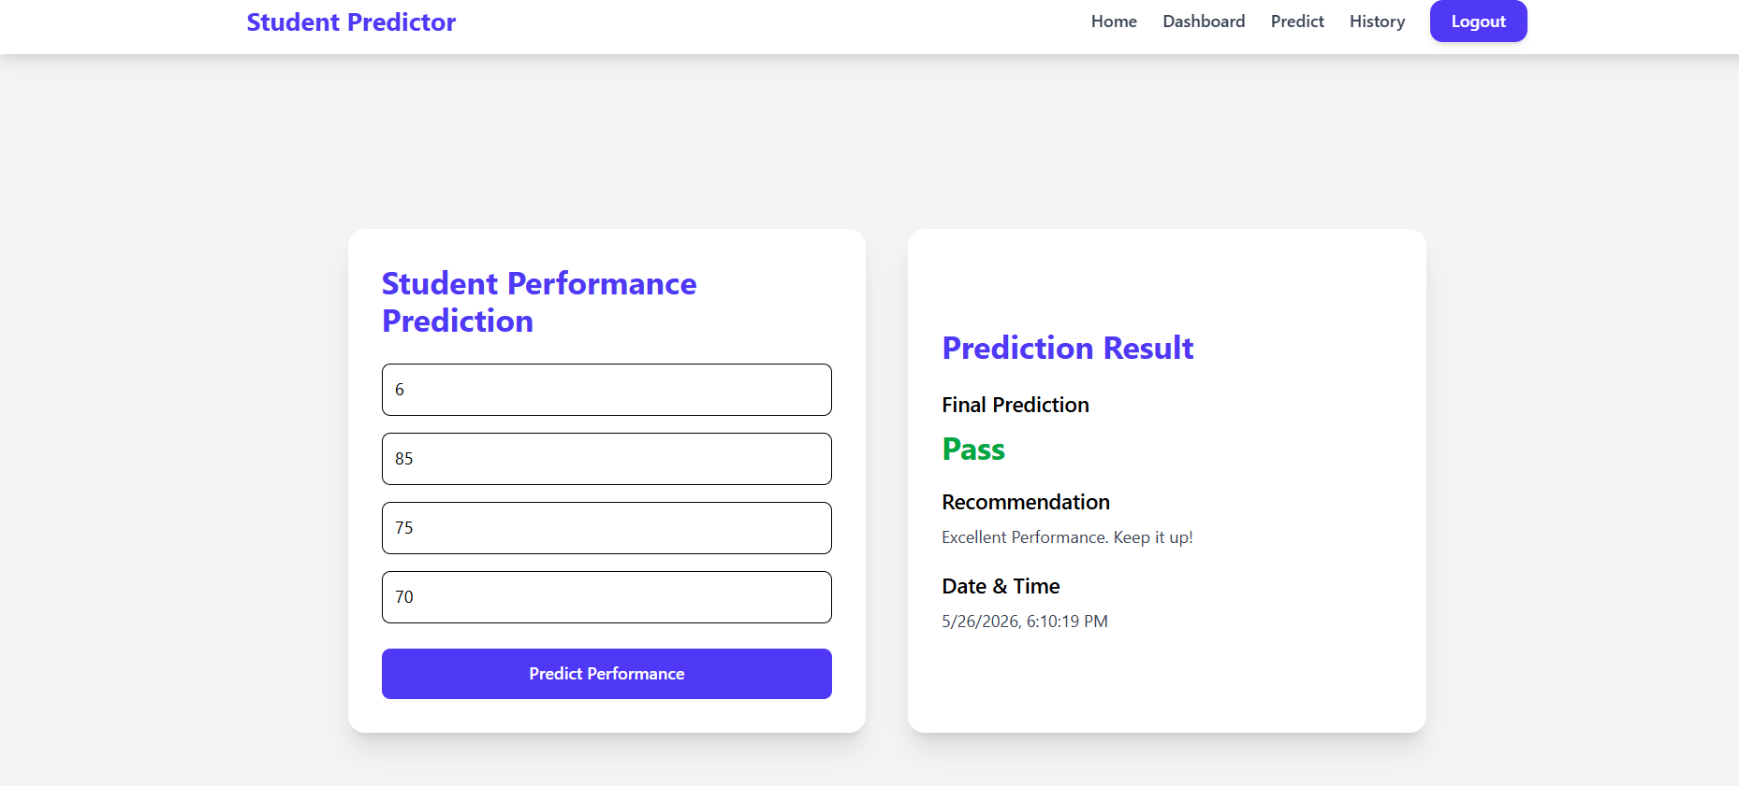
Fig 5.3 : Student Performance Prediction
5.4 Prediction History :
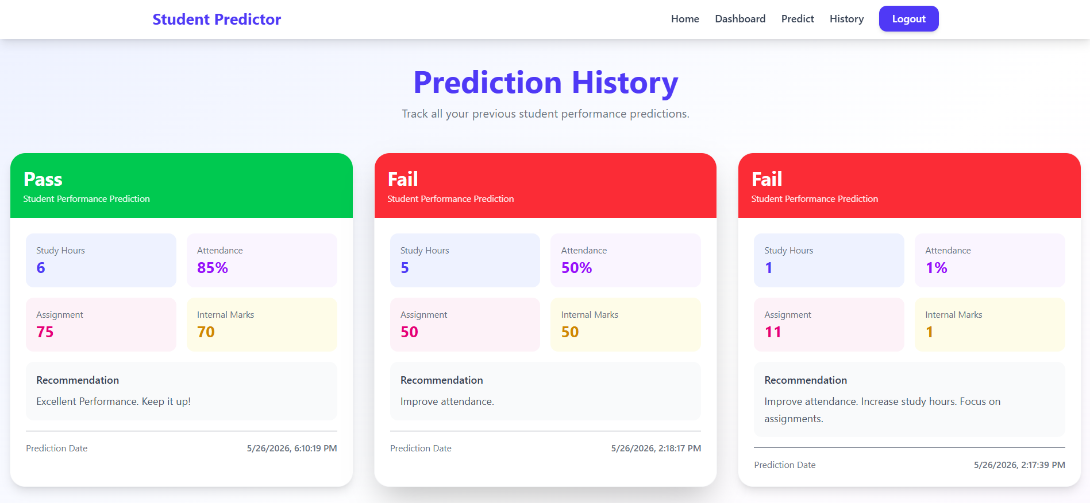
Fig 5.4 Prediction History

5.5 Database Table – User & Prediction
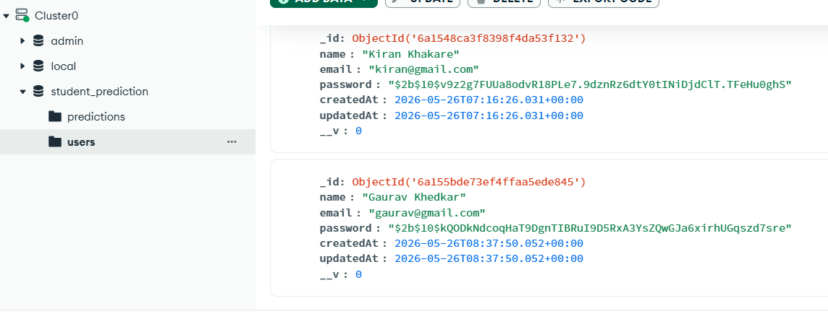
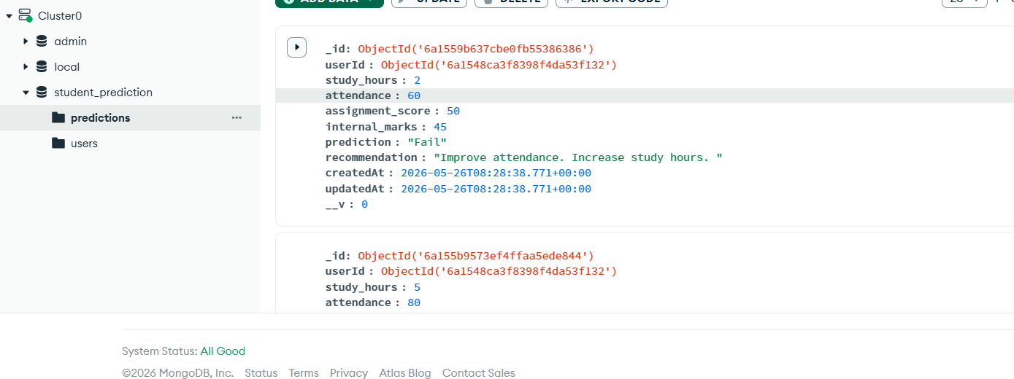
Fig 5.5 : Database Table – User & Prediction

6 . Conclusion
The “Student Performance Prediction Web Portal using Hybrid Machine Learning Algorithms” project successfully demonstrates the integration of Full Stack Web Development and Machine Learning technologies for educational performance analysis. The system is capable of predicting student academic performance based on factors such as study hours, attendance, assignment scores, and internal marks.
The project uses Hybrid Machine Learning Algorithms, including Logistic Regression and Random Forest, to improve prediction accuracy and generate reliable results. The system also provides personalized recommendations that help students improve their academic performance and learning outcomes.
The web portal includes important features such as secure authentication, dashboard analytics, graphical visualization, prediction history management, and responsive user interface design. The use of React, Node.js, MongoDB, and Python technologies makes the system efficient, scalable, and user-friendly.
Overall, the project provides a smart and intelligent educational support system that helps identify weak-performing students at an early stage and supports better academic decision-making using Artificial Intelligence and Machine Learning techniques.

REFERENCES
[1] Rodolfo Alan Martínez Rodríguez , José Manuel Valencia-Moreno , Olivia Denisse Mejía Victoria , Alma Alejandra Soberano Serrano, “Hybrid Machine Learning Pipeline for Predicting and Segmenting Academic Performance at a Mexican Public University”, Volume: 21, Page(s): 319 – 330 , IEEE , 17 April 2026
DOI: 10.1109/RITA.2026.3684879
[2] Sathiyapriya N , Rithika C , Sanjay S, Subathra S, “Utilizing Machine Learning to Forecast a Student’s Performance” , IEEE Xplore, 21 May 2024, DOI: 10.1109/AIMLA59606.2024.10531452
[3] Tao He , “Student Performance Prediction in College Using Artificial Bee Colony Algorithm and Machine Learning” , IEEE Xplore, 02 August 2024, DOI: 10.1109/ICEIB61477.2024.10602661
[4] Hariegwambe , Shakila Baskaran ,Prakash Marimuthu , “Stacking Based Machine Learning Approach for Student Performance Analysis” , IEEE , 06 February 2025, DOI: 10.1109/GCCIT63234.2024.10862313
[5] Donia Ashraf Ali;Mohamed Aborizka;Ahmed Dahroug , “Prediction of Student Performance by Using Machine Learning Techniques” , IEEE , 02 November 2023, DOI: 10.1109/AIRC57904.2023.10303160
[6] Sreeramaneni Chandrahasa , Sonti Meghala Sri Ganeshan , Rahul Chowdary Maddineni , Mellampudi Sai Divya , Praveen Tumuluru , Bulla Suneetha , “Machine Learning Algorithms based Student Performance Prediction based on Previous Records” , IEEE Xplore , 04 April 2023, DOI: 10.1109/ICCMC56507.2023.10084099
[7] V. Belsini Gladshiya, K. Sharmila , “Analyzing the Student's Risk in using Electronic Gadgets using Hybrid Machine Learning Model as Case Study” , IEEE , 24 February 2023, DOI: 10.1109/SMART55829.2022.10047035
[8] Hamza Turabieh , “Hybrid Machine Learning Classifiers to Predict Student Performance” , IEEE, 05 December 2019 , DOI: 10.1109/ICTCS.2019.8923093

