

ABDULLAH ALSHEREY

Student registration system

Contents

Home screen 2

Home Screen 2

How to login as Student/Staff ? 2

Student login page 3

faculty login page 3

After successful Student / faculty login 3

Logout 4

USER (STUDENT ACTIONS) 5

REGISTER STUDENT 5

EDIT STUDENT REGISTRATION 6

DELETE STUDENT REGISTRATION 7

sEARCH/VIEW 7

USER (FACULTY ACTIONS) 9

# Home screen

There are two types of login in the web application

* STUDENT LOGIN
* STAFF LOGIN

## Home Screen

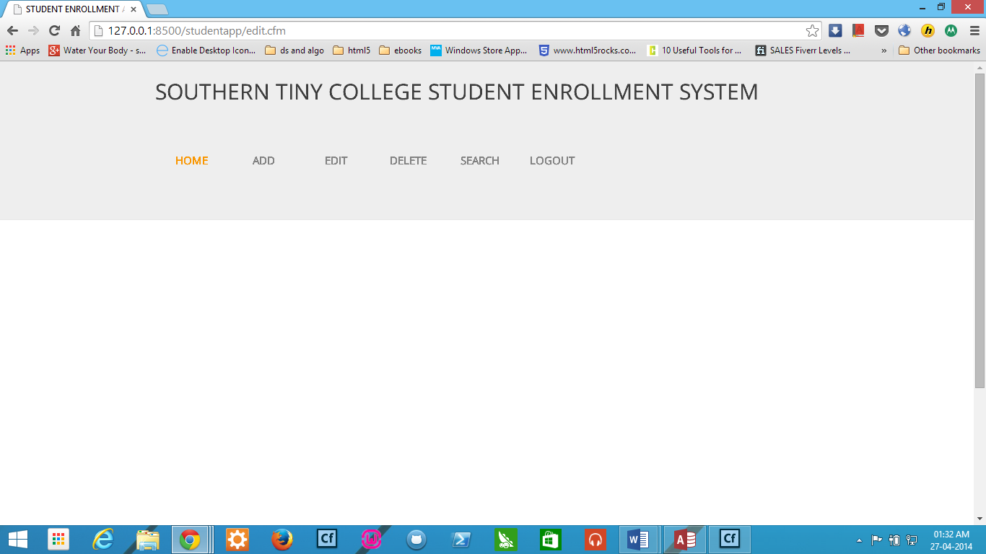

## How to login as Student/Staff ?

* Click on the STUDENT LOGIN or STAFF LOGIN

You will see the page:

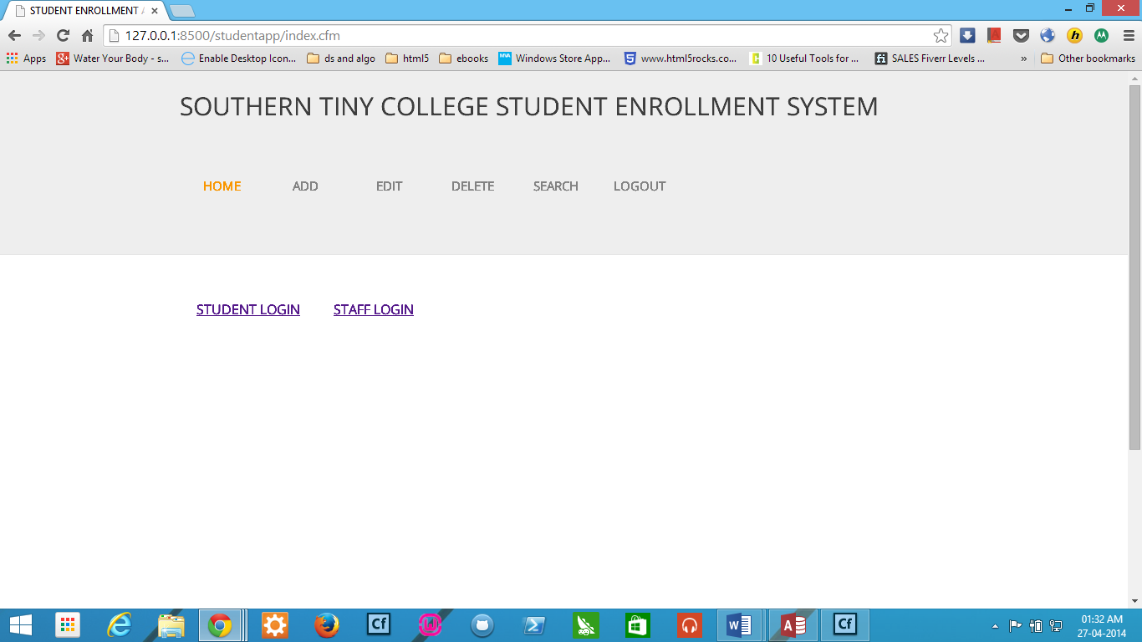

### Student login page

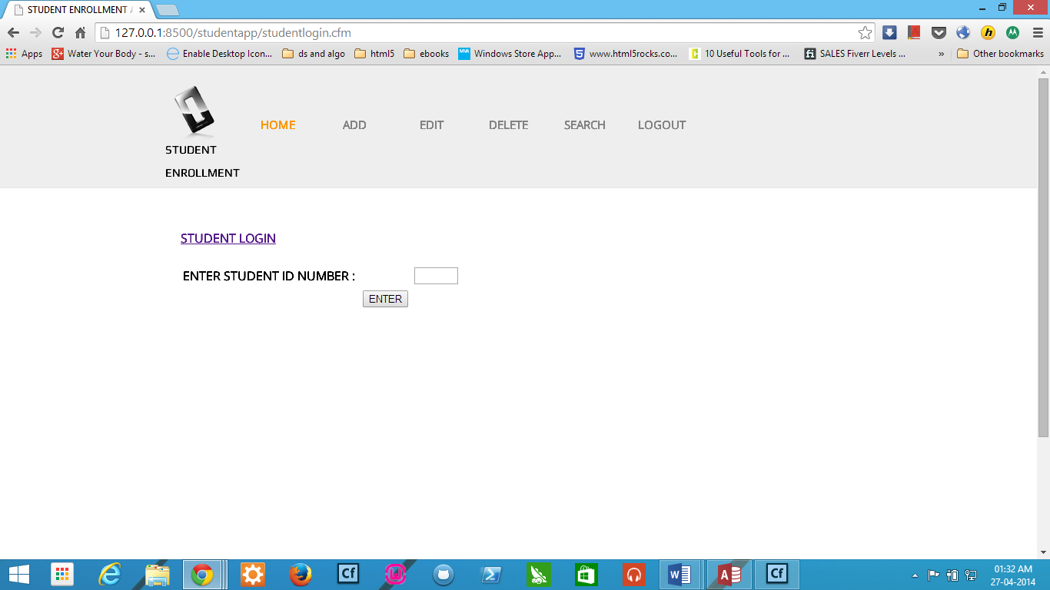

### faculty login page

* Fill in the Student/Staff ID number and Press enter

# After successful Student / faculty login

* You will see your username appear like Welcome, User

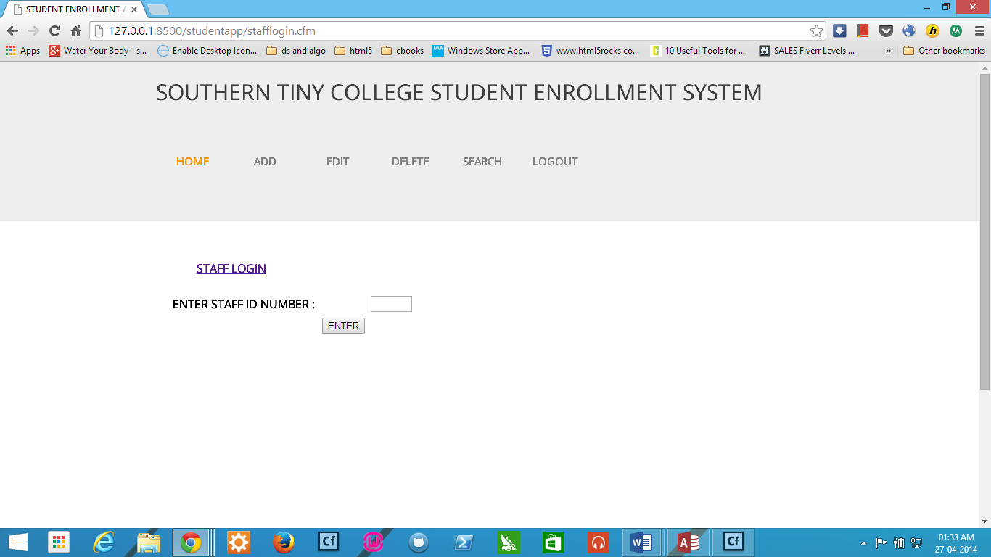

# Logout

* On clicking logout option you will logout.

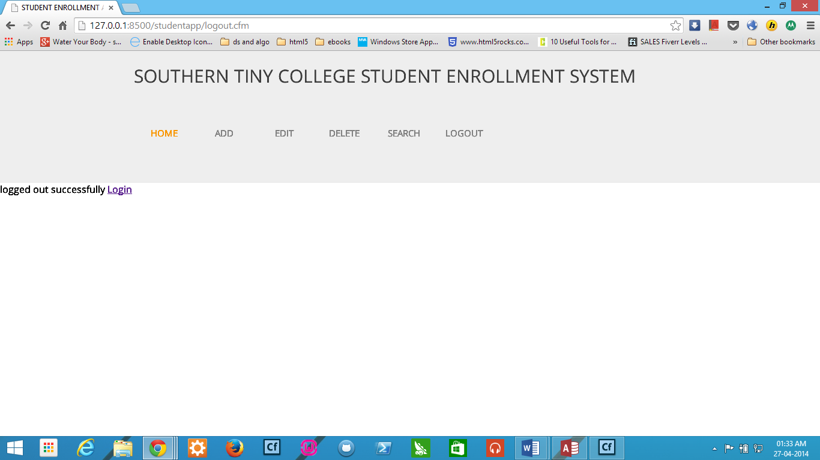

# USER (STUDENT ACTIONS)

A student can do the following activities:

* REGISTER STUDENT
* EDIT STUDENT REGISTRATION
* SEARCH STUDENT REGISTRATION
* DELETE STUDENT REGISTRATION

## REGISTER STUDENT

To register a student

* Click on REGISTER STUDENT
* Fill registration form and click submit

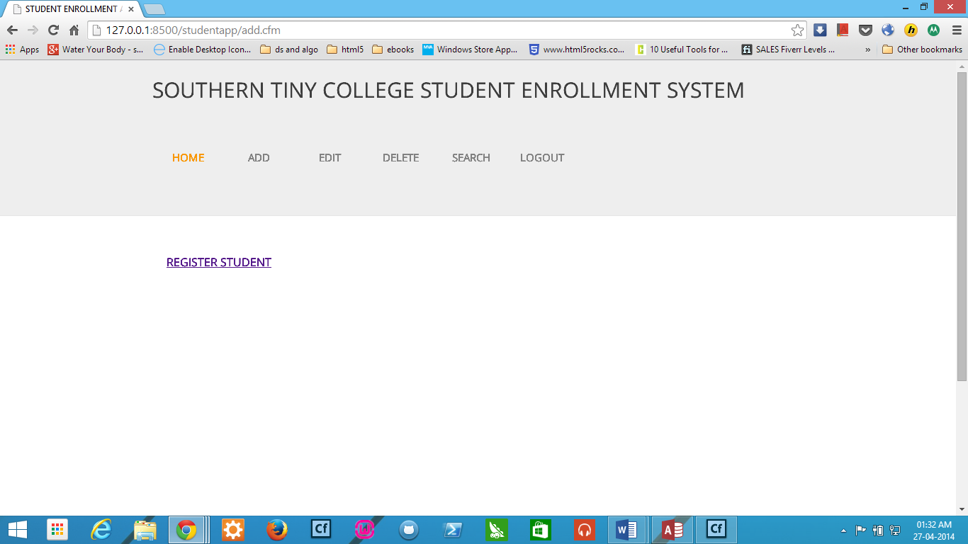

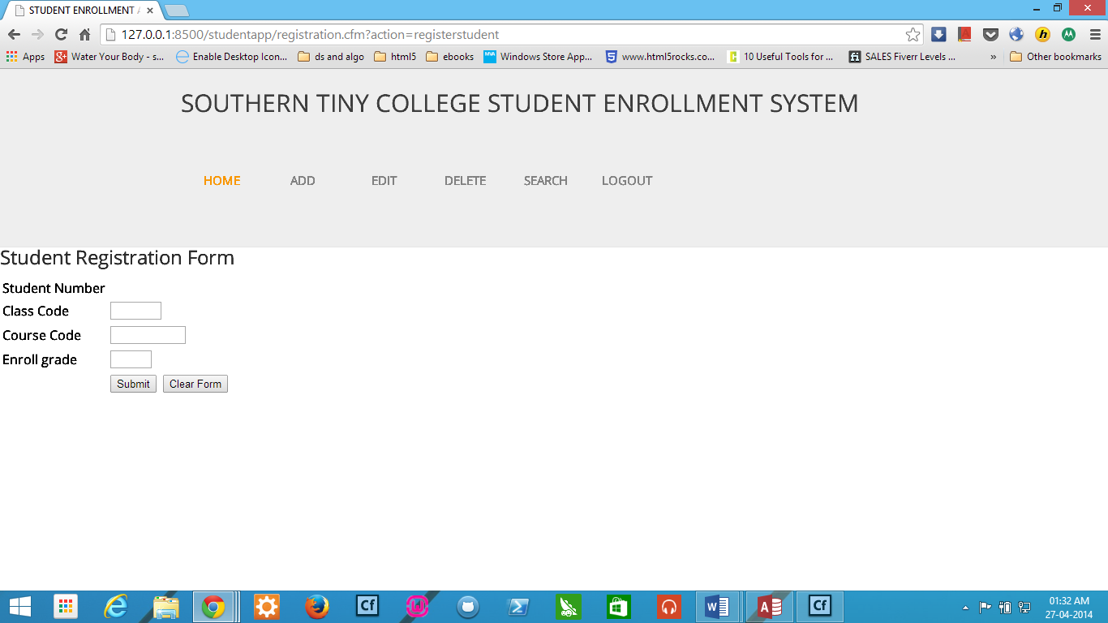

## EDIT STUDENT REGISTRATION

To edit, click on EDIT to update registration

* Click on EDIT REGISTER STUDENT
* Fill registration form and click submit

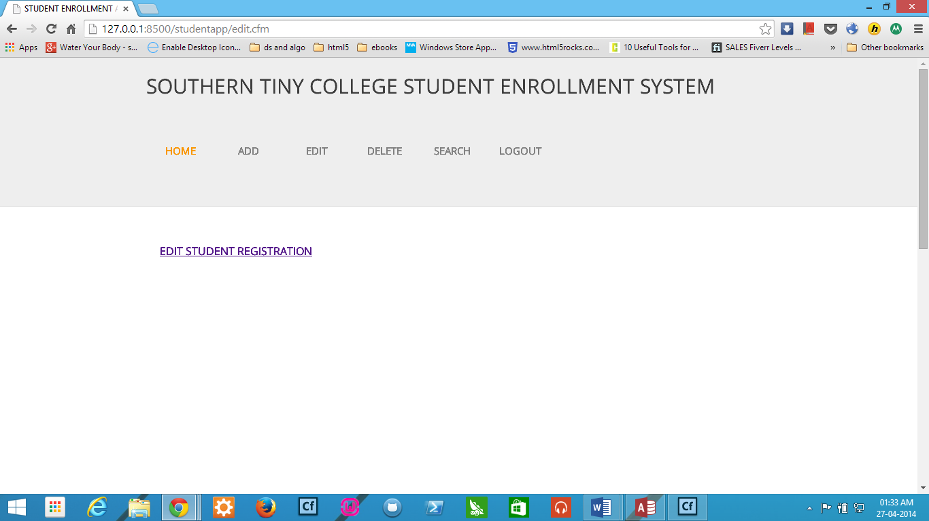

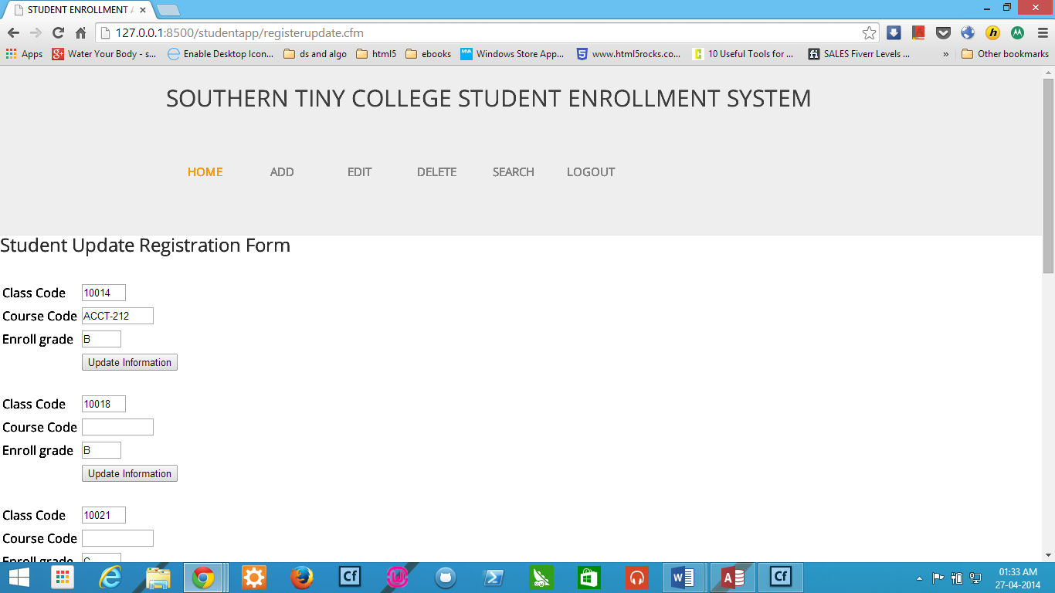

## DELETE STUDENT REGISTRATION

To edit, click on Delete registration

* Click on DELETE REGISTER STUDENT
* Enter student number, class code, course code

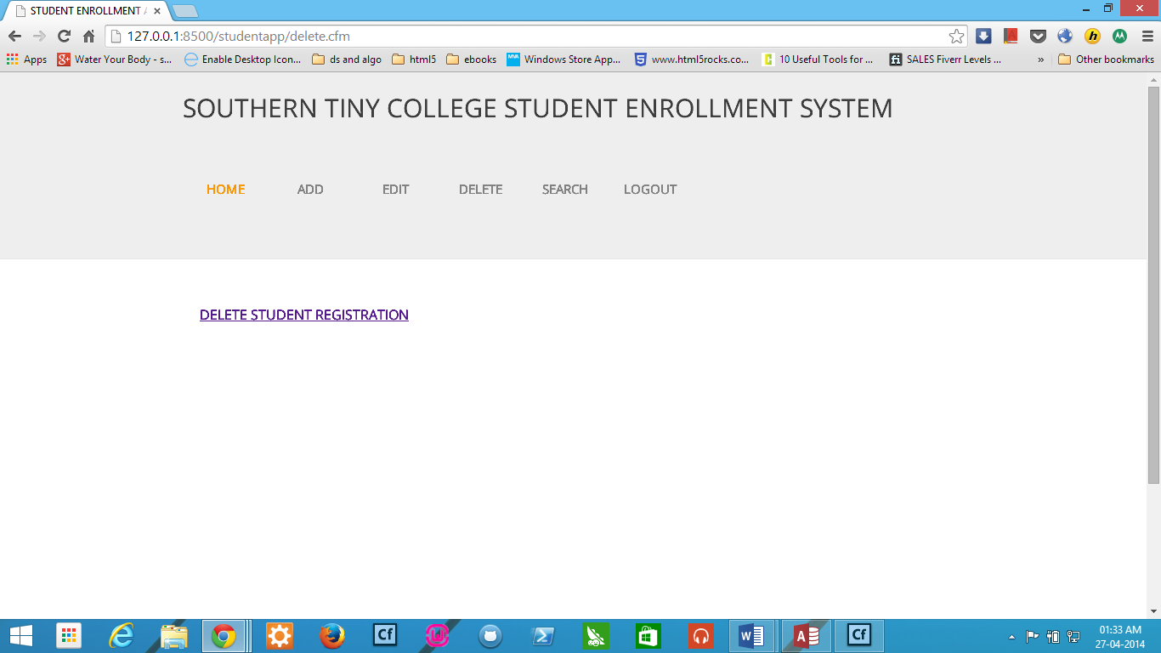

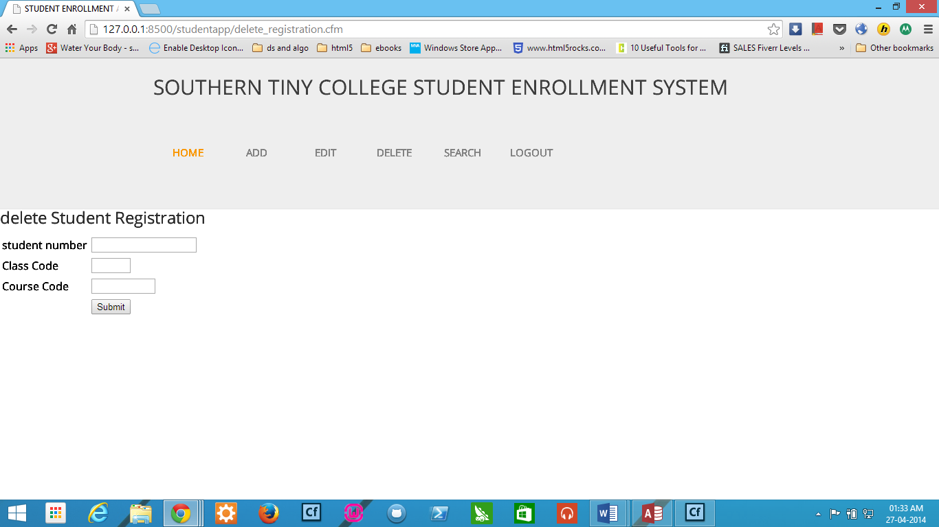

## sEARCH/VIEW

Click on search

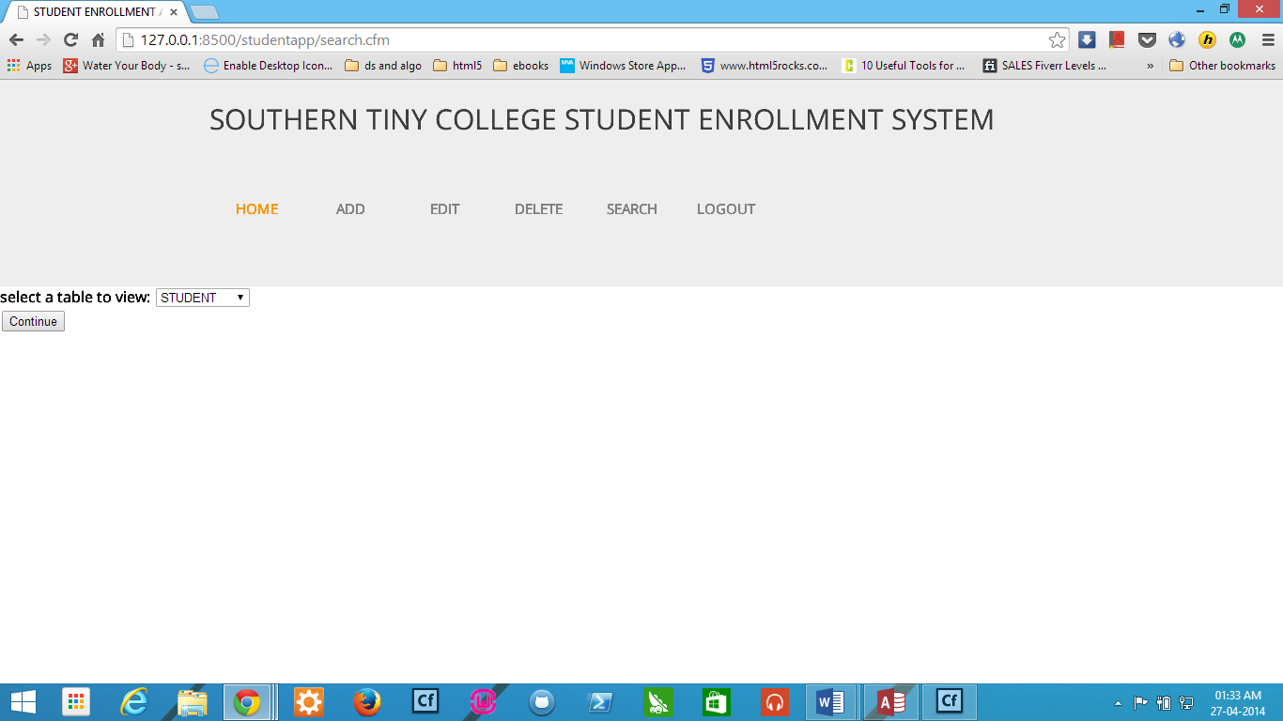

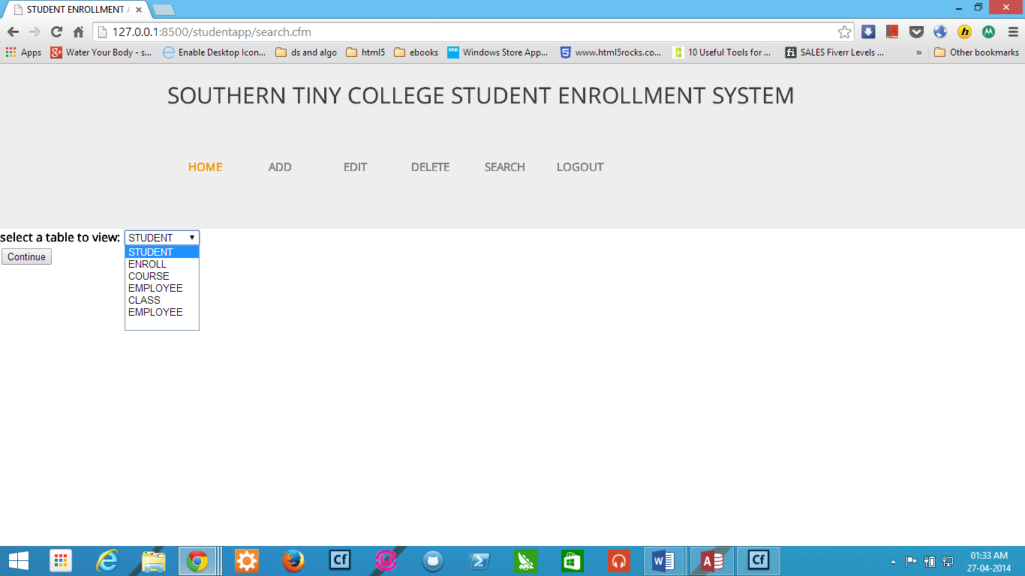

# USER (FACULTY ACTIONS)

A student can do the following activities:

* ADD
* REGISTER STUDENT as seen above
* ADD STUDENT
* ADD COURSE
* ADD PROFESSOR
* ADD CLASS
* EDIT
* EDIT STUDENT REGISTRATION
* EDIT STUDENT DATA
* EDIT COURSE DATA
* EDIT PROFESSOR DATA
* EDIT CLASS DATA
* DELETE REGISTRATION
* LOGOUT
* SEARCH

Some of the screens :



