Experiment 1

Setting Up Python Environment and Libraries – Jupyter Notebook

Aim: To configure Python, Jupyter Notebook, and verify the installation of essential data analytics libraries using the Player dataset.

Procedure:
- Install Jupyter Notebook using the command pip install notebook.
- Install Jupyter Notebook using the command pip install notebook.
- Create a new Python notebook and rename it appropriately.
- Import the required libraries such as NumPy, Pandas, and Matplotlib.
- Verify the successful installation of the libraries by checking their versions.
- Load the Player Dataset (Player.csv) using the Pandas read_csv() function.
- Display the first few records of the dataset to verify successful loading.
- Examine the dataset structure using functions such as info(), shape, columns, and describe().
- Identify missing values and duplicate records using isnull().sum() and duplicated().
- Perform basic NumPy operations to verify numerical computation capabilities.
- Generate simple visualizations (such as a histogram and bar chart) using Matplotlib to analyze the Player dataset and verify the plotting library is functioning correctly.

Code:
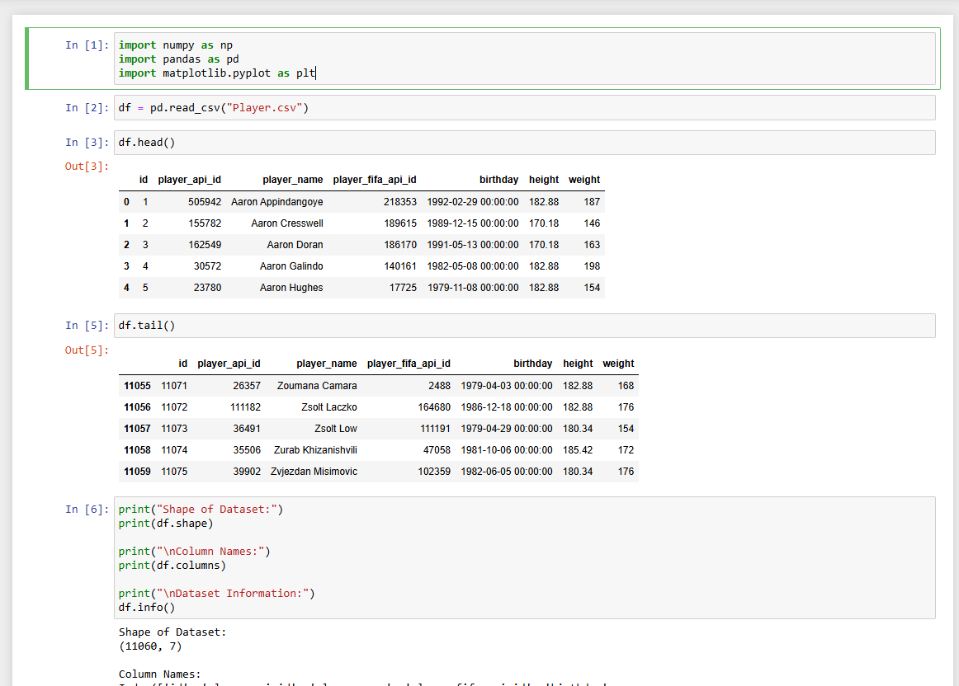
- Imported libraries
- Read csv and displayed the first and last 5 rows of the table
- Displayed the shape of the table in rows and columns
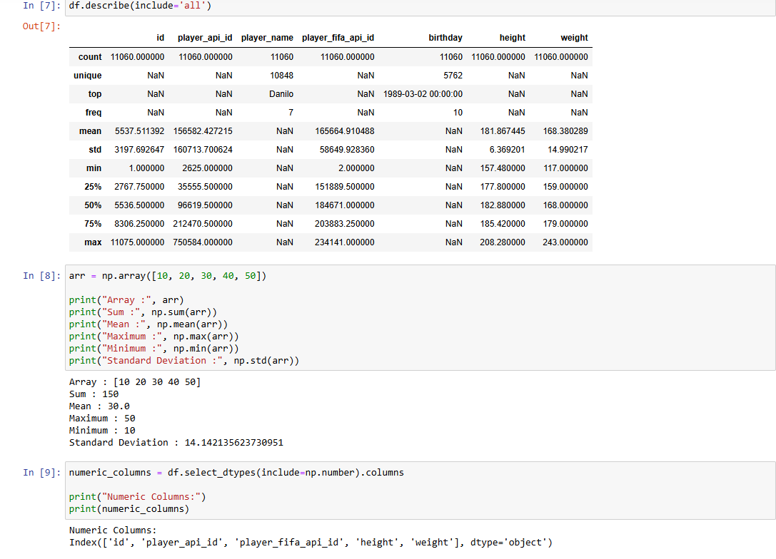
- Described the table and displayed all the column names
- Printed array, sum, mean, max, min, sd
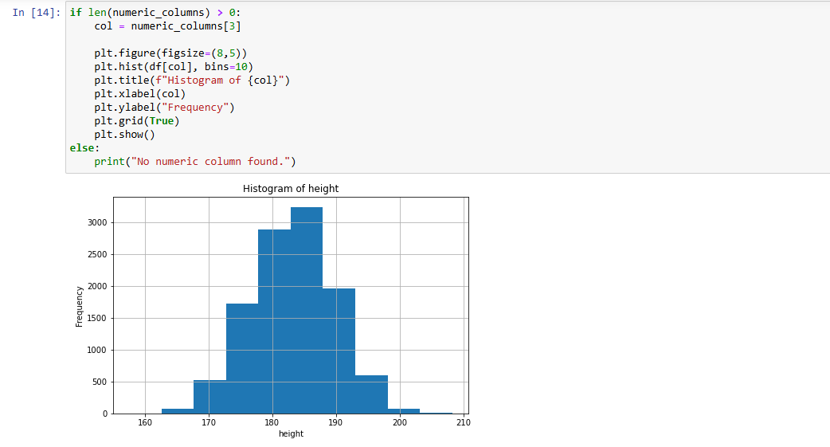
- Displayed the Histogram of the height column
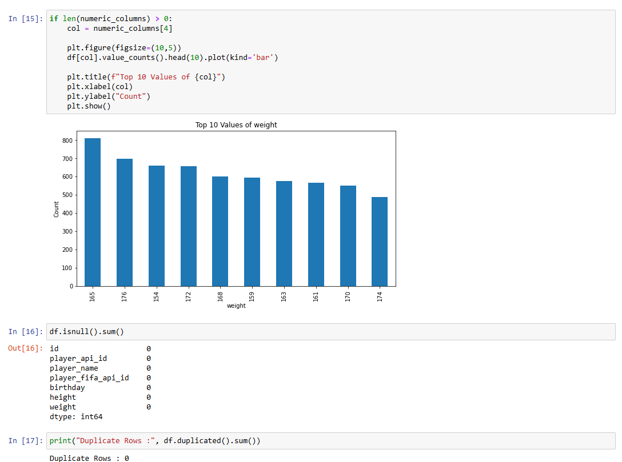

- Displayed the top 10 weight values of the column in bar chart
- Checked if there are any null values
- Checked if there are any duplicate values

Experiment 2: Exploratory Data Analysis (EDA) – Data Import and Export

Aim:

To import the Player dataset from a CSV file, perform basic exploratory data analysis (EDA) using Pandas, identify missing values and duplicate records, and export the processed dataset into different file formats.

Procedure:
- Open Jupyter Notebook and import the required libraries such as Pandas and SQLite3.
- Load the Player Dataset (Player.csv) using the Pandas read_csv() function.
- Display the first and last five records of the dataset using head() and tail().
- Examine the dataset structure using info(), shape, columns, and dtypes.
- Generate a statistical summary of the dataset using the describe() function.
- Identify missing values using the isnull().sum() function.
- Detect duplicate records using the duplicated() function and remove them if necessary.
- Save the dataset as an Excel file using the to_excel() function and verify it by importing it again with read_excel().
- Create an SQLite database and store the dataset as a table using the to_sql() function.
- Export the processed dataset to CSV, Excel, and JSON formats using to_csv(), to_excel(), and to_json() functions.
- Verify that the exported files have been created successfully by opening or importing them into Jupyter Notebook.

Code:

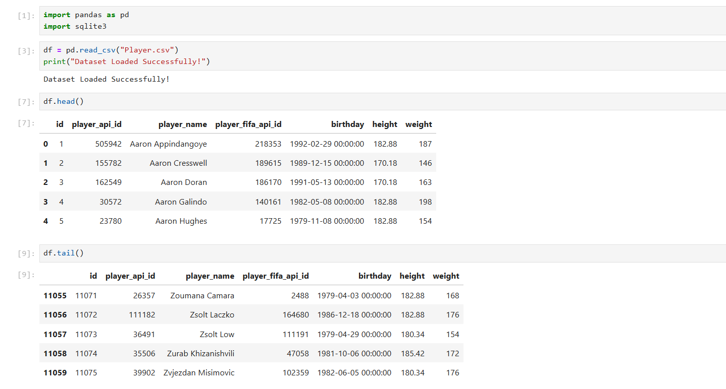
- Imported packages and read the dataset
- Displayed the first and the last 5 rows of the dataset

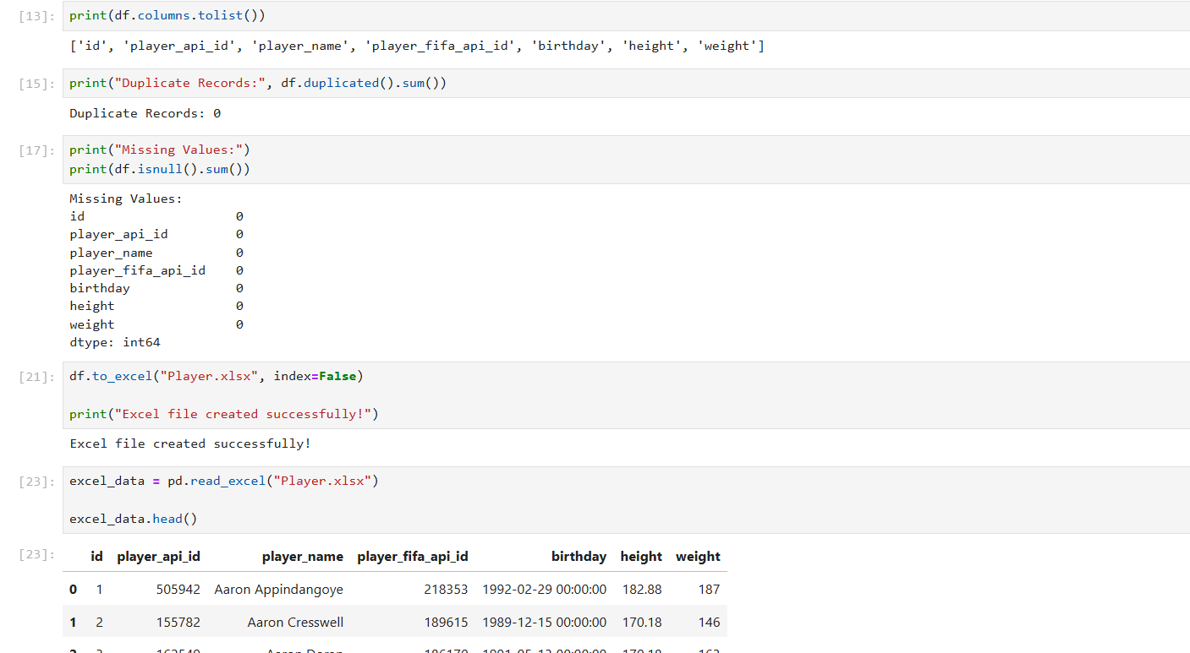
- Displayed the column name
- Checked if there are any duplicate or missing values In the dataset
- Saved the dataset as a excel file

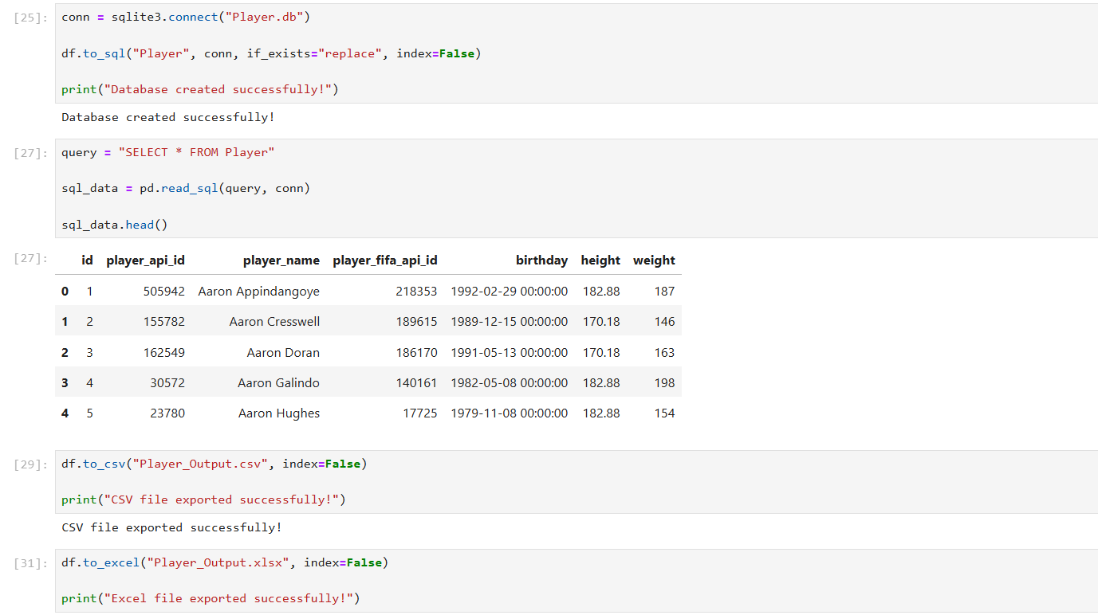

- Created SQlite Database
- Exported dataset to CSV, Excel, and JSON
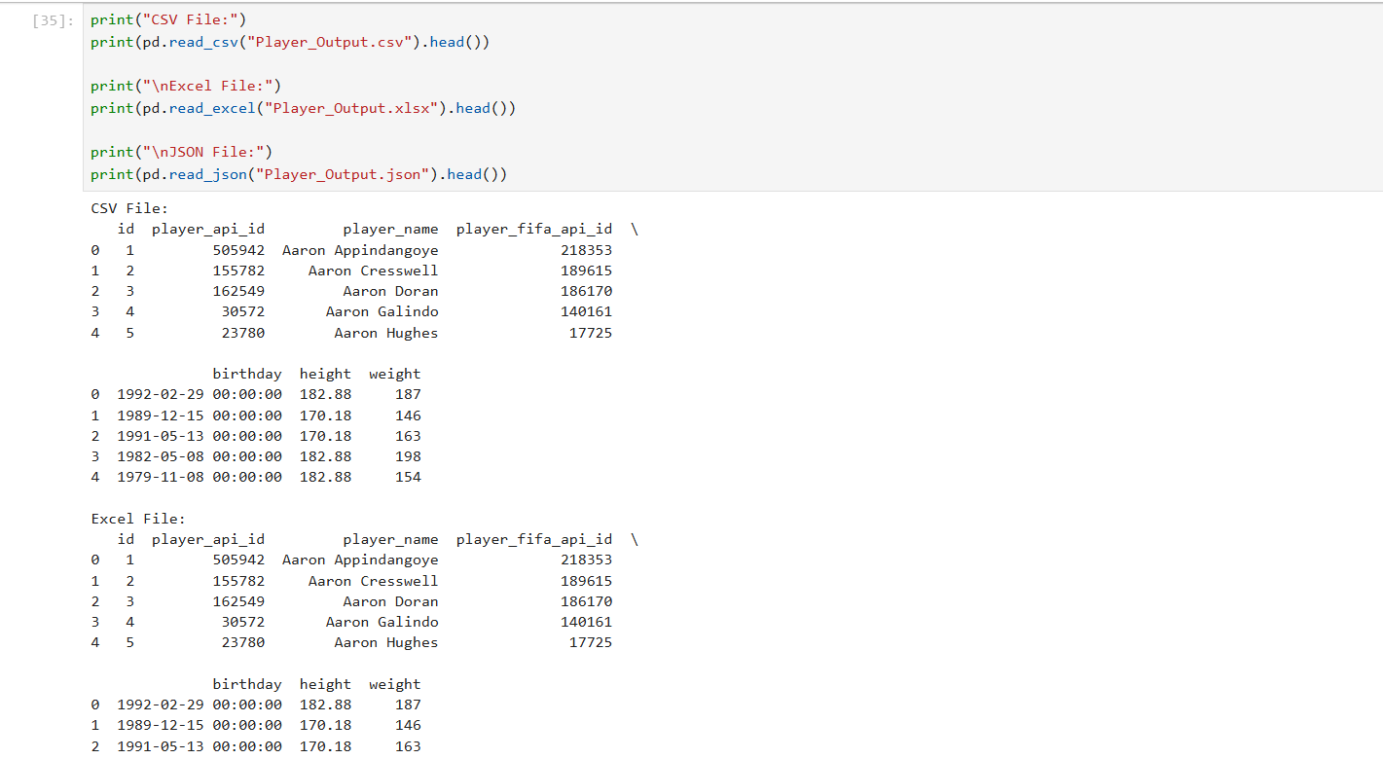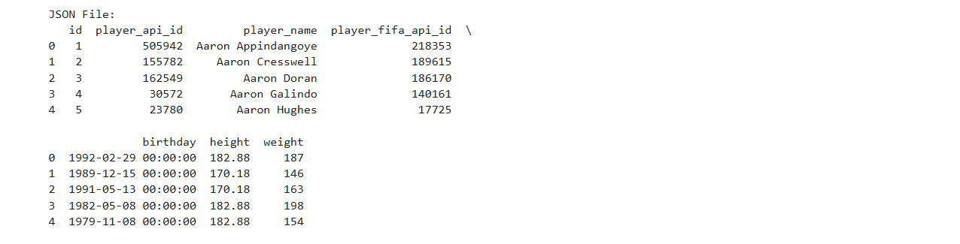
- Verified the exported CSV, Excel, and JSON files are read

