Kerberos server set up –

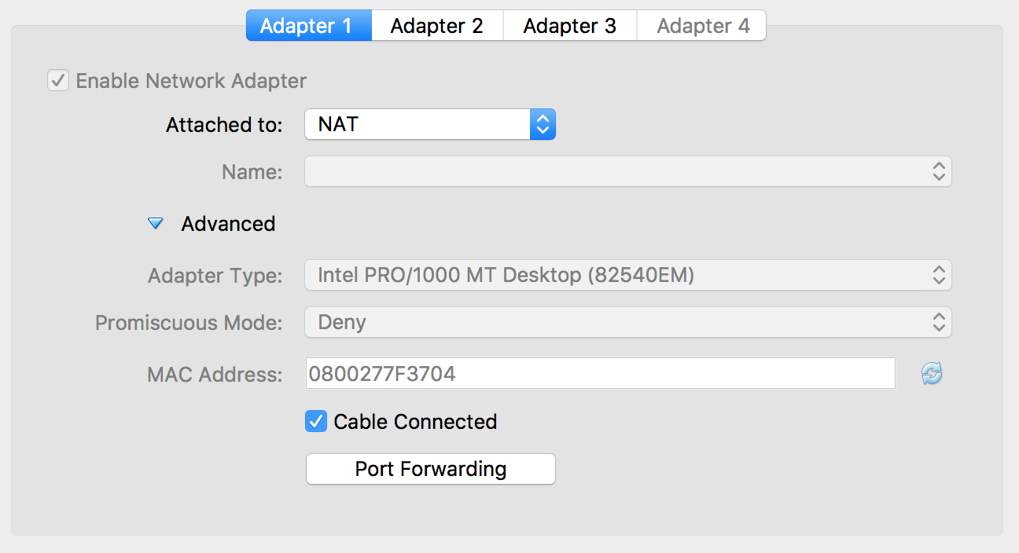

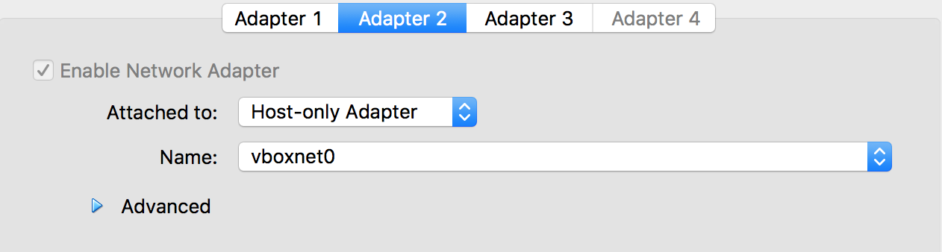

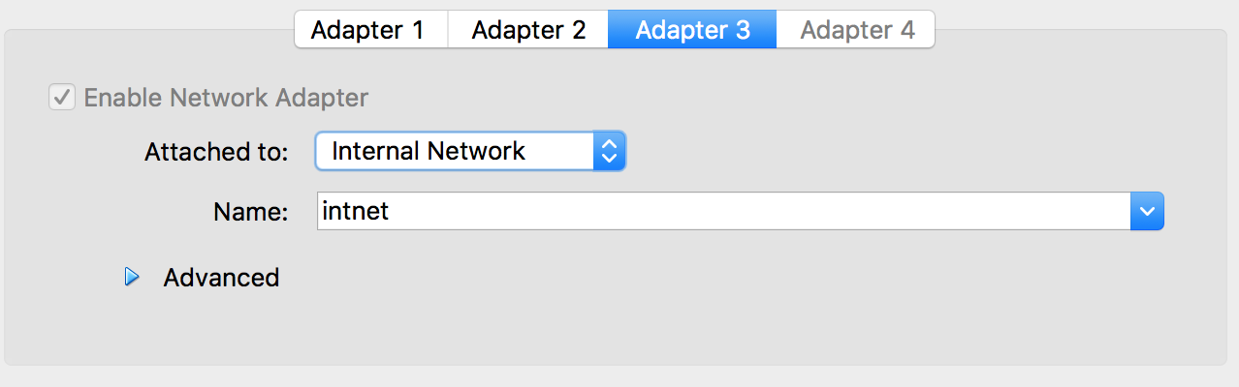

[root@kerberos ~]# hostnamectl set-hostname kerberos.example.com

[root@kerberos ~]# ip addr

1: lo: <LOOPBACK,UP,LOWER_UP> mtu 65536 qdisc noqueue state UNKNOWN qlen 1

link/loopback 00:00:00:00:00:00 brd 00:00:00:00:00:00

inet 127.0.0.1/8 scope host lo

valid_lft forever preferred_lft forever

inet6 ::1/128 scope host

valid_lft forever preferred_lft forever

2: enp0s3: <BROADCAST,MULTICAST,UP,LOWER_UP> mtu 1500 qdisc pfifo_fast state UP qlen 1000

link/ether 08:00:27:7f:37:04 brd ff:ff:ff:ff:ff:ff

inet 10.0.2.15/24 brd 10.0.2.255 scope global dynamic enp0s3

valid_lft 85612sec preferred_lft 85612sec

inet6 fe80::feef:4c29:81ae:efa9/64 scope link

valid_lft forever preferred_lft forever

3: enp0s8: <BROADCAST,MULTICAST,UP,LOWER_UP> mtu 1500 qdisc pfifo_fast state UP qlen 1000

link/ether 08:00:27:ec:ef:36 brd ff:ff:ff:ff:ff:ff

inet 192.168.99.101/24 brd 192.168.99.255 scope global dynamic enp0s8

valid_lft 922sec preferred_lft 922sec

inet6 fe80::df54:7e83:4421:75fa/64 scope link

valid_lft forever preferred_lft forever

4: enp0s9: <BROADCAST,MULTICAST,UP,LOWER_UP> mtu 1500 qdisc pfifo_fast state UP qlen 1000

link/ether 08:00:27:b4:16:99 brd ff:ff:ff:ff:ff:ff

[root@kerberos ~]# rpm -qa | grep krb

krb5-workstation-1.14.1-27.el7_3.x86_64

krb5-libs-1.14.1-27.el7_3.x86_64

krb5-server-1.14.1-27.el7_3.x86_64

pam_krb5-2.4.8-6.el7.x86_64

Step 1 :

/etc/krb5.conf

# Configuration snippets may be placed in this directory as well

includedir /etc/krb5.conf.d/

[logging]

default = FILE:/var/log/krb5libs.log

kdc = FILE:/var/log/krb5kdc.log

admin_server = FILE:/var/log/kadmind.log

[libdefaults]

dns_lookup_realm = true

dns_lookup_kdc = true

dns_fallback = yes

ticket_lifetime = 24h

renew_lifetime = 7d

forwardable = true

rdns = false

default_realm = EXAMPLE.COM

# default_ccache_name = KEYRING:persistent:%{uid}

[realms]

EXAMPLE.COM = {

kdc = kerberos.example.com

admin_server = kerberos.example.com

default_domain = EXAMPLE.COM

}

[domain_realm]

.EXAMPLE.COM = EXAMPLE.COM

EXAMPLE.COM = EXAMPLE.COM

[appsdefaults]

pam = {

debug = false

ticket_lifetime = 36000

renew_lifetime = 36000

forwardable = true

krb4_convert = false

}

step 2:

/etc/hosts

127.0.0.1 localhost

192.168.99.101 kerberos.example.com kerberos

192.168.99.102 maprdemo.example.com maprdemo

step 3 :

[root@kerberos ~]# vi /var/kerberos/krb5kdc/kdc.conf

[kdcdefaults]

kdc_ports = 88

kdc_tcp_ports = 88

[realms]

EXAMPLE.COM = {

master_key_type = aes256-cts

acl_file = /var/kerberos/krb5kdc/kadm5.acl

dict_file = /usr/share/dict/words

admin_keytab = /var/kerberos/krb5kdc/kadm5.keytab

supported_enctypes = aes256-cts:normal aes128-cts:normal des3-hmac-sha1:normal arcfour-hmac:normal camellia256-cts:normal camellia128-cts:normal des-hmac-sha1:normal des-cbc-md5:normal des-cbc-crc:normal

}

[root@kerberos ~]# vi /var/kerberos/krb5kdc/kadm5.acl

*/admin@EXAMPLE.COM *

[root@kerberos ~]# kdb5_util create -s -r EXAMPLE.COM

[root@kerberos ~]# service kadmin restart

[root@kerberos ~]# service krb5kdc restart

[root@kerberos ~]# kdb5_util -r EXAMPLE.COM

Kerberos Client Set up:







[root@kerberos ~]# hostnamectl set-hostname kerberos.example.com

[root@kerberos ~]# ip addr

1: lo: <LOOPBACK,UP,LOWER_UP> mtu 65536 qdisc noqueue state UNKNOWN qlen 1

link/loopback 00:00:00:00:00:00 brd 00:00:00:00:00:00

inet 127.0.0.1/8 scope host lo

valid_lft forever preferred_lft forever

inet6 ::1/128 scope host

valid_lft forever preferred_lft forever

2: enp0s3: <BROADCAST,MULTICAST,UP,LOWER_UP> mtu 1500 qdisc pfifo_fast state UP qlen 1000

link/ether 08:00:27:7f:37:04 brd ff:ff:ff:ff:ff:ff

inet 10.0.2.16/24 brd 10.0.2.255 scope global dynamic enp0s3

valid_lft 85612sec preferred_lft 85612sec

inet6 fe80::feef:4c29:81ae:efa9/64 scope link

valid_lft forever preferred_lft forever

3: enp0s8: <BROADCAST,MULTICAST,UP,LOWER_UP> mtu 1500 qdisc pfifo_fast state UP qlen 1000

link/ether 08:00:27:ec:ef:36 brd ff:ff:ff:ff:ff:ff

inet 192.168.99.102/24 brd 192.168.99.255 scope global dynamic enp0s8

valid_lft 922sec preferred_lft 922sec

inet6 fe80::df54:7e83:4421:75fa/64 scope link

valid_lft forever preferred_lft forever

4: enp0s9: <BROADCAST,MULTICAST,UP,LOWER_UP> mtu 1500 qdisc pfifo_fast state UP qlen 1000

[root@kerberos ~]# rpm -qa | grep krb

krb5-workstation-1.14.1-27.el7_3.x86_64

krb5-libs-1.14.1-27.el7_3.x86_64

Step 1 :

/etc/krb5.conf

# Configuration snippets may be placed in this directory as well

includedir /etc/krb5.conf.d/

[logging]

default = FILE:/var/log/krb5libs.log

kdc = FILE:/var/log/krb5kdc.log

admin_server = FILE:/var/log/kadmind.log

[libdefaults]

dns_lookup_realm = true

dns_lookup_kdc = true

dns_fallback = yes

ticket_lifetime = 24h

renew_lifetime = 7d

forwardable = true

rdns = false

default_realm = EXAMPLE.COM

# default_ccache_name = KEYRING:persistent:%{uid}

[realms]

EXAMPLE.COM = {

kdc = kerberos.example.com

admin_server = kerberos.example.com

default_domain = EXAMPLE.COM

}

[domain_realm]

.EXAMPLE.COM = EXAMPLE.COM

EXAMPLE.COM = EXAMPLE.COM

[appsdefaults]

pam = {

debug = false

ticket_lifetime = 36000

renew_lifetime = 36000

forwardable = true

krb4_convert = false

}

step 2:

/etc/hosts

127.0.0.1 localhost

192.168.99.101 kerberos.example.com kerberos

192.168.99.102 maprdemo.example.com maprdemo

Follow the steps given in below link

<http://maprdocs.mapr.com/home/SecurityGuide/Configuring-Kerberos-User-Authentication.html>

<http://maprdocs.mapr.com/home/SecurityGuide/Configuring-Kerberos-User-Authentication.html#ConfiguringKerberosUserAuthentication>

[mapr@kerberos ~]# Kinit

[mapr@kerberos ~]# maprlogin password



[mapr@kerberos ~]# Hadoop fs -ls

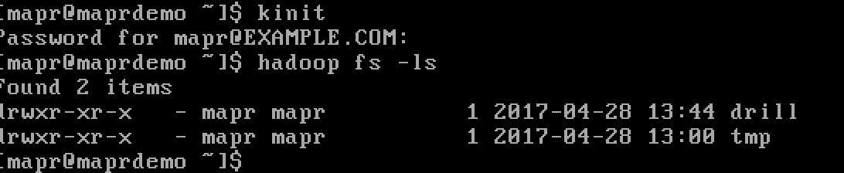

<http://maprdocs.mapr.com/home/HBase/configuring_hbase_to_use_kerberos.html?hl=kerberos>