Mini-Trello Kanban Board
Project Report

1. Student Details
Name: Kirankumar Thakor
Enrollment Number: 230390116028
Semester: 7th Semester
Subject: Mini Project
Technology: Node.js + Express + SQLite + HTML/CSS/JS

2. Project Overview
Mini-Trello is a simple single-page Kanban board application that allows users to create tasks and move them between three columns: To Do, In Progress, and Done. The project demonstrates practical application of Frontend development, Backend API creation, Database management, and Agile/Scrum methodology.

3. Features
- Create a new task (Title required, Description optional) - added to To Do
- View all tasks grouped by status in three columns
- Move tasks forward/backward using Next/Previous buttons
- Delete tasks with confirmation prompt
- Responsive, clean UI with distinct column colors
- All changes persist in the SQLite database

4. Application Screenshots
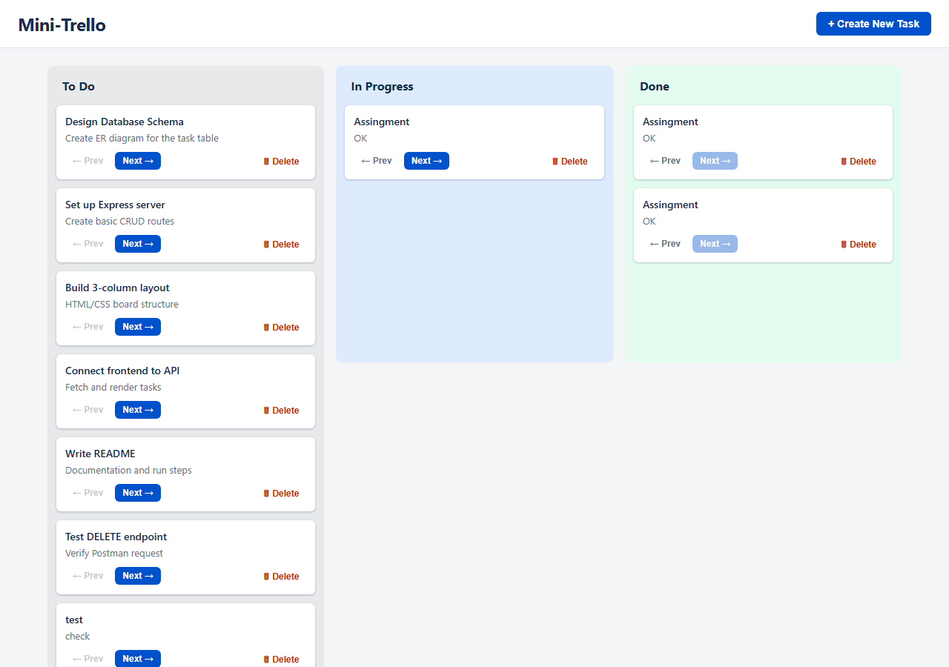
Figure 1: Main 3-column Kanban board layout with task cards (Header with "+ Create New Task" button, To Do, In Progress, Done columns)
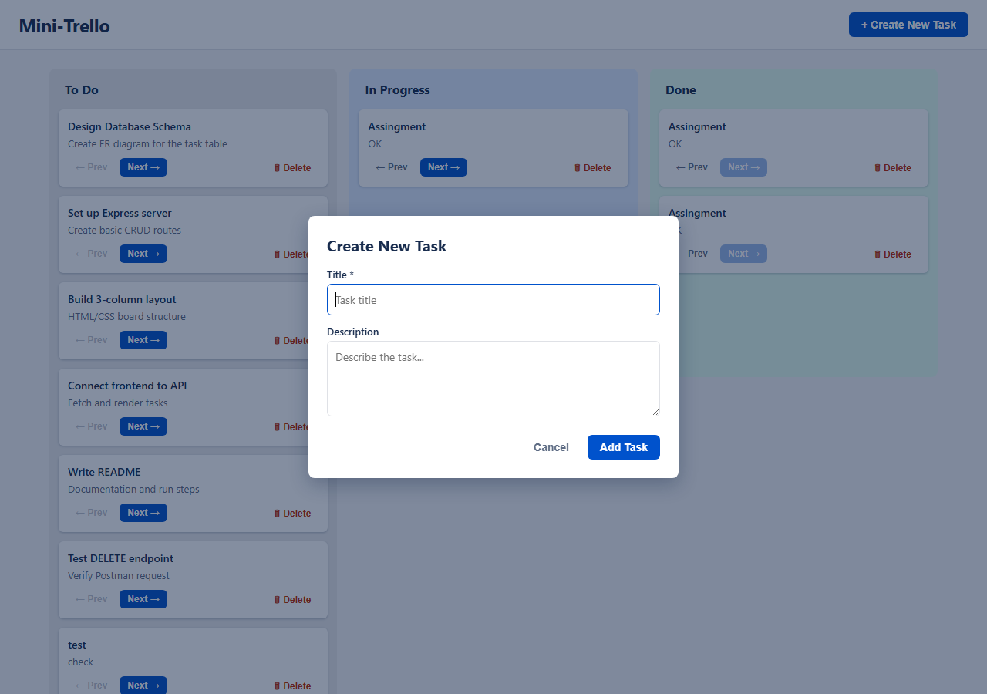
Figure 2: "Create New Task" modal dialog

5. Agile Execution Summary
The project was developed using the Agile/Scrum methodology and executed in two one-week sprints.

Sprint 1 - Foundation & Setup
- Conducted Sprint Planning and assigned tasks to team members.
- Designed the database schema for the tasks table (fields: id, title, description, status).
- Created backend API routes for Create and Read (GET all tasks, POST new task).
- Built the static HTML/CSS board layout with 3 columns.
Deliverable at Sprint 1 Review: Working database, testable API endpoints (via Postman), and a static frontend UI.

Sprint 2 - Integration & Delivery
- Conducted Sprint 1 Retrospective and Sprint 2 Planning.
- Completed Update and Delete routes (PATCH status, DELETE task).
- Connected the frontend UI to the backend API using the fetch() method.
- Ensured card creation, movement, and deletion trigger correct API calls and update the UI dynamically.
Deliverable at Sprint 2 Review: A fully functional Mini-Trello board where actions on the UI correctly persist in the database.

User Stories Addressed
- [HIGH] As a user, I want to create a new task so that I can add it to my board.
- [HIGH] As a user, I want to see all my tasks grouped by status so I know what to work on.
- [HIGH] As a user, I want to move a task from "To Do" to "In Progress" to "Done".
- [MEDIUM] As a user, I want to delete a task if it was created by mistake.

6. API Endpoints Table
Summary of developed REST endpoints:
Method | Endpoint | Description | Status Code
GET | /api/tasks | Fetch all tasks | 200 OK
POST | /api/tasks | Create a new task (status=todo) | 201 Created
PATCH | /api/tasks/:id | Update task status/title/description | 200 OK
PUT | /api/tasks/:id | Replace task fields | 200 OK
DELETE | /api/tasks/:id | Delete a task | 204 No Content

Sample Task Object (Reference)
{
"id": "101",
"title": "Design Database Schema",
"description": "Create ER diagram for the task and user tables.",
"status": "in_progress"
}

Sample Request / Response
POST /api/tasks - Request body:
{ "title": "Set up Express server", "description": "Create basic routes." }
Response (201 Created):
{ "id": "7", "title": "Set up Express server", "description": "Create basic routes.", "status": "todo" }

7. Team Responsibility Breakdown
Team Member | Role | Responsibility
[Member 1] | [Role] | [Database + Backend API]
[Member 2] | [Role] | [Frontend Layout + Integration]
[Member 3] | [Role] | [Testing + Documentation]

