1) This is the diabetes data set .The output is to predict a patient is having diabetes or not . the first thing I have done is data er-processing replacing the Nan values with diff kinds of imputation . Then I have created a dense network with activation functions like relu,elu and the output activation function is sigmoid as it is a 2 class problem .I have also done Early stopping in order to stop overfitting.

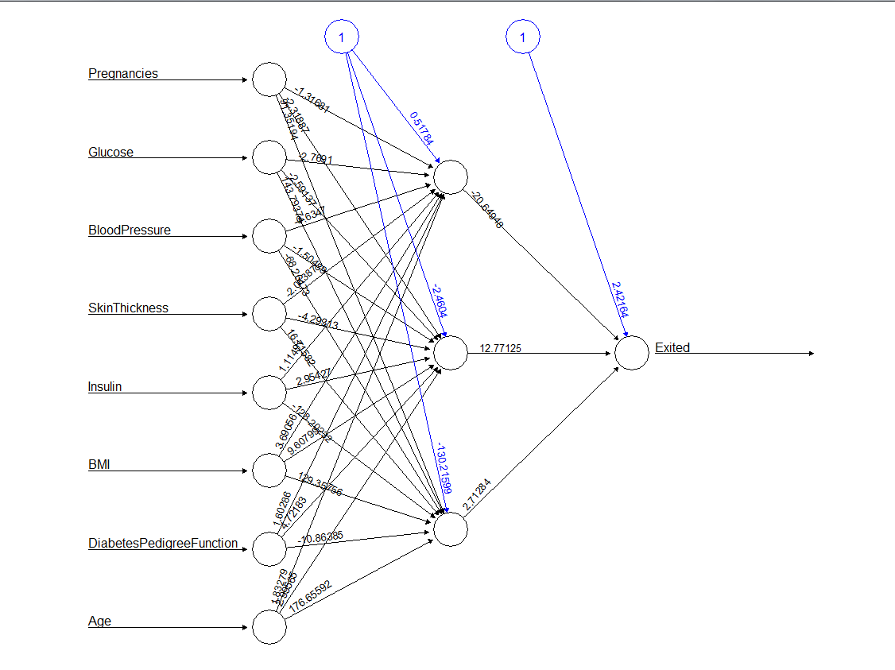

2) This is the churn data set .The output is to predict a employee churn’s out or not . the first thing I have done is data er-processing replacing the Nan values with diff kinds of imputation . Then I have created a dense network with activation functions like relu,elu and the output activation function is sigmoid as it is a 2 class problem .I have also done Early stopping in order to stop overfitting.

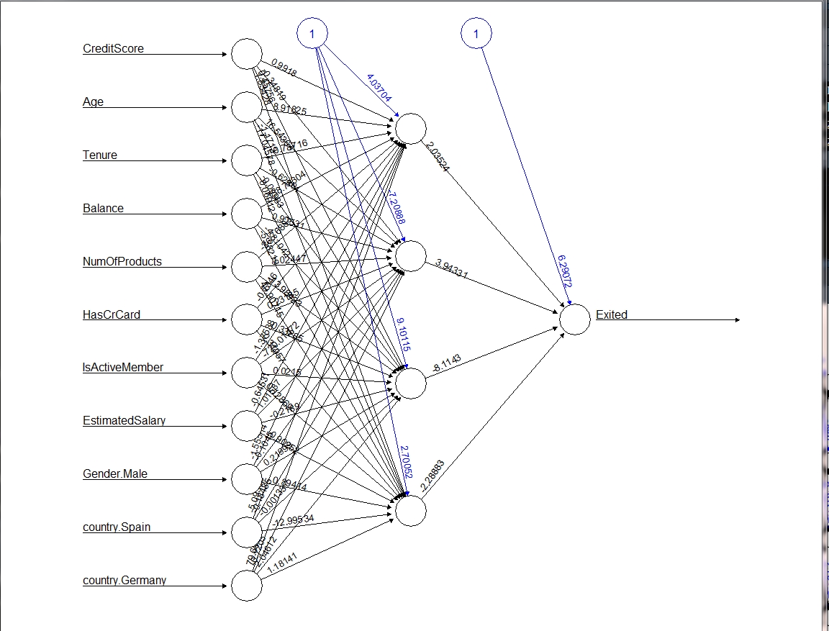

3) This is the cancer data set .The output is to predict whether a patient suffers from malignant or benign . the first thing I have done is data er-processing replacing the Nan values with diff kinds of imputation . Then I have created a dense network with activation functions like relu,elu and the output activation function is sigmoid as it is a 2 class problem .I have also done Early stopping in order to stop over fitting.

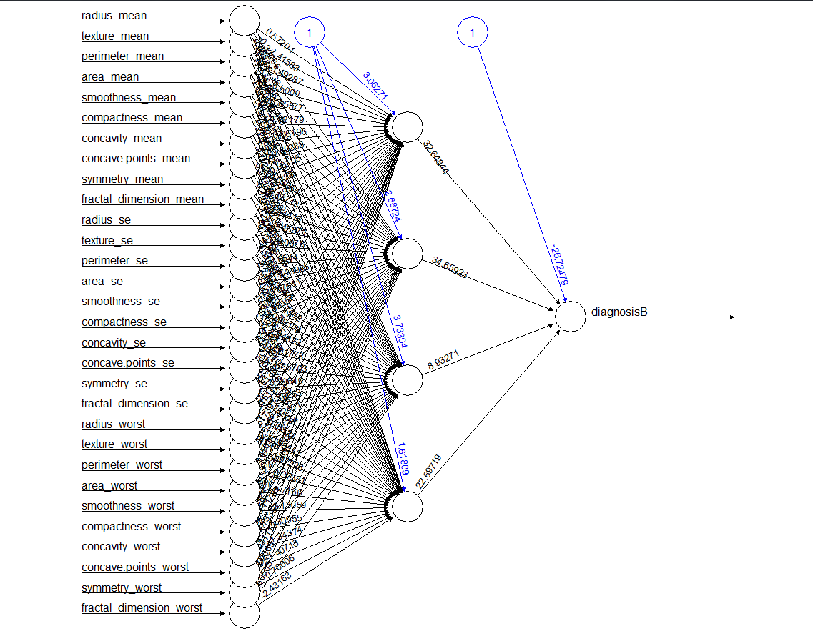

1. If I have a dataset which has images of dogs and cats of size 32x32. I need to predict the output image as a dog or a cat. Fill out the parameters that is used to build a simple ANN model

#Input layer should have _784__ number of neurons

#Output layer should have __1___ number of neurons

#_sigmoid or tanh_ activation function is used in the output layer

#_Binary cross entropy__ will be the loss function