**DECISION TREES**

**COMPANY DATASET**

Here is the tree for the data set company, I have done pre pruning in order to avoid the overfitting, by changing the max depth to 3 so that the train error and test error are similar.

Here is the tree diagram I have converted the categorical variables using label encoding and one hot encoding.

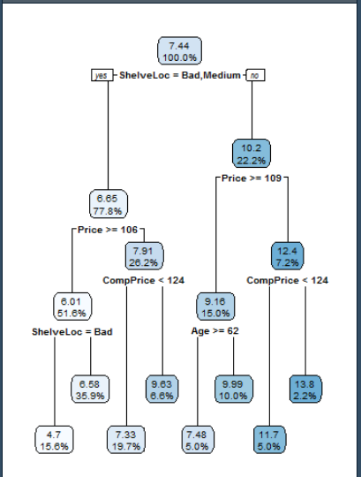

**DIABETES DATASET**

Here is the tree for the diabetes data, I have done pre pruning in order to avoid the overfitting, by changing the max depth to 5 so that the train error and test error are similar.

Here is the tree diagram I have converted the categorical variables using label encoding and one hot encoding.

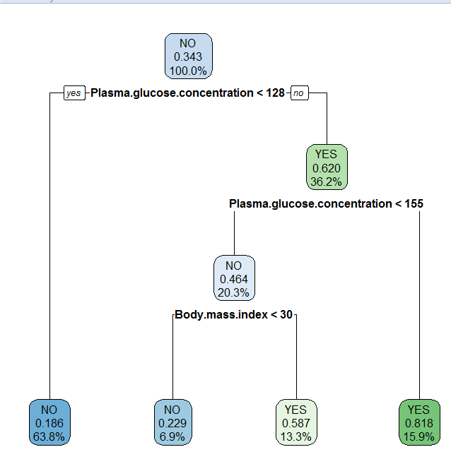

**FRAUD DATASET**

Here is the tree for the fraud data set , I have done pre pruning in order to avoid the overfitting, by changing the max depth to 5 so that the train error and test error are similar.

Here is the tree diagram I have converted the categorical variables using label encoding and one hot encoding.

