KNN

Glass Dataset

In this data set we had to perform the KNN-algorithm which is also called as lazy algorithm.First I have normalized the data as we find the distance here in this algorithm the scale might effect the result. Then after doing some pre-processing like using label encoder and one hot encoding . Then I have applied the KNN algorithm with neighbours as 21 . This is the graph I have got as output .

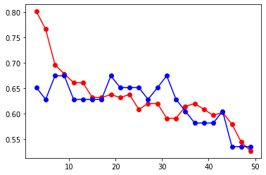

ZOO Dataset

In this data set we had to perform the KNN-algorithm which is also called as lazy algorithm.First I have normalized the data as we find the distance here in this algorithm the scale might effect the result. Then after doing some pre-processing like using label encoder and one hot encoding . Then I have applied the KNN algorithm with neighbours as 15 . This is the graph I have got as output . I have tried applying some parameters but the graph is looking the same , I have tried reducing the k-neighbours but there was no change in the graph, May be this is because of more number of factors.

