1. Calorie data set

We have to find the best fit curve for the output variable calories consumed . There is good correlation between the input and output variable . I have tried different transformations and out of them ,I have found log(calories) showing significant values , so I have built my model on that . here are the graphs of them and I have also mentioned my test rmse and train rmse .

Log of output

test_rmse=105.1039

train_rmse=107.74

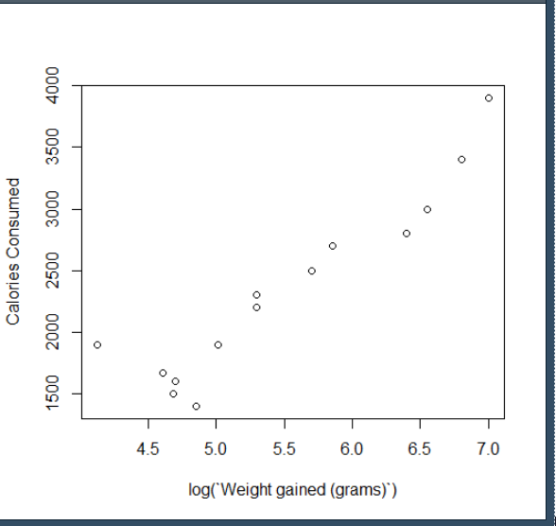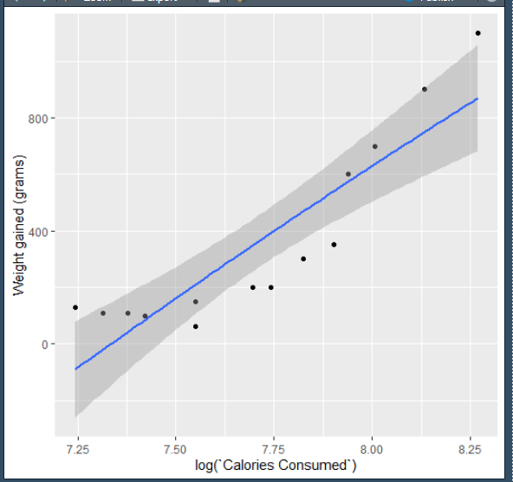

1. Delivery time data set test=rmse 3.321017, train_rmse=2.590996

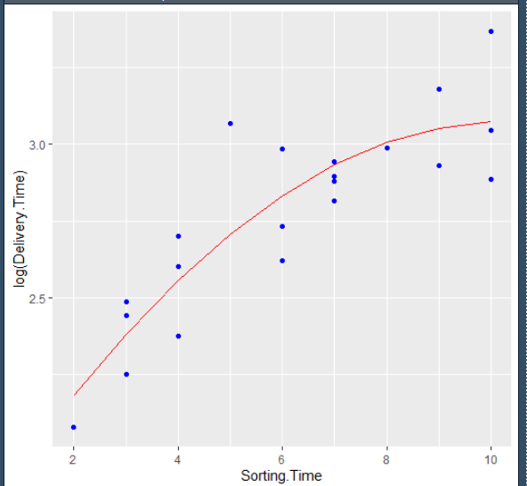

# Non-linear models = Polynomial models

# input = x & x^2 (2-degree) and output = log(y)

We have to find the best fit curve for the output variable calories consumed . There is good correlation between the input and output variable . I have tried different transformations and out of them ,I have found polynomial model the best fit and I have changed the log values and multiplied with exp , so I have built my model on that . here are the graphs of them and I have also mentioned my test rmse and train rmse .

1. Salary data set

test_rmse=3.1039

train_rmse=4.74

We have to find the best fit curve for the output variable calories consumed . There is good correlation between the input and output variable . I have tried different transformations and out of them ,I have found polynomial model the best fit and I have changed the log values of the output variable , so I have built my model on that . here are the graphs of them and I have also mentioned my test rmse and train rmse .

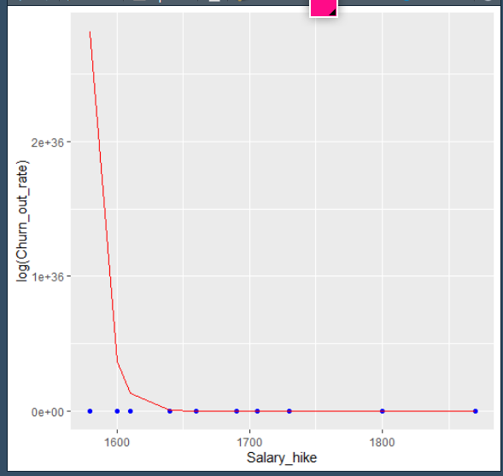

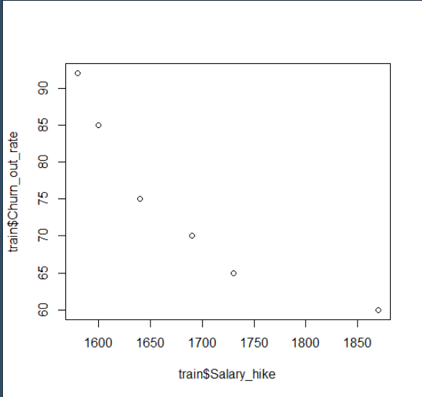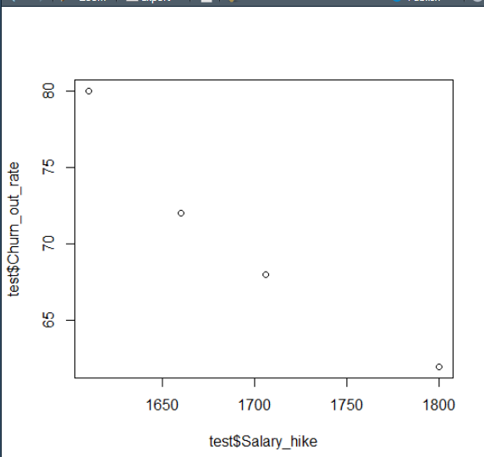

1. Experience data set

Test_mape= 0.4170281

Train_mape= 0.4151355

We have to find the best fit curve for the output variable calories consumed . There is good correlation between the input and output variable . I have tried different transformations and out of them ,I have found log(salary) showing significant values , so I have built my model on that . here are the graphs of them and I have also mentioned my test rmse and train rmse .

Log of output

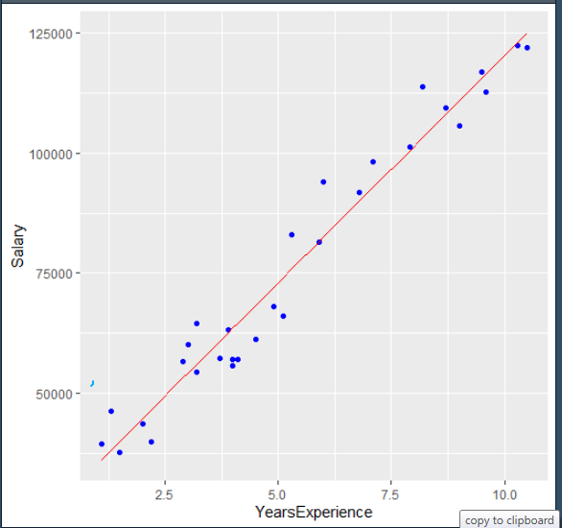

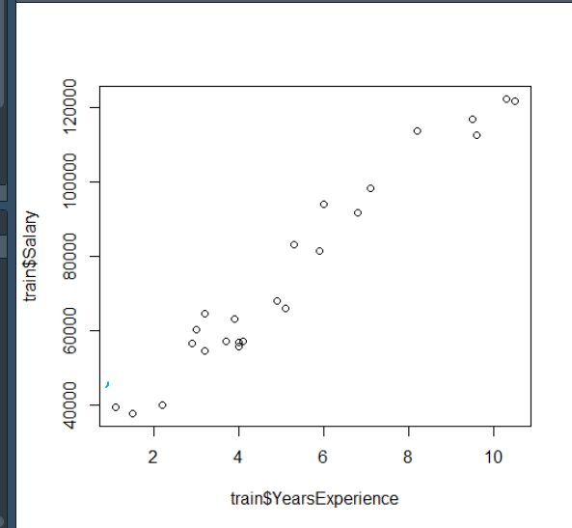 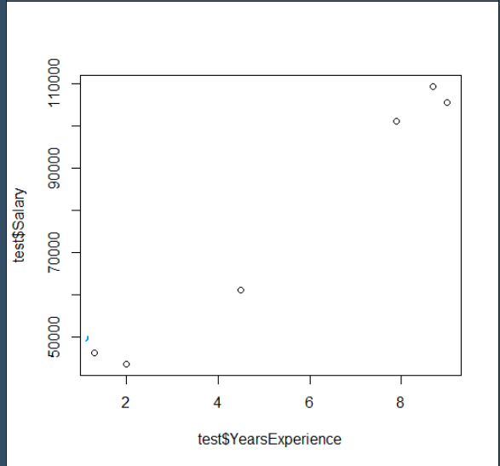

Test_mape= 0.4170281

Train_mape= 0.4151355