**Business Objective : Forecast the sales of coca-cola sales.**

**Inferences :** I have experimented on the data and found that data driven approaches are giving me better results with very less rmse values and, I have used Holts winters method for forecasting the results.The below results are the next 4 quarter results.

**Predicted values and graph :**

1. 5215.149

2 .4672.568

3 .4556.261

4 .5630.019

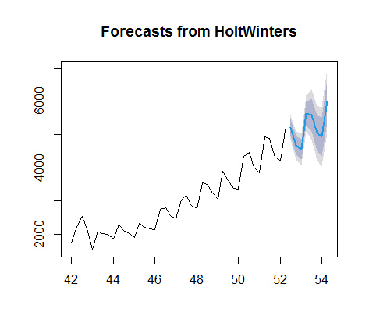

**Business Objective : Forecast the sales of airlines passengers.**

**Inferences :** I have experimented on the data and found that data driven approaches are giving me better results with very less rmse values and, I have used Holts winters method for forecasting the results.The below results are the next 4 quarter results.

**Predicted values and graph :**

0 120.911923

1 115.878128

2 130.004839

3 137.251885

4 121.280800

