**Bank data** : As we can see in the AOC-curve the area under the curve is 0.8893 , that also says that our accuracy is 89%. I have performed some transformation techniques and I have checked the significance values .

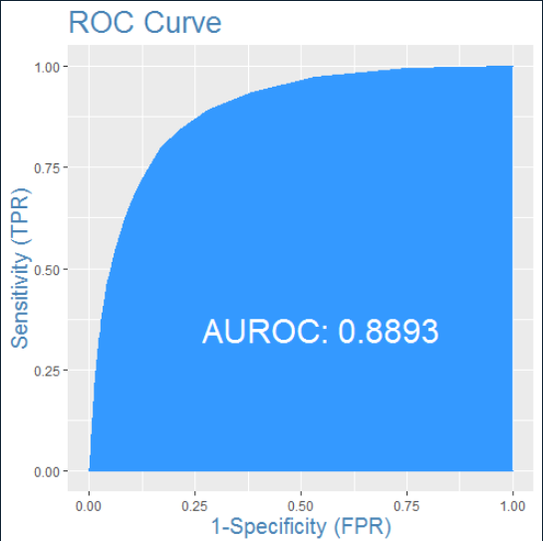

**Affair data** : As we can see in the AOC-curve the area under the curve is 0.8893 , that also says that our accuracy is 89%. I have performed some transformation techniques and I have checked the significance values .

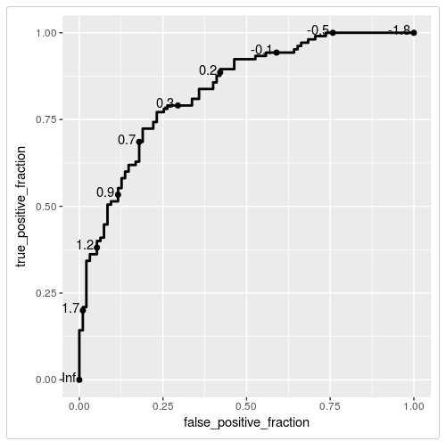

Election data set

I have achieved an accuracy of 0.9375 that’s means our model is a good model . %. I have performed some transformation techniques and I have checked the significance values .

