Detection of cancer through deep learning and transfer learning of Deep Convolution Neural Network

K.KIRAN KUMAR

The problem statement and motivation:

Detection of presence of cancer in specific organs of the human body from radiology scan images by a trained neural network at radiologist level accuracy if not better in most cases, thus detecting it even in scans where a human eye cannot effectively detect its presence.

Problem solving techniques:

Traditional machine learning uses handwritten feature extraction and modality-specific machine learning algorithms to label images or recognize voices. However, this method has several drawbacks in both time-to-solution and accuracy.

Today’s advanced deep neural networks use algorithms, big data, and the computational power of the GPU to change this dynamic. Machines are now able to learn at a speed, accuracy, and scale that are driving true artificial intelligence and AI Computing.

AlexNet is the name of a convolutional neural network, originally written with CUDA to run with GPU support, which competed in the ImageNet Large Scale Visual Recognition Challenge[[1]](https://en.wikipedia.org/wiki/AlexNet#cite_note-:0-1) in 2012. The network achieved a top-5 error of 15.3%, more than 10.8 percentage points ahead of the runner up. AlexNet was designed by the SuperVision group, consisting of Alex Krizhevsky, Geoffrey Hinton, and Ilya Sutskever.

We are gonna modify and use this Deep Neural Network and apply transfer learning and retrain it with our radiology data to work on our objective. Then we test it to see its accuracy in detection in newer data when fed.

Architecture:

Cancer present in below image

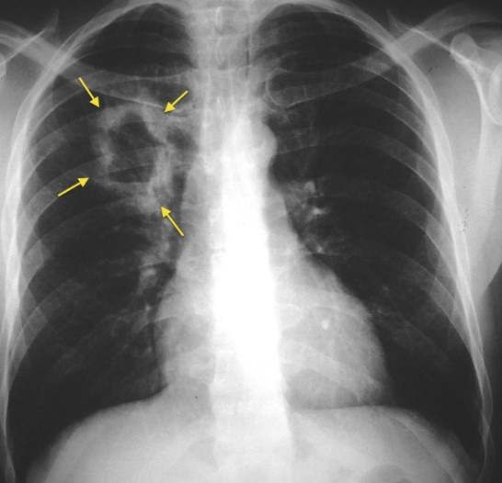

Healthy lung shown in below image

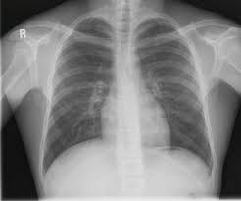

References:

1. Alex Krizhevsky, Ilya Sutskever, Geoffrey E. of Hinton University of Toronto, ImageNet Classification with Deep Convolutional Neural Networks, 2012.