Scale the service called products-fruit to 5 replicas

Step1: docker pull linuxacademycontent/fruit-service:1.0.0

Step2: docker service create -p 8080:80 --replicas 5 --name products-fruit linuxacademycontent/fruit-service:1.0.0

Step3: curl 52.13.106.36:8080

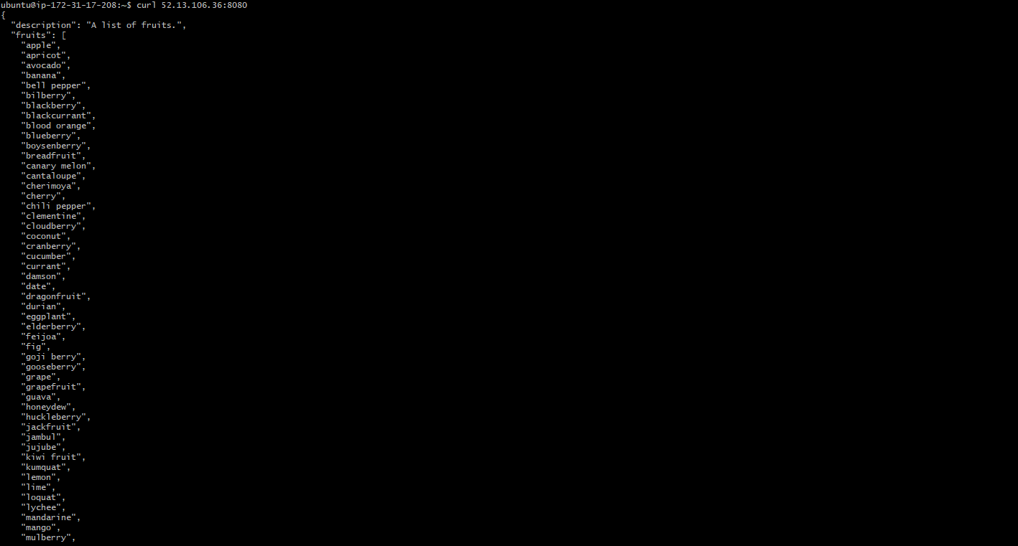

Create a new service called products-vegetables running the linuxacademycontent/vegetable-service:1.0.0 image.

Publish products-vegetables on port 8081. The application listens on port 80.

Step1: docker pull linuxacademycontent/vegetable-service:1.0.0

Step2: docker service create -p 8081:80 --replicas 1 --name products-vegetables2 linuxacademycontent/vegetable-service:1.0.0



Run products-vegetables with 3 replicas.

Step1: docker service scale products-vegetables2=3

You can test the products-fruit service from any swarm node (including the manager) with curl localhost:8080.



Once products-vegetables is running, you should be able to test it from any swarm node (including the manager) with curl localhost:8081.

