1. Create a certificate directory “/docker_data/certs/” to hold the LTS certificate



2. [Generate a SSL/TLS certificate to secure our docker registry.](https://www.blogger.com/null)  
Generate a certificate to secure our docker registry using the command "openssl". If "openssl" command is not found, please install the package "openssl" using yum repository. Refer this link if you dont know [how to configure local yum server](https://www.learnitguide.net/2015/07/how-to-configure-local-yum-repo-server.html).



Output:

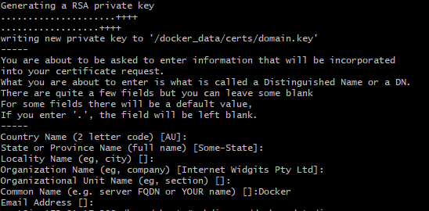

3. [Create a directory to store docker images "/docker_data/images".](https://www.blogger.com/null)



4. [Run a docker registry container in docker host "docker-registry".](https://www.blogger.com/null)  
 docker run -d -p 443:5000 \

-v /docker_data/images:/var/lib/registry \

-v /docker_data/certs:/certs \

-e REGISTRY_HTTP_TLS_CERTIFICATE=/certs/domain.crt \

-e REGISTRY_HTTP_TLS_KEY=/certs/domain.key \

--restart on-failure \

--name registry \

docker.io/registry:2