BreastCancerNet: Flask-Enabled Attention-Driven Hybrid Dual DNN Framework for Real-Time Breast Cancer Prediction

**Paper Url**: <https://ieeexplore.ieee.org/document/10923709>

**Dataset:** The **Wisconsin Diagnostic Breast Cancer (WDBC)** is widely recognized and utilized for scientific research in the analysis of breast cancer prediction.

**Database**: <https://www.kaggle.com/datasets/mohaiminul101/wisconsin-diagnostic-breast-cancer-wdbc>

**Methodology:**  
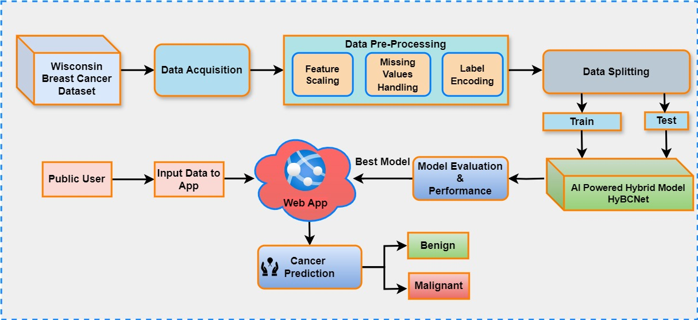

**Parts of the obtained Results:**

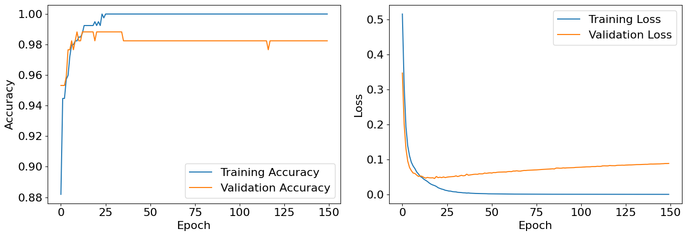

Performance curve for the customized DNN

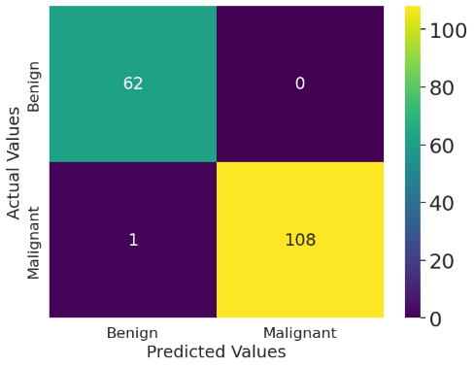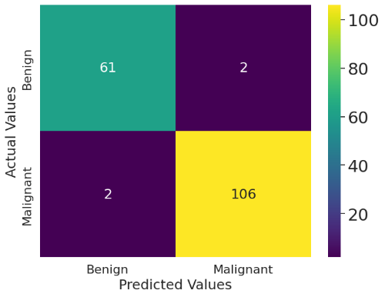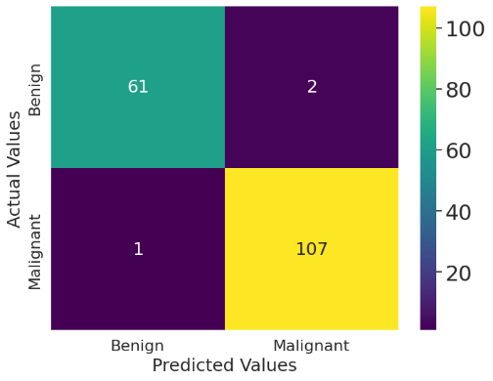

(a) DNN-I (b) DNN-II (c) BreastcancerNet

Confusion Matrices of the testing phase for Breast Cancer Diagnosis

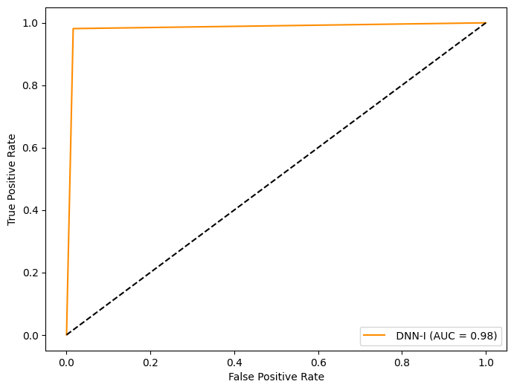 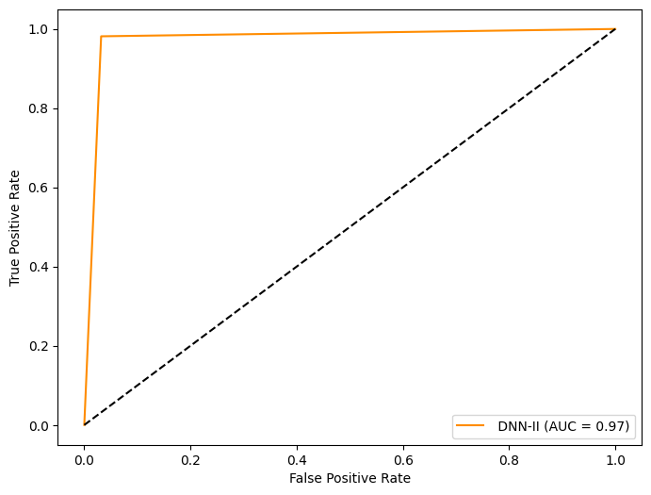

(a) DNN-I (b) DNN-II

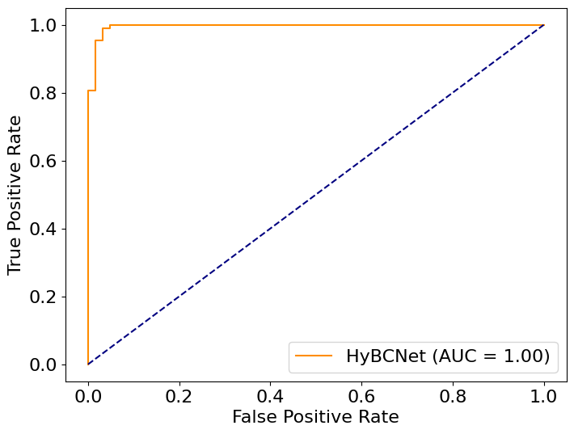

(c) BreastCancerNet

ROC curves of the testing phase for Breast Cancer Diagnosis

In our work, we have developed a web application that operates on our local device. The purpose of this app is to determine the condition of breast cancer, specifically whether it is benign or malignant.  
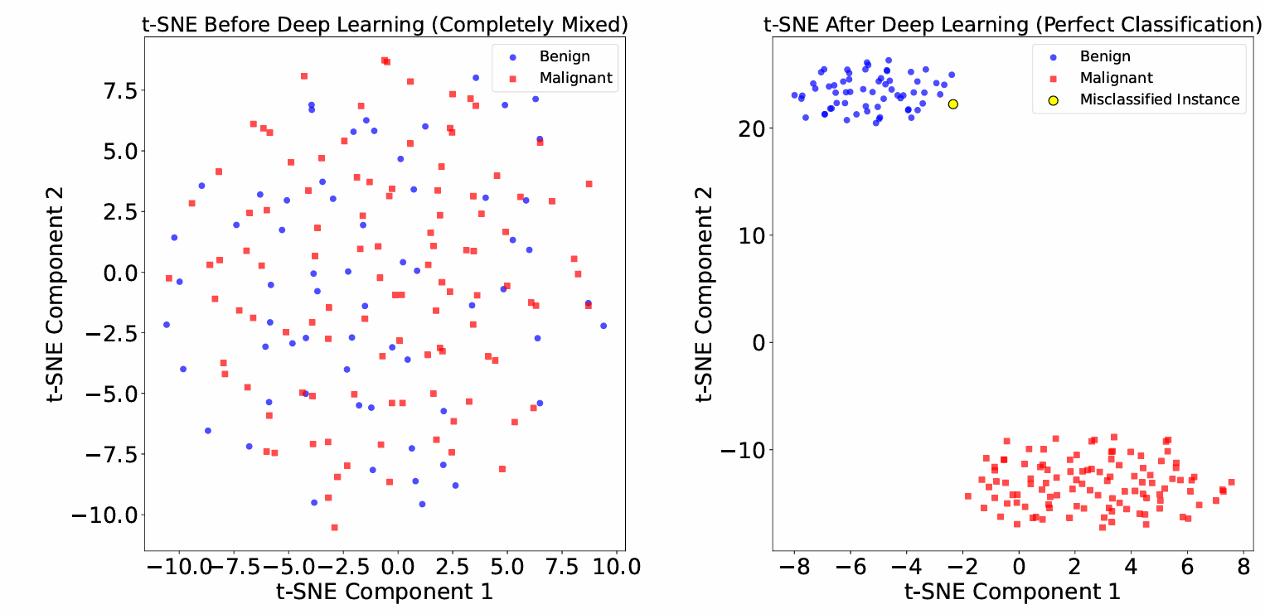

t-SNE plots



(a)

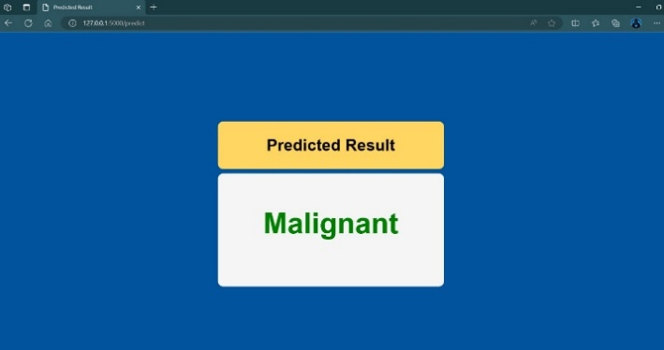

(b)

Web App design a) Input Interface b) Result

* Please note the parts of the Flask Webapp design given ipnyb file