**MalNet-DAF: Dual-Attentive Fusion Deep Learning Model for Malaria Parasite Classification**

**Paper:** <https://ieeexplore.ieee.org/document/11098949>

**Dataset:** <https://pmc.ncbi.nlm.nih.gov/articles/PMC11164904/>

* **The parts of the code are given in the repository for reference.**

**Methodology:**  
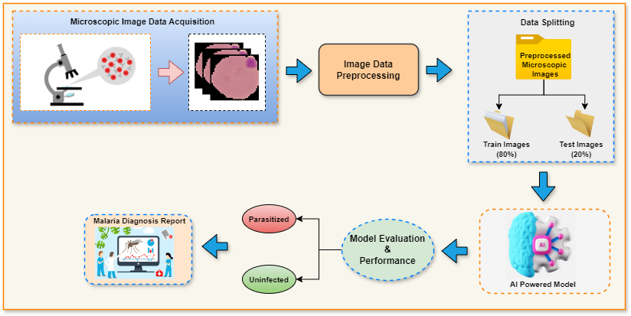

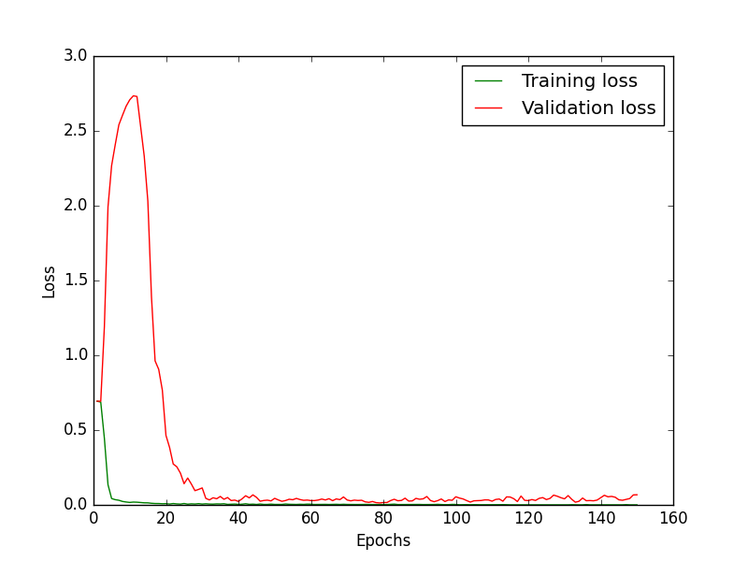**Results:**  
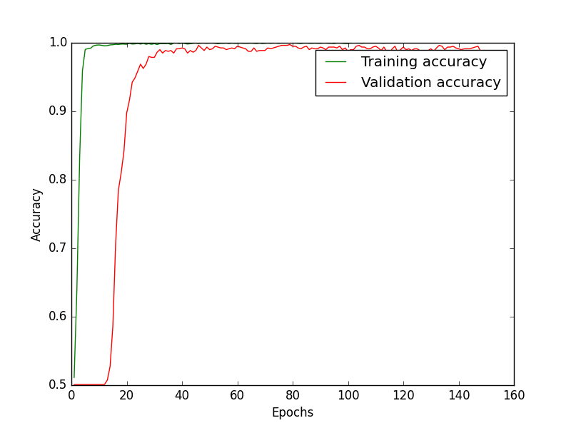

1. Accuracy (b) Loss

Training Curves

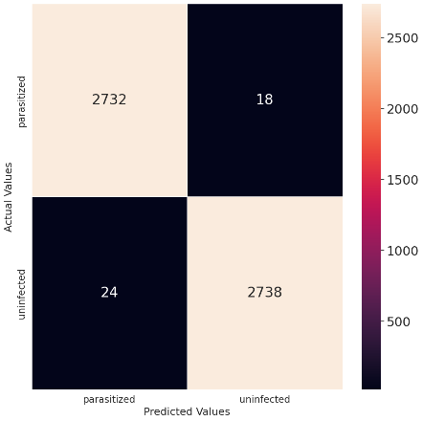

Confusion matrix for Malaria diagnosis

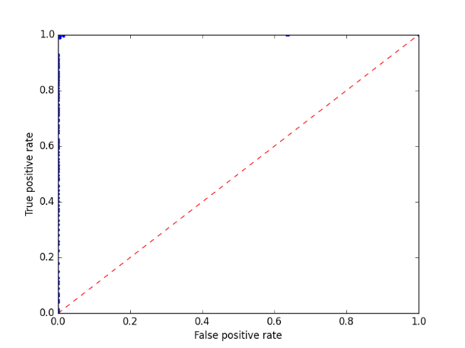

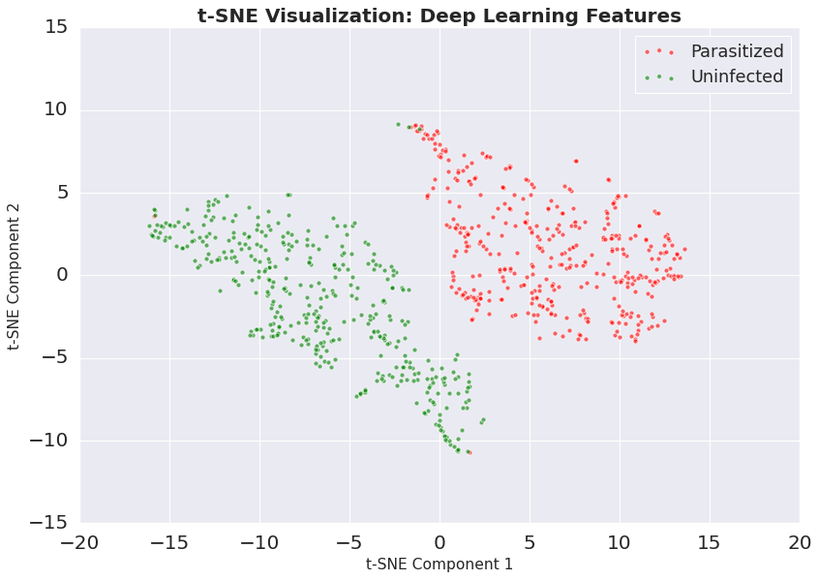ROC curve of the proposed AI model

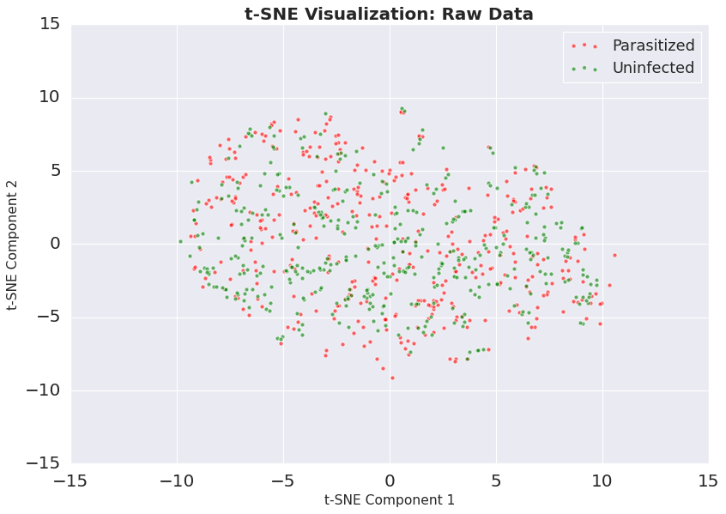

(a) (b)

t-SNE visualization (a) Raw data (b) Proposed deep learning features