**DOCKER-NGINX-PROJECT**

Nginx can serve as a reverse proxy, load balancer, and HTTP cache. It supports a wide range of protocols such as HTTP/1.0, HTTP/1.1, HTTP/2, WebSocket, and more. Nginx is known for its scalability and is often used in high-traffic websites, streaming services, and content delivery networks (CDNs).

Nginx can be used as a standalone web server or can be deployed in conjunction with other web servers such as Apache or Microsoft IIS. It is compatible with various operating systems including Linux, macOS, and Windows. Nginx is free and open source software, licensed under the BSD-like license.

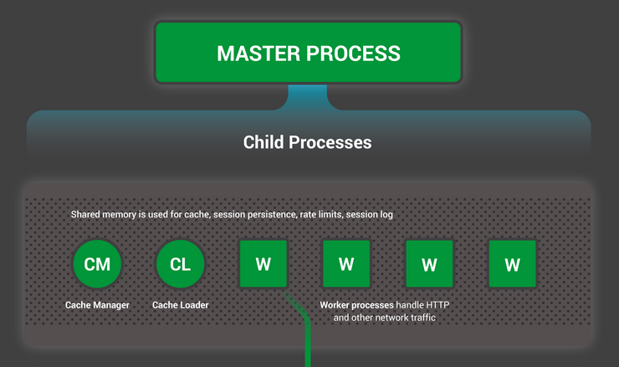

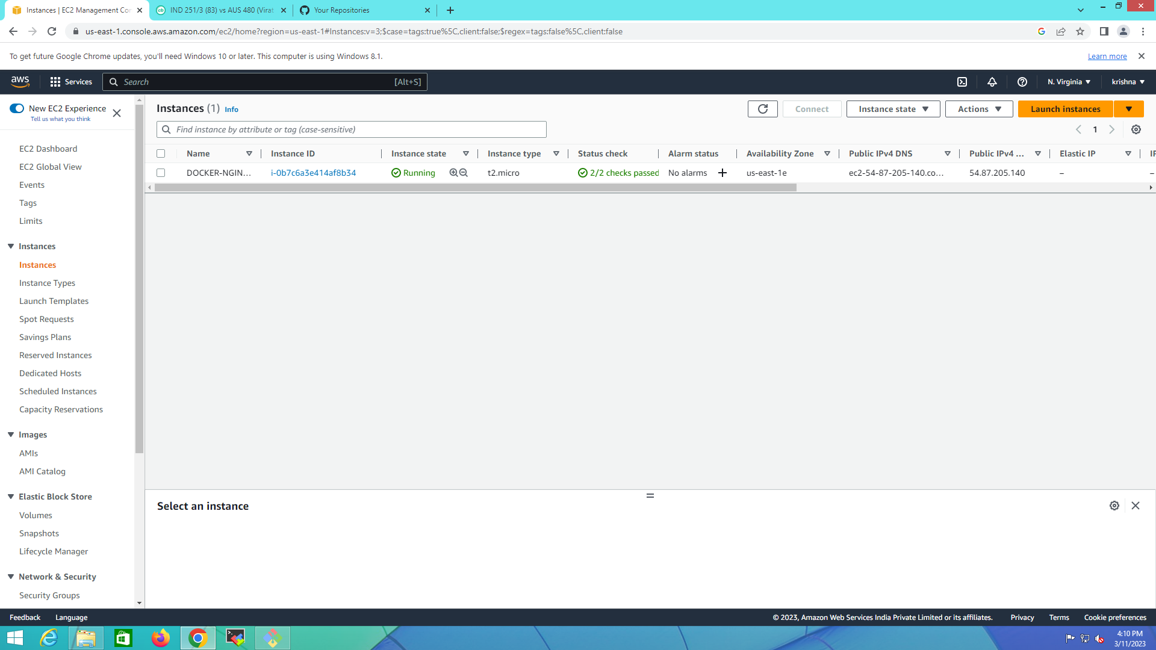

1 sudo apt-get update -y

2 sudo apt install nginx -y

3 sudo systemctl status nginx

4 sudo systemctl restart nginx

5 sudo systemctl status nginx

6 cd /var/www/html/

7 ls

8 cd

9 pwd

10 cd /etc/nginx/

11 ls

12 cat nginx.conf

13 ls

14 cd sites-enabled/

15 ls

16 cat default

17 cd

18 cd /var/www/html/

19 ls

20 cat>index.html

21 sudo cat>index.html

22 sudo vim index.html

23 cd

24 git clone https://github.com/Milky19/django-notes-app.git

25 ls

26 cd django-notes-app/

27 ls

28 sudo apt install docker.io -y

29 sudo usermod -aG docker $USER

30 sudo reboot

31 docker ps

32 cd django-notes-app/

33 docker build -t notes-app .

34 docker run -d -p 8000:8000 notes-app:latest

35 docker ps

