CMP7200 - Individual Master's Project
Research Project Proposal
PhoneGraph: A Knowledge-Graph-Grounded Conversational Recommender for Smartphone Selection with Hallucination-Aware Evaluation
Faculty of Computing, Engineering and the Built Environment
Birmingham City University
2026
Student Number: 25177996
Module Leader: Samer Bamansoor
Submission Date: 22 June 2026

Table of Contents

Abstract 3
1. Introduction 4
1.1 Background and Rationale 4
1.2 Project Aim and Objectives 4
1.3 Research Questions 5
1.4 Ethical Considerations 5
2. Literature Review 7
2.1 What is Knowledge-Graph-Grounded Recommendation? 7
2.2 The Importance of Factual Grounding in Recommendation 7
2.3 Open Challenges 7
2.4 Existing Approaches 8
2.4.1 Knowledge-Graph-Based Recommender Systems 8
2.5 The Research Gap 9
2.6 What We Propose (PhoneGraph's Contribution) 9
3. Research Methodology 10
3.1 Methodology Choice: Design Science Research 10
3.2 DSR Stages Applied to PhoneGraph 10
3.3 Data Collection and Knowledge Graph Construction 11
3.4 System Design and Implementation 12
3.5 Evaluation Strategy 13
3.6 Limitations and Threats to Validity 14
4. Project Schedule 15
5. Conclusion 16
References 17

List of Figures
Figure 1. PhoneGraph System Architecture 12
Figure 2. Smartphone Knowledge Graph Schema 12
Figure 3. Design Science Research Process Adapted for PhoneGraph 10
Figure 4. Evaluation Pipeline for Hallucination and Recommendation Assessment 13
Figure 5. Project Schedule Gantt Chart (May–September 2026) 15

Abstract
The global smartphone market contains thousands of devices and consumers increasingly rely on conversational artificial intelligence (AI) systems to help them choose a suitable model. Modern large language models (LLMs) such as GPT-4o-mini and Gemini are now common in product recommendation but they frequently hallucinate factual specifications, for example by reporting incorrect camera resolution, battery capacity or feature support. Such factual errors reduce trust and can lead to poor purchase decisions. Recent work on knowledge-graph (KG) grounding has shown that combining LLMs with structured factual sources can significantly reduce hallucinations in open-domain question answering, but this approach has not been applied to consumer product recommendation, and no published benchmark exists for evaluating hallucination in conversational smartphone recommendation. This proposal sets out PhoneGraph, a mobile system that integrates a curated smartphone knowledge graph (Neo4j), hybrid vector and graph retrieval, and constrained LLM generation through a Spring Boot microservices backend and an Android client. The work follows the Design Science Research methodology of Vaishnavi and Kuechler (2015) and the evaluation is benchmark-based, combining a self-curated set of two hundred questions, five baseline systems and an ablation study, measuring hallucination rate, retrieval quality, latency and cost with appropriate statistical tests. The project aligns with the six taught modules of the MSc Advanced Computer Science programme and aims to contribute a reproducible benchmark, a working artefact and the first dual factual-accuracy and retrieval-quality evaluation of knowledge-graph-grounded conversational product recommendation.
Keywords: Knowledge Graphs, Large Language Models, Recommender Systems, Mobile Computing, Hallucination, GraphRAG, Design Science Research.

1. Introduction

1.1 Background and Rationale
Choosing a smartphone is rarely simple: the global market spans thousands of models, each carrying dozens of technical attributes (Statista, 2024). Comparison sites help only so far: their information is fragmented and short product cycles age recommendations quickly. Consumers increasingly turn to conversational AI such as ChatGPT, Gemini and Claude for advice (Brynjolfsson, Li and Raymond, 2025).
LLMs are well suited to natural conversation, yet they are also prone to hallucination, producing fluent text that is factually wrong (Ji et al., 2023; Huang et al., 2025). In a recommendation setting this shows up as invented specifications and out-of-date prices that erode trust in a high-stakes purchase (Wu et al., 2024). Knowledge graphs supply the missing ingredient: they store verifiable facts, and recent work on Retrieval-Augmented Generation (RAG) and GraphRAG shows that grounding an LLM in structured retrieval reduces hallucination (Edge et al., 2024; Lavrinovics et al., 2025).
Despite strong evidence that KG grounding curbs hallucination in open-domain question answering, no published benchmark has tested KG-grounded conversational recommenders in the consumer-electronics domain. This project closes that gap by designing, building and benchmarking PhoneGraph, a service-oriented mobile recommender that pairs a curated smartphone knowledge graph with conversational AI.

1.2 Project Aim and Objectives
The aim is to design, build and rigorously benchmark a knowledge-graph-grounded conversational mobile recommender that cuts factual hallucination and improves recommendation quality in smartphone selection relative to baselines.
To achieve this aim, the following objectives will be met:
- Conduct a structured literature review of recent work on LLM-based recommenders, KG grounding, GraphRAG, and benchmark-based evaluation of recommender systems, using at least thirty peer-reviewed sources from 2020 to 2026.
- Design a smartphone ontology and construct a knowledge graph in Neo4j covering approximately two thousand modern smartphones, with verified specifications drawn from public sources.
- Develop a Spring Boot microservices backend that integrates the knowledge graph, a vector store, and an LLM orchestration layer based on LangChain4j, with a Spring Cloud Gateway providing a REST interface.
- Develop an Android mobile client that allows users to ask natural-language questions about smartphones and receive recommendations grounded in the knowledge graph.
- Develop a curated benchmark of two hundred questions spanning four categories: factual specification lookup, two-device comparison, recommendation with constraints, and complex multi-attribute requests.
- Evaluate the proposed system against five baseline approaches using precision at five, mean reciprocal rank, normalised discounted cumulative gain, hallucination rate (with Cohen's kappa inter-rater reliability), latency and cost per query.
- Conduct an ablation study isolating the contribution of each design component, and apply appropriate statistical tests including bootstrap confidence intervals and McNemar's test.

1.3 Research Questions
This project is guided by three research questions (RQs):
- RQ1. To what extent does knowledge-graph grounding reduce the rate of factually incorrect statements in LLM-generated smartphone recommendations, compared to zero-shot LLM and vanilla RAG baselines using the same base model?
- RQ2. How does the KG-grounded approach compare to BM25, content-based filtering, vanilla RAG and RAG-Fusion on standard retrieval metrics, including precision at five, mean reciprocal rank and normalised discounted cumulative gain at ten?
- RQ3. Which architectural component of PhoneGraph (graph retrieval, vector retrieval, hybrid fusion, constrained generation) contributes most to the observed improvements, as measured by an ablation study?

1.4 Ethical Considerations
Because the evaluation is benchmark-based and involves no human participants, formal ethics approval is not required; two issues nonetheless deserve attention. The first concerns data: specifications come only from already-public sources, requests are throttled to roughly one every three seconds, and the data serves research alone (GSMArena, 2024). The GDPR does not apply to public product specifications, but its fair-processing and transparency principles are still observed (European Parliament, 2016).
Second, cloud LLM APIs (OpenAI, Google) are configured to send no user-identifying information, with a local Ollama and Gemma deployment as a privacy-preserving fallback (Ollama, 2024). All code and the benchmark are released under an open-source licence for reproducibility (Pineau et al., 2021).

2. Literature Review
This review defines knowledge-graph-grounded recommendation, explains why it matters, sets out the open challenges, weighs existing approaches, pinpoints what is still missing, and states PhoneGraph’s contribution. Sources came from Google Scholar, Scopus, arXiv and the ACM Digital Library, with a preference for peer-reviewed venues from 2022 onwards.

2.1 What is Knowledge-Graph-Grounded Recommendation?
Knowledge-graph-grounded recommendation answers a user request from two sources at once. The first is a Large Language Model (LLM), defined by Brown et al. (2020) as a deep neural network trained on large corpora to produce fluent language. The second is a Knowledge Graph (KG), which Hogan et al. (2021) describe as a structured representation of entities (smartphones, brands, chipsets) and their relationships (e.g. MADE_BY, HAS_CAMERA). Retrieval-Augmented Generation (RAG) links the two (Lewis et al., 2020), conditioning the LLM on retrieved facts before it answers.
When that retrieval runs over a graph, the architecture is called GraphRAG (Edge et al., 2024). The goal is to marry an LLM's fluency with the factual rigour and explainability of a knowledge graph, so the system can both interpret a free-text request and ground its recommendations in verifiable data.

2.2 The Importance of Factual Grounding in Recommendation
Three reasons make this matter. Conversational AI is now a primary channel for consumer advice: Brynjolfsson, Li and Raymond (2025) report measurable productivity gains from generative AI, and surveys note rising consumer use ahead of purchases.
The cost of getting facts wrong is high, too: Wu et al. (2024) show LLM recommenders are vulnerable to manipulation and confident misstatement that undermines trust, and a single hallucinated specification can steer a buyer toward a wrong purchase worth hundreds of pounds.
Knowledge graphs, finally, are a natural fit: Hogan et al. (2021) argue they marry the structural strengths of databases with the semantic strengths of ontologies. Smartphone attributes are objective and verifiable, which suits a KG and, unlike subjective domains, makes hallucination measurable.

2.3 Open Challenges
Several challenges remain. The first is hallucination itself: Ji et al. (2023) and Huang et al. (2025) separate factuality hallucination (inventing unsupported facts) from faithfulness hallucination (contradicting a given source), both unsolved and especially damaging in recommendation.
Evaluation is a second challenge. Bowman and Dahl (2021) note that benchmark design is undervalued, and no standard benchmark for LLM recommenders pairs factual-accuracy auditing with retrieval metrics; broad frameworks such as HELM (Liang et al., 2023) do not target recommendation.
Engineering complexity is the third: combining an LLM, a vector store and a knowledge graph demands careful service decomposition. LangChain4j (LangChain4j, 2024) and Spring AI make this workable in Java, yet the architectural choices remain underexplored for mobile deployment.

2.4 Existing Approaches
Four research strands each tackle part of the problem. Geng et al. (2022) introduced the P5 framework, recasting recommendation tasks as language tasks handled by a single LLM that matched specialised baselines, while Wu et al. (2023) survey the field and identify three families: feature encoders, recommenders, and agents. Both lines chase accuracy, however, and neither measures nor mitigates factual hallucination in generated responses.
On hallucination, Lavrinovics et al. (2025) introduced MultiHal, which scores answers against knowledge-graph paths and finds that supplying those paths improves hallucination detection by 0.29-0.42 absolute points across frontier models — direct support for this project's hypothesis, though confined to open-domain question answering rather than recommendation.
GraphRAG research runs in parallel: Edge et al. (2024) showed that turning a corpus into a knowledge graph beats vector-only RAG on sense-making queries; Sanmartin (2024) carried this into commercial domains with KG-RAG, and Rackauckas (2024) proposed RAG-Fusion. None of these targets structured product recommendation.
Evaluation has its own lineage: Pu, Chen and Hu (2011) introduced the ResQue questionnaire for graphical recommender interfaces, which Jin et al. (2024) extended to conversational systems as CRS-Que, while Dietterich (1998) and Demsar (2006) laid the statistical foundations for the paired and multi-system comparisons still standard in recommender benchmarking.

2.4.1 Knowledge-Graph-Based Recommender Systems
A directly relevant strand embeds knowledge graphs into recommender systems to improve accuracy. RippleNet propagates a user’s preferences across the graph through multi-hop paths (Wang, H. et al., 2018); KGCN aggregates a node’s neighbourhood via graph convolution (Wang, H. et al., 2019a); MKR couples recommendation and graph embedding in a multi-task framework (Wang, H. et al., 2019b); and KGAT applies attention over a collaborative knowledge graph (Wang, X. et al., 2019). A survey situates these within embedding-, path- and propagation-based families (Guo et al., 2022).
These models show that graph grounding lifts recommendation quality, yet their goal differs fundamentally from PhoneGraph’s: they treat the knowledge graph as training-time side information for collaborative filtering, optimising top-N accuracy over static domains such as films and music. Being neither conversational nor generative, they never hallucinate facts. PhoneGraph instead queries the graph at inference time and constrains a generative model so a recommendation's factual content comes from verified data, making these systems natural comparators for grounding quality while leaving the conversational, hallucination-aware setting this project targets unaddressed.

2.5 The Research Gap
Taken together, these strands reveal a clear gap. LLM-based recommendation has been studied extensively (Wu et al., 2023), but for accuracy rather than hallucination; KG grounding reduces hallucination in open-domain QA (Lavrinovics et al., 2025; Edge et al., 2024), yet has not reached consumer electronics; no benchmark pairs factual-accuracy auditing with retrieval metrics for chat-based recommenders; and almost all prior work lives in Python research code that does not transfer to production mobile settings.

2.6 What We Propose (PhoneGraph's Contribution)
PhoneGraph addresses the gap on four dimensions: it unites LLM recommendation and knowledge-graph grounding in one artefact for consumer electronics; it contributes a reproducible benchmark of two hundred questions designed to expose factual hallucination; it applies attribute-level constrained generation, forcing the LLM to draw numeric and categorical values from the KG-authorised set, expected to reduce hallucination beyond vanilla RAG; and it is engineered as Spring Boot microservices with an Android client, demonstrating the approach is practical on mobile. It therefore delivers a working artefact, a reproducible benchmark and the first comparative evaluation of KG-grounded smartphone recommendation.

3. Research Methodology

3.1 Methodology Choice: Design Science Research
Three methodologies were weighed. Waterfall is predictable for well-understood requirements (Royce, 1970) but cannot absorb iterative AI experimentation, and CRISP-DM (Chapman et al., 2000), though strong for data mining, was built for tabular data and sits awkwardly with a system built around an LLM and a knowledge graph. The chosen approach is Design Science Research (DSR), formalised by Hevner et al. (2004) and refined into the five-stage model of Vaishnavi and Kuechler (2015) in Figure 3.
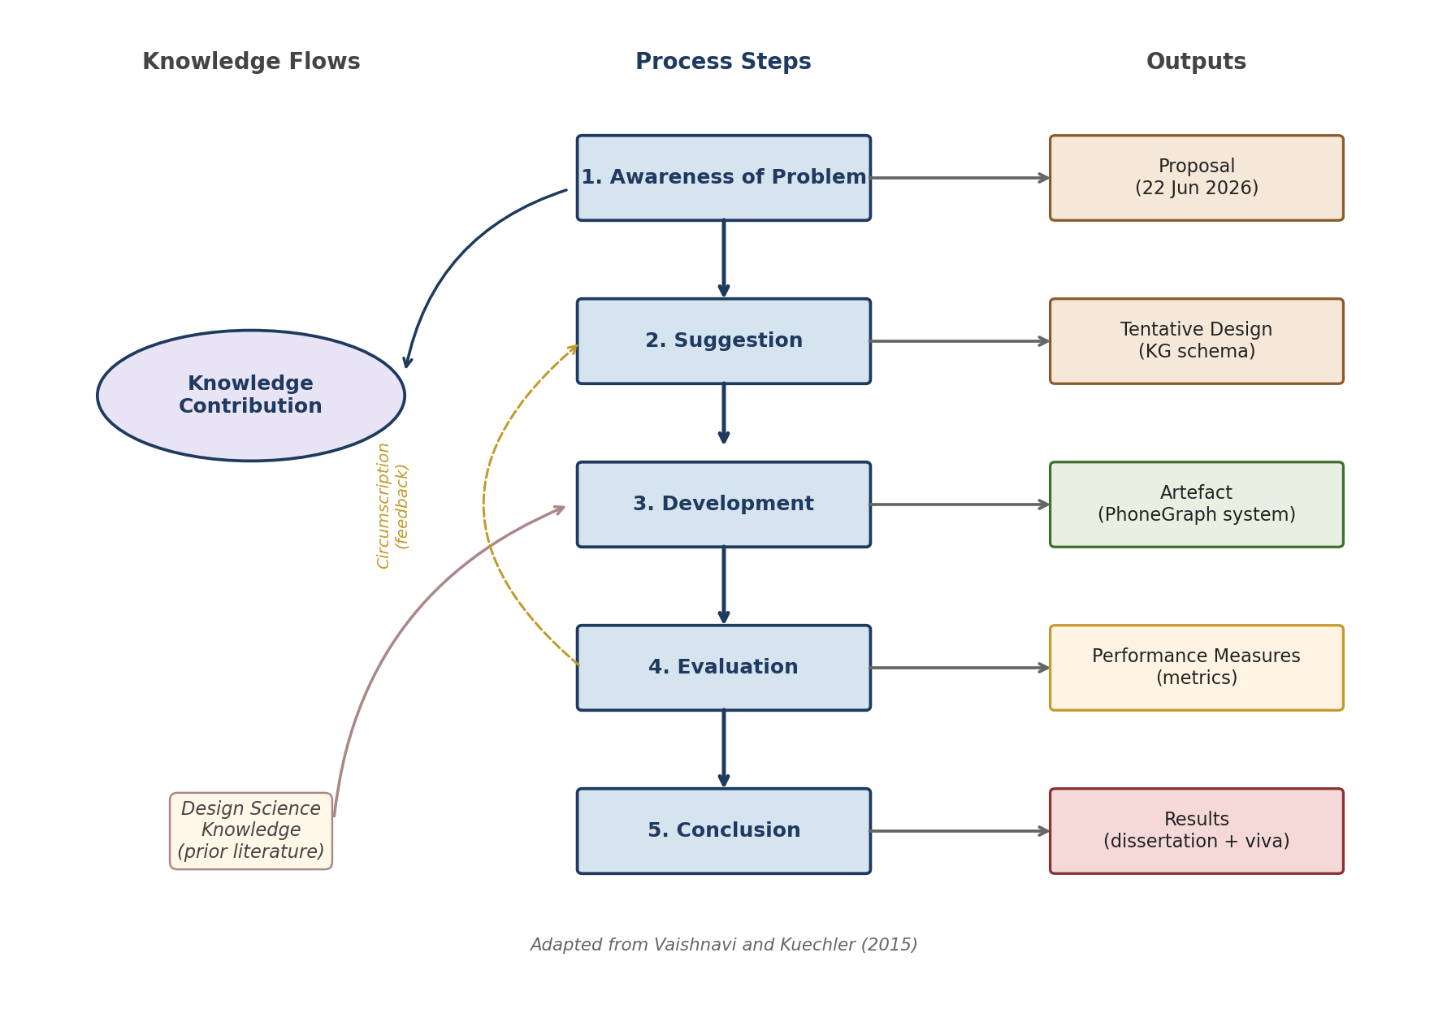
Figure 3. Design Science Research methodology applied to PhoneGraph (adapted from Vaishnavi and Kuechler, 2015).
DSR suits this project for three reasons. It centres research on an artefact (the PhoneGraph system); its five stages align with the CMP7200 learning outcomes; and its Circumscription loop (Figure 3) mirrors the iterative refinement of AI work, feeding evaluation results back into design. It is sometimes faulted as prescriptive and for underspecifying evaluation (Cronholm and Goebel, 2018), which is offset here by an Agile two-week sprint cadence (Beck et al., 2001) and the detailed strategy in Section 3.5.

3.2 DSR Stages Applied to PhoneGraph
Each DSR stage is now mapped to a concrete activity in the present project, following the structure in Figure 3:
- Awareness of Problem (Weeks 1-2): a structured review establishes that LLM recommenders hallucinate specifications and that KG grounding, while effective in open-domain QA, has not been benchmarked for smartphone recommendation. Output: this proposal.
- Suggestion (Weeks 2-3): the KG schema, the microservice decomposition and the constrained-generation design are sketched. Output: a tentative design (KG schema, Figure 2; architecture, Figure 1).
- Development (Weeks 3-11): the system is built in two-week Agile sprints, each producing a working increment — KG construction, baselines, hybrid retrieval, constrained generation, then the Android client. Output: the PhoneGraph artefact.
- Evaluation (Weeks 11-14): the benchmark, five baseline comparisons, ablation, robustness analysis and statistical tests are executed. Output: performance measures (hallucination rate, P@5, MRR, nDCG@10, latency and cost).
- Conclusion (Weeks 14-17): The results are written up in the dissertation, the artefact is released as open source, and the contribution is reflected upon. Output: the dissertation and the viva voce.

3.3 Data Collection and Knowledge Graph Construction
Two kinds of data are needed. First, specifications for roughly two thousand models (2020-2026) are gathered from GSMArena (GSMArena, 2024) with rate-limited open-source scrapers, cross-checked against Wikidata through its SPARQL endpoint, and enriched with DXOMARK camera scores (Wikidata, 2024; DXOMARK, 2024). Second, a self-curated benchmark of two hundred peer-reviewed questions covers four categories of fifty: factual lookup, two-device comparison, recommendation with constraints, and complex multi-attribute requests (Bowman and Dahl, 2021). Ground truth is fixed per question: for lookup and comparison queries it comes straight from the verified graph; recommendation queries use a gold set from the documented constraints, checked by a second annotator.
Data cleaning covers chipset-name normalisation, unit harmonisation, missing-field handling and a ten per cent triple audit against vendor sheets to confirm an error rate below five per cent. Cleaned data is loaded into PostgreSQL and a pipeline constructs the Neo4j graph. The benchmark, cleaning scripts and construction pipeline are released under an open-source licence (Pineau et al., 2021).

3.4 System Design and Implementation
The system follows a service-oriented architecture (Figure 1): the Android client calls a Spring Cloud Gateway routing to four microservices — a catalogue service (PostgreSQL), a KG and retrieval service over Neo4j and a pgvector store, an LLM orchestration service in LangChain4j, and an evaluation service. The KG schema (Figure 2) contains entities for Phone, Brand, Chipset, Display, Battery, Camera, OS, Feature and StorageVariant, with relationships such as MADE_BY and HAS_CAMERA.
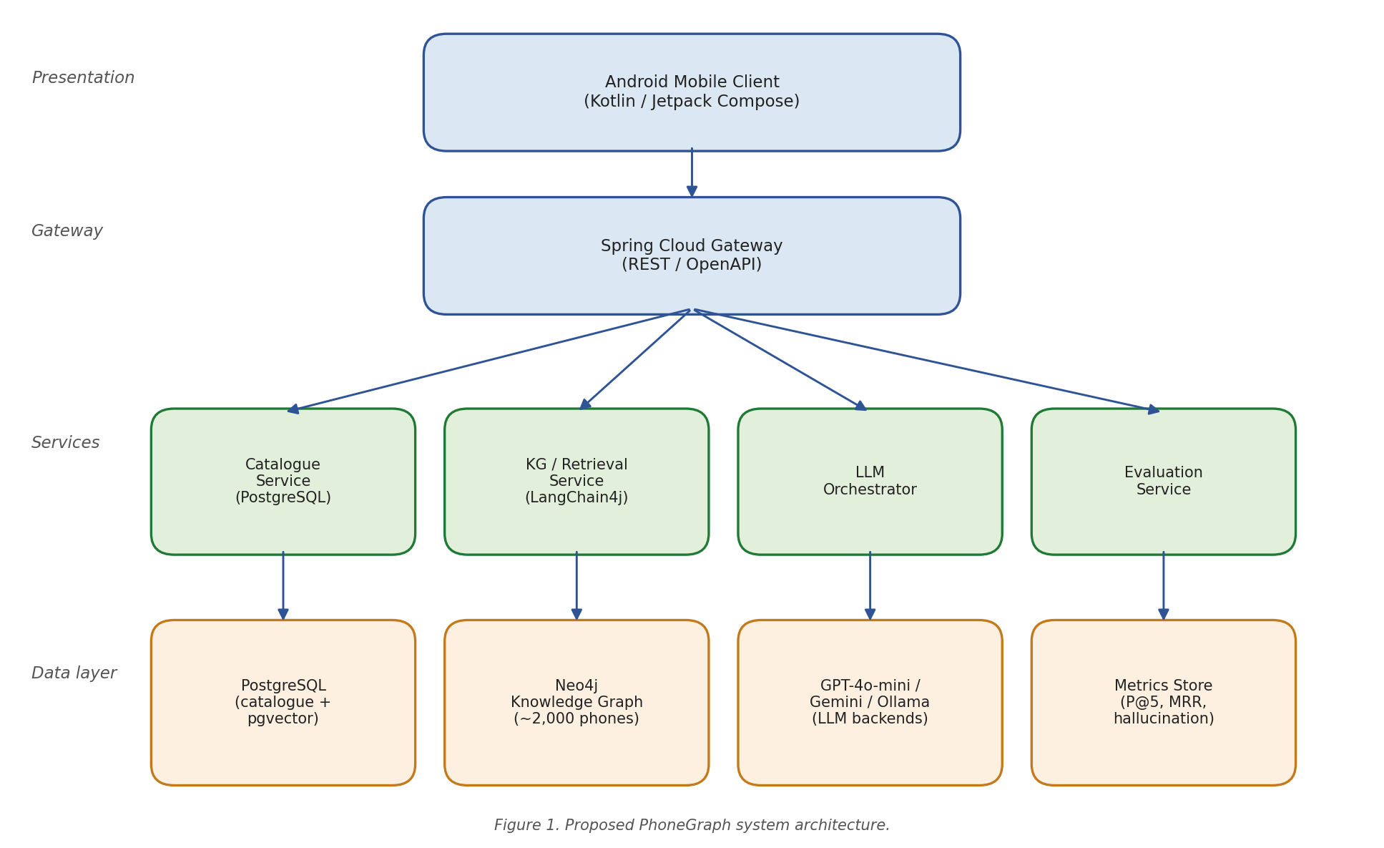
Figure 1. Proposed PhoneGraph system architecture.
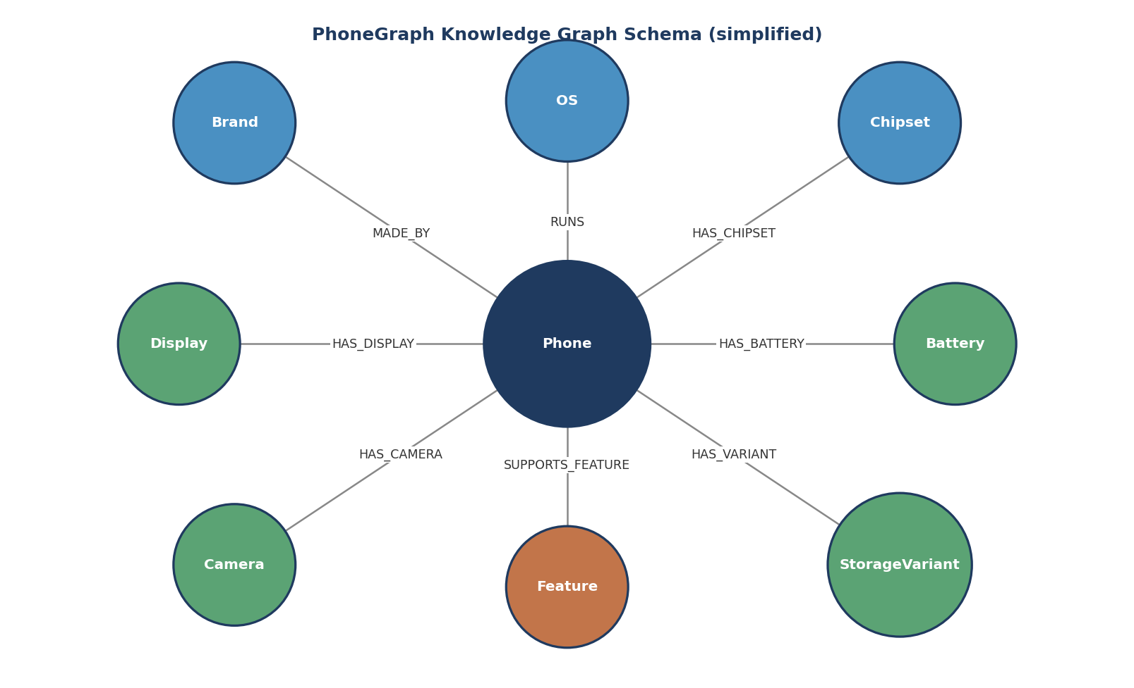
Figure 2. Simplified smartphone knowledge graph schema.
Implementation uses Java 21 and Spring Boot 3.3 for the backend, Kotlin and Jetpack Compose for the Android client, and LangChain4j for orchestration. The primary LLM is GPT-4o-mini via the OpenAI API, with Google Gemini and a local Ollama/Gemma deployment for comparison and as a privacy-preserving fallback. The code is a Maven multi-module project with GitHub Actions for CI and Docker Compose for a reproducible local environment.
The system's novel element is attribute-level constrained generation. Instead of letting the LLM emit specification values freely, the orchestration layer fetches the authorised value set for each attribute and forces every generated numeric and categorical value to come from it. Two strategies are compared: structured (function-call) generation that fills slots directly from KG values, and post-generation validation that triggers correction for any out-of-set token. This should reduce factuality hallucination beyond vanilla RAG, and the ablation in Section 3.5 isolates its contribution.

3.5 Evaluation Strategy
Evaluation carries the most rubric weight, and the design is fully benchmark-based with no human participants: a comparison against five baselines, an ablation isolating each architectural component, and a robustness analysis against adversarial inputs. Figure 4 shows the full pipeline.
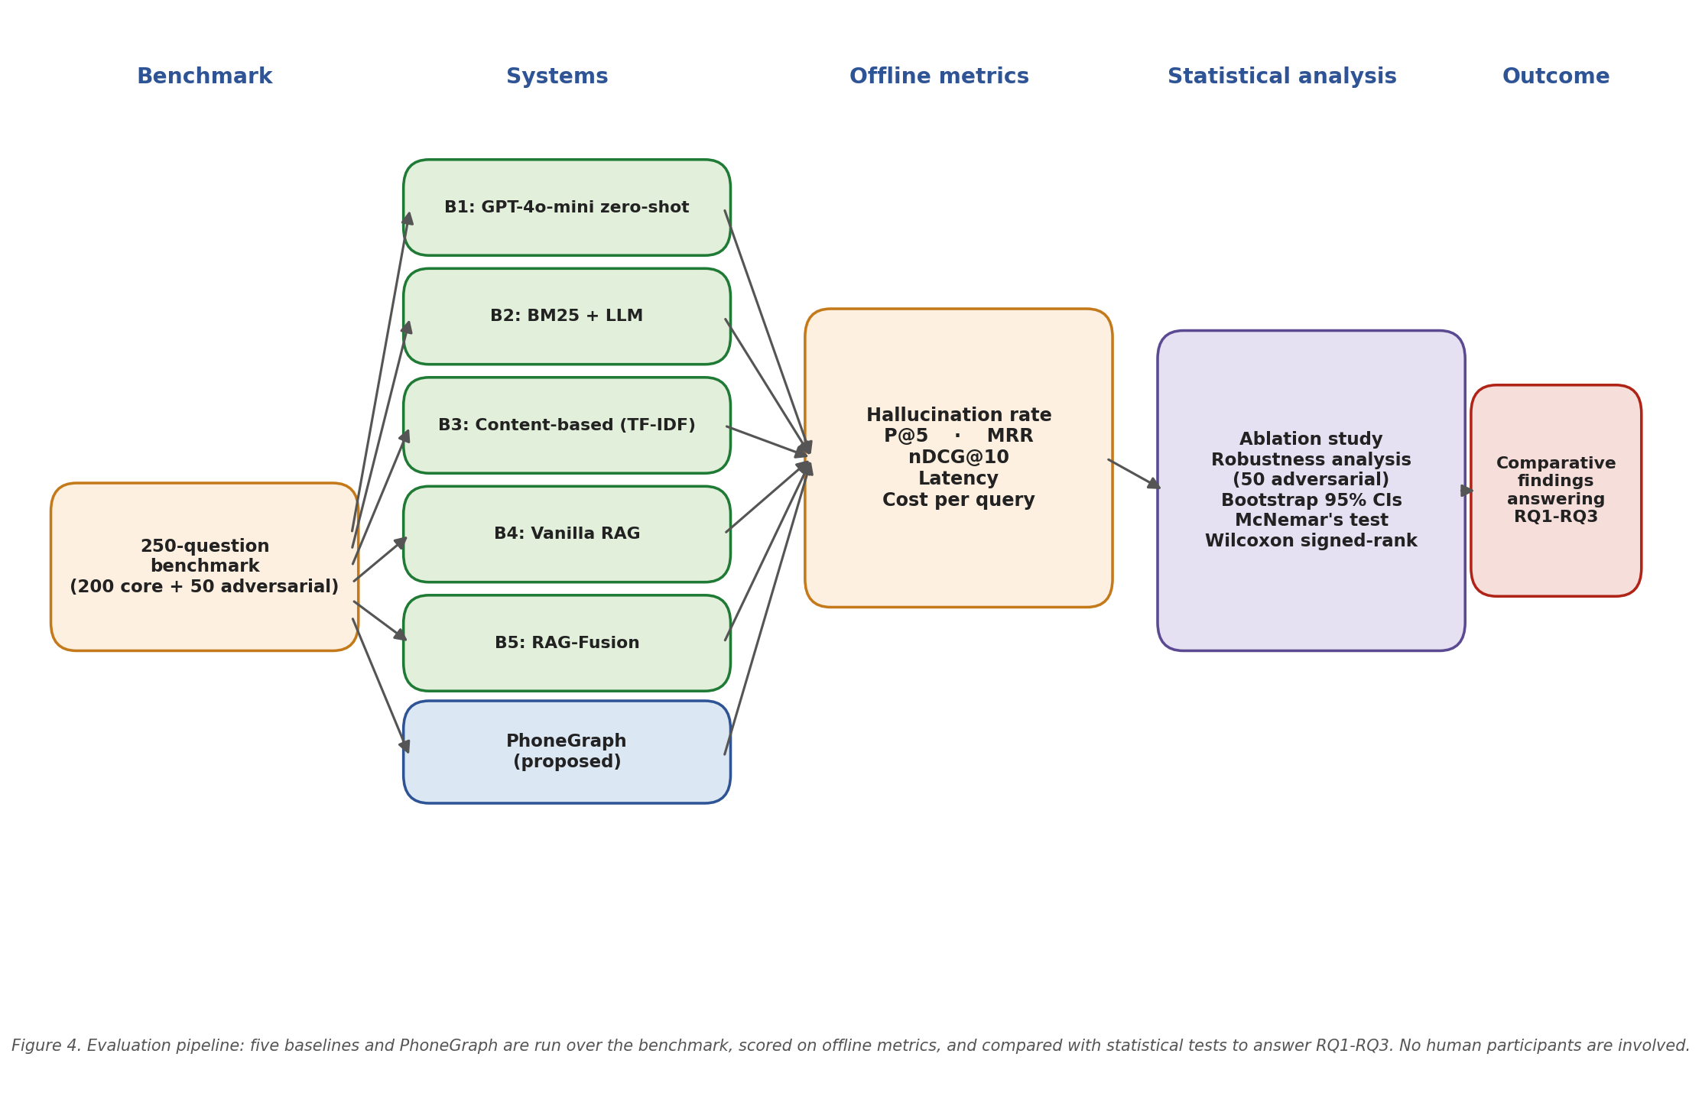
Figure 4. Evaluation pipeline showing baselines, metrics and statistical tests.
Five baselines are reproduced on the same base model: zero-shot GPT-4o-mini (no retrieval), BM25 + LLM, content-based filtering (TF-IDF), vanilla RAG over pgvector, and RAG-Fusion (Rackauckas, 2024). PhoneGraph is compared against them on the benchmark using P@5, MRR, nDCG@10, hallucination rate (a two-annotator audit with Cohen's kappa as inter-rater reliability, target 0.75), median latency and cost per query.
An ablation study isolates each component — vector-only, graph-only, hybrid without constraints, and hybrid with constrained generation — attributing any improvement to a specific design decision. A robustness analysis additionally tests fifty adversarial questions with typos, ambiguous references and out-of-distribution requests.
All metrics report bootstrap 95 per cent confidence intervals over one thousand resamples (Efron and Tibshirani, 1994). McNemar's test is applied to paired hallucination decisions (Dietterich, 1998) and the Wilcoxon signed-rank test to per-question scores, with Bonferroni correction for multiple comparisons.

3.6 Limitations and Threats to Validity
The main threats to validity are handled as follows. Construct validity rests on the graph being correct, so a ten per cent sample of triples is manually audited. Internal validity is protected by deterministic LLM settings and confidence intervals; crucially, every baseline and PhoneGraph configuration shares the same base LLM (GPT-4o-mini), so any gain is attributable to retrieval and constrained generation rather than a stronger model. External validity is limited by the absence of a user study, left to future work, while single-author bias is checked by peer review and public release. API costs are capped at one hundred pounds with a local Ollama fallback, and schedule risk is absorbed by the slack in Figure 5.

4. Project Schedule
Figure 5 presents the schedule as a Gantt chart anchored to the CMP7200 deadlines: start late May 2026, proposal 22 June 2026, dissertation and viva 7 September 2026. Five milestones are defined: proposal (M1, week 4), implementation complete (M2, week 10), evaluation complete (M3, week 14), dissertation (M4, week 16) and viva (M5, weeks 16-17). Literature review runs continuously to track this fast-moving field (Snyder, 2019). Because there is no user study, no ethics gate is required, freeing roughly two weeks of slack re-allocated to the ablation and robustness analyses, and a week-11 feature freeze prevents scope creep. In the chart, violet tasks are evaluation, blue are build and ochre are writing.
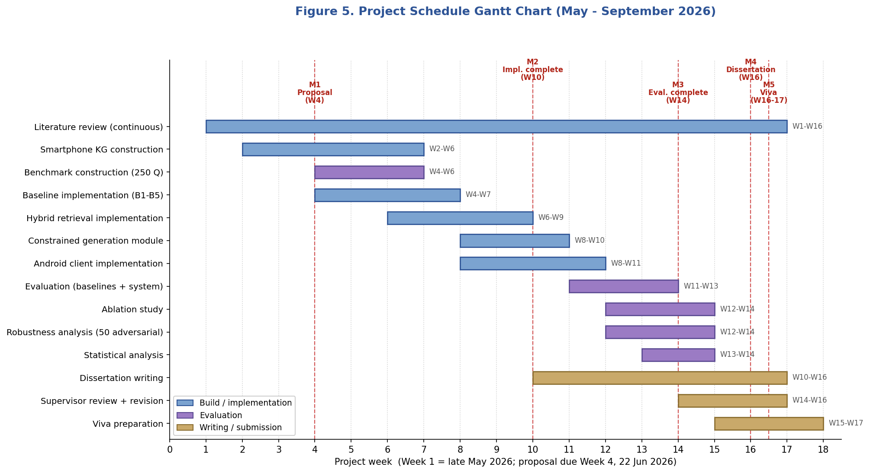
Figure 5. Project schedule Gantt chart (May to September 2026).

5. Conclusion
This proposal has laid out the rationale, methodology and schedule for PhoneGraph, a knowledge-graph-grounded conversational smartphone recommender. It targets a clear gap: KG grounding reduces hallucination in open-domain question answering but has not been benchmarked for consumer-electronics recommendation. The system pairs a Spring Boot backend, a Neo4j knowledge graph and an Android client with a benchmark-only evaluation spanning five baselines, an ablation study, a robustness analysis and statistical tests over two hundred questions. Built on the DSR methodology of Vaishnavi and Kuechler (2015), it draws on all six taught modules and is achievable within the four-month timeframe.

References
Beck, K., Beedle, M., van Bennekum, A., Cockburn, A., Cunningham, W., Fowler, M., Grenning, J., Highsmith, J., Hunt, A., Jeffries, R., Kern, J., Marick, B., Martin, R.C., Mellor, S., Schwaber, K., Sutherland, J. and Thomas, D. (2001) Manifesto for Agile Software Development. Available at: https://agilemanifesto.org (Accessed: 1 June 2026).
Bowman, S.R. and Dahl, G.E. (2021) 'What will it take to fix benchmarking in natural language understanding?', in Proceedings of NAACL-HLT 2021, pp. 4843-4855.
Brown, T.B., Mann, B., Ryder, N., Subbiah, M., Kaplan, J., Dhariwal, P., Neelakantan, A., Shyam, P., Sastry, G., Askell, A. et al. (2020) 'Language models are few-shot learners', in Advances in Neural Information Processing Systems, 33, pp. 1877-1901.
Brynjolfsson, E., Li, D. and Raymond, L. (2025) 'Generative AI at work', Quarterly Journal of Economics, 140(2), pp. 889-942.
Chapman, P., Clinton, J., Kerber, R., Khabaza, T., Reinartz, T., Shearer, C. and Wirth, R. (2000) CRISP-DM 1.0: Step-by-step Data Mining Guide. SPSS Inc.
Cronholm, S. and Goebel, H. (2018) 'Evaluation of the Information Systems Research Framework: Empirical evidence from a Design Science Research project', Electronic Journal of Information Systems Evaluation, 21(2), pp. 105-118.
Demsar, J. (2006) 'Statistical comparisons of classifiers over multiple data sets', Journal of Machine Learning Research, 7, pp. 1-30.
Dietterich, T.G. (1998) 'Approximate statistical tests for comparing supervised classification learning algorithms', Neural Computation, 10(7), pp. 1895-1923.
DXOMARK (2024) DXOMARK Mobile Image Quality Benchmark. Available at: https://www.dxomark.com (Accessed: 1 June 2026).
Edge, D., Trinh, H., Cheng, N., Bradley, J., Chao, A., Mody, A., Truitt, S. and Larson, J. (2024) 'From Local to Global: A Graph RAG approach to query-focused summarization', arXiv preprint arXiv:2404.16130.
Efron, B. and Tibshirani, R.J. (1994) An Introduction to the Bootstrap. New York: Chapman and Hall/CRC.
European Parliament (2016) 'Regulation (EU) 2016/679 (General Data Protection Regulation)', Official Journal of the European Union, L119, pp. 1-88.
Geng, S., Liu, S., Fu, Z., Ge, Y. and Zhang, Y. (2022) 'Recommendation as language processing (RLP): A unified pretrain, personalized prompt and predict paradigm (P5)', in Proceedings of the 16th ACM Conference on Recommender Systems, pp. 299-315.
GSMArena (2024) GSMArena.com - Mobile Phone Reviews, News, Specifications and More. Available at: https://www.gsmarena.com (Accessed: 1 June 2026).
Guo, Q., Zhuang, F., Qin, C., Zhu, H., Xie, X., Xiong, H. and He, Q. (2022) ‘A survey on knowledge graph-based recommender systems’, IEEE Transactions on Knowledge and Data Engineering, 34(8), pp. 3549-3568.
Hevner, A.R., March, S.T., Park, J. and Ram, S. (2004) 'Design science in information systems research', MIS Quarterly, 28(1), pp. 75-105.
Hogan, A., Blomqvist, E., Cochez, M., d'Amato, C., de Melo, G., Gutierrez, C., Kirrane, S., Labra Gayo, J.E., Navigli, R., Neumaier, S. et al. (2021) 'Knowledge graphs', ACM Computing Surveys, 54(4), pp. 1-37.
Huang, L., Yu, W., Ma, W., Zhong, W., Feng, Z., Wang, H., Chen, Q., Peng, W., Feng, X., Qin, B. and Liu, T. (2025) 'A survey on hallucination in Large Language Models', ACM Transactions on Information Systems, 43(2), pp. 1-55.
Ji, Z., Lee, N., Frieske, R., Yu, T., Su, D., Xu, Y., Ishii, E., Bang, Y.J., Madotto, A. and Fung, P. (2023) 'Survey of hallucination in natural language generation', ACM Computing Surveys, 55(12), pp. 1-38.
Jin, Y., Chen, L., Cai, W. and Zhao, X. (2024) 'CRS-Que: A user-centric evaluation framework for conversational recommender systems', ACM Transactions on Recommender Systems, 2(1), pp. 1-34.
LangChain4j (2024) LangChain4j: Supercharge your Java application with the power of LLMs. Available at: https://github.com/langchain4j/langchain4j (Accessed: 1 June 2026).
Lavrinovics, E., Biswas, R., Hose, K. and Bjerva, J. (2025) 'MultiHal: Multilingual dataset for knowledge-graph grounded evaluation of LLM hallucinations', arXiv preprint arXiv:2505.14101.
Lewis, P., Perez, E., Piktus, A., Petroni, F., Karpukhin, V., Goyal, N., Kuttler, H., Lewis, M., Yih, W., Rocktaschel, T., Riedel, S. and Kiela, D. (2020) 'Retrieval-augmented generation for knowledge-intensive NLP tasks', in Advances in Neural Information Processing Systems, 33, pp. 9459-9474.
Liang, P., Bommasani, R., Lee, T. et al. (2023) 'Holistic Evaluation of Language Models (HELM)', Transactions on Machine Learning Research, December 2023.
Ollama (2024) Ollama: Get up and running with large language models locally. Available at: https://ollama.com (Accessed: 1 June 2026).
Pineau, J., Vincent-Lamarre, P., Sinha, K., Lariviere, V., Beygelzimer, A., d'Alche-Buc, F., Fox, E. and Larochelle, H. (2021) 'Improving reproducibility in machine learning research', Journal of Machine Learning Research, 22(164), pp. 1-20.
Pu, P., Chen, L. and Hu, R. (2011) 'A user-centric evaluation framework for recommender systems', in Proceedings of the 5th ACM Conference on Recommender Systems, pp. 157-164.
Rackauckas, Z. (2024) 'RAG-Fusion: A new take on retrieval-augmented generation', arXiv preprint arXiv:2402.03367.
Royce, W.W. (1970) 'Managing the development of large software systems', in Proceedings of IEEE WESCON, pp. 1-9.
Sanmartin, D. (2024) 'KG-RAG: Bridging the gap between knowledge and creativity', arXiv preprint arXiv:2405.12035.
Snyder, H. (2019) 'Literature review as a research methodology: An overview and guidelines', Journal of Business Research, 104, pp. 333-339.
Statista (2024) Global Smartphone Market Statistics. Hamburg: Statista. Available at: https://www.statista.com (Accessed: 1 June 2026).
Vaishnavi, V.K. and Kuechler, W. (2015) Design Science Research Methods and Patterns: Innovating Information and Communication Technology. 2nd edn. Boca Raton: CRC Press.
Wang, H., Zhang, F., Wang, J., Zhao, M., Li, W., Xie, X. and Guo, M. (2018) ‘RippleNet: Propagating user preferences on the knowledge graph for recommender systems’, in Proceedings of the 27th ACM International Conference on Information and Knowledge Management (CIKM ’18), pp. 417-426.
Wang, H., Zhao, M., Xie, X., Li, W. and Guo, M. (2019a) ‘Knowledge graph convolutional networks for recommender systems’, in The World Wide Web Conference (WWW ’19), pp. 3307-3313.
Wang, H., Zhang, F., Zhao, M., Li, W., Xie, X. and Guo, M. (2019b) ‘Multi-task feature learning for knowledge graph enhanced recommendation’, in The World Wide Web Conference (WWW ’19), pp. 2000-2010.
Wang, X., He, X., Cao, Y., Liu, M. and Chua, T.-S. (2019) ‘KGAT: Knowledge graph attention network for recommendation’, in Proceedings of the 25th ACM SIGKDD International Conference on Knowledge Discovery & Data Mining (KDD ’19), pp. 950-958.
Wikidata (2024) Wikidata SPARQL Query Service. Available at: https://query.wikidata.org (Accessed: 1 June 2026).
Wu, L., Zheng, Z., Qiu, Z., Wang, H., Gu, H., Shen, T., Qin, C., Zhu, C., Zhu, H., Liu, Q., Xiong, H. and Chen, E. (2023) 'A survey on Large Language Models for recommendation', arXiv preprint arXiv:2305.19860.
Wu, L., Wang, S., Zhang, J., Tang, X., Hou, Y., Lai, X. and Liu, Q. (2024) 'On the effectiveness of LLM-based recommender systems against user manipulations', in Proceedings of RecSys 2024, pp. 234-244.

