Development Intelligence Platform — Italy
Renewables · BESS · Grid Data Centers · Port Grids Simulation · Optimisation · BTM
Scope and approach
Phase 1 sizes the system. CAPEX and electricity prices are excluded — Sizing before economics.
The tool sizes a behind-the-meter (BTM) system in Italy combining renewable generation, battery storage (BESS), and an electrical load (off-taker).
Economic assessment and financial models are deliberately left out; they enter only in Phase 2, once the sizing curves exist, and only rank designs that Phase 1 has already proven feasible.
The engine runs a full-year, 15-minute simulation under perfect foresight: it is handed one complete year of load and generation profiles and optimizes dispatch knowing the entire year in advance. The resulting BESS size is therefore a best-case theoretical lower bound, not a number a real-time controller is guaranteed to achieve operationally.

System Boundary
Everything inside the behind-the-meter boundary is modelled: generation, BESS, and load. The grid sits outside the boundary and is import-only.
Energy flows modelled:
- Generation → Load (direct self-consumption)
- Generation → BESS (charging from generation)
- BESS → Load (discharge to serve load)
- Grid → Load (import to cover deficit)
- Grid → BESS (charging from grid if MW_{load}<MW_{grid})
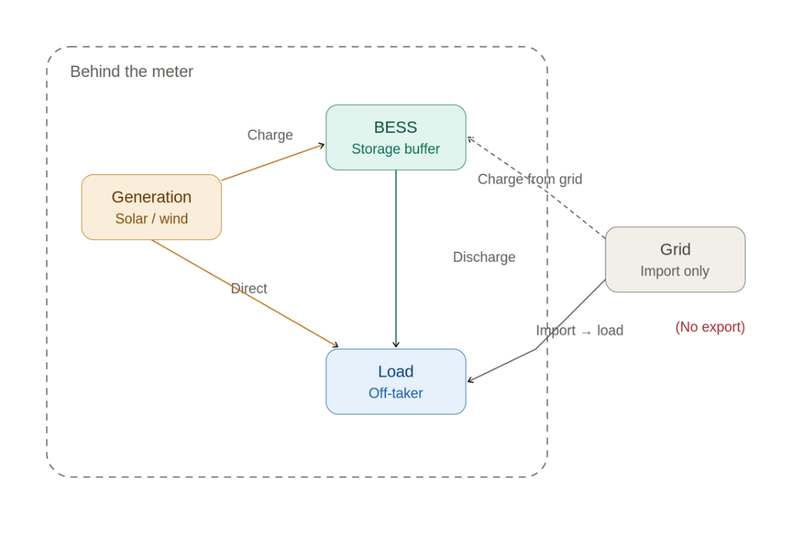
Sizing Dataset – Input vs. Output
The engine is not a one-direction calculator; the same physics can be queried in several directions. The load (off-taker) profile and the generation (PV) profile are the only values that are always a fixed input.

Item | Always input | Can be input | Can be output
Load / off-take Profile | Yes — fixed profile | — | No
Generation (PV) Profile | Yes — fixed profile | — | No
Load / off-take size | No | Yes — user fixes Load size | Yes
Generation (PV) size | No | Yes — user fixes PV size | Yes — PV size solved for (see Sec. 6)
BESS (power MW) | No | Yes — when querying SSR/MW achieved | Yes — minimum size solved for each target SSR/MW
BESS (energy MWh) | No | Yes — when querying SSR/MW achieved | Yes — minimum size solved for each target SSR/MW
SSR (%) | No | Yes — as a target to meet | Yes — as a curve profile
Grid connection size (MW) | No | Yes — as a ceiling to meet | Yes — as a curve profile

The Battery model should also consider: Battery round-trip efficiency, Charge/Dischage electrical efficiency, SOC limits ecc.
The Timestep — 15 minutes (35,040 steps/year). This matches Italian contracted-power assessment; an hourly engine would systematically under-size for peak shaving.
Degradation — must be modelled over the asset life (~20 years, e.g. one representative year replicated). The tool supports two modes: (a) oversize day-one capacity so the target is still met at end of life, or (b) size for day one and flag the resulting underperformance over time.

Two scenarios
Both reduce dependence on the grid — but they go in different directions.
- Main — Generation + BESS + Load. A behind-the-meter scheme in which the site may only withdraw from the grid (no export assumed for sizing).
- Sub-scenario — BESS + Load only. No on-site generation (e.g. a data centre with storage); the site may only withdraw from the grid, and the battery charges from the grid. Backup power is a sizing driver here.

The site cannot export. Any generation exceeding load plus available charging is curtailed.
Sizing objectives
Both reduce dependence on the grid — but they go in different directions.
- Peak shaving – Grid withdrawal power (MW). Reduce the peaks of the load so the grid connection can be smaller — measured in MW.
- Self-sufficiency ratio — SSR (MWh). Reduce the energy withdrawn from the grid down to a target value — measured in MWh.
The trade-off
These two objectives do not always align. The simulation must select one priority — MW or MWh from the grid — and size the BESS on it.

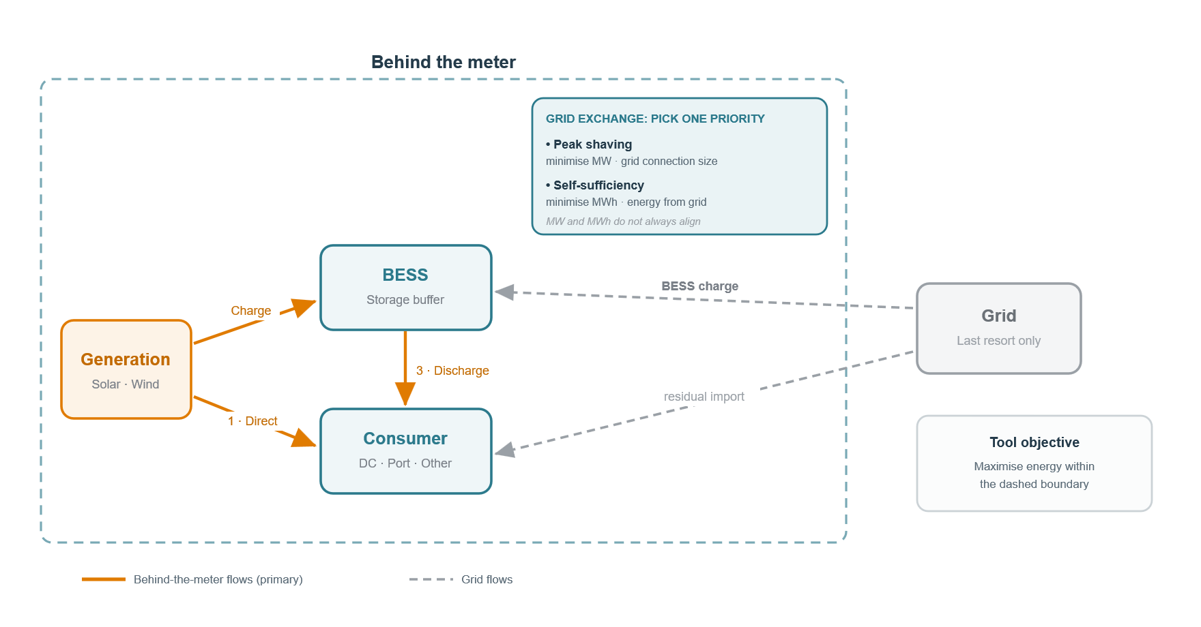
Figure 1 — Behind-the-meter flows and the MW vs MWh sizing objective on the grid exchange.
Try Different Sizing Targets
For each scenario, sweep the target and return the minimum BESS size that meets it. The output is a curve, not a single point.
Main scenario · SSR target · bess sIZING
- Fix the load size (MW) and generation size (MW).
- Output: BESS capacity and energy (MW & MWh).
- Find the minimum BESS size (MW and MWh) that reaches each SSR by time-shifting the energy produced by generation.
- With no economics in the loop, the result is a curve: for each SSR value, the corresponding minimum BESS size. The curve is expected to be parabola-like.
- Tie-breaker: where capacity and power of the BESS must be traded off, take the minimum-power (MWh) solution for each SSR. (In a certain E/P ratio, like 2h to 8h)
- Identify the maximum SSR reachable with the available generation. No reason to simulate up to 100%.
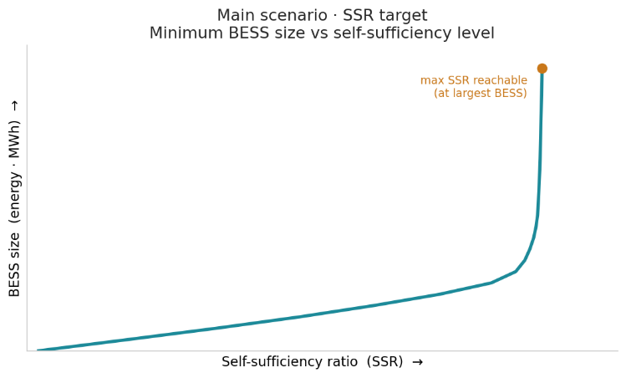

Main scenario · peak shaving · bess sIZING
- Fix the load size (MW) and generation size (MW).
- Output: BESS capacity and energy (MW & MWh).
- Find the minimum BESS size (MW and MWh) that allows a target grid-connection size (MW) by time-shifting the generation energy to flat the load.
- The result is again a curve: for each grid-connection size (MW), the minimum BESS size the software finds.
- Tie-breaker: take the minimum-power (MW) solution for each grid-connection size. In this case there should be no need to prioritize BESS MW in respect to MWh.
- Identify the minimum grid connection limit with the available generation to avoid extra calculations.
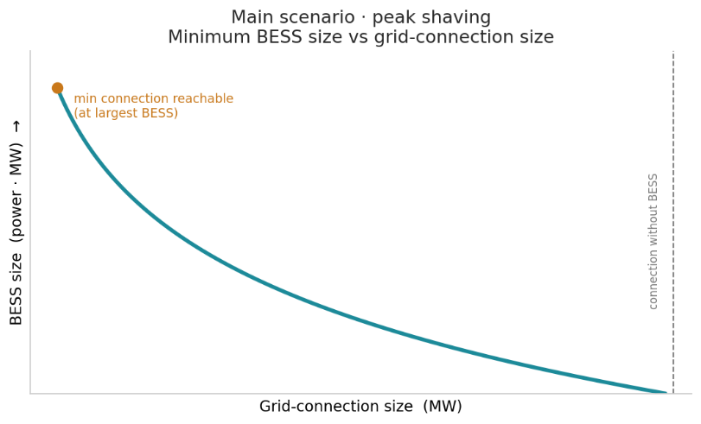
Main scenario · ssr target · bess & pv sIZING
- Optimize both the generation size and storage size at once, with the load fixed.
- The result is no longer a curve but a surface — Generation (x) × BESS (y) × SSR (z).
- To converge on a single design the search probably needs an extra constraint linking the two parameters — for example a fixed generation-to-storage ratio? This is a topic to be explored further.

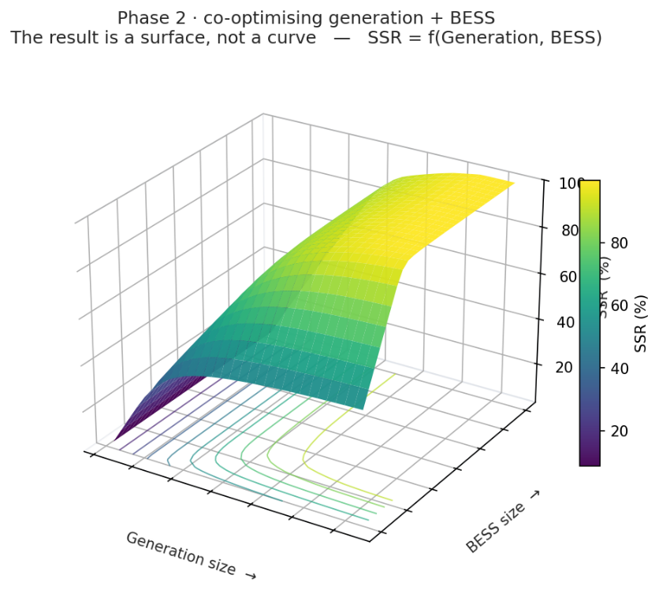
Sub-scenario · peak shaving (no generation, SSR = 0%)
- Represents a data center plus BESS, with no on-site generation.
- Find the minimum BESS size (MW and MWh) that holds a target grid-connection size (MW) by time-shifting generated energy to flatten the load — the battery time-shifts the energy withdrawn peak from the grid.
- The result is a curve: for each grid-connection size in MW, the minimum BESS size.
- Key difference: with no generation the BESS cannot improve self-sufficiency — every MWh still comes from the grid — so its only role here is peak shaving. The minimum grid connection keeps falling as the BESS grows. To avoid sizing an oversized, barely-used battery, the search should carry a minimum utilization constraint on the BESS — e.g. a minimum number of equivalent full cycles or operating hours per year. Alternatively, the full curve can be carried into Phase 2, where the techno-economic layer rules out the under-utilised region on cost grounds.

The search loop
1.For every scenario the engine runs hundreds, thousands of full-year simulations to trace the entire SSR or grid-size curve, not a single point.
2. For every scenario the engine is able to converge on the specific SSR or grid-size target input, without simulating the entire curve..
Phase 2 — techno-economic layer
Only once the sizing curves exist do CAPEX and prices select the optimum point on them.
- Co-optimise SSR and Grid connection size. Understand how to optimize both variables at once, with the load fixed.
taking the larger of two independently-sized batteries would not be, because the two objectives compete for the same SOC.
For each Grid connection size value, there are multiple SSR which can be obtained by changing the size of the BESS system.
- Add CAPEX and price curves. Overlay them on the Phase-1 sizing curves to find the techno-economic optimum along each curve.
- Seasonal grid time-shifting. For a data-centre load, enable time-shifting from the grid when peak shaving is not binding — in winter the base load is lower than in summer, leaving headroom under the connection.
- Grid services. Introduce a revenue stream and a reserved state of charge to provide grid balancing and power services from the data center.
- Site-area constraint (to explore). A future phase should consider bringing the available site area into the model as a constraint, bounding designs to what physically fits on the plot and opening up area-driven questions (for example sizing the consumer or the generation to a given area). Approach and scope to be defined.
Phase-1 test
The sizing curves must be producible with no price or CAPEX input. Economics only ranks points already on those curves.

